Department / Program Review
Self Study Report
for
Transfer Programs
2017 – 2018

Departments: 0501 – Associate of Science (LA.S.AS)
0573 – Engineering University Parallel (ESUP.S.AS)

Science, Mathematics and Engineering Division
Sinclair College

Department/Program Review
Self-Study Report
for Transfer Programs

2017 - 2018

Departments: 0501-Associate of Science (LA.S.AS)
0573-Engineering University Parallel (ESUP.S.AS)

Section I: Program Background, Innovations and Accomplishments
Please list noteworthy innovations in instruction, curriculum and student learning over the last five years (including student awards, faculty awards, etc.).

Both the Associate of Science degree (LA.S.AS) and Engineering University Transfer degree (ESUP.S.AS) are unique degrees in that they are housed within the dean’s office of the Science, Mathematics, and Engineering Division with no faculty directly assigned to these programs. The courses in both programs utilize existing offerings to build a curriculum tailored to a student’s academic endeavor. Courses within each program are often made up of students pursuing many different degrees and are not limited to transfer students. For example, Engineering Transfer students enrolled in MAT2270 Calculus and Analytic Geometry I may be sitting next to students majoring in an associate degree in Chemistry, Geology or Physics.

The Associate of Science degree is designed for students who wish to transfer to a four year university to obtain a baccalaureate degree in fields such as Biology, Chemistry, Geology, Mathematics, Physics or pre-professional programs such as Medicine or Pharmacy. The degree allows students the flexibility to build their own degree program in satisfying the freshman and sophomore requirements of most four-year schools within the State of Ohio while recognizing significant financial savings. Students must complete the requirements of the Ohio Transfer Module in order to graduate. These required courses can be found in Appendix A.

The Engineering University Transfer degree is designed for students wishing to transfer to a four-year university to obtain a baccalaureate degree in an engineering discipline, such as Mechanical Engineering, Biomedical Engineering or Chemical Engineering. The degree is built upon a core group of courses with numerous electives chosen by the student based on the discipline and school to which the student wishes to transfer. Students must complete the requirements of the Ohio Transfer Module in order to graduate. These degree requirements can be found in Appendix B.

Both degrees rely heavily upon Academic Advising to help students determine which courses they need to take in order to successfully transfer to their school of choice. The Engineering University Transfer program is led by a strong advisory board made up of Sinclair representatives including the SME dean and assistant dean, science and mathematics chairs, academic advisors and faculty as well as deans and program directors from local universities including Central State University, Miami University, Wilberforce University, Wright State University, University of Cincinnati, and the University of Dayton. A complete list of advisory board members and the most recent copy of the minutes can be found in Appendix C.

The Engineering University Transfer degree uses the input of this advisory board to determine course requirements within the program. Course changes at the university level necessitate changes in the associate degree to help insure Sinclair students have the most number of credits transfer.

There are 486 active students enrolled in the Liberal Arts and Sciences degree (LA.S + LA.S.AS) and 744 active students enrolled in the Engineering University Transfer degree (ESUP.AS + ESUP.S.AS) for the 2017-2018 academic year.

Section II: Annually Reviewed Information

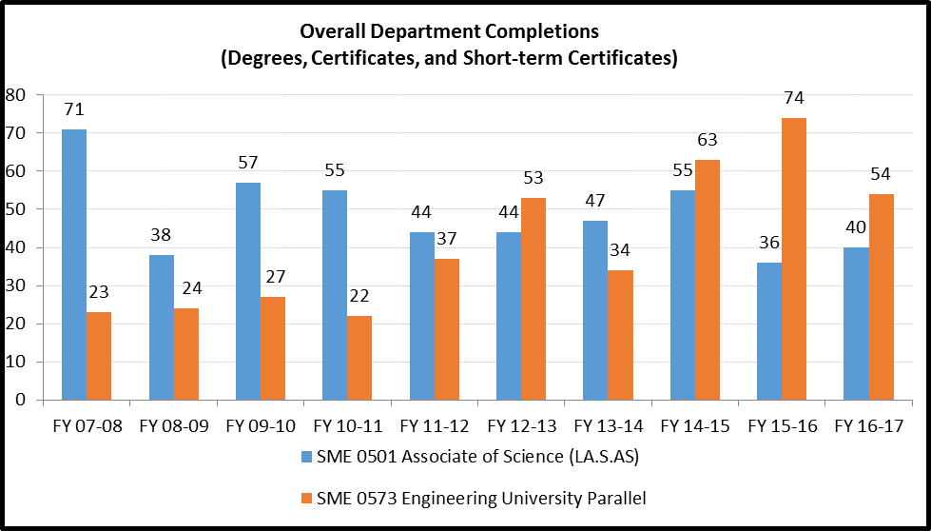

A: Program Trend Data, Interpretation, and Analysis

Degree and Certificate Completion Trend Data – OVERALL SUMMARY

Please provide an interpretation and analysis of the Degree and Certificate Completion Trend Data: i.e. What trends do you see in the above data? Are there internal or external factors that account for these trends? What are the implications for the program? What actions have been taken that have influenced these trends? What strategies will be implemented as a result of this data?

Please be sure to address strategies you are currently implementing to increase completions of degrees and certificates. What plans are you developing for improving student success in this regard?

Both the Associate of Science degree (LA.S.AS) and the Engineering University Parallel degree (ESUP.S.AS) are associate degrees only with no embedded certificates.

Graduation data for the Engineering University Transfer program reached a peak in FY15-16 as the program coordinator (SME assistant dean) manually evaluated transcripts and found un-awarded degrees.

The program coordinator is currently working with Academic Advising and the Engineering Transfer Advisory Board to create multiple degrees instead of a generic single degree with multiple electives. Feedback from students has indicated that students would like to have an associate degree that specifically names their attained degree. For example, currently when students graduate, their degree reads, “Engineering University Transfer”. The hope is to create a degree for each discipline (mechanical, chemical, etc.) that would read, for example, “Mechanical Engineering Transfer” associate of science on the diploma.

There is current discussion with the universities to streamline the process of reverse transfer. This will allow Sinclair to award an associate degree to students who left before completing but have since completed the requirements while at the university. It is anticipated that this will increase the number of completions within the Engineering University Transfer program as most students enrolled in the program will leave Sinclair before having enough credits to be awarded an associate degree.

There are several scenarios why students may not complete a degree at Sinclair before transferring, including:
- Students who may not have been initially accepted to an engineering program are taking coursework until they are accepted.
- Sinclair’s program does not align exactly with the university program of choice so students will not take any additional coursework.
- Students enrolled in the engineering program are not able to complete the calculus based math and science requirements and switch to an engineering technology program.
- Students discover that they do not like engineering and change majors.
- Students stop out due to life circumstances.

It is the goal of the program coordinator to double the number of completions within the next five years. The following is being implemented as part of that strategy:
- Work with partner universities to develop multiple associate of science degrees (as opposed to one catch-all degree) that more closely align with their engineering degrees.
- Work with partner universities to award a Sinclair credential through reverse transfer.
- More frequent contact of Sinclair students concerning resources available for help including academic advising, tutoring and counseling.

B: Progress Since the Most Recent Review
Below are the goals from Section IV part E of your last Program Review Self-Study. Describe progress or changes made toward meeting each goal over the last year.
NOTE – LAS.S.AS HAS NEVER HAD A PROGRAM REVIEW BEFORE, ALL GOALS ARE FOR ESUP.S.AS.
GOALS | Status | Progress or Rationale for No Longer Applicable
Explore adding global awareness to the courses/program. | In progress  Completed  No longer applicable | Affects transfer. Students are allowed to take any OTM courses and then follow specific guidelines from their receiving institution.
Online courses. | In progress  Completed  No longer applicable | Some general education courses are available on-line. No plans to make the core engineering courses on-line. The University of Dayton has said they will not allow students to transfer any on-line engineering courses, although they will accept other on-line courses if the exams are proctored.
New calculus based Thermodynamics course as suggested by most universities. | In progress  Completed  No longer applicable | MEE 2201 was successfully offered Fall 2012 and Spring 2013. Course will remain in the schedule each fall and spring. Course has been offered every fall and spring, going to two offerings a term starting in Fall 2015.

Below are the Recommendations for Action made by the review team. Describe the progress or changes made toward meeting each recommendation over the last year.
NOTE – LAS.S.AS HAS NEVER HAD A PROGRAM REVIEW BEFORE, ALL RECOMMENDATIONS ARE FOR ESUP.S.AS.
RECOMMENDATIONS | Status | Progress or Rationale for No Longer Applicable
The program coordinator has done much to revitalize this degree program, but his efforts need to be formalized so that when responsibility for this program transfers to someone else at some future time the momentum that has developed in this program is not lost. Due to the nature of the program, it is recommended that, like the current coordinator, any future coordinators have an engineering background. The current coordinator has done a stellar job of overseeing this program, and that should not be lost at some point in the future when he hands his responsibilities over to someone else. A formalized and well-documented transition process will need to be developed in anticipation of this. The advisory committee may have some insights on how to accomplish this. | In progress  Completed  No longer applicable | Program has transitioned to new coordinator. Several new initiatives are under way to better serve students in the program (see later).
The coordinator has developed a marketing plan, and it is recommended that the marketing plan be pursued as a way of attracting students to the program. | In progress  Completed  No longer applicable | During 2012-13 held two outreach nights for HS students and their parents. Participated in college fairs at Mason and West Carrollton. Displayed at tech prep night. Will display at Sinclair Welcome Week in the fall and scheduled for two Sinclair Talks on Engineering in 2013-2014.  2014-15, participated in numerous college fairs, including West Carrollton, Ponitz and Centerville. Present at Fall and Spring Affair, Tech Prep “Getting Ready for College night”, Multiple other tech prep events. Did evening outreach meeting at Xenia HS.  2017-18: Marketing is currently ongoing. Outreach events include college fairs at local high schools, the SME led “Engineers Day”, the ETD organized open house and various Sinclair sponsored events such as “Getting Ready for College Night”.

Strong relationships already exist with area universities, particularly with the University of Dayton. It is recommended that the coordinator continue to maintain these relationships. | In progress  Completed  No longer applicable | Relationships are strong with both WSU and UD. Developing relationships with Central State and Wilberforce. Opening a new dialog with UC and Miami.  2014-15: Completed articulation with Wilberforce. Central State agreement is on hold while they re-work their curriculum. Progress with Miami has come to a halt as Miami faculty interest in SCC students has is lukewarm. No progress yet with UC.  2015-16: Updated articulation agreements with UD and WSU.  2017-18: Based on feedback from Academic Advising and the Advisory Board, the program coordinator is working on creating individual degrees for each university pathway instead of a single generic degree.

Much of the knowledge regarding this program is held by the coordinator and by a Senior Academic Advisor. It is recommended that cross-training occur and documentation of policies and procedures be made, such that when other individuals transition into these positions there is continuity of policies and procedures. There is a pressing need for clear documentation that will allow a variety of academic advisors to assist interested students. | In progress  Completed  No longer applicable | Work continues on training addvisors. Two training sessions held. New pathway documents will also be of help to advisors.  2014-15: New advising model works well. Meet with them periodically to communicate changes to program.  2015-16: New transfer guides prepared and shared based on updated transfer agreements.
The formation of the advisory committee was an important step for this program. It is recommended that the coordinator work closely with the committee, such that the committee feels engaged in program maintenance and improvement. The self-study mentions that a “definite plan will be developed in the advisory committee meeting in Spring 2010” to increase student retention, and it is recommended that this be pursued in that meeting. | In progress  Completed  No longer applicable | Spring 2012 marketing initiatives were implemented. Work with advisory is ongoing and additional actions will be taken in the future.
Work recently began on the web page for the program, and continued development of this is recommended. | In progress  Completed  No longer applicable | As part of the college’s transition to a new website, an EUT program page was created to complement the other SME programs. The new EUT program page highlights, among other things: program specific information, transfer opportunities, the differences between engineering and engineering technology was highlighted on this page, as well as scholarship opportunities.
Continue efforts to better communicate with students in the program. | In progress  Completed  No longer applicable | Developed Angel community for better communication with students. Electrical students now have a class assignment in a basic class (EET 1131) that requires them to contact the EUT corrdinator if they are engineering students.  2014-15: New eLearn site is not yet up but should be activated sometime this year.  2015-16: New eLearn site exists but requires work to keep the student roster current. The EUT coordinator has done several outreach events for both existing and new students, including setting up an engineering panel and a presentation from WPAFB. In addition, several emails have gone to EUT students on events and scholarships.  2017-18: The eLearn community shell, titled “Engineering University Transfer – Community” is the primary tool used to communicate with EUT students though it can be a challenge updating the roster on a semester by semester basis.

C: Assessment of General Education & Degree Program Outcomes

Sinclair General Education Outcomes are listed below. Please report assessment work that has been done in these areas since the last Program Review. It is recommended that General Education assessment work that has been reported in program Annual Updates for the past several years form the basis for this section, although departments are strongly encouraged to include any General Education assessment that was not previously reported in Annual Update reports.

General Education Outcomes | Courses identified by the program where mastery could be assessed | Assessment Methods  Used | What were the assessment results?  (Please provide brief summary data)
Critical Thinking/Problem Solving
Cultural Diversity and Global Awareness
Computer Literacy |  | 0573 - Computer Literacy General Education Assessment Rubric applied to assignments in select courses. | Please see below.
Information Literacy |  | 0501 - Information Literacy General Education Assessment Rubric applied to assignments in select courses | Please see below.

Oral Communication | OPTIONAL | 0501 - Oral Communication General Education Assessment Rubric applied to Dynamic Duos assignment in COM sections.  0573 - Oral Communication General Education Assessment Rubric applied to Dynamic Duos assignment in COM sections. | Please see below.  Please see below.
Written Communication | OPTIONAL | 0501 - Written Communication General Education Assessment Rubric applied to Final Paper in ENG 1101 sections.  0573 - NOTE – NO WRITTEN COMMUNICATION RUBRIC RESULTS ARE YET AVAILABLE FOR 0573 – ENGINEERING UNIVERSITY PARALLEL | Please see below.
Are changes planned as a result of the assessment of general education outcomes? If so, what are those changes? | Computer Literacy: The sampling size is quite small. No current changes are planned. Continue to monitor.  Information Literacy: No changes are planned. Continue to monitor.  Oral Communication: No changes are planned. Continue to monitor.  Written Communication: No changes are planned. Continue to monitor.
How will you determine whether those changes had an impact? | N/A

Computer Literacy Rubric Results for Students with a Program Code in 0573-Engineering University Parallel
Dept. | General Education Component | General Education Subcomponent | 17/SP - 17/FA - Does not meet expectations (less than 70%) | 17/SP - 17/FA - Meets expectations (70% or above) | 17/SP - 17/FA - Exceeds Expectations (90% or above) | 17/SP - 17/FA - PERCENT MEETS OR EXCEEDS EXPECTATIONS
0573 | Computer Literacy | Excel | 1 | 0 | 3 | 75.0%
0573 | Computer Literacy | PowerPoint | 0 | 0 | 4 | 100.0%
0573 | Computer Literacy | Software Quiz | 1 | 2 | 1 | 75.0%
0573 | Computer Literacy | Word | 1 | 0 | 3 | 75.0%
SINCLAIR OVERALL | Computer Literacy | Excel | 10 | 5 | 63 | 87.2%
SINCLAIR OVERALL | Computer Literacy | PowerPoint | 1 | 0 | 77 | 98.7%
SINCLAIR OVERALL | Computer Literacy | Software Quiz | 17 | 47 | 14 | 78.2%
SINCLAIR OVERALL | Computer Literacy | Word | 4 | 4 | 70 | 94.9%

Information Literacy Rubric Results for Students with a Program Code in 0501-Associate of Science
Dept. | General Education Component | 16/SP - 17/SP DEVELOPING | 16/SP - 17/SP COMPETENT | 16/SP - 17/SP EXCEPTIONAL | 16/SP - 17/SP PERCENT COMPETENT OR EXCEPTIONAL
0501 | Criterion 1: Pose valid research or discovery questions based on need and formulate thesis idea and purpose connected to research. | 0 | 11 | 0 | 100.0%
0501 | Criterion 2: Organize and integrate information and use information ethically. | 0 | 11 | 0 | 100.0%
0501 | Criterion 3: Select sources that are appropriate, credible and relevant to the idea being supported. | 1 | 10 | 0 | 90.9%
SINCLAIR OVERALL | Criterion 1: Pose valid research or discovery questions based on need and formulate thesis idea and purpose connected to research. | 2 | 108 | 1 | 98.2%
SINCLAIR OVERALL | Criterion 2: Organize and integrate information and use information ethically. | 8 | 104 | 4 | 93.1%
SINCLAIR OVERALL | Criterion 3: Select sources that are appropriate, credible and relevant to the idea being supported. | 10 | 97 | 7 | 91.2%

Oral Communication Rubric Results for Students with a Program Code in 0501-Associate of Science
Dept. | General Education Component | General Education Subcomponent | 17/SP - Level 5 Not Applicable / Did not Complete | 17/SP - Level 4 Developing | 17/SP - Level 3 - Competent | 17/SP - Level 2 Competent | 17/SP - Level 1 Exemplary | Percent Competent or Exemplary (Excludes Level 5)
0501 | Compose and organize oral communication messages appropriately. | Note - Four measures of this Gen Ed Component are added together across each level (Stages 1-4 in the assignment) | 0 | 7 | 7 | 42 | 32 | 92.0%
0501 | Use effective verbal and non-verbal skills to deliver appropriate messages effectively | Proofreading and Organization |  |  | 4 | 7 | 11 | 100.0%
SINCLAIR OVERALL | Compose and organize oral communication messages appropriately. | Note - Four measures of this Gen Ed Component are added together across each level (Stages 1-4 in the assignment) | 13 | 94 | 364 | 1057 | 1324 | 96.2%
SINCLAIR OVERALL | Use effective verbal and non-verbal skills to deliver appropriate messages effectively | Proofreading and Organization | 5 | 17 | 102 | 235 | 354 | 96.9%

Oral Communication Rubric Results for Students with a Program Code in 0573-Engineering University Parallel
Dept. | General Education Component | General Education Subcomponent | 17/SP - Level 5 Not Applicable / Did not Complete | 17/SP - Level 4 Developing | 17/SP - Level 3 - Competent | 17/SP - Level 2 Competent | 17/SP - Level 1 Exemplary | Percent Competent or Exemplary (Excludes Level 5)
0573 | Compose and organize oral communication messages appropriately. | Note - Four measures of this Gen Ed Component are added together across each level (Stages 1-4 in the assignment) | 0 | 5 | 22 | 52 | 53 | 96.2%
0573 | Use effective verbal and non-verbal skills to deliver appropriate messages effectively | Proofreading and Organization |  | 2 | 6 | 6 | 19 | 93.9%
SINCLAIR OVERALL | Compose and organize oral communication messages appropriately. | Note - Four measures of this Gen Ed Component are added together across each level (Stages 1-4 in the assignment) | 13 | 94 | 364 | 1057 | 1324 | 96.2%
SINCLAIR OVERALL | Use effective verbal and non-verbal skills to deliver appropriate messages effectively | Proofreading and Organization | 5 | 17 | 102 | 235 | 354 | 96.9%

Written Communication Rubric Results for Students with a Program Code in 0501-Associate of Science
Dept. | General Education Component | General Education Subcomponent | TOTAL FAILING 15/FA - 17/SU | TOTAL PASSING 15/FA - 17/SU | TOTAL PERCENT PASSING 15/FA - 17/SU
0501 | Critical Response: Appropriately and effectively incorporate another writer's material. | Read and respond critically to another writer 's material | 10 | 126 | 92.6%
0501 | Structure of the Message: Prepare written material whose message is shaped to appeal to appropriate audiences and situations. | Shape messages to appeal to appropriate audiences and situations | 10 | 126 | 92.6%
0501 | Structures of Composition: Prepare written material that applies the correct structures of composition. | Compose works using the correct structures of composition | 10 | 126 | 92.6%
0501 | Topics and Controlling Ideas: Select a topic that is clear, manageable, flows logically, and has sufficient supporting examples. | Arrange ideas appropriately | 0 | 134 | 100.0%
0501 | Topics and Controlling Ideas: Select a topic that is clear, manageable, flows logically, and has sufficient supporting examples. | Generate and select logical and sufficient support | 14 | 122 | 89.7%
0501 | Topics and Controlling Ideas: Select a topic that is clear, manageable, flows logically, and has sufficient supporting examples. | Identify and develop clear topics and controlling ideas | 4 | 130 | 97.0%
Written Communication Rubric Results for Students with a Program Code in 0501-Associate of Science (Continued)
Dept. | General Education Component | General Education Subcomponent | TOTAL FAILING 15/FA - 17/SU | TOTAL PASSING 15/FA - 17/SU | TOTAL PERCENT PASSING 15/FA - 17/SU
SINCLAIR OVERALL | Critical Response: Appropriately and effectively incorporate another writer's material. | Read and respond critically to another writer 's material | 552 | 3234 | 85.4%
SINCLAIR OVERALL | Structure of the Message: Prepare written material whose message is shaped to appeal to appropriate audiences and situations. | Shape messages to appeal to appropriate audiences and situations | 314 | 3532 | 91.8%
SINCLAIR OVERALL | Structures of Composition: Prepare written material that applies the correct structures of composition. | Compose works using the correct structures of composition | 440 | 3350 | 88.4%
SINCLAIR OVERALL | Topics and Controlling Ideas: Select a topic that is clear, manageable, flows logically, and has sufficient supporting examples. | Arrange ideas appropriately | 370 | 3478 | 90.4%
SINCLAIR OVERALL | Topics and Controlling Ideas: Select a topic that is clear, manageable, flows logically, and has sufficient supporting examples. | Generate and select logical and sufficient support | 578 | 3282 | 85.0%
SINCLAIR OVERALL | Topics and Controlling Ideas: Select a topic that is clear, manageable, flows logically, and has sufficient supporting examples. | Identify and develop clear topics and controlling ideas | 234 | 3620 | 93.9%

The Program Outcomes for the degrees are listed below. All program outcomes must be assessed at least once during the 5 year Program Review cycle, and assessment of program outcomes must occur each year.
Program Outcomes | To which course(s) is this program outcome related? | Year assessed or to be assessed. | Assessment Methods  Used | What were the assessment results?  (Please provide brief summary data)
Calculus and Analytical Geometry - Develop skills in calculus, analytical geometry and differential equations to analyze and solve engineering problems. (ESUP.S.AS) | MAT 2270  MAT 2280 | 2014-15  2019-20 | Common test questions in Calculus | 2014-15: Student performance varied from a high of 82% (correct mathematical notation, unit conversion) to a low of 30% (correct integral and correct answer). Overall performance was 60% over 9 distinct areas.
Written and Oral Communication - Demonstrate written and oral communication skills for effective presentations. (ESUP.S.AS) | ENG 1101  ENG 1201  COM 2211  OTM Arts/Humanities Elective  OTM Social/ Behavioral Elective | 2014-15  2020-21 | Written assignments in Thermodynamics | 2014-15: All students successfully completed writing assignments at the 80% or greater competency by rubric.
Problem Solving - Use mathematics and analytical tools for engineering and related problem solving. (ESUP.S.AS) | EGR Electives  SME 1101 | 2011-12  2018-19 | Exams | 2011-12: Section averages consistently above 75%, consistently higher than WSU students on same exam in parallel course.

Basic Laws of Physics - Identify and apply the basic laws of physics and chemistry including mechanical, electrical, heat, light, sound, and inorganic chemistry to enhance comprehension of engineering topics. (ESUP.S.AS) | CHE 1211  PHY 2201  PHY 2202 | 2014-15  2021-22 | Exams | 2014-15: 70% of students met the standard of 80% success in Physics-provided questions.
Are changes planned as a result of the assessment of program outcomes? If so, what are those changes? | Based on current information, no changes are currently planned.
How will you determine whether those changes had an impact? | N/A

Section III: Overview of Program
- Mission of the program and its programs(s)
What is the purpose of the program and its programs? What publics does the program serve through its instructional programs? What positive changes in students, the community and/or disciplines/professions is the program striving to effect?

The purpose of both the Associate of Science degree (LA.S.AS) and the Engineering University Transfer degree (ESUP.S.AS) is to help students prepare for enrollment in a science or engineering program at a four year university. Most students come directly from high school, though the programs does have adult students returning to college to pursue a new career path.

Attending Sinclair as a transfer student has numerous benefits, including:
- Enormous cost savings through paying the lowest tuition in the State of Ohio.
- Small class sizes and personal attention.
- Well maintained state-of-the-art labs and facilities.
- Excellent instructors, many of which possess real-world experience.
- Numerous course offerings.

The primary universities that students transfer to is:
- Central State University
- Miami University
- The Ohio State University
- The University of Dayton
- Wilberforce University
- Wright State University

Student enrolled in Sinclair’s transfer programs choose a variety of four year degrees, including:
- Biology
- Biomedical Engineering
- Chemical Engineering
- Chemistry
- Computer Engineering
- Computer Science
- Electrical Engineering
- Geology
- Industrial Systems Engineering
- Mechanical and Materials Engineering
- Mechanical Engineering
- Physics

For additional information about the focus of each program, please see Section I.
Section IV: Overview of Program
- Analysis of environmental factors
Based on your discussion with the Assistant Provost in the Environmental Scan process, how is the department responding to the (1) current and (2) emerging needs of the community? The college?

According to the Bureau of Labor Statistics, engineering jobs (all disciplines combined) are expected to grow about 4% over the next seven years. Professions such as mechanical engineering is expected to grow over 5% with biomedical engineering expected to grow at 23.1%.

With a median annual salary for all engineers being over $90,000 per year, the current forecast looks good for students wishing to enter the fields of engineering found at our university partners.

Science disciplines also show a strong job outlook, with professions such as physicists projected to grow 14% over the next ten years with chemists showing an increase of 6%.

For additional information, please see Appendix D.

Data Source: https://www.bls.gov/opub/ted/2016/employment-outlook-for-engineering-occupations-to-2024.htm

- Department Completion Plans
Below are five milestones that are highly predictive of students graduating in a timely manner.
- Students solidify their choice of major within the first or second term
- Students receive a MAP to completion within the first or second term
- Students complete a college-level Math and English class within the first year
- Student take 30 credits within the first year, including summer
- Students take 9 credits in their major area of interest within the first year, including summer
Please describe any work the department has done over the past five years which may have impacted these milestones.

Both programs (LA.S.AS and ESUP.S.AS) rely heavily upon the skills and knowledge of Sinclair’s Academic Advisors to help students enter into the correct program of study and map out their courses semester by semester. Many students who enroll in these programs typically do not need as much remediation in mathematics as technology students. However, students who are not ready to start Calculus are often disadvantaged because many courses within each program have Calculus as a prerequisite. There are courses that can be taken while students work towards Calculus, such as English Composition or an OTM course, but course selection narrows quickly from one term to the next without Calculus completed.

Section V: Program Quality

- Evidence of student demand for the program
How has/is student demand for the program changing? Why? Should steps be taken to increase the demand? Decrease the demand? Eliminate the program? What is the likely future demand for this program and why?

While program enrollment is healthy, there is ample room for expansion, including the potential to offer sections of various engineering courses at learning center locations.

Increased enrollment would necessitate the need for additional course sections, especially in specific calculus-based engineering courses such as MEE 2101 Statics for Engineers, which would give students more scheduling options.

- Evidence of program quality from sources outside of the department (e.g., advisory committees, accrediting agencies, other departments on campus, transfer partners, etc.)
What evidence does the department have about evaluations or perceptions of department/program quality from sources outside the department? Who are your stakeholders, and what feedback are you receiving from them about program quality?

Advisory members from other institutions are universally complimentary of our students and their academic preparation to move into upper-level work, describing them as being “as prepared or better prepared” than native students.

Partner universities recommend to their students requiring remediation, or those whose schedules require alternate class times, that they take those classes at Sinclair College. Each term the college typically has a few transient students in each engineering elective class, as well as in math, physics and chemistry classes.

- Evidence of the cost-effectiveness of the department/program
What is the department doing to manage costs? What additional efforts could be made to control costs? What factors drive the costs for the department, and how does that influence how resources are allocated? What has the Average Class Size been for the department since the last Program Review, and what are steps that the department could take to increase Average Class Size? If Average Class Size has decreased, what is the explanation?

Both programs (LA.S.AS and ESUP.S.AS) are housed under the SME dean’s office and are not their own department. There is no budget for either program. Any associated costs are paid from the SME division’s budget.

Calculus based courses such as MEE 2201 Thermodynamics for Engineers have slowly seen a rise in seat count generating the need to add additional course sections. Summer offerings have also become more robust in their offerings. This can be attributed to students returning home to Dayton and while here taking a class to transfer back to their home institution.

The contribution margin, as supplied by Sinclair’s budget office, for the Engineering Transfer program is shown on the next page.

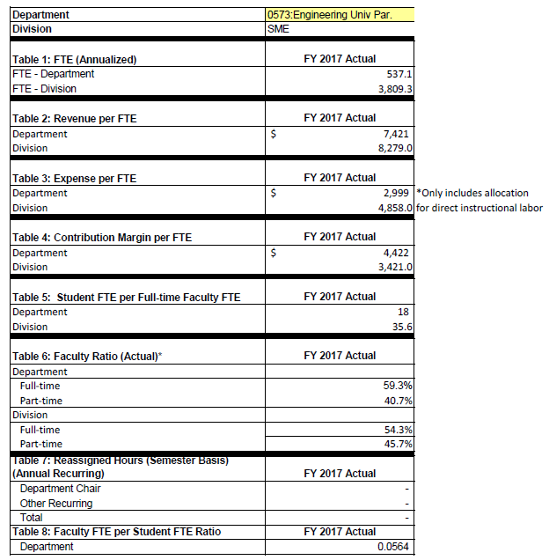

Section VI: Department/Program Status and Goals
- List the program’s strengths, weaknesses, opportunities, and threats (SWOT analysis).

Strengths:
- Sinclair students are well prepared for university coursework.
- Sinclair has a good reputation among university partners.
- Strong advisory board participation for the Engineering University Transfer program.
- Most coursework transfers directly into university program requirements.
- Program coordinator is able to contact all declared students via eLearn.
- Healthy enrollment (declared majors).
- Low tuition for students wishing to complete freshman and sophomore coursework in an engineering or science related program.

Weaknesses:
- Students not ready for Calculus have fewer course options.
- Students transfer to university before being awarded an associate degree.
- Wright State University no longer offers robust transfer scholarships.
- Not all coursework in current associate degree program transfers to all university programs.
- eLearn community shell requires manual updating from term to term.
- Students do not always check their email.
- Transfer (with the most credits awarded) generally limited to schools within the state.
- No sense of an “Engineering Student” community.
- No capstone course in which to measure exit-level skills.

Opportunities:
- Update articulation agreements for receiving universities.
- Increase reverse transfer to increase number of completers.
- Develop more program pathways that align with specific university degree programs.
- Name new program pathways with degree name (Mechanical Engineering Transfer instead of Engineering University Transfer).
- Increase participation at outreach events such as “Getting Ready for College Night” and college fairs.
- Offer select engineering courses at Learning Centers.
- Conduct more degree audits to find additional completers.
- Work to develop a bigger sense of community among “Engineering Transfer Students”.

Threats:
- Changes in university program requirements after students already enrolled in coursework at Sinclair.

- What are the department’s/program’s goals and rationale for expanding and improving student learning, including new courses, programs, delivery formats and locations? Are there unmet goals from the most recent Program Review? Please note that the program goals listed in this section will be reviewed for progress on Annual Updates and in your next Program Review.

Over the next several years, the program coordinator will address each items in the “Opportunities” portion of Section VI, A Goals. Work has already begun on development of more individualized programs as a move from a single degree with multiple electives.

- What resources and other assistance are needed to accomplish the department’s/program’s goals?

The Engineering Technology Design Department is in the processes of hiring a program coordinator to help with the seven degree programs within the department. The department chair anticipates using this coordinator to help with outreach events including marketing the Engineering University Transfer degree and to assist in updating the eLean community shell.

Section VII: Appendices: Supporting Documentation

Appendix A: LA.S.AS Degree Requirements
Appendix B: ESUP.S.AS Degree Requirements
Appendix C: EUT Advisory Board Members and Meeting Minutes, October 2017
Appendix D: USDOL: Bureau of Labor Statistics Projections

Appendix A: LA.S.AS Degree Requirements

Associate of Science (LA.S.AS) Degree Requirements
Curriculum
Course | Title | Credits
COM 2206  or  COM 2211  or  COM 2225 | Interpersonal Communications  Effective Public Speaking  Small Group Communications | 3
ENG 1101 | English Composition I | 3
MAT 1580 | Precalculus | 5
SCC 1101 | First Year Experience | 1
OTM | Arts & Humanities Elective | 6
OTM | Natural & Physical Sciences Elective | 12
OTM | Social & Behavior Sciences Elective | 6
OTM | Natural & Physical Sciences Elective  or  Mathematics Elective | 3
 | Multicultural Elective | 3
 | Any Course in Catalog Elective | 18

Appendix B: ESUP.S.AS Degree Requirements

Engineering University Transfer (ESUP.S.AS) Degree Requirements
Core Courses – All Majors
Course | Title | Credits
CHE 1211 | General Chemistry I | 5
CHE 1251 | Lab for CHE 1211 | 0
COM 2211 | Eﬀective Public Speaking | 3
ENG 1101 | English Composition 1 | 3
MAT 2270 | Calculus & Analytic Geometry I | 5
MAT 2280 | Calculus & Analytic Geometry II | 5
MAT 2310  OR  MAT 2330 | Elementary Diﬀerential Equations  OR  Diﬀerential Equations & Linear Algebra | 4 or 5
PHY 2201 | General Physics I | 5
PHY 2207 | Lab for PHY 2201 | 0
PHY 2202 | General Physics II | 5
PHY 2208 | Lab for PHY 2202 | 0
SOC/BS | Social/Behavioral Science Electives | 6
ART/HUM | Arts & Humanities Electives | 6
Elective | Engineering Electives | 14

Electives – Based on Desired Degree
Course | Title | Credits
BIO 1141 | Principles of A&P | 4
CHE 1221 | General Chemistry II | 5
CHE 1261 | Lab for CHE 1221 | 0
EGR 2201 | Circuit Analysis | 4
EGR 1101 | Introductory Mathematics for Engineering  Applications | 4
EGR 2261 | Programming in C & C++ | 4
MAT 2290 | Calculus & Analytic Geometry III | 5
MAT 2310 | Elementary Diﬀerential Equations | 4
MAT 2320 | Linear Algebra | 3
MAT 2330 | Diﬀerential Equations & Linear Algebra | 5
MEE 2101 | Statics for Engineers | 3
MEE 2201 | Thermodynamics for Engineers | 3
MEE 2301 | Strength of Materials for Engineers | 3
MEE 2401 | Dynamics for Engineers | 3
MET 1101 | Introduction to Engineering Drafting | 2
MET 1301 | SolidWorks Basics | 3
MET 1371 | CAD Concepts using AutoCAD | 3
PHY 2210 | Problem Solving in Physics with Matlab | 3

Appendix C: EUT Advisory Board Members and Meeting Minutes, October 2017


Dayton Campus
444 West Third Street
Dayton, Ohio 45402-1460
Science, Mathematics and Engineering

Engineering University Transfer
Minutes
Advisory Committee Meeting
October 25, 2017
8:30am – 10:00am
Room 12-133

Members Present:
Karen Blake, Eric Dunn, Karl Hess, Nathan Klingbeil, Ph.D., Lalitha Locker, Wendell Meyers, Augustus Morris, Ph.D., Deok Hee Nam, Ph.D., Anthony Ponder, Nick Reeder, Ph.D., Scott Segalewitz, Michael Simmons

Members Absent:
Chad Bridgman, Dr. Jose Camberos, Diane Delisio, Paul Lawrence, Dr. Rodnery Roseman

Guests Present:
Najat Baji

Eric Dunn called the meeting to order. He introduced himself as the new Assistant Dean for the Science, Mathematics and Engineering (SME) division and thanked everyone for their participation on the committee. Introductions of the committee were made. Tony Ponder thanked everyone for their attendance.

Dr. Nick Reeder announced that the new Engineering Digital Design course, EGR 2131, has been processed. It is a sophomore level course and is a required course for most students in the Electronics Engineering Technology (EET) program. The course was offered this semester, 17/FA; however, it did not achieve the expected enrollment. The department hopes to market future offerings.

Dr. Reeder announced that there is already an articulation agreement in place with Wright State University (WSU) for this course. He will resend the course information to the other university partners so that they can share it with their EE or EECE departments to establish transferability.

Karl Hess provided an update regarding the Applied Statistics course, MAT 2600. This course was based off of WSU’s STT 3600 course. The course ran for the first time in 17/SP. It had 11 students enrolled and 9 finished the course. It is not a high enrollment course at WSU either. WSU offers it one time per year in fall and Sinclair Community College (SCC) will offer it one time a year in spring.

Mr. Hess introduced Najat Baji to the committee. Ms. Baji taught the MAT 2600 course. She explained that the course is very helpful for actuarial scientists. The course uses programming to do many of the projects. The course was very successful.

MAT 2600 is an alternative to Differential Equations for Math majors. It is also of interest to Computer Engineering students. Dr. Nate Klingbeil stated that MAT 2600 is also a potential pathway for WSU’s ISE class and will benefit mechanical engineering students. Dr. Klingbeil stated that he would support accepting the transfer for the ISE course.
Dr. Augustus Morris informed Mr. Hess that he has a course that he would like to equate to MAT 2600. Mr. Hess provided Dr. Morris with the syllabus. The syllabus will also be sent to all committee members after the meeting.

Karen Blake distributed copies of the Engineering University Transfer (EUT) Program Pathway. She believes the electives grouping is confusing because there are two tracks listed. She distributed copies of a student’s degree audit. The way the program is set up with the two tracks, a student will never graduate without intervention from an academic advisor. The advisor has to make several manual overrides for the student to graduate. The current set up does allow students to take more courses and use financial aid, but none will automatically graduate.

Another concern is that the pathway shows a total of 66 hours, not 60. Mr. Ponder explained that Kimberly Collins, Program Director for Enrollment Management, Student Affairs and Regional Centers, is working on that concern at the college level. Mr. Ponder suggested that Ms. Blake and Mr. Dunn meet to revise the pathway and resolve any other concerns.

Scott Segalewitz asked if SCC works with other institutions to do reverse transfers. Are students aware that they can take courses at SCC, transfer to universities and transfer the university credits back to SCC to complete graduation? Ms. Blake stated that she does tell students that when she meets with them, but some students don’t see an advisor.

There was much discussion about reverse transfers. Mr. Segalewitz suggested having the advisors at the University of Dayton (UD) talk to students about transferring their UD credits back to SCC to complete their degree. Dr. Klingbeil suggested that SCC work with the various university partners (Provosts and Registrars) to set up an automatic process. The institutions should work together to develop a process in which once necessary courses are completed at the university, the credits are automatically transferred back to SCC. The student would then receive a letter stating they have completed the requirements of their SCC program and have earned their associate’s degree.

Wendell Meyers shared information about the Workforce GAP in STEM fields. Between 2001 and 2014, women’s participation in engineering jobs has decreased from 13% to 12%. There is no improvement in the African American, Latino and underrepresented populations in US STEM jobs. The demand for STEM workers is exceeding the supply.

Mr. Meyers wants Tech Prep to be more intentional about sharing the need for STEM workers and asked university partners for feedback. There was much discussion - students don’t know about the opportunities to get certificates and degrees; students don’t have an understanding of the skills needed to meet their end goals; EET enrollment has gone down because we aren’t communicating the need to students; students want to work in the health sciences (HS) industry, but don’t understand to work on hospital equipment, it requires an EET degree, not a HS degree. We need to develop a better marketing plan and create marketing materials to reach students.

Mr. Meyers stated that Tech Prep is now trying to reach women and minorities in middle school. Girls are turned off to engineering before high school and a lot of them want to go into service related careers. We need to inform students that engineering can be service related and does help people. Another concern is the students that are interested in engineering until they take their first math course and realize they don’t have the foundation to be successful. It was suggested that students not be put into math sequences of prerequisites. Instead they should be started at College Algebra and wrap co-requisite remediation with it. WSU is currently doing this and more students are finishing. SCC started co-requisite remediation last spring. Mr. Hess worked with WSU to implement it. The success rate has stayed the same, but enrollment has increased.

It was suggested that the EUT program be split into clear pathways. The generic EUT program should be retained, but there could be various pathways – Mechanical Engineering University Transfer, Electrical Engineering University Transfer, etc. It was agreed that the program should be kept together, but different tracks or concentrations should be developed. This would make the pathway less confusing for students. Marketing materials could then be created so students would know what options are available and high school teachers would be better able to explain the pathways.

Dr. August Morris from Central State University (CSU) announced that he will make an effort to establish a true articulation agreement with SCC. He is still working on reducing the credit hours in his Manufacturing Engineering program, but he would like to move forward with getting an agreement in place. There will still be some classes that SCC doesn’t require and students will need to complete before achieving junior status at CSU.

Dr. Morris announced that he would like to start different concentrations in his Manufacturing Engineering degree program, but he can’t offer all the required classes. He would like to work with university partners to supply classes and transfer the credit back to CSU. UD and WSU said they would be happy to accommodate. They advised Dr. Morris that he needs to create the classes at CSU even if he doesn’t offer them. They would then equate the UD and/or WSU courses to fulfill the requirement.

Scott Segalewitz from UD announced that UD has 500+ first year students and their largest number of domestic students. For the first time, their Chemical Engineering program has more women than men enrolled. They have experienced a 5% increase in female students and a 5% increase in minority students.

Mr. Segalewitz stated that the Sinclair Academy is doing well. There were 47 applicants in fall. Currently there are 13 students enrolled in engineering programs from the academy. UD has a fixed tuition model. When students enroll in the academy their UD tuition rate is fixed while they complete their degrees at SCC and UD.

Dr. Nam from Wilberforce announced that they used to have a combined degree with the University of Cincinnati for their Civil Engineering program. He is interested in other agreements like those mentioned by Dr. Morris in which Wilberforce students take classes as university partner institutions and transfer the credit back to Wilberforce for completion.

Mr. Simmons from Wilberforce stated that per the Higher Learning Commission’s (HLC) guidelines, they had to reduce their programs to 120 hours. A lot of this was done by reducing general education requirements and/or reducing the credit hours in various courses. Overall, the objective is to provide an avenue for students to graduate in four years.

Dr. Nate Klingbeil from WSU stated that engineering is strong at WSU. They have 3,000 total head count in engineering and the College of Engineering and Computer Science is currently the largest college at WSU.

WSU has experienced a reduction in international graduate students and is trying to regenerate that population. The domestic population is at an all-time high. Departments have been trying to put articulation agreements in place. There is a new Electrical Computer Technology degree and they would like to also create an Information and Cyber Technology pathway. They currently have a graduate program for Cyber Technology, but it is designed more for developers. They would like to create a pathway at the undergraduate level to meet the workforce needs.

Mr. Dunn reviewed the previous action items with the committee. Dr. Klingbeil confirmed that internships do need to be at the 3000 level equivalent to count as internship credit at WSU.

Karl Hess asked the committee about restructuring the Calculus II and III courses. He currently serves on the Ohio Department of Higher Education (ODHE) Math panel and there has been a lot of discussion about restructuring these courses to benefit engineering students. He asked for feedback from the university partners. It was agreed that restructuring the curriculum would help engineering students. If specific content in Calculus III could be taught in Calculus II, some programs wouldn’t have to require Calculus III. It might be beneficial to create two versions of the Calculus II course based on the student’s discipline. For example, a mechanical engineering student would take Calculus II-A, and an electrical engineering student would take Calculus II-B. It would be based on the need of the program.

Central State has already worked with their Mathematics department to bring some of the Calculus III content to Calculus II and it has benefited their engineering students. Some of them no longer need the Calculus III course. It also helped the programs reach the 120 credit hour limit because they were able to eliminate a course.

Dr. Klingbeil suggested that Karl’s Math ODHE panel communicate with the Engineering ODHE panel to make sure the changes work for everyone. It would be nice if all the foundational instruction could be housed in Calculus I and then have two options for Calculus II based on the discipline. The goal of course is to make it more flexible for student completion. Mr. Segalewitz suggested checking ABET requirements before making any changes. UD is currently at their minimum ABET requirement; therefore, they would not be able to drop a Mathematics class.

Action Items:

- Send EGR 2131 course information to university partners. University partners from UC, UD, Miami and Wilberforce will share the information with their EE or EECE departments for consideration of transferability. (Dr. Nick Reeder, Dr. Rodney Roseman, Scott Segalewitz, Diane Delisio, Dr. Deok Hee Nam)
- Send the MAT 2600 syllabus to all university partners. (Karl Hess)
- Review/revise EUT program pathway. Possibly remove the two program electives tracks and reduce the total hours to 60. (Eric Dunn, Karen Blake)
- Develop a process to address reverse transfers to increase degree completion. (Eric Dunn, Karen Blake, University Partners)
- Develop EUT concentrations to ensure clear pathways for students. (Eric Dunn)
- Review the possibility of restructuring Calculus II and Calculus III courses to benefit engineering students (Karl Hess)

Mr. Dunn announced that the next meeting of the EUT Advisory Committee will be held in fall of 2018. Information will be e-mailed to the committee prior to the meeting.

The meeting was adjourned at 10:10am.

Appendix D: USDOL: Bureau of Labor Statistics Projections

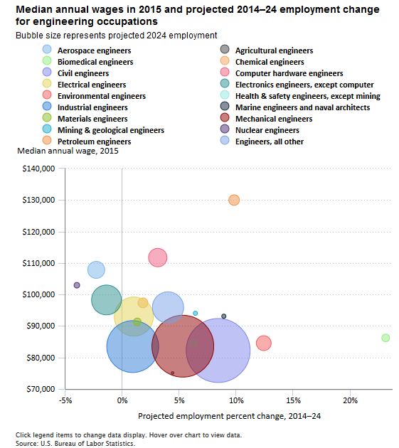

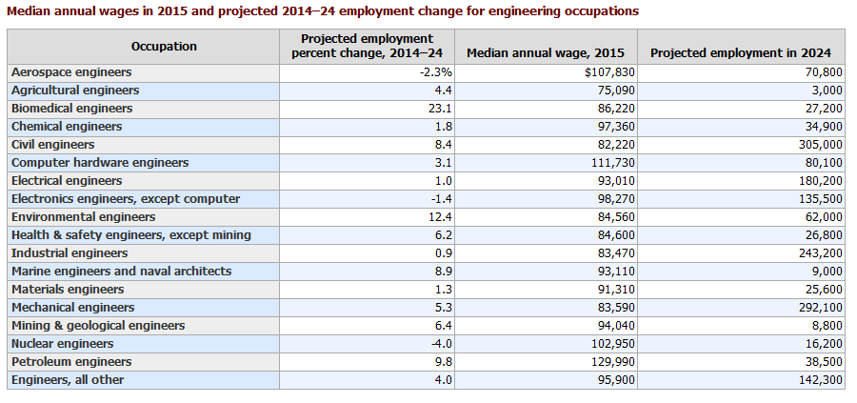
Source: U.S. Bureau of Labor Statistics


