Department/Program Review
Self-Study Report Template

2020 - 2021

Department: 0570-Computer Aided Manufacturing

Section I: Innovations and Accomplishments
Please list noteworthy innovations in instruction, curriculum and student learning over the last five years (including student awards, faculty awards, etc.).

1. Initiated a welding program with full Welding Lab, first offered in SP/20.

2. Moved the Precision Machining Program from the Main Campus to offsite at

Eaker Street. This was a major undertaking moving the lab from its location in Bldg. 10 in Eaker St. Warehouse in order to accommodate the renovation of Bldg.10. The move resulted in less than half space occupied in Bldg. 10 and was supposed to be of a temporary nature, half of the total equipment was moth-balled and subsequently sold due to deuteriation. This also resulted in a show place of Machining on campus to a warehouse with less appeal to students and parents.

3. Created new certificates and Degrees:

A. Advanced Precision Machining (CAMAPM.S.CRT), FA/21.

B. Tool Maker (CAMTM.S.CRT), SP/21.

C. Welding and Metals Joining (CAMWM.S.STC), SP/21.

D. Basic Quality Certificate (BQ.S.STC), FA/20

E. Manufacturing Technology (MFGT.S.ATS), FA/21.

4. Embedded Industry Recognized Certificates (IRC) into Degree and Certificate programs:
A. NIMS (National Institute for Metalworking Skills)

Measurement, Materials & Safety, FA/20.
B. NTMA (National Tooling and Machining Association)

Aptitude Test Certificate SU/20.

C. PC-DMIS (Hexagon Manufacturing National Certification for CMM), FA/19.
D. MSSC CPT (Manufacturing Skill Standards Council - Certified Production Technician Certificate), FA/19.

5. Developed and offered new Courses:

A. CAM 1180 Welding and Metal Joining I, SP/20.

B. CAM 1181 Welding and Metal Joining II, SP/21

C. Hybrid CAM 1109 Fundamentals of Tooling & Machining change from CBE, FA/19.

D. Hybrid CAM 1107 Principles of Manufacturing change from CBE, SP/20.

E. Hybrid CAM 1116 Fundamentals of CNC Operations, change from CBE, FA/19
6. Installed a state-of-the-art functionality to the Metrology Laboratory with the addition of two Hexagon 454 CMM (Coordinate Measuring Machines) machines, capable of measuring the geometry of physical objects by sensing discrete points on the surface of the object with a probe to 0.0001 inches, one Hexagon four Axis Articulating Arm capable of measuring to 0.0001 inches and one Hexagon six Axis Articulating Arm with Laser Digital Scanner, capable of capturing 6 million data points per 3x3 inches of scan to 0.001 per point location.

7. Had the first students achieve certificates in the new IRC’s:

A. NIMS Measurement, Materials & Safety – 3 students

B. NTMA Aptitude Test Certificate – 32 students

C. PC-DMIS for CMM – 48 students

D. MSSC CPT – 19 students
Section II: Completions and Course Success
A: Department Trend Data, Interpretation, and Analysis

Degree and Certificate Completion Trend Data – OVERALL SUMMARY

Please login to the Program Review Dashboard in SAS Visual Analytics (https://dawn.sinclair.edu:8443/SASVisualAnalyticsHub/index.jsp) and review the “Credential Completion” tab after selecting your division and department. Provide an interpretation and analysis of the degree and certificate completion trend data provided on this tab. Responses might include, but need not be limited to, the following:

- What overall trends do you see?
- Are there internal or external factors that account for these trends?
- What are the implications for the department?
- What actions has the department taken that have influenced these trends?
- What strategies will the department implement as a result of this data?

Between 2015-2018, on an annual basis, the CAM Department awarded over 125 credentials (degrees, certificates, and STCs). In AY2018-2019, the number dropped to 115 and then again dropped in AY2019-2020 to 88.
Full Associates degrees have assumed 20-22% of the total credentials awarded since the ’16-’17 year up double from the 10% full Associate degree graduation level of the ’15-’16 year.
The factors affecting the trends in credential awarding are the primary result of outside factors in business and the economy. The school and department have contribution from the standpoint of continuing to use old existing programs within the department at a time of great change in industry. The primary business and economic changes that have driven the changes include: a strong economy and business growth from 2015 – 2019 which kept our department statistics at an even level with some minor increases/decreases. Major changes started in 2019 -2020 as a result of softening in hard good orders, supply disruption and general economic fear resulting from the order softening, uncertain political and social concerns followed by a complete shutdown world-wide due to the COVID Pandemic which continues to plague the economic situation globally.
The results of all the economic global factors confronting business in the Dayton Regional area have driven a number of major supporting business practices which affect our student enrollment. First and foremost, many machining and manufacturing companies have been forced to lay off substantial numbers of people or even shut down as the economy slowed to a halt. Reduced revenues meant the inability to support any student training and at the same time for students without pay checks to drop educational desires to start or continue in the education process. At the same time that many manufacturing/machining businesses were stopping there were others in the region supporting key industries such as aerospace and military providers who were working 24 hours a day with reduced labor availability due to COVID. What resulted was the working of employees for extended hours to keep running . This meant that employees had no time to attend school and the employers had no desire to allow their overworked employees to have any time given for them to attend. In addition, there was much concern by many students to not attend any CAM classes that could not be delivered face-to-face.
One of the key CAM programs attracting many students is the STEP II program which for 40+ years has required 2 full 8 hrs. days on campus per week for 2 semesters to complete the certificate. There was no way that employers could continue any support of their program due to time away from work as well as students not being able to earn enough if they attended school for 2 full days per week All of the above has led to major reductions in program headcounts, not only in STEP II, but across all CAM programs.
In an effort to reverse the current downward trend in credentialling, the department has added another option to the Precision Machining certificate which has commenced in the Spring of 2021 and will be fully operational in Fall 2021. It provides all the hours of STEP II but reduces the contact time to 4 hour segments which can be taken mornings, afternoons or evenings. This will allow students and employers much more opportunity to support the CAM programs again. Additionally, the Department is putting together a CNC Boot Camp 2 week overview course that will focus on the unemployed and underemployed in the region. The program which will kick off later in Spring 2021 will bring together the unemployment agencies and underemployed groups to get people into the course. At the same time Sinclair will be reaching out to the industrial employers in the region to interview at least 3 of the participants who have been given basic manufacturing skills and hopefully offer all participating a job opportunity. We are seeing a continuing growth in Welding and with the addition of the new STC along with a degree plan will bolster our overall numbers. We are also just kicking off the Tool Maker Certificate program and had strong industry interest in supporting that program mostly through apprenticeships. Unfortunately, the interest has cooled right now due to the need for workers in the plants and the budget constraints on any educational funding.

Course Success Trend Data – OVERALL SUMMARY

Please login to the Program Review Dashboard in SAS Visual Analytics (https://dawn.sinclair.edu:8443/SASVisualAnalyticsHub/index.jsp) and review the “Course Success” tab after selecting your division and department. Provide an interpretation and analysis of the success rate trends provided on this tab. Responses might include, but need not be limited to, the following:

- What overall trends do you see?
- What trends do you see in your high enrollment courses?
- What trends do you see in courses used largely by other departments?
- Are there courses that have experienced changes in success? Why?
- What actions have the department taken that have influenced these trends?
- What strategies will the department implement as a result of this data?

Overall, the Course Success Rates achieved by the CAM department over the last 5 years (2015-2020) as reflected in the Visual Analytics charts, has been 86-90% which has exceeded both the SME Division success rate of 72-74% over the same period and the College success rate of 76-79% during that time. These are very positive numbers for the department, but there are other pluses and minuses that must be looked at. In that regard there are three areas to look at. First our credentials earned by year have very steady through ’18, but have shown a decrease stating in ’19 due to business economics and then a major drop in the ’20 year due to the massive shut down in the economy as a result of COVID. Secondly, Enrollment must be looked at and has held very steady over the past 5 years but is very low in comparison to other programs in SME due to the intensity on hands-on lab time which has been severely restricted due to the move of Precision Machining to Eaker St. which reduced our available lab stations by one half along with classrooms that are half the size of previous classrooms. This has forced the Department to limit the number of students that can participate. The situation has been further encumbered by classroom reductions at Eaker St due to the MECA (Masters Electrical Contractors Association Training School) electrician program which has increased in numbers rapidly, consuming many more class section times than previously used. This school is an external electrical journeyman program for electricians which rents training space at Sinclair and uses Sinclair Adjuncts to teach it. The whole situation has been halved again for classrooms as a result of COVID restrictions. At the current time we are at maximum run capacity on the evening classes with all the competing program conflicts and COVID restrictions. The morning and afternoon availability is very open, but due to most of our participants working the Day Shift, there is very low availability of students to attend during these times. This situation is further acerbated by Industry partners who due to economic and operating conditions are not releasing students from work to attend school or compensating them either with pay or tuition help to attend. The third chart of the story, Credentials Earned by Year, is the number of graduates we have from the various credentials offered which was running at or above 125 awarded credentials per year from ’15-‘18 mostly due to the embedding of credentials in the full degree program which allows students to achieve many credentials over time on the path to an associate degree while only having a small number of total students in the program. A big positive is the student employment statistics from the Graduate Outcomes chart which is very high due to many of the students being already employed while attending and then the Department programs achieving over a 95% job placement into their field of work, following program completions. Again because of the economic situation downturn starting in 2019 – 2020 coupled with the Covid issues in 2020 and into 2021 there is a declining slope in these measures; Credentials Earned has dropped from 130 in ’18 to 120 in ’19 to 85 in ’20.
The Department has been aware of the recent downward trend in our number of participating students and had already started to take corrective action steps prior to COVID. These actions included a re-evaluation of our programs that have served the community well for 40+ years but need to be changed to meet new industry and student needs. The long and short of the situation is that we can no longer continue to do things the same way and expect a different outcome. In that light, we are actively redesigning our program and course contents to meet the new need. One of the first steps has been to revise the STEP II program with its high hour content to a much more friendly process by reducing the contact hours time to four hour periods versus the full day activities of the STEP II. This will allow both Industry and students far greater flexibility to participate in the Machining programs. We have added a number of new credentials to the program as cited above in Section 1. These were added at the request of our Industry advisors to meet a gap. In like manner based on Industry partner input we have initiated noncertified welding courses in a new lab and have begun to grow a full Welding/Metal Joining certificate and Degree program. In addition, the program is in the midst of advancing both Precision Machining (PM) and Computerized Digital Control (CNC) Machining to the next level of training skills. This is being accomplished by taking the PM lab from classical manual machining to the next level of digital manual machining. At the same time the CNC lab is moving to the next level of digital operation including the addition of robots to the machine operation and enhancing students to both program the cutting machines and the robots. Both upgrades will allow our students to produce data from their operations inclusive in the Digital Thread aspect of Industry 4.0. This move will require a rewrite of many course syllabi and the addition on new courses, certificates, and potential degrees to the program. The review of the changes needed to incorporate the next steps in Manufacturing with the Digital Thread into our course materials has begun in SP/21 and should be complete by SP/22, however like all digital changes, such as computing in the world, this will continue to evolve and change continuously. This incorporation of the Digital Thread into our programs is critical to our local industries to get the trained/skilled technicians required to survive in the coming manufacturing world. Furthermore, the addition of the CNC Boot Camp as covered in Section A above will add the potential to support local industry needs for basic starting employees, and will also bring in new STEM people to the school who were not aware of the earnings potential in Manufacturing and give them a 2 hour course credit for the Boot Camp, this may stimulate them to start or return to complete Certificates or Degrees at Sinclair in Manufacturing or other Departments. The Boot Camp success will also help to show other non-STEM people not at the school that they can do it as well.
B: Progress Since the Most Recent Review
Goals from the last Program Review
Your department’s most recent Annual Update report on goals from the last Program Review is provided in Appendix A. Please provide a brief summary of your department’s progress on goals from the last Program Review Self-Study.
- 2020 CY Update status: Completed. Three courses originally created using the CBE model were converted to hybrid, which has shown to be a better fit for student learning in areas with significant lab exposure. The Hybrid model allows the students to take the course classroom work on-line in controlled periods with deadline completions for each major element and then they are required to come on campus for F2F labs with instructors, Lab Techs and their fellow students to perform the intensive machining assignments and complete their progressively more difficult projects over the semester time. The attempt to instruct such courses as a CBE with unregimented start dates did not allow for enough time to learn lab equipment operation or to complete the 6 major projects which grow on each other as the skill level improves over the course timeline. The courses changed and start dates were:

Hybrid CAM 1109 Fundamentals of Tooling & Machining, FA/19

Hybrid CAM 1107 Principles of Manufacturing, SP/20.

Hybrid CAM 1116 Fundamentals of CNC Operations, FA/19.

- 2020 CY Update status: In Progress. A plan to facilitate the total CAM program at Mason Campus was put together and presented for approval. Due to COVID and the major impact on the school budget the plan has been shelved until budgetary constraints are relieved.
- 2020 CY Update status: Completed. The Department has made numerous changes in curriculum and courses to better meet student and Industry partner needs. A new certificate program. Advanced Precision Machining will be offered in 2021 starting in the Fall Semester which reduces the two 8 hour days in class per week for STEP II to a maximum of 4 hour sections. While keeping total hours the same for the Certificate this results in a much more flexible situation for employers and students to get the certificate. The Step II Certificate and new Advanced PM (Precision Machining) Certificate will run in the Fall Semester to determine where Industry will focus student attention and after several semesters the Department will be able to make long term viability changes for the two programs to co-exist or potentially drop STEP II.
In addition, new certificates were added to meet employer requests and a Welding program has been started again at Sinclair after a 25 year hiatus, at the request of both students and Advisory Board employers. This area will grow over time into several certificates and potentially a full degree in Welding & Metal Joining. The certificates added and their start dates are:

A. Advanced Precision Machining (CAMAPM.S.CRT), FA/21.

B. Tool Maker (CAMTM.S.CRT), SP/21.

C. Welding and Metals Joining (CAMWM.S.STC), SP/21.

D. Basic Quality Certificate (BQ.S.STC), FA/20

E. Manufacturing Technology (MFGT.S.ATS), FA/21.
4. 2020 CY Update status: Completed. The summer orientation program for CAM students to help with retention into the STEP II program started in 2016 which showed initial improvement fell off as a result of incoming students not attending those sessions. That orientation process was replaced in 2018 with direct individual Face to Face meetings with the Department Coordinator prior to the start of the students first semester which has shown 100 % of the students participating in their first semester with the exception of students who registered for the program but then realized it was not what they wanted and changed direction to another program before the start of classes. The process was changed from F2F in 2020 to a virtual meeting due to COVID, but has shown the same positive results.
5. 2020 CY Update status: Completed. The addition of the DEV 0020 prerequisite to CAM 1161 was changed to include the testing of incoming students by the Course Placement Testing in Math, If the entering student does not score above 14 points on the Placement test, they are required to take the MAT 0050 Arithmetic Refresher course which allows them to take MAT 1110 Mathematics for Technologists and to enter the CAM program.

Recommendations from the last Program Review
Your department’s most recent Annual Update report on Review Team recommendations from the last Program Review is provided in Appendix B. Please provide a brief summary of your department’s progress on recommendations from the last Program Review Self-Study.
- 2020 CY Update Status: Completed. Recommendation 1 and Goal 3 both address the implementation of measures to improve student retention and completion. The Department has made numerous changes in curriculum and courses to better meet student and Industry partner needs as well as improve student retention particularly with new Advanced PM Certificate. A new certificate program. Advanced Precision Machining will be offered in 2021 starting in the Spring Semester which reduces the two 8 hour days in class per week for STEP II to a maximum of 4 hour sections. While keeping total hours the same for the Certificate this results in a much more flexible situation for employers and students to get the certificate. The Step II Certificate and new Advanced PM (Precision Machining) Certificate will run in the Fall ’21 Semester to determine where Industry will focus student attention and after several semesters the Department will be able to make long term viability changes for the two programs to co-exist or potentially drop STEP II.
- In addition, new certificates were added to meet employer requests and a Welding program has been started again at the request of both students and employers. This area will grow over time into several certificates and potentially a full degree in Welding & Metal Joining.
Please refer to the information in Goal 4 & 5 (page 7) to review the impact of the implementation of summer orientations and the addition of a DEV0020 prerequisite for CAM1161.
- 2020 CY Update Status: In Progress. After a strong start with Apprenticeships in the CAM area of study, apprenticeships have taken a major hit due to the economic impact on the revenues seen by the supporting companies as well as COVID restrictions reducing their ability to support the apprenticeship program or add more. Issues with employer needs has been improved with course, certificate and degree additions. The department is focusing on a new approach in 2021 to bring unemployed and underemployed students into Manufacturing through a 2 week developmental Boot Camp with support with Business partners to interview and take on these people where possible.
- 2020 CY Update Status: Completed. The feasible ideas brought forth from the Advisory Team discussions have been incorporated in the last year. Key items were, the addition of a welding course and development of a program around Welding & Metal Joining, the new Advanced PM Certificate to give other options to the STEP II Certificate and addition of a Tool Maker Certificate. Many other smaller suggestions were additionally included. As a new initiative in 2021, the CAM Advisory Board will be increased in size. All Industry participants who deal with the department such as those new with Internships and Apprenticeships will be invited to join and attend the meetings. Letters of invitation to go out in the Spring 2021.
- 2020 CY Update Status: In Progress. We continue to monitor our competition in all aspects of offerings and changes to their programs or advertising. In the most recent past we have seen a shrinkage in some of these programs due to Covid restrictions and lessening support from Industry to push the programs. In contrast, we have continued to strengthen our program by acquiring state of the art equipment and providing cutting edge training using the latest research, better preparing our students for the current industry and its evolution. New equipment acquisitions include: a portable 5 axis Coordinate Articulating Arm (2017), two new bridge Hexagon 454 CMM machines (2018-2019), a 6 Axis Articulating Arm with a Laser Scanner (2020), an OMax Protomax Waterjet Cutter which is capable of cutting ½” tool steel using water and abrasive grit (2019), a Laser Etcher (2019) and 12 Fully equipped Welding Booths with capability to teach MiG, Tig, Stick and Oxyacetylene welding and cutting (2019). These acquisitions put us a major step ahead of our competition. However, beyond that, the new acknowledgement of the importance of the Digital Thread (DT), birth to death tracking of a product as part of Industry 4.0, and the incorporation of DT recognition and training in Data Literacy and Data Empathy across our programs along with detailed lab, problem solution work and demonstration of a DT manufacturing process will further move us forward ahead of other schools and more importantly provide the new skilled labor force to local industry. This change in curriculum will start in 2022.
- 2020 CY Update Status: Completed. No change from last year. The department maintains that a 3D printing stand-alone program would be more appropriately housed in the Mechanical Engineering Technology MET Dept. while being supported by the Metrology Lab.
C: Assessment of General Education & Degree Program Outcomes

General Education Outcomes
All available General Education Outcome rubric data for your department is provided in Appendix C. Please provide a brief summary and analysis of these assessment results. In addition to this data, please review and briefly discuss any assessment work your department might have done in these areas in the past five years. Also, please provide a response to the following two questions:
- Are changes planned as a result of the review of general education outcomes assessment data for your students? If so, what are those changes?
- How will you determine whether those changes had an impact?
Written Communication, Oral Communication, Cultural Diversity and Global Citizenship are each assessed outside CAM program courses. At this time, due to such a small number of CAM students being assessed (in most cases 1-8 students per year), it is not possible to draw meaningful conclusions on the proficiency of CAM students in these areas. However, as the institutional general education outcomes dataset grows, we anticipate having the ability to take a deeper dive into this data to look for any achievement gaps that could exist within our student population.

The Oral Communication dataset is the largest of the 5 general education outcomes areas for which we had data to review. The number of students assessed per FY ranged from 3 – 38. Overall, for the four Oral Communication criteria, the number of CAM students assessed as “Competent or Proficient” ranged from 67-100%. For the criteria addressing “Diverse Opinions and Conflict”, “Message Composition” and “Message Delivery”, 90-100% of CAM students scored “Competent or Proficient”. The criterion for which CAM students scored lowest (with 67-78% scoring “Competent or Proficient”) is the criterion addressing “Listening Behaviors” where students must demonstrate attentive, effective, and respectful listening behaviors as well as accurately paraphrase information and opposing points of view”.
- The Department feels that CAM program courses do address aspects of this, allowing our students opportunities to improve upon their ability to communicate. For example, the preparation of students seeking internships through the Meet & Greet program puts each student through an intense overview of themselves and they are taught the refinements of public speaking, self-introduction techniques and formal presentation of detailed projects that they have accomplished. The training is done through the CAM instructors with major support and teaching from the Work Based Learning Dept. The final in this endeavor is the Meet and Greet day when the students present themselves and their capabilities to perspective employers in a face to face session. They have learned to listen intently to their interviewers from the employers and to respond to their questions clearly and concisely. Having watched three years of the process it an exceptional event to watch the students present themselves so professionally to new, unfamiliar and questioning people with no issues. I watch them go from new student novices to capable speakers in two and a half months of preparation. It should be noted that we have a 99.9 percent internship placement rate from the event.
- The College recently revised the rubric used for the institutional assessment of the Critical Thinking General Education Outcome. In 2021-22, the CAM department plans to review that rubric to determine its potential for application in an upper level CAM program course. We can see how critical thinking can be accessed via a project similar to what is done in the OPT1101 course. By the end of this course, the CAM students have worked collaboratively with students from the Industrial Engineering Tech Program and the Business Program in teams exchanging Manufacturing ideas, solving problems and solving a simulation problem requiring the employment of critical thinking skills, culminating in a final formal engineering report and final presentation.
Degree Program Outcomes
Your department’s most recent Annual Update report on assessment of program outcomes is provided in Appendix D. Please provide a brief summary and analysis of assessment results for your program outcomes since the last Program Review. Also, please provide a response to the following two questions:
- Are changes planned as a result of the assessment of general education outcomes? If so, what are those changes? Unclear if this section is covering General Education Outcomes or Degree Program Outcomes?? I will answer both ways.
- How will you determine whether those changes had an impact? Unclear if this section is covering General Education Outcomes or Degree Program Outcomes?? I will answer both ways.
- GE No major changes as a result of the general education assessment are planned. We have an ongoing review of all our classes where we can incorporate written reports and presentations into the classes as opportunities arise. Math and problem solving elements are incorporated in all classes already. The Department is working on new recruiting methods to reach out to minority, under served and underemployed to increase numbers in the program.
- DPO Yes, changes are planned as a result of the Degree Program Outcomes Review. The changes include the following:
  - As a result of not receiving Internship Supervisor evaluation forms back for sponsored Interns the following changes are being made. Clear statements will be added to the Internship application that is signed by the student and employer that a Supervisor Evaluation form will be required at internship completion to Sinclair for the student to receive a grade for the course. If not received the WBL (Work Based Learning ) Learning Dept will follow up with the company and the Faculty Advisor will follow back with the Company Supervisor to get the form finalized. This to start in SU/21.
  - Additional algebraic formula problems in various CAM classes will be added to quizzes and tests to assist in developing greater skill in the CAM students to demonstrate applied competencies in the areas of Machining Applications and Drafting/Blueprint areas. Classes to be determined by SU/21 and added problems initiated by FA/21.
  - A form will be developed that each graduating student in final advanced courses, CAM 2212, 2700, 2780 and 2781 of our programs, will fill out with their instructor prior to the final class day to validate their understanding of the need to stay current in new technology and/or additional training to stay current as they proceed in their career. This to be started in FA/21.

- GE Evaluation will be from observation of students demonstrating improvement in the areas we work on as is done with Meet and Greet and the OPT 1101 course.
- DPO Evaluation of the impact of a-c above will be assessed as follows:
  - The Intern application will be revised and added to the Intern process. The process will be validated for compliance with follow up beginning SU/21.
  - Classes and questions to be added will be set up and reviewed by Course Coordinators in the designated classes and the process initiated in FA/21. Long term follow up will occur over the ‘22 and ’23 school years to determine if improvements are validated in student capability.
  - A form will be developed and approved by the Department Coordinator and approved by the Chair and initiated in FA/21 with the Fall classes.

Section III: Overview of Department Mission
- Mission of the department and its programs(s)
Please provide the department’s mission statement, and then address the following questions:
- What is the purpose of the department and its programs?
- What publics does the department serve through its instructional programs?
- What positive changes in students, the community and/or disciplines/professions is the department striving to effect?

- The mission of Sinclair’s Computer Aided Manufacturing (CAM) department and its programs is to provide world-class educational and training support in the areas of tooling, machining and computer numerical control (CNC).
- The key stakeholders of the CAM department include students, faculty, staff, local manufacturing employers, associated Sinclair departments, professional societies such as the Dayton Tooling and Manufacturing Association, Dayton Regional Manufacturing Association (DRMA), the Society of Manufacturing Engineers, and other organizations like the Dayton Urban League and the Job Center. The department strives to support the manufacturing sector in the Dayton region, even as employers are struggling with global competition, outsourcing, economic downturns and COVID. The face of manufacturing has changed over the years, but it remains a critical part of the region’s economy and Sinclair needs to continue to supply qualified technicians.
- Currently, manufacturers in the Dayton region have shown resilience and flexibility in the face of global economic changes, as companies have incorporated new technologies and have expanded their product lines to include nontraditional applications such as medical devices and major aerospace applications.
The faculty and staff of the CAM department are well qualified to respond to the changing needs of local manufacturers. They have extensive industrial and classroom experience, and they continually learn new technology and techniques. This expertise helps drive the curriculum to always meet the changing needs of local manufacturers and students. The CAM department offers courses, certificates and associate degrees in:
Associate Degrees
- Computer Aided Mfg. / CNC Technology AAS Degree
- Computer Aided Mfg. / Precision Machining AAS Degree
- CAM Welding and Fabrication - AAS Degree (NEW Fall 22)
- Manufacturing Technology CAM Option ATS Degree (Fall 21)
Certificates
- Computer Aided Mfg. / STEP II
- Advanced Precision Machining Certificate (NEW Fall 21)
- Welding, Metal Joining & Fabrication (NEW Spring 22)
- Tool & Die Technology (New Fall 21)
Short Term Certificates
- Computer Aided Mfg. Basic Machining Skills
- Computer Aided Mfg. Precision Machining
- Computer Numerical Control Technology
- Welding and Metal Joining (NEW Fall 21)
- Advanced Precision Machining (NEW Fall 21)

This curriculum is taught in a hands-on manner, with extensive lab experiences for our students. Our facilities rank among the best in the nation, with a comprehensive PM (Precision Machine) shop and CNC (Computerized Numerical Control) lab.

- Department Completion Plans
Below are five milestones that are highly predictive of students graduating in a timely manner. What specific strategies or plans does the department have to help more students achieve one or more of these milestones?

- Students solidify their choice of major within the first or second term
- Students receive a MAP to completion within the first or second term
- Students complete a college-level Math and English class within the first year
- Students take 30 credits within the first year, including summer
- Students take 9 credits in their major area of interest within the first year, including summer
Please describe any work the department has done over the past five years which may have impacted these milestones.
- The CAM Department Coordinator meets with all prospective students once they have expressed interest in any CAM program. Even prior to their declaration of major, the Coordinator creates a personalized degree completion plan for each student that considers their availability, work commitments, and their choice of full-time vs part-time status. This allows students to know up front what their level of commitment will be to succeed within the program, allowing them to solidify their choice of major with a full understanding of the expectations from the very beginning. The CAM Department Coordinator also continues to meet and mentor students after they have formally declared their intended major.
- The Department has detailed Maps of how to achieve completion in the program of study . These maps are used by both Advising and the CAM Coordinator and shared with each student.
- The MAPs used for CAM students includes a college-level English and Math class within the first year.
- CAM students all achieve 9 credits or much more in their chosen CAM program within their first year of study. Based on guidance from Advising and or the CAM Coordinator.
- Specialized Accreditation

Does your department have any specialized accreditations or other form of external review?
________ Yes ____X____ No

If yes, please briefly summarize any commendations or recommendations from your most recent accreditation or external review. Note any issues that the external review organization indicated need to be resolved.
Not Applicable

Section IV: Overview of Environmental Factors
- Analysis of environmental factors
Based on your discussion with the Assistant Provost in the Environmental Scan process, how is the department responding to the (1) current and (2) emerging needs of the community? The college?
- The Department is constantly assessing the needs of the industrial community supported through regular direct input by Advisory Board members. These insights have led to changes in courses and curriculums. We review their changing needs as well as assess the overall economy changes in the Region and across the nation to also help adjust our curriculums and courses to meet current and projected needs. The Department has revised and added new Certificates in the past year to meet the requested and required changes to stay current. Another example is the advancement of new technology in line with the advent of Industry 4.0 and the Digital Thread, both of which are the next steps in Manufacturing. Both require a high regard for the use of data to control, monitor, run and document everything that goes on in manufacturing as we move forward.
- The Department is constantly reviewing its course and program offerings to support a sustained enrollment level in line with the needs of the college. Further we are continuously looking at any and all recruiting opportunities to expose more parents, students and school systems to the opportunities in the CAM jobs. The addition of the Advanced Precision Machining certificate will eliminate the current financial loss from the running of the STEP II certificate program with the downturn in participation due to the economic factors confronting Regional industry.

- Evidence of program quality from sources outside of the department (e.g., advisory committees, accrediting agencies, other departments on campus, transfer partners, etc.)
What evidence does the department have about department/program quality from sources outside the department?
- Our recognition of the quality of our graduates comes directly from the Industry Partners we support as we hear at Advisory Boards and from their repeat actions in taking on Interns as they proceed through our programs. We continue to have better than a 95% Internship placement.
- Direct recognition from Industry Partners, the DRMA (Dayton Regional Management Association) and others, that our student capability coming out of our CAM programs far exceeds those coming from High School Tech Prep programs and from other southern Ohio Community Colleges and Universities.

Section V: Student Demand, Placement of Graduates, Cost Effectiveness

- Evidence of student demand for the program
Please login to the Program Review Dashboard in SAS Visual Analytics (https://dawn.sinclair.edu:8443/SASVisualAnalyticsHub/index.jsp) and review the “Enrollment” tab after selecting your division and department. Provide an interpretation and analysis of the enrollment trend data provided on this tab. Responses might include, but need not be limited to, the following:
- How has/is student demand for the program changing? Why?
- Should the department take steps to increase the demand? Decrease the demand?
- What is the likely future demand for this program and why?

- Student demand for CAM over the last 5 years remained steady with a slight increase ’15-’18, however showed a decrease in 2019 which continued downward in 2020 due to economic downturn and unsureness, coupled the very disruptive results of Covid shut down and global order changes. The student demand is reflected by both the lack of industry support to release or pay for student education, as well as a loss of work hours to allow students to pay for their own education.
- The department has taken steps in the courses offered and Certificates offered to help draw more Industry support by meeting new specific needs. The department has extending recruiting efforts as well as the most recent reach out planning to get CAM in front of the unemployed and underemployed through planned Boot Camps.
- There continues to be a high job demand into the future for CAM job offerings, as noted from the Bureau of Labor Statistics. The demand per government surveys shows a national gap in Machinists and other CAM skill sets through 2030, much being driven by an aging Machinist population that will be retiring and needing replacement. In addition, the advancement of new machining skill sets will require new skill sets of newly trained students.

- Evidence of the placement/transfer of graduates

Please login to the Program Review Dashboard in SAS Visual Analytics (https://dawn.sinclair.edu:8443/SASVisualAnalyticsHub/index.jsp) and review the “Graduate Outcomes” tab after selecting your division and department. Provide an interpretation and analysis of the placement and/or transfer trend data provided on this tab. What is your interpretation of the available transfer and placement data?
- Credentials Earned by Year is the number of graduates we have from the various credentials offered which was running at or above 125 awarded credentials per year from ’15-‘18 mostly due to the embedding of credentials in the full degree program which allows students to achieve many credentials over time on the path to an associate degree while only having a small number of total students in the program. A big positive is the student employment statistics from the Graduate Outcomes chart which is very high due to many of the students being already employed while attending and then the Department programs achieving over a 95% job placement into their field of work, following program completions. Again because of the economic situation downturn starting in 2019 – 2020 coupled with the Covid issues in 2020 and into 2021 there is a declining slope in these measures; Credentials Earned has dropped from 130 in ’18 to 120 in ’19 to 85 in ’20.
- The Department has been aware of the recent downward trend in our number of participating students and had already started to take corrective action steps prior to COVID. These actions included a re-evaluation of our programs that have served the community well for 40+ years but need to be changed to meet new industry and student needs. The long and short of the situation is that we can no longer continue to do things the same way and expect a different outcome. In that light, we are actively redesigning our program and course contents to meet the new need. One of the first steps has been to revise the STEP II program with its high hour content to a much more friendly process by reducing the contact hours’ time to four hour periods versus the full day activities of the STEP II. This will allow both Industry and students far greater flexibility to participate in the Machining programs. We have added a number of new credentials to the program as cited above in Section 1. These were added at the request of our Industry advisors to meet a gap. In like manner based on Industry partner input we have initiated noncertified welding courses in a new lab and have begun to grow a full Welding/Metal Joining certificate and Degree program. In addition, the program is in the midst of advancing both Precision Machining (PM) and Computerized Digital Control (CNC) Machining to the next level of training skills. This is being accomplished by taking the PM lab from classical manual machining to the next level of digital manual machining. At the same time the CNC lab is moving to the next level of digital operation including the addition of robots to the machine operation and enhancing students to both program the cutting machines and the robots. Both upgrades will allow our students to produce data from their operations inclusive in the Digital Thread aspect of Industry 4.0. This move will require a rewrite of many course syllabi and the addition on new courses, certificates, and potential degrees to the program. The review of the changes needed to incorporate the next steps in Manufacturing with the Digital Thread into our course materials has begun in SP/21 and should be complete by SP/22, however like all digital changes, such as computing in the world, this will continue to evolve and change continuously. This incorporation of the Digital Thread into our programs is critical to our local industries to get the trained/skilled technicians required to survive in the coming manufacturing world. Furthermore, the addition of the CNC Boot Camp as covered in Section A above will add the potential to support local industry needs for basic starting employees, and will also bring in new STEM people to the school who were not aware of the earnings potential in Manufacturing and give them a 2 hour course credit for the Boot Camp, this may stimulate them to start or return to complete Certificates or Degrees at Sinclair in Manufacturing or other Departments. The Boot Camp success will also help to show other non-STEM people not at the school that they can do it as well.
- Evidence of the cost-effectiveness of the department/program
Please login to the Program Review Dashboard in SAS Visual Analytics (https://dawn.sinclair.edu:8443/SASVisualAnalyticsHub/index.jsp) and review the “Course Characteristics” tab. Provide an interpretation and analysis of the average class size and faculty ratio trend data provided on this tab. Also, please discuss any measures the department has taken to reduce costs. Responses might include, but need not be limited to, the following:
- What is the department doing to manage costs? Examples might include:
  - Managing Average Class Size
  - Managing full-time/part-time ratios
  - Specific cost saving measures implemented by the department
- What additional efforts could be made to control costs?
- What factors drive the costs for the department, and how does that influence how resources are allocated?

- The average class sizes in the department have been reduced with the move of the PM (Precision Machining) Lab to Eaker St. which resulted in about half the equipment being eliminated, originally stored, but since sold due to deteriation and age. In addition, as a result of COVID the class size was reduced again due to classroom restrictions coupled with class conflicts at Eaker St. with the MECA (Masters Electrical Contractors Association Training School) electrician program which has increased in numbers rapidly, consuming many more class section times than previously used. This school is an external electrical journeyman program for electricians which rents training space at Sinclair and uses Sinclair Adjuncts to teach it. The result is that program has consumed nearly all the evening classroom space for evening classes. The whole situation has been halved again for classrooms as a result of COVID restrictions. At the current time we are at maximum run capacity on the evening classes with all the competing program conflicts and COVID restrictions. The morning and afternoon availability is very open, but due to most of our participants working the Day Shift, there is very low availability of students to attend during these times. This situation is further acerbated by Industry partners who due to economic and operating conditions are not releasing students from work to attend school or compensating them either with pay or tuition help to attend.
- The major cost creator has been the running of the STEP II program at its current level of students which is a loss to the school but an absolute need to local Industry. In order to alleviate the financial burden on the college a new curriculum to replace STEP II has been initiated effective Jan 2021, Advanced Precision Machining Certificate, which makes this new curriculum with the same hours content a money maker at current student levels and appears to be the new way for the future in the PM (Precision Machining) Certificate program.
- The Department is constantly looking at all ways to reduce costs while maintaining the highest level of training for the students. A request has been made to add four more Welding stations to the Welding curriculum where demand is running very high and restricted by the current number of stations.
- The Department is driven by the capital cost of the equipment to run effective classes and the space requirements for the large labs. In both cases the amount of equipment limits the number of students who can participate in any single class.
Section VI: Department/Program Status and Goals
- Based on the environmental scan, data in the Program Review Dashboard, information provided in this self-study, and other factors, please briefly list the department’s/program’s Strengths, Weaknesses, Opportunities, and Threats (SWOT analysis). Please list as many as appropriate in each category.

Strengths:
- High demand from Industry both Regionally and Nationally for CAM student graduates.
- Sinclair recognized by Industry and agencies for producing high quality graduates from its CAM programs
- Having a wide variety of short term, full Certificates and Degree offering to students and Industry to meet all needs in the CAM area.

Weaknesses:
- Declining Industry support to feed or cover costs of educational endeavors currently due to extreme economic constraints and the unknown.
- The non-ideal setting of the program to sell it to new students and parents with its off-campus location on Eaker St.
- When located in building 10 the PM (Precision Machining) Lab drew the attention of Non-STEM and Non-CAM students to inquire about the program. With the move of the Lab to off campus to an old warehouse on Eaker St. exposure to other students on the regular campus has been totally lost with the corresponding recognition that there is a major opportunity with CAM as they don’t get to observe it functioning in labs.
Opportunities:
- Manufacturing is in a need mode, but the unknown has restricted their proactiveness to placing and supporting students. Hopefully when the economy is back to normal following COVID we will see a major pick-up in numbers.
- Moving the whole departmental focus to Industry 4.0, sometimes referred to as the Fourth Industrial Revolution is the transformation of industry through the intelligent networking of machines and processes with the help of information and communication technology along with the Digital Thread, which is the communication framework that allows a connected data flow and an integrated view of the asset's data throughout its lifecycle across traditionally siloed functional perspectives. Both of these new requirements to Manufacturing will be incorporated into all aspects of the curriculums which will increase the demand for our students with industry to survive as the changes occur.

- Reaching out to the unemployed and underemployed, along with other non-STEM students will increase enrollment through activities such as the CNC Boot Camp being implemented.
Threats:
- Low enrollment as a result of the economy not returning to the levels that were there before COVID.
- The move of the new elected government to support of off-shoring content to American business or the return to higher non-competitive Manufacturing tax structure could result in major loss of Industry support for Manufacturing jobs in the USA.
- Continuance of the Global Pandemic due to evolving to new uncontrollable strains.
- Lack of Industry support for Apprenticeships and Internships.
- The continuance of the off-site operation of the PM(Precision Machining), Welding and Metal Forming Labs at the Eaker St. location based on all the previously cited concerns of space and presentation to students, parents and the community.

- What are the department’s/program’s goals for expanding and improving student learning, including new courses, programs, delivery formats and locations? Please note that the department goals listed in this section will be reviewed for progress on Annual Updates and in your next Program Review.
- The Department will be adding two to three additional advanced courses to the Welding Program which will allow tor release of a Welding AAS degree. A number of CAM courses will need to be upgraded and/or new courses added to the program to meet the content required for Industry 4.0 and Digital Thread.
- Adding a focus on Industry 4.0 and the Digital Thread to the program Curriculums.
- Reaching out to non-STEM potential students to bring them into the program.
- Adding CAM programs to the MASON campus through moving equipment located at FESTO to the Mason Campus for PM (precision Machining) and then using older CNC (Computerized Numerical Control) machines to equip the Mason Campus in 3 years.
- Revising the Program Outcomes to create more specific and measurable outcomes that better address the knowledge and skills necessary for graduates of CAM programs .
- What resources and other assistance are needed to accomplish the department’s/program’s goals?
- Accomplishment of the Digital Thread Contract to allow the moth balling of the current CNC machines. The Contract with the US Government will allow us to store existing CNC equipment replacing it with digital CNC machines capable of demonstrating the Digital Thread concepts along with 4 new Digital Tool Room machines for the PM lab. Also, the training of faculty in Industry 4.0/Digital Thread concepts.
- Additional Faculty to support the Mason Campus and expansion of classes at the Dayton Campus.
- Replacement of the full time Sr. Lab Tech who retired effective August 2020 and who has not been replaced. This job function is responsible for overall lab operations, supply ordering and inventory, routine maintenance and preventative maintenance in the PM (Precision Machining) Lab, Welding Lab, Sheet Metal Lab, Metrology Lab and the Industrial Engineering Lab.
- Addition of a P/T Lab tech position to support the expanding Welding and Metal Joining Labs.
- Approval for a full time recruiter role moving it from a 9 month position to a 12 month position.
- Capital monies to secure state-of-the-art digitized machines in the PM (Precision Machining) lab. The current machines are 25-40 years old and are not capable of being upgraded to meet the needs of teaching students the aspects of Industry 4.0 or the Digital Thread.

Section VII: Appendices: Supporting Documentation

- Appendix A: Progress on goals from the last Program Review
- Appendix B: Progress on recommendations from the last Program Review
- Appendix C: General Education Rubric Data
- Appendix D: Program Outcome Assessment Data from the last Annual Update

Appendix A: Progress on goals from the last Program Review
Below are the goals from Section IV part E of your last Program Review Self-Study. Describe progress or changes made toward meeting each goal over the last year. Responses from the previous year’s Annual Update are included, if there have been no changes to report then no changes to the response are necessary.
GOALS | Status | Progress or Rationale for No Longer Applicable
Distance Learning: The CAM Department will continue to implement and evaluate distance learning elements for some of its manufacturing courses, including the development and implementation of hybrid, competency-based courses through the AccelerateMFG program as funded by the Ohio TechNet grant. | In progress  Completed  No longer applicable | The CAM Department has continued to implement and evaluate the competency-based education (CBE) modality. In 2017/18, we added CAM 1141 and 1214 to the list of courses be offered as CBE, joining CAM 1107, 1109, 1116, 1141, MET 1131, and OPT 1100. The department will continue these efforts beyond the Ohio TechNet grant which concluded in March of 2018. Our initial evaluation shows that CBE is a better fit for courses with less intensive labs (like CAM 1141, 1142, 1107, 1214, OPT 1100, and MET 1131).  2019 CY Update: Courses 1107,1109 and 1116 are being converted from CBE to Hybrid courses effective Fall 2019 due to the lab requirements which could not be effectively administered as a pre CBE.  2020 CY Update: Courses 1107,1109 and 1116 have all been changed from a CBE format to Hybrid format and are being offered in the scheduling process.
Warren County: The CAM Department will pursue opportunities to establish a presence in Warren County, to better address the education needs of a region filled with advanced manufacturing companies. | In progress  Completed  No longer applicable | The CAM Department has established a Machining Lab in Warren County, as part of the Mechatronics Apprenticeship program being offered jointly by Sinclair and Festo Didactic. The equipment is in place (at Festo in Mason) and the first class (CAM 1109) was held there in SU/2017.  Eventually we would like to see that machining lab located in a facility owned or rented by Sinclair. We would also like to have CNC machining capability in that lab.  2019 CY Update: Contact has been made with the new Director at the Mason Courseview Campus thru the SME Dean that a plan should be evaluated to move the equipment currently located at Festo to the Sinclair Courseview campus so that it can be utilized beyond Festo use.  2020 CY Update: A proposal to establish a full CAM Program at the Mason Campus was presented including all CAM Labs, but was tabled due to the Covid crisis and the lack of Capital Budget funding to support such an activity which would require a new or rented building space.
Retention and Completion: The CAM Department will improve processes and procedures to improve retention and completion of students in CAM programs, with an emphasis on the STEP II certificate program. | In progress  Completed  No longer applicable | Taking a suggestion from the 2015/16 Program Review, the CAM Department implemented a series of summer orientations (beginning in SU/2016) for incoming CAM students to help prepare them for their programs of study and to make sure they understand what they are getting into. In doing so, we hope to improve program retention and completion. We’ve seen encouraging results after the first summer of orientations – early attrition (no-shows and first week drops) went from 12.5% in FA/2015 to 6.9% in FA/2016.  We also added a DEV 0020 prerequisite to CAM 1161, which is the initial STEP II course, effective FA/2017. This was done as a result of department analysis of student success and completion data.  2020 CY Update status: Completed. The summer orientation program for CAM students to help with retention into the STEP II program started in 2016 which showed initial improvement fell off as a result of incoming students not attending those sessions. That orientation process was replaced in 2018 with direct individual Face to Face meetings with the Department Coordinator prior to the start of the students first semester which has shown 100 % of the students participating in their first semester with the exception of students who registered for the program but then realized it was not what they wanted and changed direction to another program before the start of classes. The process was changed from F2F in 2020 to a virtual meeting due to COVID, but has shown the same positive results.  2020 CY Update status: Completed. The addition of the  DEV 0020 prerequisite to CAM 1161 was changed to include the testing of incoming students by the Course Placement Testing in Math, If the entering student does not score above 14 points on the Placement test, they are required to take the MAT 0050 Arithmetic Refresher course which allows them to take MAT 1110 Mathematics for Technologists and to enter the CAM program.

Appendix B: Progress on recommendations from the last Program Review
Below are the Recommendations for Action made by the review team. Describe the progress or changes made toward meeting each recommendation over the last year. Responses from the previous year’s Annual Update are included, if there have been no changes to report then no changes to the response are necessary.

RECOMMENDATIONS | Status | Progress or Rationale for No Longer Applicable
In the discussion with the Review Team, a great deal of time was devoted to discussion of the retention rates in the STEP II cohorts. This is problematic because empty seats in the cohort due to dropouts impact enrollment in subsequent courses in the program. Several possible solutions were suggested in the meeting with the Review Team, and the department is strongly encouraged to explore the best of these suggestions and pilot an approach within the next two years. One suggestion was to have a delayed start course in the Step II program that begins on a 12 week schedule, which would allow for an additional small cohort to provide replacements for students who have dropped out, allowing the cohort to continue in the second semester with a full contingent. | In progress  Completed  No longer applicable | To address retention in the STEP II cohorts, the CAM Department implemented a series of summer orientations for incoming CAM students to help prepare them for their programs of study and to make sure they understand what they are getting into  We also added a DEV 0020 prerequisite to CAM 1161, which is the initial STEP II course, effective FA/2017. This was done as a result of department analysis of student success and completion data.  2020 CY Update status: Completed. The summer orientation program for CAM students to help with retention into the STEP II program started in 2016 which showed initial improvement fell off as a result of incoming students not attending those sessions. That orientation process was replaced in 2018 with direct individual Face to Face meetings with the Department Coordinator prior to the start of the students first semester which has shown 100 % of the students participating in their first semester with the exception of students who registered for the program but then realized it was not what they wanted and changed direction to another program before the start of classes. The process was changed from F2F in 2020 to a virtual meeting due to COVID, but has shown the same positive results.  2020 CY Update status: Completed. The addition of the  DEV 0020 prerequisite to CAM 1161 was changed to include the testing of incoming students by the Course Placement Testing in Math, If the entering student does not score above 14 points on the Placement test, they are required to take the MAT 0050 Arithmetic Refresher course which allows them to take MAT 1110 Mathematics for Technologists and to enter the CAM program.
The department is in the unusual position of having too many employers needs and too few students to meet them. The faculty already go above and beyond in their involvement in recruitment activities, so what else can be done to attract more students to the department’s programs? How can we better align the number of students we are providing with the needs of employers? Given the current marketing situation at Sinclair, what innovative approaches could be adopted to make students aware of the abundant opportunities for high-paying jobs that are presented by these programs? Could Competency-Based education and/or more flexibility in scheduling labs allow the department to increase the capacity in these programs of study? Would adopting the schedule that AUT uses where students spend 8 weeks in class then 8 weeks in internships every term perhaps increase the capacity of these programs? There are strong and clear indications that there will be unmet need in local industry unless we can attract and support more students in the programs that the department currently produces. | In progress  Completed  No longer applicable | We were able to take advantage of the Ohio TechNet grant for CBE course development and leverage some grant resources for the purpose of marketing our programs. By marketing the grant-funded CBE program in Basic Machining Skills, we are also marketing the full range of CAM programs. The grant hired a marketing firm to develop and implement an innovative strategy including social media, webinars, and connections with “influencer” groups. The new marketing strategy was in place since November of 2016, but we have not seen a positive impact on enrollment.  In early 2018 we have begun to work with the new Apprenticeship Grant. We expect to attract more students and employers with the apprenticeship model of education.  2019 CY Update: Initial entrant students have entered the apprenticeship CAM program at Sinclair effective Spring 2019. Currently have 3 students started in addition an apprenticeship coordinator has been assigned full time to that function and is increasing our industry meetings on apprenticeships to find employers willing to host apprentices and to find students to fill them.  2020 CY Update Status: Completed. The Department has made numerous changes in curriculum and courses to better meet student and Industry partner needs as well as improve student retention particularly with new Advanced PM Certificate. A new certificate program. Advanced Precision Machining will be offered in 2021 starting in the Spring Semester which reduces the two 8 hour days in class per week for STEP II to a maximum of 4 hour sections. While keeping total hours the same for the Certificate this results in a much more flexible situation for employers and students to get the certificate. The Step II Certificate and new Advanced PM (Precision Machining) Certificate will run in the Fall ’21 Semester to determine where Industry will focus student attention and after several semesters the Department will be able to make long term viability changes for the two programs to co-exist or potentially drop STEP II. In addition, new certificates were added to meet employer requests and a Welding program has been started again at the request of both students and employers. This area will grow over time into several certificates and potentially a full degree in Welding & Metal Joining.  2020 CY Update Status: In Progress. After a strong start with Apprenticeships in the CAM area of study, apprenticeships have taken a major hit due to the economic impact on the revenues seen by the supporting companies as well as COVID restrictions reducing their ability to support the apprenticeship program or add more. Issues with employer needs has been improved with course, certificate and degree additions. The department is focusing on a new approach in 2021 to bring unemployed and underemployed students into Manufacturing through a 2 week developmental Boot Camp with support with Business partners to interview and take on these people where possible.
Given the close working relationship and valuable feedback that the department receives from its Advisory Committee, the department is encouraged to share this Commendations and Recommendations document with its Advisory Committee for their validation and input. | In progress  Completed  No longer applicable | We shared the Commendations and Recommendations document with our Advisory Committee during our meeting on 4/29/16, and dedicated a part of the meeting to discussion in order to get their validation and input.  2019 CY Update: An additional 6 people will be added to the board from local businesses at the Spring 2019 meeting. The Fall 2018 meeting was devoted to a brainstorming session on what needs to be changed and improved to meet current industry needs. Those ideas are being incorporated into future department planning. The need for Basic Welding training was pointed out and currently a capital expenditure for lab equipment for a new welding lab has been initiated with first classes Spring 2020.  2020 CY Update Status: Completed. The feasible ideas brought forth from the Advisory Team discussions have been incorporated in the last year. Key items were, the addition of a welding course and development of a program around Welding & Metal Joining, the new Advanced PM Certificate to give other options to the STEP II Certificate and addition of a Tool Maker Certificate. Many other smaller suggestions were additionally included. As a new initiative in 2021, the CAM Advisory Board will be increased in size. All Industry participants who deal with the department such as those new with Internships and Apprenticeships will be invited to join and attend the meetings. Letters of invitation to go out in the Spring 2021.
With the wide open opportunities in this field of study, it is inevitable that other educational providers will begin offering programs in this area. One nearby community college already has. The department is strongly encouraged to monitor both existing and emerging competitors, and develop strategies – particularly in regard to marketing – to protect and perhaps enhance Sinclair’s market share. We should not assume that students will not select one of our competitors, even if their programs are less rigorous and do an inferior job of preparing students for the workplace. | In progress  Completed  No longer applicable | We are monitoring our competitors by collecting marketing literature, visiting websites, and observing news media. We also speak to Sinclair students who had initially attended our competitors but then decided to switch to Sinclair. Those students have been able to tell us about the content of their labs and the quality of their courses.  Clark State has a portable coordinate measuring arm to be used for precision measurement of manufactured parts. Independently, we had already requested a portable coordinate measuring arm in the 2017/18 capital budget. The device was installed in our Metrology Lab in late 2017 and is being incorporated into our classes.  2019 CY Update: We are continuing to monitor our competition, but continue to see that our programs appear to be offering our students a better education and placement into actual jobs following graduation, which is key to our success. The Roamer arm portable CMM is finally being incorporated into our classes effective Fall 2019 along with the addition of a new Bridge Hexagon 454 machine which was just purchased Fall 2018 which will also be fully operational Fall 2019.  2020 CY Update Status: In Progress. We continue to monitor our competition in all aspects of offerings and changes to their programs or advertising. In the most recent past we have seen a shrinkage in some of these programs due to Covid restrictions and lessening support from Industry to push the programs. In contrast, we have continued to strengthen our program by acquiring state of the art equipment and providing cutting edge training using the latest research, better preparing our students for the current industry and its evolution. New equipment acquisitions include: a portable 5 axis Coordinate Articulating Arm (2017), two new bridge Hexagon 454 CMM machines (2018-2019), a 6 Axis Articulating Arm with a Laser Scanner (2020), an OMax Protomax Waterjet Cutter which is capable of cutting ½” tool steel using water and abrasive grit (2019), a Laser Etcher (2019) and 12 Fully equipped Welding Booths with capability to teach MiG, Tig, Stick and Oxyacetylene welding and cutting (2019). These acquisitions put us a major step ahead of our competition. However, beyond that, the new acknowledgement of the importance of the Digital Thread (DT), birth to death tracking of a product as part of Industry 4.0, and the incorporation of DT recognition and training in Data Literacy and Data Empathy across our programs along with detailed lab, problem solution work and demonstration of a DT manufacturing process will further move us forward ahead of other schools and more importantly provide the new skilled labor force to local industry. This change in curriculum will start in 2022.
The Review Team wondered whether a program in 3D Printing would be appropriate. The department has done a phenomenal job of incorporating this relatively new technology into its existing course offerings, but should carefully consider whether at some point a separate program for 3D Printing would be needed to prepare students for specific high-tech jobs in the area. | In progress  Completed  No longer applicable | The field of 3D printing has been rapidly changing over the past several years. We are monitoring its use by local manufacturers and have incorporated aspects of 3D printing into CAM 2225 and CAM 2780. We will continue to monitor this technology and incorporate it in our programs as appropriate.  As for a stand-alone program dedicated to 3D printing, that would probably fit best in the Mechanical Engineering Technology department at this point.  2020 CY Update Status: Completed. No change from last year. The department maintains that a 3D printing stand-alone program would be more appropriately housed in the Mechanical Engineering Technology MET Dept. while being supported by the Metrology Lab and design aspects taught in the CAM 2225 & 2780 courses and rely on the MET Lab to produce parts.

Appendix C: General Education Rubric Data
Critical Thinking

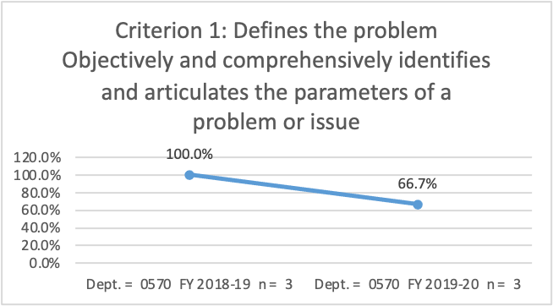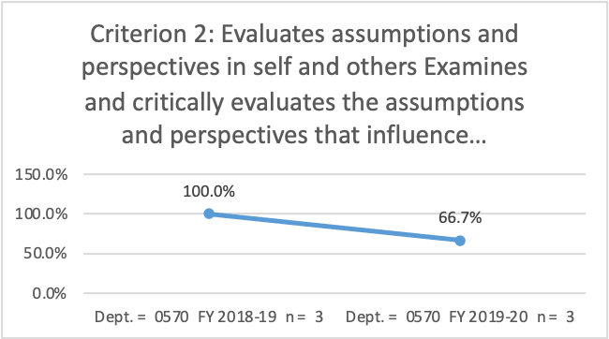
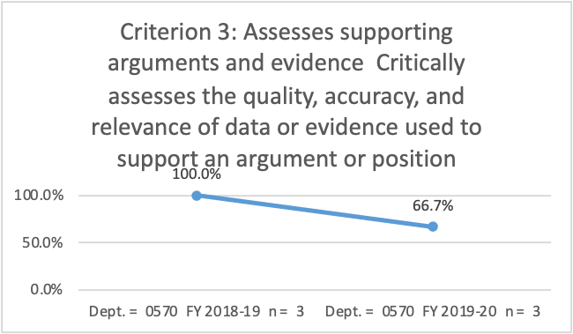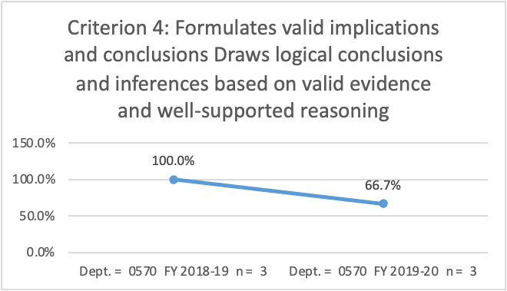

Cultural Diversity and Global Citizenship

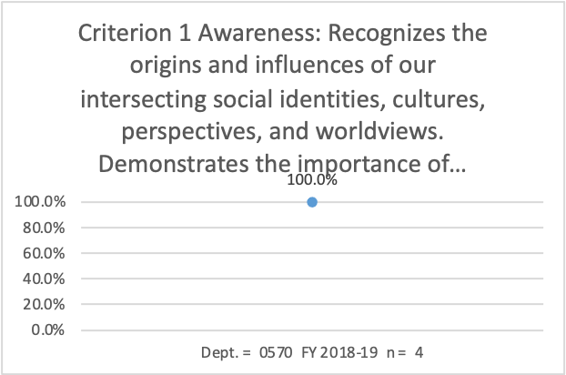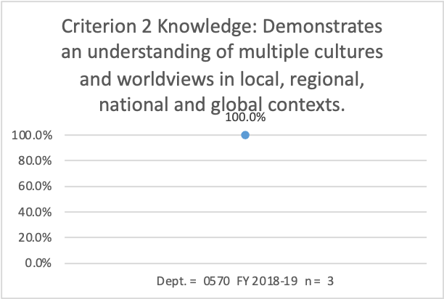
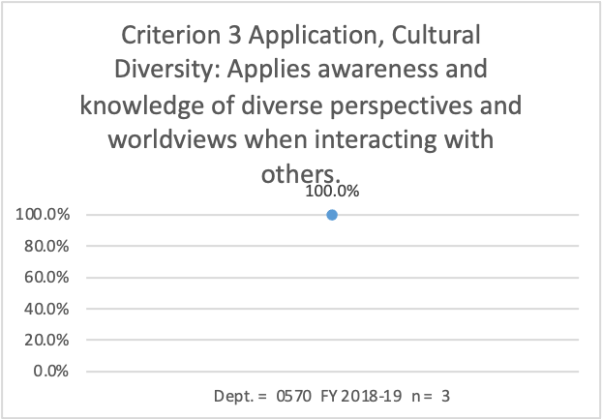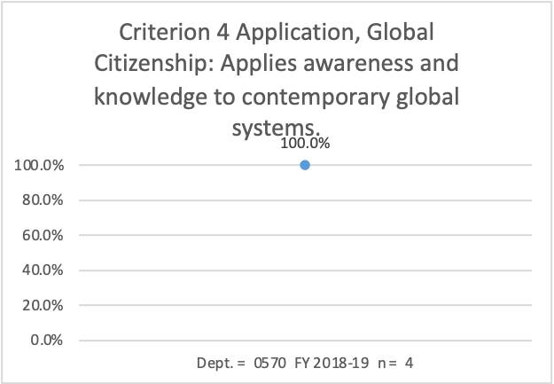
Information Literacy
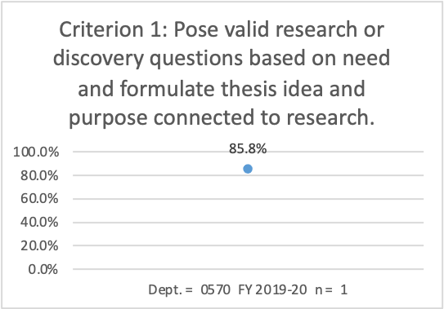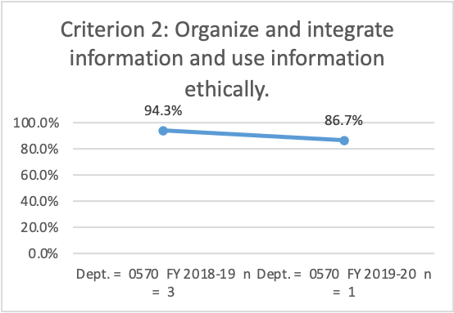

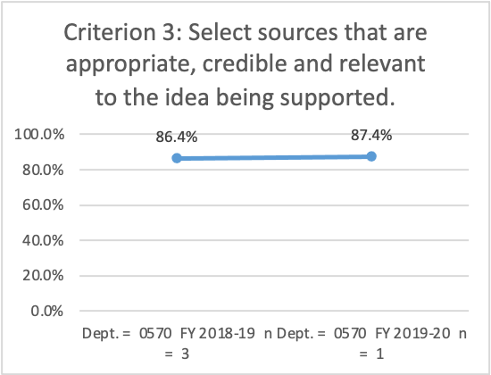
Oral Communication
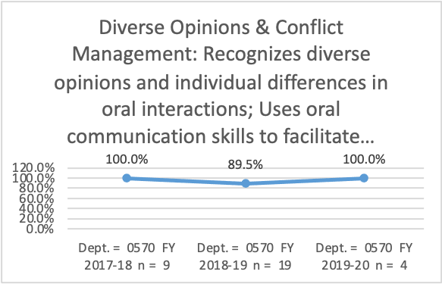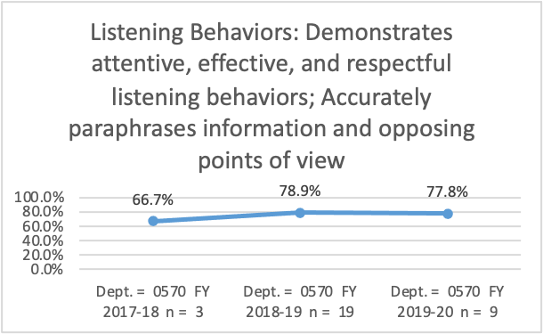

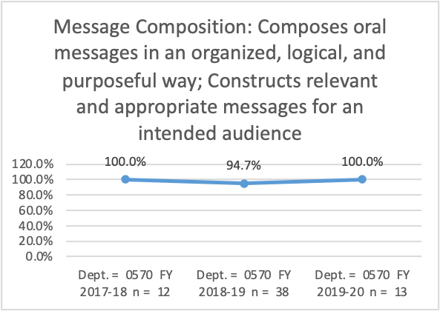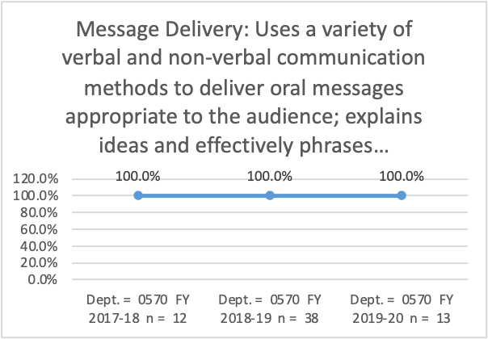
Written Communication
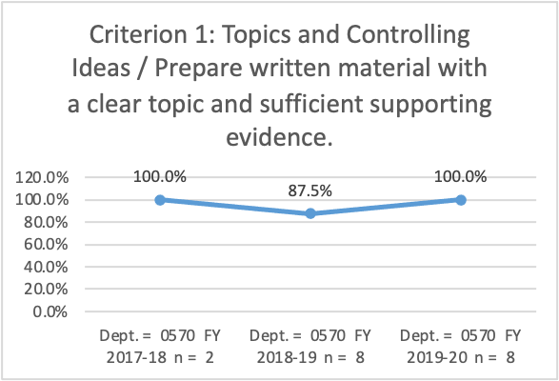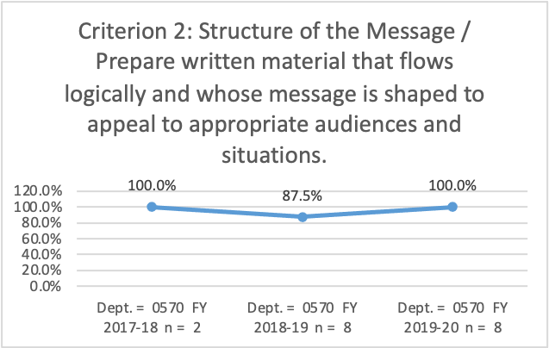

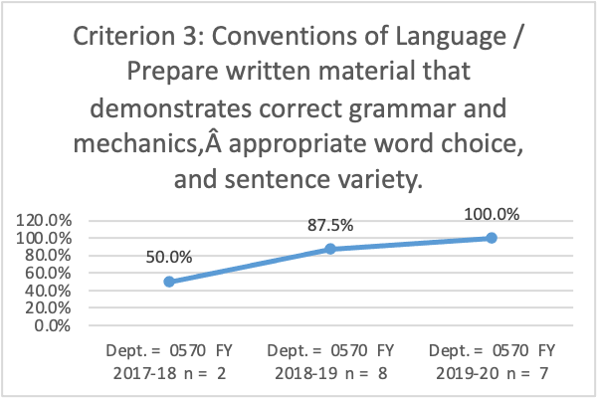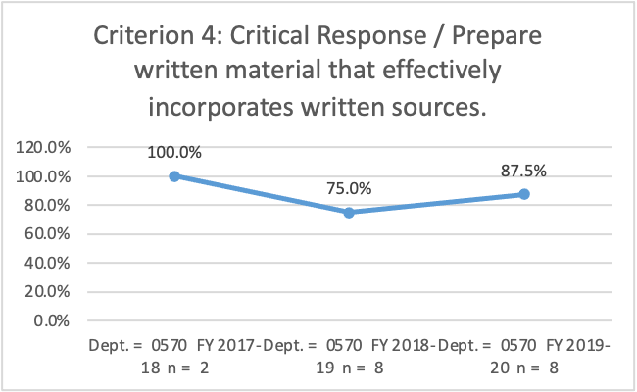
Appendix D: Program Outcome Assessment Data from the last Annual Update

The Program Outcomes for the degrees are listed below. Responses from previous years are provided below. All program outcomes must be assessed at least once during the 5 year Program Review cycle, and assessment of program outcomes must occur each year.

Program Outcomes | To which course(s) is this program outcome related? | Year assessed or to be assessed. | Assessment Methods  Used | What were the assessment results?  (Please provide brief summary data)
Analyze manufacturing engineering problems (general and technical) and make appropriate decisions. | CAM 1107, 2145, 2204, 2212, 2700, OPT 1100, MET 1131, OPT 2240 | 2017-18  (previously 2012-13) | Employer Feedback – CAM 2700 Internship Supervisor Survey Results | SP/2017: Internship Supervisor Performance Appraisal Results: Including four questions on problem solving and critical thinking skills, 100% of responses rated students as “excellent” or “competent.” Data included 13 students and 8 employers.  FA/20 – Due to Covid and the reduced number of students we only received two completed Supervisor Performance Appraisals. The four questions on problem solving and critical thinking skills both rated the two students as Excellent or Competent.
Demonstrate applied competencies in the areas of machining applications, drafting techniques, and blueprint interpretation. | CAM 1107, 1109, 1161, 1162, 2114, 2212, 2225, OPT 1113 | 2016-17 | Locally Developed Exams – Using the CAM 2225 tests, questions relevant to machining applications, drafting techniques, and blueprint reading. | In FA/2016, students correctly answered 86% of the relevant questions on the CAM 2225 tests.  FA/2020 - There were 3 tests given in CAM 2225. The average scores for those tests were: 76%, 71%, 78%.  Math, CAD/Drafting and Mechanical design problems in tool engineering make up the content for this course. The average final numerical grade for this semester was 79%.  The program outcomes for the machining, drafting and print reading are average. Where we fall short is on math problems and being able to manipulate algebraic formulas.  Moving forward additional problem solving using algebraic formulas will be utilized throughout the program to help remedy the situation.
Demonstrate mathematical skills required for occupation. | CAM 1116, 1141,1142,  MAT 1110 | 2019-20 (previously 2014-15) | Locally Developed Exams – Using the CAM 1141 tests. Since the courses are Shop Floor Calculations I and II, all test questions are related to mathematical skills. | In FA/2014, 70% of CAM students scored “C” or better on the tests in CAM 1141 and 1142. This is lower than we would like to see, and the department is looking into it. On the other hand, 84% of CAM 1141 and 1142 students received a course grade of “C” or better.  FA/2015 Update: 79% of CAM students scored a “C” or better on the tests in CAM 1141. Also, a new data point shows CAM students scoring an average of 95% on applied math questions on the CAM 1116 midterm and final.  2020 CY – In 2019 CAM 1141 Shop Floor Calculations I was changed to a Math course MAT 1110 Math for Technologists to give students in CAM Programs a math credit to meet graduation requirements, the course remained the same in content leaving only CAM 1142 Advanced Shop Floor Math as the math course within the CAM Program. For FA/20 the two Math courses were taught as CBE’s, MAT 1110 which is now made up of both CAM and Non-CAM students, of 20 students there were 9 A’s, 7 B’s and 4 withdrawals. For CAM 1142 all 7 students passed the course with a B or better.
Demonstrate technical engineering skills appropriate to program requirements. | CAM 1109, 1116,2145, 2204,2212, 2214,2780 | 2018-19  (previously 2012-13) | Employer Feedback – CAM 2700 Internship Supervisor Survey Results | SP/2015 Update: Internship Supervisor Survey Results: Including three topics on technical skills, 100% of supervisor responses rated students as “excellent” or “competent.”  FA/20 - Due to Covid and the reduced number of students we only received two completed Supervisor Performance Appraisals. Both rated the two students as Excellent or Competent.
Identify new changes in career field and build personal skills to maintain state-of-the-art competencies. | CAM 1107, 1109, 1161, 1162, 2212, 2700, 2780, 2781 | 2020-21  (previously 2015-16) | Graduate Exit Interviews | In SP/2016, Graduate Exit Interviews showed that 100% of students were able to identify new changes in the career field and determine strategies to maintain competence.  2020 CY -
  Students in our programs are taught
  from the outset that they must be
  adaptive to ever changing updates
  in the machining profession, from
  the fundamental skill sets in
  CAM 1107, 1109, 1161, and 1162
  they develop through the course
  progression to learn new skills and
  adapting to changes in the career
  field, they learn continuous
  improvement in their personal
  competencies which are proven
  and assessed in their final
  advanced courses, CAM 2212,
  2700, 2780 and 2781 of our
  program, including the internships
  and capstones. Random
  follow-up with graduates shows a
  continuing growth of all skill levels
  and changing capability based
  on their change philosophy.

