Sinclair Community College
Continuous Improvement Annual Update 2017-18

Please submit to your Division Assessment Coordinator / Learning Liaison for feedback no later than March 1, 2018

After receiving feedback from your Division Assessment Coordinator, please revise accordingly and make the final submission to your dean and the Provost’s Office no later than May 1, 2018

Department: HS - 0630 - Surgical Technology
Year of Last Program Review: FY 2014-2015
Year of Next Program Review: FY 2019-2020

Section I: Progress Since the Most Recent Review

Below are the goals from Section IV part E of your last Program Review Self-Study. Describe progress or changes made toward meeting each goal over the last year. Responses from the previous year’s Annual Update are included, if there have been no changes to report then no changes to the response are necessary.
GOALS | Status | Progress or Rationale for No Longer Applicable
Full implementation of the Sterilization Processing Technician short-term certificate program at Courseview in SP 15. | In progress  Completed  No longer applicable | Update 2017-18:  Since full implementation of this program, progress has been positively notable. The department has hired two (2) adjuncts and enrollment has been steady. Twenty (20) were enrolled for both FA 17 and SP 18 cohorts. The move to offer the program in an A-Term / B-Term format has increased registration and interest.  Registered Enrolled Completed  FA 17 19 12 11  SP 18 21 13 10  21 Completed  The overall job placement rate for the FA 17 cohort was 80%.  HOWEVER, the job placement rate for those actively seeking employment for the FA 17 cohort was 100%. Two students chose not to seek employment in the field. One was due to a pregnancy and the other was offered a position, but the hours were not what she desired.
Development and tentative implementation of the Perioperative Nursing short-term certificate program at Courseview in FA 15 or SP 16. | In progress  Completed  No longer applicable | Exploring feasibility of offering in both Cincinnati and Dayton markets at the Courseview Campus.  Update 2017-18: (continuing).  The department will seek to offer the Perioperative Nursing Program in the Dayton as there has been low response to inquiries from the Cincinnati market has been low.  The department is in the process of hiring an adjunct who is a Perioperative Nurse with much experience in teaching this course. We will target new RN graduates from Sinclair and RN’s throughout the Premier Health Network in Dayton. The department feels offering this program in the Dayton market will fill the need of this high demand skill set. Kettering Health Network has been approached and their interest is low as they offer a similar program though-out the KHN.  An Advisory Board made up of hospital partners will meet on May 11, 2018 to assess the need and desire for Sinclair certificate program in Perioperative Nursing.
Development and tentative implementation of the Surgical First Assisting Program at Courseview in FA 16 / SP 17. | In progress  Completed  No longer applicable | Reviewing development requirements for full accreditation.  Update 2017-18: (continuing).  The Department Chair will hire an Adjunct or offer an SSA to begin development of this post-graduate program. An applicant is actively going through the hiring process and will be brought on board as soon as the process is complete. The new adjunct will work closely with the Department Chair to develop the course content and curriculum so that is ready for FA 18.

Below are the Recommendations for Action made by the review team. Describe the progress or changes made toward meeting each recommendation over the last year. Responses from the previous year’s Annual Update are included, if there have been no changes to report then no changes to the response are necessary.
RECOMMENDATIONS | Status | Progress or Rationale for No Longer Applicable
This is a dynamic department with a positive attitude and a high capacity for meeting stakeholder needs – how can this be modeled for other departments? It may be that workshops and presentations regarding the work of the department could help pass some of this positivity on to other departments. Specifically, the department is encouraged to develop a presentation on developing and implementing new programs, since the Vet Tech program is such an excellent example of how this can be done right. | In progress  Completed  No longer applicable | Update for 2017-18 No Longer Applicable  As a smaller department, time to develop a CTL presentations on this subject is challenging while also working on developing new certificates and increasing co-hort size in the degree program. However, I am able to consult with other department chairs interested in developing new programs, as needed.
RECOMMENDATIONS | Status | Progress or Rationale for No Longer Applicable
In many ways the assessment work that the department performs is very impressive – rubrics are used to assess program outcomes and General Education outcomes, and this data is supported by employer data that echoes the high level of achievement of its students. However, many of the assessment results show students achieving 100% levels, and while this indicates an extremely high level of achievement in terms of students meeting the outcomes, it provides limited data regarding where improvements can be made. The Review Team recommends that the department find ways to dig deeper into its assessment data to identify actionable improvements. This is clearly a high functioning department that does a stellar job of preparing its students to meet program outcomes – however, it may be that fine tuning the assessments would allow the department to collect actionable data that could lead to improvements. The Review Team recommends working with the Divisional Assessment Coordinator, who is a valuable resource for improving assessment practice. The department should not think that the Review Team finds its assessment work lacking – on the contrary, it is impressive. The Review Team is simply suggesting that even with an impressive assessment program there may be an opportunity to collect additional assessment data that could lead to program improvement. | In progress  Completed  No longer applicable | Update for 2017-18  Ongoing  GEN-ED OUTCOME:  Computer Literacy  Information Literacy  Oral Communication  The above General Education Outcome Rubrics have been adapted for the program and are imported into their perspective eLearn shells.  The rubrics can be viewed in Section II (pages 14-17).  .
RECOMMENDATIONS | Status | Progress or Rationale for No Longer Applicable
The department noted the growing challenge of finding practicum placements for all of its graduates, and during the meeting with the Review Team the dean expressed an interest in helping to nurture relationships with practicum sites. The department is strongly encouraged to work with the dean’s office and secure their support in bringing about greater involvement in maintaining and enhancing relationships with practicum sites. | In progress  Completed  No longer applicable | Progress:  With the proposed changes to the clinical and lecture schedule in full swing (as described in the 2016-17 Annual Update), the program was able to increase its FTE’s by 104.26% from SP 17 to SP 18.  The department also continues to work with the Dean’s office who has an open dialogue with both PHP and KHN network leaders to assist with consistent placement of students into clinical positions at all of the area hospitals.  Close attention will be paid to all 5 accreditation program outcomes to ensure the increase is FTE’s continue to meet each benchmark set by our accrediting body and continues to meet community needs.
As is the case for many Health Sciences departments diversity of students and faculty remains an issue. The department is strongly encouraged to explore ways of increasing diversity, particularly in terms of recruitment in areas with a high population of potential minority students. The department is also encouraged to seek out information on programs that might help them increase diversity. | In progress  Completed  No longer applicable | The program plans to form a Focus Group to reach out to current minority students and past minority program graduates. This Focus Group will open a dialogue to collect ideas on how to reach deeper into minority populations to encourage careers in surgery.  We also plan to meeting with the college’s Diversity Office to learn of ways we can reach the minority populations at Sinclair to increase awareness of our program.  The department has a very high participation rate in all high school career fairs both on and off campus. We especially ensure we participate in recruitment opportunities with organizations that have high minority populations.
RECOMMENDATIONS | Status | Progress or Rationale for No Longer Applicable
The SUT program noted that a BIO 2205 prerequisite has been implemented – the department should carefully consider the possible impacts of this change based on available data. The Review Team recommends that the department meet with the Dean and the Division Assessment Coordinator to discuss possible impacts of this change, and whether it is supported by the available data. | In progress  Completed  No longer applicable | As stated in our last Annual Update:  Based on the recommendations from the Department Review Committee in 2015, the department has taken the suggestions and revised the curriculum accordingly, removing BIO 2205 and BIO 1222 as prerequisites.  There has been no increase in attrition seen since removing both BIO 2205 and BIO 1222 as pre-requisites to core coursework.
The Health Sciences Strategy that Sinclair is developing and will soon be implementing calls for inter-professional strategies that acclimate students to working in teams with professionals from other disciplines. The SUT program lends itself well to these kinds of arrangements – the department is encouraged to consider how the Vet Tech program might also be incorporated into these inter-professional approaches. | In progress  Completed  No longer applicable | The program not only continues to work closely with the VET Tech program to provide inter-professional opportunities, but is working closely with the RAT, NUR and END programs as well.  Although no formal simulations have taken place between multiple groups of students, active measures have been taken to provide realistic educational opportunities to RAT, NUR, and END students.
RECOMMENDATIONS | Status | Progress or Rationale for No Longer Applicable
The SUT program has set goals for developing three programs: full implementation of the Sterilization Processing Technician short-term certificate, the Perioperative Nursing short-term certificate, and the Surgical First Assisting Program, some of which are slated for within the next few terms. The departments should consider whether the staffing requirements of full implementation of these programs might be prohibitive, and whether additional efforts at recruiting and training adjunct faculty might be required. | In progress  Completed  No longer applicable | Progress: same  The department has hired a total of 5 new Adjunct Faculty.  Two fully credentialed adjuncts were hired for the Sterile Processing Program  Three fully credentialed adjuncts were hired for the Surgical Technology Program. These adjunct positions were needed to accommodate the changes made to the program’s lecture and clinical schedule.  Further selection of qualified applicants to fill new program positions will continue.

Section II: Assessment of General Education & Degree Program Outcomes

For the FY 2016-17 Annual Update, departments are asked to provide assessment results for Information Literacy.

General Education Outcomes | Year assessed or to be assesse | Course identified by the department where this outcome could be assessed | Assessment Methods  Used | What were the assessment results?  (Please provide brief summary data)
THIS YEAR’S ASSESSMENT RESULTS

Computer Literacy | 2017-2018 | SUT 1110 |  | Computer Literacy is assessed in SUT 1110, which the 1st year students are currently enrolled. The assignment in which Criterion 1 was assessed was due until April 21st, 2018.  Criterion 1: 80% of the students scored a 4 (Proficient 90%-100% accuracy) in accurately following MLA or APA format and properly following and using the ‘Dropbox’ instructions.  20% of the class scored a 3 (Competent 70% to 89% accuracy) in accurately following MLA or APA format and properly following and using the ‘Dropbox’ instructions.  Overall, most errors were minor formatting errors and all appeared to have retained the knowledge gained in ENG 1101.  Criterion 2: 100% of the students passed the HIPAA exam which assessed the students ability to exhibit knowledge in the ethical use of computers in the OR.  I have imported the rubric into the course shell for SUT 1110, and have made edits to the prescribed rubric so that in matches closely the course objectives. The rubric is below:
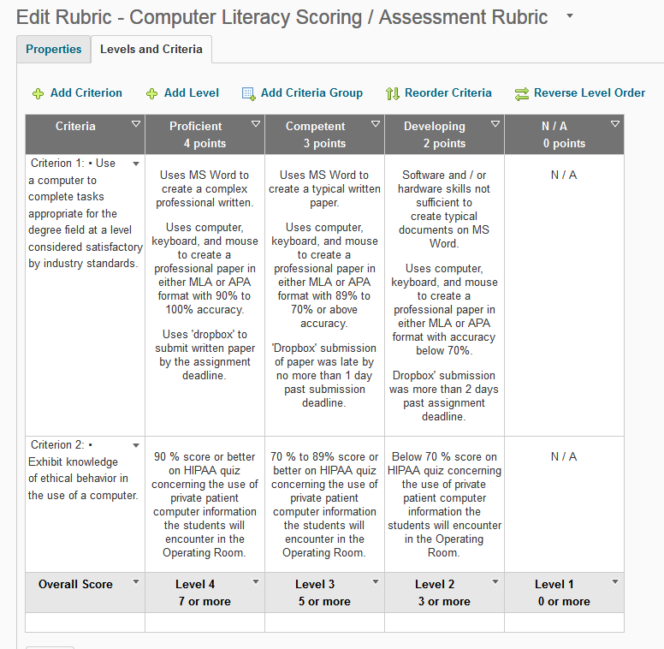

LAST YEAR’S ASSESSMENT RESULTS
Information Literacy | 2016-2017 | SUT 1110 | Direct Method – Written Paper on topic relevant to the fundamental course objective.  Rubric provided to the student  Indirect Method –  End of Course Evaluation Survey | The students were provided a Rubric with scoring in 5 information literacy areas:  4 organization and content areas, and an area to assess overall clarity and correctness of information formally written and cited. Scores of 4, 3, 2, or 1 were given for each area on the rubric.  4 = Excellent  3 = competent  2 = Minimal  1 = Unacceptable  The instructor assessed and scored each paper using the rubric, and added additional valuable written feedback to each student.  Assessment Data: Written Paper & Rubric  Scoring Area Data Results  Area 1 – Introduction 4=78%, 3= 10%, 2=10%, 1= 2%  Area 2 – Body 4=60%, 3=30%, 2=9%, 1=1%  Area 3 - Content 4=70%. 3=22%, 2=8%, 1=0%  Area 4 – Conclusion 4=60%, 3=38%. 2=2%, 1=0%  Area 5 – Clarity & Correctness 4=38%, 3=46%, 2-10%, 1=5%  Assessment Data: End of Course Survey  Response Rate = 82%  Data results: 100% of respondents scored the faculty the median score of 5 (Strongly Agree) on a 5-point Likert Scale.  Analysis of Data:  The statistical analysis of the data shows a knowledge deficit in Content Area 5 of the assignment, which was ‘Clarity and Correctness of Writing’. 15% of the students scored minimal or unacceptable in the following area: ‘Adheres to APA or MLA style in formatting, organization and construction, including full review of the literature’.  Most sources cited by the student were not professional sources and many used the course Lecture Guide as their primary source. Some students provided no professional information sources.  Evaluation and Plan for Improvement:  Revise rubric to emphasize use of type and number of professional sources.  Review use of APA and MLA format. Share data and work collaboratively with ENG department to provide feedback on student retention of material mastered in ENG 1101.  Review with students how to find professional sources on the internet and how to cite digital sources in a professional paper.

The Program Outcomes for the degrees are listed below. Responses from previous years are provided below. All program outcomes must be assessed at least once during the 5 year Program Review cycle, and assessment of program outcomes must occur each year.

Program Outcomes | To which course(s) is this program outcome related? | Year assessed or to be assessed. | Assessment Methods  Used | What were the assessment results?  (Please provide brief summary data)
1.  Utilize critical thinking as a basis for clinical judgment and anticipatory decision making when providing perioperative care. | SUT 1110/1117, 1120/1127, 2110/2117, 2120/2127, 2200/2207,  BIO 1121,1222, 2205; ALH 1142, 1201; MAT 1130, SUT Elective | Assessed annually. | ‘End of Course’ Student Evaluation Rubric for SUT 2200 completed by faculty.  CST exam pass rate | 100% scored 3 or 4 in the ‘critical thinking / clinical judgment’ portion of SUT 2200 rubric.  Benchmark Pass rate of at least 70% met all years except 2012.
2.  Demonstrate safe performance of perioperative skills. | SUT 1110, 1117, 1120, 1127, 2110, 2120, 2127. 2200; 2207, COM 2206 or 2211; HIM 1101; MAT 1130; BIO 1121, 1122, 2205; ALH 1142 | Assessed annually. | ‘End of Course’ Student Evaluation Rubric for SUT 2200 completed by faculty.  Employer Satisfaction Survey | 100% scored 3 or 4 in the ‘technical skills’ portion of SUT 2200 rubric.  100% of employer responses showed 3 or above on 1 to 5 Likert scale responses on area concerning safe performance of peri-op skills.

3.  Demonstrate professional behaviors of caring, accountability, responsibility, and respect for the patient’s rights of privacy, confidentiality, dignity, comfort, and quality of care. | SUT 1110, 1117, 1120, 1127, 2110, 2117, 2120, 2127, 2200; 2207, COM 2206 or 2211; ALH 1101; PSY 1100, HUM Elective, SUT Elective | Assessed annually. | ‘End of Course’ Student Evaluation Rubric for SUT 2200 completed by faculty.  Employer Satisfaction Survey | 100% scored 3 or 4 in the ‘professional skills’ portion of SUT 2200 rubric.  100% of employer responses showed 3 or above on 1 to 5 Likert scale responses on area professionalism.
4.  Utilize effective interpersonal communication and group process skills. | SUT 1110, 1117, 1120, 1127, 2110, 2117, 2120, 2127, 2200; 2207, COM 2206 or 2211; ALH 1101; ENG 1101, PSY 1100 | Assessed annually. | ‘End of Course’ Student Evaluation Rubric for SUT 2200 completed by faculty.  Employer Satisfaction Survey | 100% scored 3 or 4 in the ‘communication skills’ portion of SUT 2200 rubric.  100% of employer responses showed 3 or above on 1 to 5 Likert scale responses on area concerning effective communication skills.
5.  Assume the role of an involved, supportive surgical team member. | SUT 1110, 1117, 1120, 1127, 2110, 2117, 2120, 2127, 2200; 2207, PSY 1100; COM 2206 or 2211; ALH 1101 | Assessed annually. | ‘End of Course’ Student Evaluation Rubric for SUT 2200 completed by faculty.  Employer Satisfaction Survey | 100% scored 3 or 4 in the ‘professional skills’ portion of the SUT 2200 rubric.  100% of employer responses showed 3 or above on 1 to 5 Likert scale responses on area concerning competent role performance.
6.  Provide for physiological safety and emotional security of patient and surgical team. | SUT 1110, 1117, 1120, 1127, 2110, 2117, 2120, 2127, 2200, 2207; COM 2206 or 2211; PSY 1100 | Assessed annually. | ‘End of Course’ Student Evaluation Rubric for SUT 2200 completed by faculty.  Employer Satisfaction Survey | 100% scored 3 or 4 in the ‘critical thinking / critical judgement’ portion of the SUT 2200 rubric.  100% of employer responses showed 3 or above on 1 to 5 Likert scale responses on area concerning provision of safety.

Are changes planned as a result of the assessment of program outcomes? If so, what are those changes? | To better assess our program outcomes, the department plans to add IPE (Interprofessional Education) to assist in preparing our students to provide patient care in a collaborative team environment. Work has begun in developing scenarios with the RAT department.
How will you determine whether those changes had an impact? | We will assess student self-reported changes in their attitudes towards interprofessional teams and interprofessional learning, and their self-reported perception of effectiveness as team members.

OPTIONAL:

Please use the space below to keep track of any annual data that your department wishes to maintain. This section is completely optional and will not be reviewed by the Division Assessment Coordinators.
Accreditation  Program Outcome Measures | 2002 | 2003 | 2004 | 2005 | 2006 | 2007 | 2008 | 2009 | 2010 | 2011 | 2012 | 2013 | 2014 | 2015 | 2016 | 2017
Retention Rate  Benchmark (70%) | 79% | 88% | 71% | 65% | 70% | 70% | 63% | 85% | 85% | 88% | 79% | 81% | 71% | 87% | 77% | 82%
Job Placement Rate  Benchmark (80%) | 100% | 100% | 100% | 100% | 100% | 88% | 92% | 94% | 88% | 93% | 82% | 81% | 82% | 87% | 100% | 93%
PAE Exam Pass Rate  Benchmark (100%) | 87% | 94% | 92% | 100% | 100% | 100% | 100% | 100% | 100% | --NA- | --NA- | --NA- | --NA- | --NA- | --NA- | --NA-
CST Exam Pass Rate  Benchmark (70%) | --- | --- | --- | --- | 100% | 88% | 100% | 89% | 88% | 90% | 45% | 86% | 91% | 85% | 90% | 86%
Student Satisfaction  Benchmark (85%) | 100% | 100% | 100% | 100% | 100% | 100% | 100% | 100% | 100% | 100% | 100% | 100% | 100% | 100% | 100% | 100%
Employer Satisfaction  Benchmark (85%) | 100% | 100% | 100% | 100% | 100% | 100% | 100% | 100% | 100% | 100% | 100% | 100% | 100% | 100% | 100% | 100%

GENERAL EDUCATION RUBRICS for eLEARN
SUT.S.AAS

ORAL COMMUNICATION
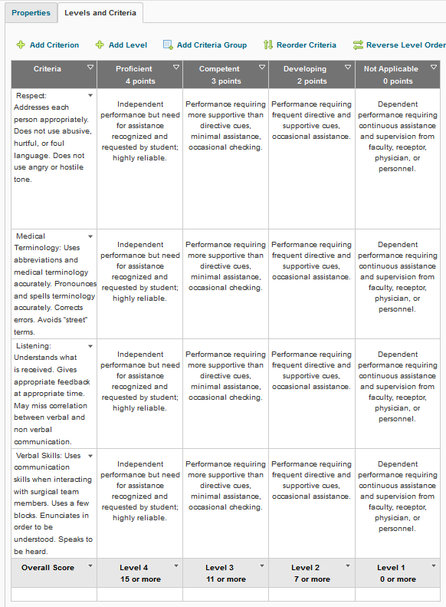

COMPUTER LITERACY
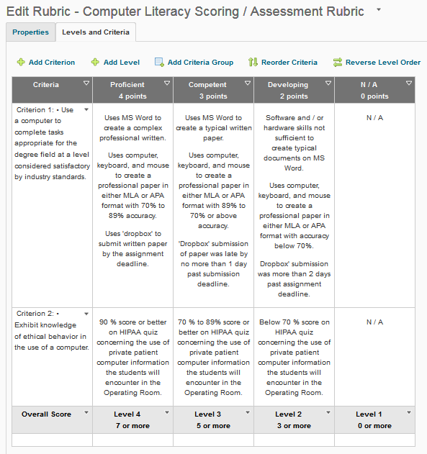

INFORMATION LITERACY

Criteria | Exceptional  4 points | Competent  3 points | Developing  2 points | N / A  0 points
Criterion 1: Pose valid research or discovery questions based on need and formulate thesis idea and purpose connected to research. | Presents a defensible question or topic. Topic is "real world" and unique.  Appropriately ties research to the main concept and shows relevance.  Provides sufficient research to support main topic using more sources than the minimum required | Presents a defensible question or topic.  Appropriately ties research to the main concept and shows relevance.  Provides sufficient research to support main topic using multiple sources. | Does not present a defensible question or topic  or  Does not tie research to the main concept or show relevance  or  Does not provide sufficient research to support main topic using multiple sources. | N / A
Criterion 2: Organize and integrate information and use information ethically. | Presents material in a clear and coherent fashion.  Integrates information from more sources than the minimum required into complete ideas.  Uses information that is not falsified, invalid, misleading or plagiarized.  Cites sources. | Presents material in an orderly fashion.  Integrates information from multiple sources into complete ideas.  Uses information that is not falsified, invalid, misleading or plagiarized.  Cites sources. | Does not present the material in an orderly fashion  or  Does not integrate information from multiple sources into complete ideas  or  Uses information that is falsified, invalid, misleading or plagiarized  or  Does not cite sources | N / A
Criterion 3: Select sources to support an idea that are appropriate, credible and relevant to the idea being presented. | Incorporates a variety of sources.  Includes exceptional sources (from journals, other publications and websites of organizations recognized in the field as first-rate).  Provides sufficient reference information for the reader to clearly identify the source.  Uses sources relevant to the topic.  Uses more than three sources that support and corroborate each other UNLESS the artifact is examining a controversial topic with different perspectives.  Provides sufficient reference information for the reader to clearly identify the source. | Incorporates a variety of sources.  Includes sources that appear credible (from journals, other publications and websites of known organizations).  Provides sufficient reference information for the reader to clearly identify the source.  Uses sources relevant to the topic.  Uses two to three sources that support and corroborate each other UNLESS the artifact is examining a controversial topic with different perspectives.  Provides sufficient reference information for the reader to clearly identify the source. | Does not incorporate a variety of sources  or  Does not include sources that appear credible (from journals, other publications and websites of known organizations)  or  Does not provide sufficient reference information for the reader to clearly identify the source  or  Does not use sources relevant to the topic  or  Does not use multiple sources that support and corroborate each other  or  Does not provide sufficient reference information for the reader to clearly identify the source. | N / A
Overall Score | Level 4  11 or more | Level 3  8 or more | Level 2  5 or more | Level 1  0 or more

