Sinclair Community College
Continuous Improvement Annual Update 2016-17

Please submit to your Division Assessment Coordinator / Learning Liaison for feedback no later than March 1, 2017

After receiving feedback from your Division Assessment Coordinator, please revise accordingly and make the final submission to your dean and the Provost’s Office no later than May 1, 2017

Department: BPS - 0421 - Management& Marketing
Year of Last Program Review: FY 2012-2013
Year of Next Program Review: FY 2018-2019
Section I: Progress Since the Most Recent Review

Below are the goals from Section IV part E of your last Program Review Self-Study. Describe progress or changes made toward meeting each goal over the last year. Responses from the previous year’s Annual Update are included, if there have been no changes to report then no changes to the response are necessary.

GOALS | Status | Progress or Rationale for No Longer Applicable
There are a couple of areas worthy of note in this area. First, the department has recently begun discussion with Wright State to have Wright State teach a 3000 level management or marketing course at Sinclair to students considering transfer to Wright State. This offer is made in hopes that students will experience a university course while still in a familiar Sinclair setting, thus easing the transition to Wright State or another four-year institution. | In progress  Completed  No longer applicable | During the year, we worked with Wright States Roj Soin College of Business and offered a WSU marketing course at Sinclair's main campus, and another course at Courseview. The course offering at Courseview can be considered successful, but the offering at the main campus only enrolled WSU students. After three weeks, the course was moved back to WSU at the request of students.  We are also working with Dr. Shu Shiller, Chair Information Systems and SCM from WSU to identify Sinclair courses in the supply chain management curriculum that could transfer to WSU's SCM program. The outcome of the first meeting was very positive, and Dr. Shiller is working with her faculty to get several courses approved. This would enable students to experience a much smoother transition from Sinclair to WSU Raj Soin School of Business.  2017 Update: The department is continuing to work with Dr. Schiller from WSU to define areas we can develop articulation agreements in the area of SCM.
The second area the department has been working on is the expansion of its Supply Chain Management program to the Courseview campus. While there has been limited success to date, there has not been much in the area of marketing of the offerings to help drive enrollment. | In progress ☐  Completed  No longer applicable ☐ | We have worked with Courseview over the last year to define what their program needs are. It has become clear that the need is more closely aligned with the work that is going on with the NSF Supply Chain Technology Education. As a result, Courseview is working closely with the engineering technology department and offering classes in industrial maintenance.

Below are the Recommendations for Action made by the review team. Describe the progress or changes made toward meeting each recommendation over the last year. Responses from the previous year’s Annual Update are included, if there have been no changes to report then no changes to the response are necessary.

RECOMMENDATIONS | Status | Progress or Rationale for No Longer Applicable
The discussion with the review team regarding the deactivation of the marketing program and the department’s contemplation of development of a digital marketing program was very enlightening. The implementation of the prerequisite on the TAG marketing course by the state has had an adverse effect on enrollment statewide, and was directly responsible for the deactivation of the program. Considerations of a new digital marketing program will need to include plans for overcoming this barrier. The department has discussed development of a non-TAG marketing course get around this obstacle, and that is a possible approach, although there may be some benefits to working with the state to remove the troublesome TAG prerequisite. However the department chooses to address this challenge, the review team recommends careful consideration and thought regarding the need for a digital marketing program, and if the decision is made to pursue it, careful attention to the development of this program. Transfer possibilities and employment prospects for graduates should be among the major factors taken into consideration as the department explores this opportunity. The department should formalize an approach to making the determination regarding whether this program should be developed. | In progress ☐  Completed  No longer applicable ☐ | A new digital marketing program and two certificates was developed and approved by the curriculum committee. Three new courses were also developed, including a non-TAG Intro to Marketing course. This course, MRK 2100 does not require ECO 2180 as a prerequisite. This was done to allow students that are not planning on transferring to a 4-year state school to be better able to complete. As a result, we would expect to see the number of completers increase.  2016 UPDATE: Financial aid was finally approved, after a year and a half, for the Digital Marketing AAS degree beginning spring semester, so we expect to see enrollment begin to improve. Additionally, a Digital Marketing Analytics Certificate has been developed, and added to the degree program.
The department should also formalize an approach for deciding whether or not to require internships for all of its students. This possibility is presently at the discussion stage in the department, and the department should develop a clear and explicit rationale for deciding whether or not to implement this idea. The department should be very clear about how this will be decided. | In progress ☐  Completed  No longer applicable ☐ | The feedback from the Digital Marketing Focus Group was indeed supportive of the internship requirement. As a result, the new digital marketing program requires an internship as a core piece of the curriculum.
An approach for making improvements to the Advisory Board should also be formalized – the department should state explicitly why improvements are needed, what the goals of the improvements are, and what the strategies for achieving those goals should be. As part of the rationale for the improvements, the department should specify how the Advisory Board will function differently than it has in the past, should specify how the structure will differ from what it has been in the past, and a timeline should be developed that will guide the department’s efforts to strengthen its Advisory Board. | In progress  Completed  No longer applicable ☐ | The department is continuing to revise the membership of the advisory board to meet our needs. We have also started working on a way to get the advisory board more involved with the students. Beginning in the fall semester, we plan on having the advisory board develop a scenario based case for a cross disciplinary group of students (MAN 1107, MAN 2150, MAN 1110, MAN 2155, and MRK 2101). The classes are being scheduled in the same time block, and three times during the term, the advisory board will meet with the classes and facilitate a session. Each class will then approach the problem from the perspective of the discipline of their class.  2016 UPDATE: The business simulation was developed, and run during fall 2105 with the five classes listed above. The scenario developed focused on the City of Dayton, and the economic crisis faced by the region after the loss of thousands of jobs. The advisory board members worked with students on the project, and assisted with the final assessment of students. At the last advisory board meeting in December 2015, it was decided to continue business simulation and to use the City of Dayton scenario again for spring. There was discussion of the opportunities for improvement which included updating the grading rubric, revising the presentation assignment to include a recommendation, better defining the role of the advisory board members, and finally, revising the use of Google docs and the final reporting parameters for students.  In fall 2016, we have invited Kathy Rowell to have her class (sociology) join us as we attempt to expand the business simulation to include not only other departments, but their advisory board as well. ( Update: This department chose not to participate in the business simulation)  2017 UPDATE: The department has continued to develop the advisory board by adding new members who are actively involved in our business simulation project. Additionally, we have involved the PLS department and Professor Charles Curran to join the simulation with his State and Local Government class for spring 2017.
The department has demonstrated an exemplary level of commitment to the collection and use of data, and has worked hard in this area. The review team has the sense that these data collection efforts could be made more efficient and less onerous through the use of some of the resources offered by other departments. For example, RAR may be able to extract data from multiple sections in Angel more easily than the department can with its current processes. When collection of data becomes resource-intensive, the department is strongly encouraged to consult with RAR, the Provost’s Office, and other areas on campus to see if there aren’t more effective and efficient ways to obtain the data the department needs. It may be appropriate to invite a representative from RAR to a department meeting to discuss some of the services that they can provide. | In progress  Completed ☐  No longer applicable ☐ | Work in this area will be on-going. As we have needs to access/extract assessment data from Angel, we will continue to reach out to RAR and others to look for ways to streamline the process.  2016 UPDATE: The department is investigating new product offerings from both Pearson and McGraw Hill which will facilitate cross-sectional course assessment capability. Currently, the course coordinator has to go into each course section within eLearn, and pull data from each assessment being used. Next the data has to be compiled, manually transferred to excel, and analyzed. The publisher platforms appear to allow for an easy was to pull the data from a single source. The department plans on piloting at least one of these platforms for fall 2016.  2017 UPDATE: The department piloted an offering from both Pearson and McGraw Hill in fall 2016. The Pearson product was offered in the MAN 1110 class, and was a complete failure, as their product did not perform as it was sold. Professor Ned Young has had better results with the McGraw Hill offering, and has used it in the MAN 2150 course.  The MAN 1110 course has switched to the McGraw Hill product for spring 2017 delivery.
.  The department has shown a great deal of concern about students knowing the difference between the Business Administration transfer degree and the General Business Management Applied Associate of Science degree. Despite this concern, there appears to still be some confusion among students and others regarding how these degrees differ in terms of post-graduation outcomes and opportunities. The review team recommends that the department find ways to communicate more effectively with students regarding the differences between these degrees. One option may be to have something on the department website that makes the differences between these degrees more clear and explicit. Other efforts at outreach to students and others who may be unclear on the differences may be warranted, especially to Enrollment Services and Academic Advising. The department should come up with a plan with specific actions that are designed to decrease confusion regarding these two distinct degree pathways. | In progress □  Completed  No longer applicable ☐ | The department has worked closely with the academic advisors, as well as developing detailed program sheets for each degree. The advisors are making a point to stress the difference with students as they meet with them. During our outreach events we are also emphasizing the differences as well. Finally, we have developed better relationships with schools like Franklin University and Ohio University and have articulation agreements in place so that students that have completed an AAS degree can still transfer and receive credit for the coursework they have completed in their degree program.
Since the department is seriously considering a digital marketing degree, an increased use of social media and other digital platforms may be warranted. Use of these tools by the department may both increase its capacity for educating students in these areas and allow the department to demonstrate to its students the potential for these approaches. | In progress  Completed  No longer applicable ☐ | See comments above re: development of a marketing certificate/program. Also, Dennis Brode and Chrissann Ruehle will be doing a presentation at the ACBSP Annual Conference in Philadelphia on the topic of digital marketing/social media in the classroom. Additionally, we are continuing to look for ways to increase the use in more subtle ways. For example, Dennis Brode has been piloting the use of REMIND.COM for his face-to-face classes since fall 2014 with very positive results.  2016 UPDATE: Beginning in fall 2016, Chrissann Ruehle began working with a representative within each department within the BPS Division to establish a LinkedIn group to better communicate, and track students – both current and former, to be better able to gather data about employment. Additionally, Chrissann has been tapped to develop a digital marketing plan for the career communities to better connect with current, and potential students. Eric Smith was asked to be the MAN/MRK LinkedIn Captain, and is working to set-up and manage the group for the department.  2017 UPDATE: There has been no progress on this since the last annual update. Eric Smith did not complete any work on this project in the last year. A new lead for this project is being considered at this time.

Section II: Assessment of General Education & Degree Program Outcomes

For the FY 2016-17 Annual Update, departments are asked to provide assessment results for Information Literacy.

General Education Outcomes | Year assessed or to be assessed. | Course identified by the department where this outcome could be assessed | Assessment Methods  Used | What were the assessment results?  (Please provide brief summary data)
Information Literacy | 2016-2017 | NO COURSES PROVIDED
NEXT YEAR:
Computer Literacy | 2017-2018 | NO COURSES PROVIDED

The Program Outcomes for the degrees are listed below. Responses from previous years are provided below. All program outcomes must be assessed at least once during the 5 year Program Review cycle, and assessment of program outcomes must occur each year.

Program Outcomes | To which course(s) is this program outcome related? | Year assessed or to be assessed. | Assessment Methods  Used | What were the assessment results?  (Please provide brief summary data)
Apply contemporary approaches to management and organizational success within the framework of the classroom and written assignments. | ACC-1220  ECO-2160 ECO-2180 LAW-1101 MAN-1107 MAN-1110 MAN-2150 MAN-2279 MAT-1460 MAT-2170 MRK-2101 | 2014 | Test questions were developed to measure student knowledge in two primary areas – isolationism and general management. These test questions are embedded in every section of the MAN 2150 course. | 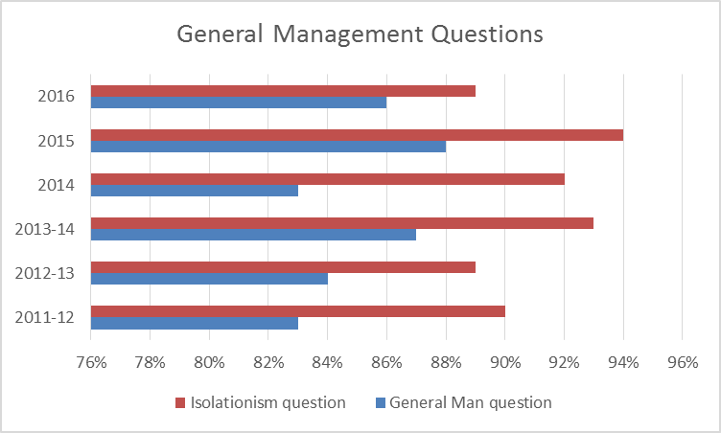  In 2011-12, the questions used to measure these areas were randomly selected, and over 200 students were tested; for 2014, the questions were placed in a separate folder, and every student received these questions. For analysis purposes, we pulled data from five course sections (three f-2-f and two on-line). The data represents over 300 students. Results indicate a decline in both area, but we are still well above the goal of 70%. Starting in fall 2015, we will place more emphasis in these areas in both on-line and face-to-face classes.
Apply principles of organizational behavior and human relations, including methods used to create, maintain and improve a positive and diverse work environment. | MAN-1107 MAN-2150 MAN-2279 | 2014 | Test questions were developed to measure student knowledge in these areas. These test questions are embedded in every section of the MAN 2150 course. | In 2011-12, the questions used to measure these areas were randomly selected, and over 200 students were tested; for 2014, the questions were placed in a separate folder, and every student received these questions. For analysis purposes, we pulled data from five course sections (three f-2-f and two on-line). The data represents over 300 students. For both questions, a slight increase in improvement was witnessed. At this point we are achieving the minimum outcome threshold of 70%.
Apply proper oral and written communication, quantitative methods, critical thinking, research, ethics, computer literacy, and global citizenship skills. | BIS-1120 COM-2211 ENG-1101 ENG-1131 ENG-1201 | 2016-17
Demonstrate methods of planning, leading, organizing and controlling within organizational systems and strategy development, particularly in the context of mission, values, goals and objectives. | MAN-1107 MAN-1110 MAN-2101 MAN-2150 MAN-2155 MAN-2270 MAN-2279 MRK-2101 | 2014 | Test questions were developed to measure student knowledge in the areas of planning, organizing, and control. These test questions are embedded in every section of the MAN 2150 course.  Program Outcomes:  A: Planned Changes to help impact the 2017 year  Although improvements were found, there are still four question types that fall below an 80% average (although our assessment threshold is 70%). Therefore, additional improvements will be made and data will continue to be collected to analyze the results. Improvements include:  1) Additional instructions will be provided to faculty to help them use the new Connect tools to better assess student learning and provide methods to improve key-concept understanding and retention.  2) The Connect system facilitates the collecting of data across all sections as opposed to the previous system of sampling 4-5 sections per semester. This will provide a much wider selection of data and a better understanding of learning across both on-line and face-to-face sections.  3)Because of the improvement in data collection, the department will begin collecting data associated with the entire quizzes and, perhaps, learning objectives to better pinpoint areas for improvement.  3) Collection and analysis of the data will continue  B: How will impact be determined?  The analysis of the selected questions will continue for subsequent terms and progress will be charted. The department will determined if the improvements provide increased success or whether additional changes will be warranted. | 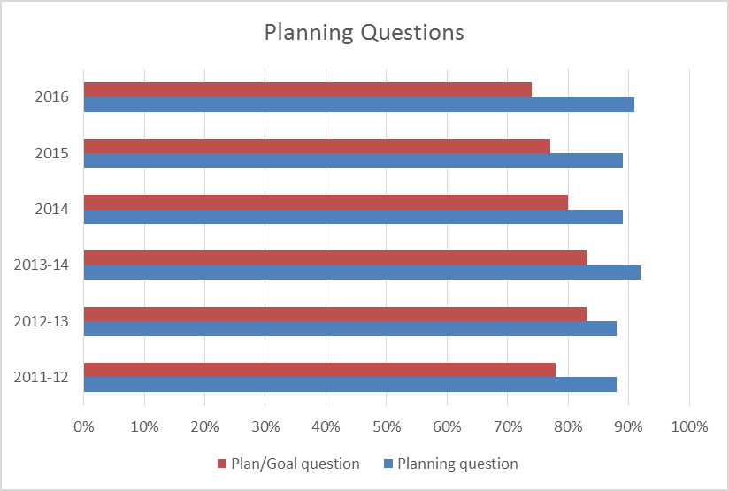  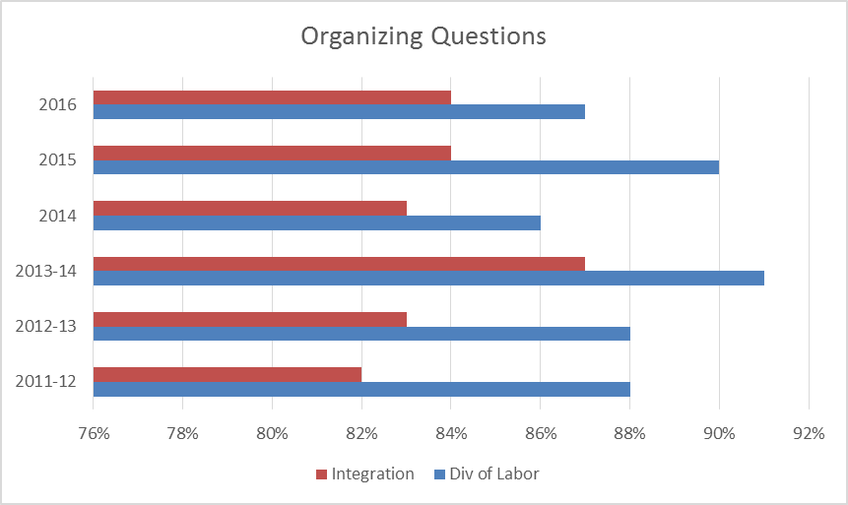  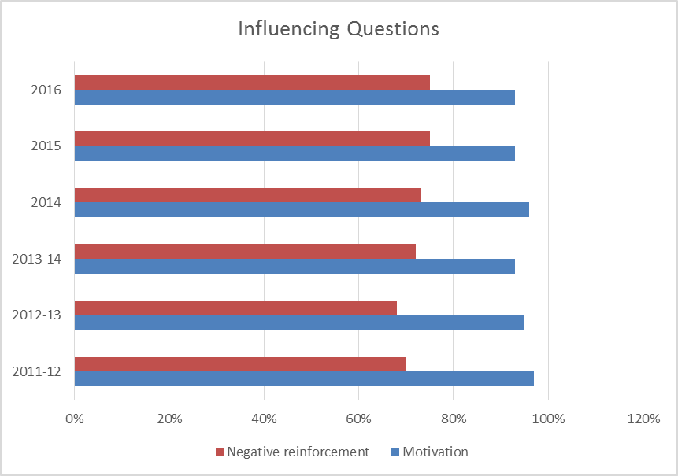  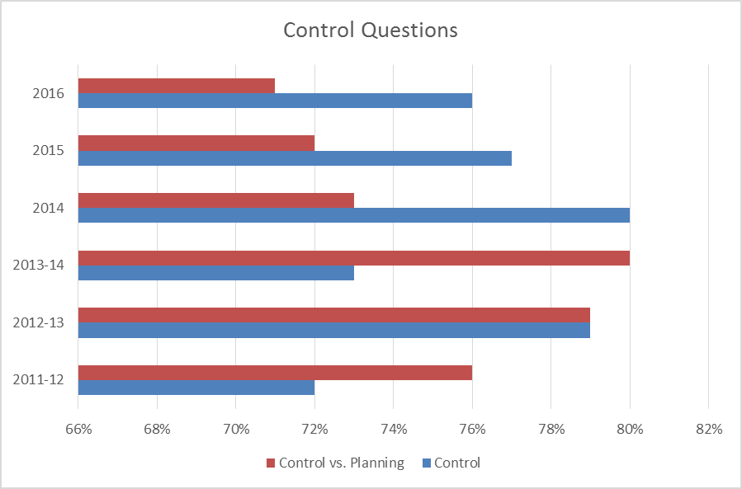  Summary: MAN 2150 was first run during Fall 2012 and was developed, for the semester conversion. It was converted from the MAN 250 course which was a combination of MAN 205 and MAN 225. As such, this is a foundational course for the Management program and will be assessed relative to GBM.S.AAS program outcome #5. The department faculty determined that the results of selected quiz questions, as answered by students, would be analyzed for assessment purposes. There are five main topic areas associated with MAN 2150 course including the history/definition of management, planning, organizing, influencing and controlling. Two quiz questions were selected for each topic (10 questions total) and the results from randomly sampled sections of MAN 2150 (Summer 2015, Fall 2015) were analyzed (see attached Excel spreadsheet). In all, 10 separate sections were analyzed comprising 12 week Summer and 16 week Fall sections. Since the same 10 questions were administered during the MAN 250 course (Fall 2011 – Summer 2012) and the new MAN 2150 course (Fall 2012-Fall 2015), comparisons can be made between all years.  A: 2015 Results  For the 2015 Summer/Fall data, six questions were answered at an 80% rate or higher and five of the six demonstrated improvement over the 2014 data. Of the four questions scoring below 80%, 1 question showed improvement over the 2014 but three questions dipped slightly below the 2014 mark. Three of the four questions below the 80% mark scored at least 75% with the lowest question earning a 72% score.  By category, both general management questions exceeded the 2014 mark; the general planning question tied last year’s score and the goal/planning question dipped from 80% to 77%; both organizing questions exceeded last year’s total; for influencing, the negative reinforcement question exceeded last year’s mark but the motivation question slipped from 96% to 93%; both control questions slipped slightly from last year (1% and 3%).  B: Changes implemented during the 2015 year  1) The Angel-based learning management system was replaced with the Desire to Learn ELearning system. Both students and faculty were in the midst of a learning curve which may have had some impact on quizzes (all quizzes are taken using the Elearn platform). Even with this massive change, the assessment results were generally positive with some of the questions (as noted above) exceeding 2014 results.  2) Practice quizzes 2, 4 and 5 were modified to included questions directly related to the above topics  3) Collection and analysis of the data continued  Additional iterations of these changes will be implemented during the 2016 academic year with particular focus on negative reinforcement, organizing and the integration points of planning and control.  Fall 2016, major changes were instituted into the course. A new condensed (“magazine”) version of the textbook was adopted as well as the addition of the publisher’s (McGraw Hill) electronic digital teaching and learning environment (called “Connect”). This was a major change for both the faculty and the students so the data will likely require a semester or two to equalize and demonstrate consistency.  A: 2016 Results  For the 2016 Spring/Summer/Fall data, six questions were answered at an 80% rate or higher, three questions were equal to the 2015 results and one question demonstrated improvement over the 2015 data. Of the four questions scoring below 80%, 1 question was equal to the 2015 but three questions dipped slightly below the 2015 mark. Two of the four questions below the 80% mark scored at least 75% with the lowest question earning a 71% score.  By category, one planning question exceeded the 2015 mark; both influencing questions tied the 2015 marks as did the integration question in the organizing section.
Demonstrate synthesis of general education concepts into the required management and business application. | BIS-1120 COM-2211 ENG-1101 ENG-1131 ENG-1201 | 2015-16
Supply Chain: Explain the functions of supply chains, their purpose, marketing and sales impact, use and management in a global context and their impact on customer service and profitability.  2016 UPDATE:  Changes were made to the SCM.S.AAS degree during 2016 based on employer feedback received from a Supply Chain Skills Survey as well as an Employer Compression Session held in May, 2016.  The resulting lean, 60-credit hour program is aligned with employers needs and focuses on skills required for employees to be successful in entry-to-mid-level jobs in supply chain and logistics.  In addition, full-time students can participate in the 15 Months To Your Future program and complete the degree in four consecutive semesters. | MAN-1106 MAN-2110 MAN-2144 MAN-2155 MAN-2159 OPT-2251 | 2014 | Three different assignments are being used to assess this outcome. The first is the Metropolitan University (Case Study), the second is the Inventory and Forecast Calculations (Quantitative), and the third is the PMI (Purchasing Manager’s Index) Analysis (Research and Report).  Quantitative problems have proven to be difficult for students. Inventory and forecasting calculations are critical for successful SC planning and execution.  The Purchasing Manager Index (PMI) is an economic indicator issued monthly by the Institute for Supply Management (Professional Organization important in the SC community). There are reports for both manufacturing and service industries and the information can be found regionally, nationally, and globally. The students are asked to play the role of SC manager and analyze how the information in this report would affect their buying decisions. | 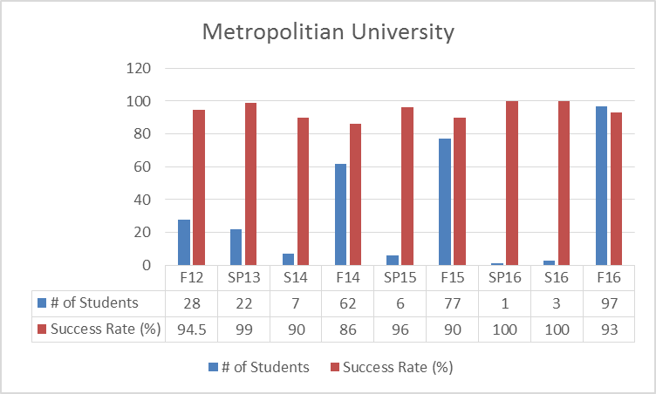  Based on 5 years of consecutive results, students have proven mastery of the outcome being measured by the assessment - The Metropolitan University Case.  A new case study assignment – North Eastern Equipment Company will be reviewed beginning spring 2017  Based on 5 years of consecutive results, students have proven mastery of the outcome being measured by the assessment – Inventory and Forecast Calculations (Quantitative).  An on-line forecasting simulator will replace the Inventory and Forecast Calculations as the reviewed assessment. This is a new assignment introduced to students in spring 2017 sections of MAN2159.  While we see some fluctuation each term, we continue to exceed our goal of 70%. A new research assignment – Green and Sustainable Policies will be reviewed beginning spring 2017.

Program Outcomes | To which course(s) is this program outcome related? | Year assessed or to be assessed. | Assessment Methods  Used | What were the assessment results?  (Please provide brief summary data)
Digital Marketing: Demonstrate the ability to comprehend, evaluate, and apply basic digital marketing strategies. | MRK 2135  MAT 1460 ACC 1210  ECO 2180  BIS 1120  MAN 2155  ACC 1100  MAN 2270  MAN 1107 MRK 2101 | 2014-15 | The assessment method used is an internal, summative assessment. The students complete a marketing plan. | After piloting the new grading rubric in summer 2015 and launching it across all sections in fall 2015, the grades appear to be more consistent across all the sections, but the overall scores are lower. We believe raising the bar on quality is good and we need to identify better approaches to help students to cross that threshold.  2017 UPDATE: The area of Utility Concepts is the weakest area for students. Additional focus will be given to this are moving forward.
GBM – Entrepreneurship:  Demonstrate and apply solid business communication skills as exhibited throughout written and oral presentations. | COM 2206  BIS 1120  ENG 1131  ENT 2160 | 2014-15 | The assessment method used is an internal, summative assessment.  The Business Plan Development course (ENT 2160) is the capstone course for this program. Students will incorporate professional written and oral communication skills into the completed final project (business plan) in ENT 2160 as evidenced by their written business plan and oral presentations. The goal is to reach a greater than 70% level of acceptable business writing and oral communication skills as assessed by the ENT 2160 final project grading rubric. | 2013 – n =68  2014 – n = 48  2015 – n = 65  2016 – n = 120  Learning modules were added to entrepreneurship course shells with lessons that teach students how to utilize widely used business software to properly format business documents with table of contents, in-text citations, and bibliographies. ENT 2160 students are introduced to Sinclair Research Librarians and learn how to properly utilize and assess research tools for business writing. Templates were added to course shells that include proper formatting (MLA 7th) for paper content and bibliography.  2017 UPDATE: Since we have been exceeding the 70% goal for several periods, we will be increasing the goal to 80% moving forward.

Are changes planned as a result of the assessment of program outcomes? If so, what are those changes? | One change being considered is an analysis of some of the publisher platforms which now provide cross-sectional assessment analysis capability. We are considering piloting either the Pearson, or the McGraw Hill platforms for fall to verify the claims of being able to easily pull data from across all sections of a particular course to easily analyze the data for outcomes assessment purposed.  MAN 2150: Although improvements were found, there are still four question types that fall below an 80% average (although our assessment threshold is 70%). Therefore, additional improvements will be made and data will continue to be collected to analyze the results. Improvements include:  1) Additional instructions will be provided to faculty to help them use the new Connect tools to better assess student learning and provide methods to improve key-concept understanding and retention.  2) The Connect system facilitates the collecting of data across all sections as opposed to the previous system of sampling 4-5 sections per semester. This will provide a much wider selection of data and a better understanding of learning across both on-line and face-to-face sections.  3) Because of the improvement in data collection, the department will begin collecting data associated with the entire quizzes and, perhaps, learning objectives to better pinpoint areas for improvement.  3) Collection and analysis of the data will continue
How will you determine whether those changes had an impact? | We will analyze the impact by the time saved for the course coordinators to gather, analyze, and present the outcomes assessment data. Currently, to provide the data presented, the course coordinator has to go into each course shell, find and pull the particular data, and then manually transfer the data to a spreadsheet for analysis. This is a very time consuming process.  MAN 2150: The analysis of the selected questions will continue for subsequent terms and progress will be charted. The department will determined if the improvements provide increased success or whether additional changes will be warranted.

OPTIONAL:

Please use the space below to keep track of any annual data that your department wishes to maintain. This section is completely optional and will not be reviewed by the Division Assessment Coordinators.

