Department/Program Review
Self-Study Report Template

2017 - 2018

Department: 0415-Computer Information Systems

Section I: Innovations and Accomplishments
Please list noteworthy innovations in instruction, curriculum and student learning over the last five years (including student awards, faculty awards, etc.).
- The Computer Information Systems (CIS) Department has submitted to the state of Ohio a new degree, Data Analytics. The department designed two new courses for the new degree: CIS 2265 Data Visualization and CIS 2266 Data Analytics using Scripting Language.
- Student Parker Row won a National Science Foundation grant to spend the summer at Wright State learning about reverse engineering software.
- Kyle Jones completed Master Degree in Information Security Assurance.
- Kyle Jones received the Southwestern Ohio Council for Higher Education Teaching of Excellence Award.
- Eric Renegar completed Master Degree in Information Technology.
- The SCOPE LAB provides hundreds of service learning hours and saves students on average $80,000 on Desktop and Laptop repairs per year.
- The department moved to cloud-based technical labs in several degree programs.This greatly enhanced the student experience and the skills that could be taught in classes.
- Patricia Santoianni was awarded Professor Meritorious.
- Competency-Based Education $12 million U.S. Department of Labor Project (grant period: 09/2012—09/2016). The department successfully developed competency-based education courses and programs.
- Designated a Center of Academic Excellence in Cyber Defense by the National Security Agency and the Department of Homeland Security.
- Awarded a National Science Foundation Grant for a Convergence Center for the amount of $80,961.
- Awarded a National Science Foundation Grant for Pathways for Big Data Career for the amount of $80,008.
- Awarded Ohio Department Higher Education Regionally Aligned Priorities in Delivering Skills (RAPIDSII) equipment grant for the amount of $46,293.
- Awarded a National Security Agency Grant for Cyber Defense Applied Training Project Grant for the amount of $202,828.
- National Security Agency (NSA) Expansion of Center of Academic Excellence in Education Grant with the University of Cincinnati Grant for the amount of $23,053.
- Applied for a National Science Foundation Advanced Technical Education Enhancing Degrees Grant for the amount of $599.986.

Section II: Annually Reviewed Information

A: Department Trend Data, Interpretation, and Analysis

Degree and Certificate Completion Trend Data – OVERALL SUMMARY

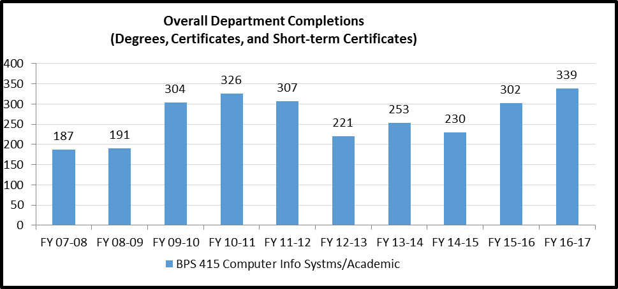

Please provide an interpretation and analysis of the Degree and Certificate Completion Trend Data: i.e., What trends do you see in the above data? Are there internal or external factors that account for these trends? What are the implications for the department? What actions have the department taken that have influenced these trends? What strategies will the department implement as a result of this data?

Please be sure to address strategies you are currently implementing to increase completions of degrees and certificates. What plans are you developing for improving student success in this regard?

Currently Implementing
- Completion was high in 2010-11 because the unemployed from GM and other manufacturing companies were completing their two-year degree.
- Also, students were encouraged to complete their degrees before the quarter to semester conversion.
- We increased our retention rates.
- We adjusted our math requirements to match industry needs by removing the high-level math classes that are not needed for IT jobs. For example, statistics from our desktop support degree.
- Coursework has been adjusted in subtle ways to encourage completion without sacrificing rigor. For example, giving students better and more resources to study for exams so that they maintain confidence throughout a course and don’t consider dropping.

Plans to Develop and Improve Student Success
- The CIS Department focuses on collaborating with university partners. Some of these partnerships include working with the University of Dayton on a 30-credit hour one-year certificate. We also focused on creating a new associates of science degree. This degree would service many students transferring to Wright State that are currently enrolled in the CIS Department.

- We know that technology is the driving force to most business and the economy in the Dayton region. In the past few years, there have been several significant companies leave the area. There has also been a few enter the region such as CareSource. However, the trend is smaller companies making up most of the IT marked in Dayton. So, the CIS Department has seen a change in employers hiring students in the district. Most of these employers are companies with 500 or fewer employees. That means employers are now considered small businesses according to the small business development centers of Ohio. These are the companies now hiring our students.

- We’re also seeing students wanting to enter into technology fields in high school. As technology tends to grow so are the job markets that are currently in the Dayton area. Now, the Bureau of Labor Statistics indicates that each of our degree paths has an average of a 16.5% increase in Job outlook in the next five to ten years. Please refer to the occupation data in appendix A1.

Course Success Trend Data – OVERALL SUMMARY

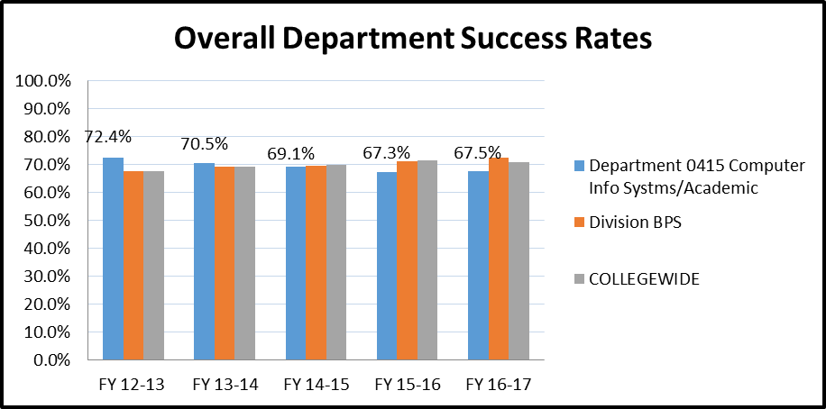

Please provide an interpretation and analysis of the Course Success Trend Data. Please discuss trends for high enrollment courses, courses used extensively by other departments, and courses where there have been substantial changes in success.
Please be sure to address strategies you are currently implementing to increase course success rates. What plans are you developing for improving student success in this regard?

- Department success rates have mostly mirrored the overall college trend. While slightly down the overall rate has been consistent. During this time of review, many programs were updated and made more rigorous to better match the needs of industry. New faculty and changes in instruction have led to better outcomes. While some loss would be expected in such an effort, completers now have better skills than before without a significant dip in overall numbers.
- High enrollment and core degree course completion are about the same. But students are also completing more advanced, rigorous, and up-to-date coursework at those levels as well.
- Increased the number of more meaningful hands-on activities in several degree programs. Students enjoy hands-on work over theory, which has led to better retention.
- Two-year cycle of updates on our Microsoft Curriculum. Students always know that they are learning the latest technology that meets industry standards.
- Where students are completing the most advanced coursework before graduation, the course completion rates are much higher and reflect the growth of student capacity and dedication throughout our programs.
- The department sets the standards for skill set attainment based on employer needs. Many of our students do internships, and the internship instructor visits the site and speaks with the supervisor. The feedback is overwhelmingly positive. Our students are ready for the job market. One reason why they are ready is we set very high standards.
- Our Cisco courses have been converted back to only teach core Cisco material. In the past, the classes covered multiple vendors and certification. After the changes, we saw a 60% increase in student enrollment.
- Submitted a National Science Foundation Grant for Enhancing Degrees to remove redundancies in the curriculum to improve student learning.

Please provide any additional data and analysis that illustrates what is going on in the department (examples might include accreditation data, program data, benchmark data from national exams, course sequence completion, retention, demographic data, data on placement of graduates, graduate survey data, etc.)

- For the academic year 2016/2017, the success rate (C or better) for CIS 1107 and CIS 1111 was 60.48% and 50.63%. CIS 1107 and 1111 are our “gateway” courses. Most students start with either both the classes or one of them. The average for all other courses was 83%.
- Through connections on LinkedIn faculty regularly get feedback on student success and career growth. Many of the faculty encourage students to connect on professional social media to open that channel to direct success tracking. Results are overwhelmingly positive.
- The data from the summary of the employment questions from the Recent Graduate Survey is very positive. Forty-five students responded to the survey. Of those who responded 73% are employed in their field of study and 82% responded they were somewhat prepared to very prepare to fulfill the responsibilities of their current position. Please see table in Appendix A5.
- Several faculty are involved in student clubs and other extracurricular activities that have been shown to increase completion and promote retention.
- The CIS Department hosts a Hackathon every year with AT&T. This hackathon brings in area high schools that help solve issues with the use of innovative technology innovations.
- The CIS Department Faculty have been in the local news media. Many of them are on call for special news broadcasts either recorded of live broadcasts.
B: Progress Since the Most Recent Review

Below are the goals from Section IV part E of your last Program Review Self-Study. Describe progress or changes made toward meeting each goal over the last year.
GOALS | Status | Progress or Rationale for No Longer Applicable
In light of designation as a Center of Academic Excellence in Information Assurance 2-Year Education, explore, research and prioritize courses on Cyber Security and Information Assurance (CSIS). | In progress  Completed  No longer applicable | Note: The name of the designation has been changed to National Center of Academic Excellence in Cyber Defense  The department applied for renewal of certificate spring 2017. The curriculum has been updated to meet the requirements of the certificate, specifically CIS 2640 Network Security, CIS 2630 OS Security, CIS 1130 Network Fundamentals, and CIS 2510 Windows Server OS. The short-term certificate ISSC.STC courses are in embedded in 3 degrees.  Sinclair applied to renew our Center for Academic Excellence; it was approved in 2017. Our knowledge units mapped to designation classes are completed. All core competencies were outlined.  We have a new site for the designation www.sinclair.edu/cae2y.
Given increasing demand for “Big Data” skill sets among practitioners, explore, research and prioritize courses on Data Analysis and Analytics (DAA). | In progress  Completed  No longer applicable | The CIS Department has submitted to the state of Ohio a new degree, Data Analytics. The department designed two new courses for the new degree: CIS 2265 Data Visualization and CIS 2266 Data Analytics using Scripting Language. The Business Information Systems Department developed a new class that will be included in the degree, BIS 1600 Data Management & Visualization. The work in this area was supported by a National Science Foundation grant.
Considering the continued demand for Game Development skills, explore, research and prioritize courses on Games, Graphics, and Visualization (GGV). | In progress  Completed  No longer applicable | Currently, there is not enough demand in this region for game developers  The department is focusing our efforts on mobile device programming and technology  We are looking into Unity and expanded our C# programming classes. We added a beta mobile app course.
Noting growth in “baby-boom generation” demand for healthcare, explore, research and prioritize courses on Health Care Information Technology (HCIT) – in conjunction with Allied Health Department. | In progress  Completed  No longer applicable | The department collaborated in 2012 with the Health Information Management Department to create a 2 + 2 articulation agreement with Miami University/Regional. The result was the Health Information Technology ATS degree.
In light of the high and increasing demand for Mobile Device Software and Web Developers, explore, research and prioritize courses on Mobile Computing Devices (MCD). | In progress  Completed  No longer applicable | Substantial progress has been made to add mobile development to the CIS curriculum. Spring 2016, one CIS faculty member and a practitioner wrote a mobile app course. The course was tested B term Spring 2017. The course, CIS 2240 was approved spring 2017. There are plans to create additional courses to go into more depth.  Additional material has been added to other classes to address mobile development and devices. For example, CIS 1107 has added an extra module on mobile operating systems
Considering the increased need for Cyber Security, explore, research and prioritize the inclusion of Software and Web Development courses of Writing Secure Software Development Applications and Writing Secure Web Development Applications. | In progress  Completed  No longer applicable | Even though the department recognizes the importance of secure code and websites, it has not been able to allocate resources to the development of content in this area.  The department has since added a Network Security class to the web degree. This course now covers web exploits and how to prevent them.  The department is also adding more scripting in our server classes in Powershell and even in the terminal in the Linux class. The department is exploring creating an introduction to programming course using the programming language Python. Python is a multifunctional language and can be used to program servers as well as software applications.
Given the increased emphasis both internationally and at Sinclair Community College on the “Cloud,” explore, research and prioritize the inclusion in courses of Virtualization, and especially VMWare and Microsoft Hyper-V. | In progress  Completed  No longer applicable | A capital request was approved to have our servers to support virtualization or cloud environment. Cloud and virtualization have been added to our curriculum.  CIS 1107 has a chapter on Cloud, and we first introduce students to VMWare. There are also instructional videos built into the 1107 shell that teaches students how to use VMWare and ISO’s from Microsoft Imagine. The updated curriculum in CIS 1130 covers a chapter and labs on the intro to Cloud.  The updated curriculum in CIS 2640 now covers cloud services and securing cloud environments.  Future rebuild of CIS 2510, CIS2515 and CIS 2520 will include extensive sections on cloud computing.
Considering the increasingly competitive nature of the network hardware and software marketplace, explore, research and prioritize Network Engineering courses on Enterasys and Juniper Equipment. | In progress  Completed  No longer applicable | Additional vendors (Extreme, Palo Alto, and Juniper) were added to the Network Engineering curriculum. While this provided valuable hands-on experience for students, the department removed the additional vendors from the degree due to the cost of the academies and equipment. The department is in the process of aligning ourselves with a national Cisco center.
Given the increased automation of system administration tasks and duties, explore, research and prioritize course material on Microsoft Windows PowerShell Task Automation Framework. | In progress  Completed  No longer applicable | Four classes, CIS 2630, 2510. 2515, and 2520 added PowerShell and automation. This was part of revising our curriculum to meet the requirements of National Center for Academic Excellence in Cyber Defense application.  PowerShell is fully integrated into all Windows Server courses. Students practice and learn more about PS in-class labs and during group projects. Will be adding even more PowerShell when courses are upgraded in Summer 2018.

Below are the Recommendations for Action made by the review team. Describe the progress or changes made toward meeting each recommendation over the last year.
RECOMMENDATIONS | Status | Progress or Rationale for No Longer Applicable
these results would be helpful to identify areas of improvement.” The department is encouraged to develop a formal assessment plan that specifies the exams, assignments, and activities in classes that will be used to demonstrate that students are achieving general education and program outcomes. Thought will need to be given to how data will be collected, analyzed, and reported. It was mentioned at the review team meeting that the department is talking about developing pre/post. Most of the data provided in the self-study regarding assessment were course success rates. While this can be a valuable data point, assessment data needs to be more focused and targeted. Course success rates do not provide much data regarding how well specific outcomes of the course are being met. Other assessment strategies need to be developed. As the department noted in its self-study, “A consistent assessment for every faculty to use for all courses is needed for general education outcomes. Consistent collection of measures for program outcomes – it is also recommended that the department move toward development of these measures. | In progress  Completed  No longer applicable | Each course in our department has been assigned a course coordinator. The coordinator has worked to standardize all course assessment. The course coordinators provide the chair with data that assesses specific outcomes. Faculty look at student success rates and use elearn tools (Lift and Inspire) to analyze if students are mastering the outcomes. Courses are continuously modified in order to improve results.  The National Center of Academic Excellence in Cyber Defense application required the department to focus on and analyze four classes: CIS 1130, 2510, 2630, 2640. Within this analysis 110 knowledge units were analyzed. This allowed the department to standardize content and assessment within these classes.  The faculty individually review student results and continuously modify curriculum. We also use tools such as Lift and Inspire for Faculty.
The department is responsible for overseeing a large number of academic programs. Where possible, it is beneficial to students for degree programs to be as short as possible without sacrificing quality and the ability to prepare students for transfer or employment. It is recommended that the department review its academic programs to explore whether there are opportunities for trimming credit hours, although it is emphasized that lowering program credit hours should never be done in a way that would compromise the preparation of our graduates. | In progress  Completed  No longer applicable | All degree hours have been decreased to be below 63 hours.
Related to exploring whether degree programs should be shortened, it is also recommended that the department work to be sure its programs are current and are preparing students adequately for the types of jobs they will be applying for at the time they leave Sinclair. | In progress  Completed  No longer applicable | The department is aware of the importance of keeping the curriculum current with industry needs.  Twice a year the department holds Advisory Committee meetings to obtain feedback from industry.  Also, feedback from internship visits is provided to the chair and appropriate faculty members.  Given the nature of Information Technology, the curriculum has to be updated much more quickly than most college programs to keep up with the current state of technology. Faculty update curriculum often to keep up as much as possible. But there are delays in updates because of there is a limit to how much faculty can do. Distance learning has assisted at times, but their required project lead times often make collaboration impossible. There are also technical challenges that must be overcome, and campus support services are not always as helpful in bridging those gaps as they could be.  Despite those troubles, our curriculum stays more up to date than other institutions.
The adjunct mentoring program that the department has under development has the potential to have a great impact on adjuncts. It is recommended that the department pursue this program and provide updates through the Annual Update process every year on how well it is working. | In progress  Completed  No longer applicable | The course coordinators mentor adjuncts. Usually, the bond formed between adjunct and faculty member continue beyond the term they are mentored. The program has been very successful given the student feedback and retention of our adjuncts.  College Credit Plus mentors need to be assigned
There are some higher education competitors for this department – the department should carefully examine these competitors and think about ways that they could increase their market share by attracting students to Sinclair instead of these competitors. This would be beneficial for both the department and the students who would be recruited who would have otherwise gone to other educational providers. | In progress  Completed  No longer applicable | The department has increased its visibility in the community through company visits, Internship visits and increased activity in social media and local news appearances.  Also, the department is working closely with high schools through College Credit Plus, Tech Prep and hosting a hackathon for high school students.  The Internship Office and the Computer Information Systems Department started a LinkedIn alumni group with over 215 members.
The department has an aggressive Action Plan – however, given that there are constraints regarding the resources that can be devoted to its activities, it is recommended that the department formalize priorities that it will focus on regarding implementation of the Action Plan. This is also true of the degree programs that the department is considering developing – since new degree development is a time-consuming process, it is recommended that the department prioritize development of one or two degree programs it feels would be most likely to lead to gainful employment for students in areas where there are great opportunities for employment. | In progress  Completed  No longer applicable | In recent years 2 transfer degrees were negotiated with Miami University/Regional, Wright State University, and the University of Cincinnati. The software curriculum was revised to transfer to Wright State University.  The department has also requested grant funds to physically update our classrooms with up-to-date equipment. We also applied for a National Science Foundation Advanced Technical Education grant that will also help the department eliminate redundancies in the curriculum across multiple classes.  The CIS Department is also in the process of creating two new degrees one is an AAS in Data Analytics and other is an AS in computer science. We feel like these two new degrees will help students achieve new jobs in the ever-changing computer information systems environment.
The department has done an excellent job of keeping up with trends in the field, and the department is encouraged to continue to look at emerging technologies and trends and to explore developing courses and programs in response where appropriate. | In progress  Completed  No longer applicable | Currently, the focus in our department is mobile, big data, and network/data security curriculum.  Faculty members are attending national/international conferences to improve technical skills and increase exposure to new technology. The list of conferences faculty attended from July 2016-December 2017 is listed below  July 2016 through June 2017  - 2016 Community College Summit (3Cs)  - DefCon24 Conference  - Federal Bureau of Investigation InfraGard Round Table  - 2016 High Impact Technology Exchange (Hi-Tec) Conference  - 2016 Winter Industry Connecting Technology Educator Conference  - 2016 National Initiative for Cybersecurity Education (NICE) Conference  - 2016 Ohio Information Security conference  - 2017 ComSpark Innovation Tech Summit  - 2017 CBExchange Conference  - Southwestern Ohio Council for Higher Education Generation Z Goes to College  - Center of Academic Excellence (Center of Academic Excellence) and Knowledge Unit (KU) Workshops  - 2017 Great Lakes Regional Cisco Academy Conference  - National Centers of Academic Excellence in Cyber Defense Principal’s Meeting  - 2017 Community College Summit (3Cs)  July 2017 – December 2017  - 2017 Advanced Technical Education National Principal Investigators Conference  - Microsoft Ignite Conference  - Competency-Based Education Conference  - 2017 Southwestern Ohio Council for Higher Education Conference  - National Security Agency-Center of Academic Excellence Cyber Defense Summer Workshops  - CompTIA Education Partner Summit  - DefCon25 Conference  - 2017 International Information Systems Security Certification Consortium (ISC²) Security Conference
With the current emphasis on completion at the institution, the department is encouraged to make sure that its activities are well aligned with Sinclair’s and the state’s completion goals, and that the department is actively working to increase completion rates. | In progress  Completed  No longer applicable | The department recently removed five math credits from our degrees and all degree programs hours are 63 hours or less. Course coordinators are continually reviewing their curriculum to make improvements to increase individual class completion thus increasing the degree and short-term certificate completion rates.  Several short-term certificates have been embedded in our degrees. The certificates give students an incentive to finish a certificate and then complete the degree.

C: Assessment of General Education & Degree Program Outcomes

Sinclair General Education Outcomes are listed below. Please report assessment work that has been done in these areas since the last Program Review. It is recommended that General Education assessment work that has been reported in department Annual Updates for the past several years form the basis for this section, although departments are strongly encouraged to include any General Education assessment that was not previously reported in Annual Update reports.

General Education Outcomes | To which degree(s) is this program outcome related? | Assessment Methods  Used | What were the assessment results?  (Please provide brief summary data)
Critical Thinking/Problem Solving | All programs | CIS 1111 midterm and final project have students identify a problem and then create a program to solve it.  Students program a problem every week. The midterm is different where the student needs to design everything from start to finish. Students are assessed via grading guidelines | 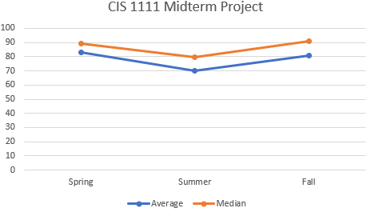  The results are as expected; the median is higher than the average since the average includes those students who did not submit a midterm. They didn’t withdraw from the class they just stopped submitting assignments. The scores during the summer tend to be lower since 16 weeks worth of content is fit into a 12-week term. Students still need to cover the same material and do the same assessment but in a short period.
Cultural Diversity and Global Awareness | All programs |  | CIS1140 has paper to research an ethical topic However, we fell it did not assess cultural diversity and global awareness it was more ethics topic.
Computer Literacy | All programs | CIS1107 is an Introduction to Operating Systems Class. This class discusses many computer literacy concepts. Including week 10’s discussion on Connecting to the internet and Working with Internet Clients.  CIS 1140 assigns a paper to research an ethical topic in Information Technology. | CIS 1107  118 section of CIS1107 has ran since Fall of 2015 through Spring of 2018. With a random selection of six classes there was a 90% success rate in the Working with Internet Clients quiz. This class was rebuilt in Fall 2016 to incorporate the newest internet browsers and standers.  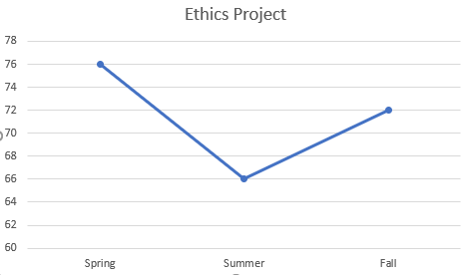  CIS 1140  The project is broken into four parts and covering a range of topics that bring cultural diversity issues to the forefront. There are four parts to the project. Students work on the project all term.
Information Literacy | All programs | In CIS 2170 the discussion forum on keeping current with technology measures information literacy in 2170. Students either earn full credit (if they participated) or zero (if they did not participate)  In CIS 1111 students explore Sinclair’s career services and then research a company they want to work for. The students who do the assignment do very well. It is an assignment they enjoy doing. | 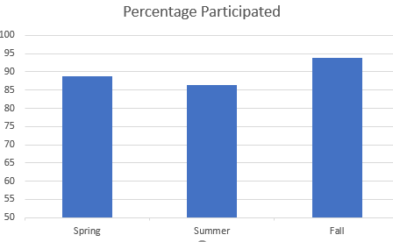  Students enjoy researching and sharing how to keep current with technology. To improve this assignment, detailed grading guidelines could be incorporated into the assessment.  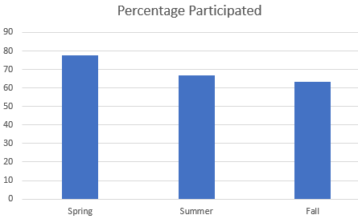  The participation rate is disappointing. For those who did submit the assignment the average grades for Spring, Summer, Fall was 87.22, 100, and 100. The median grade was 100.
Oral Communication | OPTIONAL | Oral Communication Rubric | The department is glad that the data is reported on. Data shows that we are meeting the three criteria at 100% which exceeds Sinclair’s overall rating. However, data is only for two students. Looking forward to future reports.
Written Communication | OPTIONAL | Written Communication Rubric | The students are preforming at B+ or higher level in the written communication components.
Are changes planned as a result of the assessment of general education outcomes? If so, what are those changes? | The department needs to educate faculty on general education outcomes and how to measure them. We could do this by having the faculty attend the Curriculum and assessment track offered by the CTL or other assessment offerings.
How will you determine whether those changes had an impact? | The faulty would be able to gather and assess general education outcomes.
The Program Outcomes for the degrees are listed below. All program outcomes must be assessed at least once during the 5 year Program Review cycle, and assessment of program outcomes must occur each year.
Program Outcomes | To which course(s) is this program outcome related? | Year assessed or to be assessed. | Assessment Methods  Used | What were the assessment results?  (Please provide brief summary data)
Apply medical terminology and other common healthcare language in the delivery of customer service, project planning, and project completion in the information technology business environment. | HIM 1101 Medical Terminology | 2015-2017 | This course continues to enroll over 1,000 students each academic year as it is incorporated in many program curricula. We attribute the 2014-15 “dip” to the LMS implementation of eLearn from ANGEL; students were new to eLearn plus we revised 50% of the assignments during the LMS implementation. We made a few assignment adjustments in the course and the success rate increased to the typical success rate | 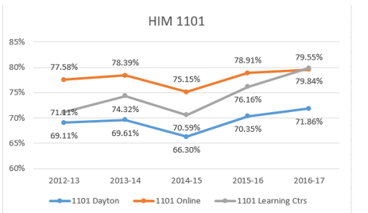  Another statistically interesting observation in this course: online students show a typical 5%-8% increased success rate over on-campus students. Student feedback provides no indication for this difference in success rates and we cannot determine a cause for this difference. (Note: the course utilizes exactly the same assignments and exams in the classroom sections as online sections, and all assessments and exams are completed online and not proctored for both groups.)
Apply policies and procedures concerning release of medical information, protecting patient confidentiality, HIPAA regulations and ethical issues in healthcare settings. | HIM 1204 Medicolegal/Ethics in Healthcare Records | 2015-2017 | Note: this class is not in our department. Health Information Management (HIM) Department supplied the information. The outcome is from the HIT.ATS transfer degree.  This is a Transfer Agreement Guarantee (TAG) course, and therefore the learning objectives are set by the Ohio Department of Higher Education (ODHE). The varying degree of success rates for on-campus students is due to low enrollment (only one on-campus section is run per year. It is 50% of the time run as independent study), so one non-success student dramatically skews the data. (Note: non-success results typically reflect non-cohort students are taking the course.) | 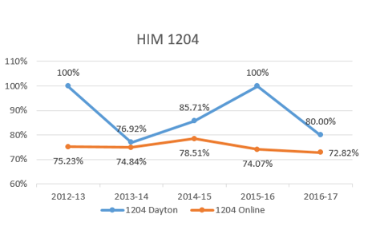  Based on the adjunct instructor and student feedback, we are continuing to increase learning resources to engage online learners. Results and adjustments will continue to be monitored.
Apply programming, database, operating systems and business application skills to solve and troubleshoot business and information technology problems related to the area of concentration. | CIS 2165 | 2016 | Database project that consisted of 7 assignments. The culmination was a well thought out database.  The course coordinator will be updating content which should result in higher mastery of the outcome. | 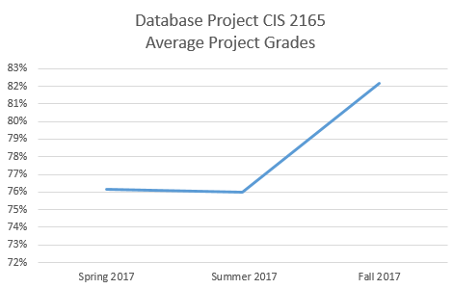  The average score on the final project increased Fall 2017.  What did you learn?  During the summer the course coordinator revised the course and added additional videos.
Configure client and server machines, using a variety of operating systems, to exist in a networked environment with the highest possible degree of security. | CIS 2640 | 2016 | Lab 5 Incident Response Procedures measures whether students have mastered the outcome.  Note the course was revised for 2017 to meet the requirements of the National Center of Academic Excellence in Cyber Defense application. | 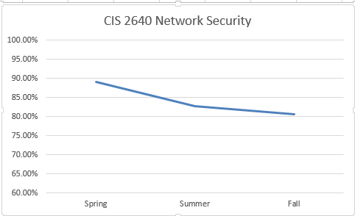  The graph represents Spring, Summer and Fall of 2016.  What did you learn?  That student need additional hands-on activities to master the outcomes.
Configure routers and switches and networks, troubleshoot network components and connections. | CIS 1411 and CIS 2426 | 2016 | CIS 1411 Final Hands-on Skills Exam  CIS 2426 Final Hands-on Skills Exam  Direct (Labs & PTs),  Indirect (Course Feedback & Student Survey), Formative (Chapter Tests), Summative (Final Exam),  Comparative | 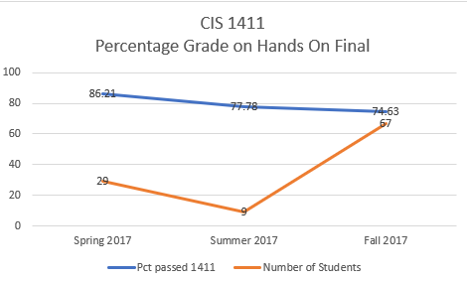  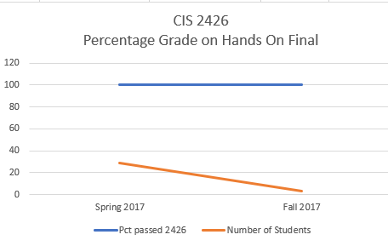  What are your current results?  Enrollment in the Network Engineering program declined thus the number of students in the upper-level class was very low. The department has worked to increase the numbers by revising the curriculum and offering times when students are available. The decline in test scores was address spring 2018. There were inconsistencies in the assessment given by faculty.  The department is satisfied with the percentage of success in CIS 1411. It is the first of 4 classes in the network engineering program. It is expected that once a student has completed the first three courses that they will be successful in the last course (CIS 2426).
Demonstrate ability to research, select, use and troubleshoot hardware and network components or connections appropriate to area of concentration. | CIS 2731 | 2016 | Test Out scores. The department subscribes to a testing service. The test assesses the same objectives of the A+ exam | 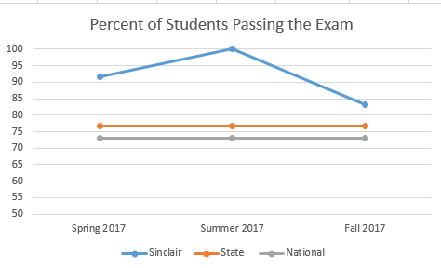  What did you learn?  Our students did better than the state and national average pass rates for 12 month period
Diagnose and prescribe solutions to hardware, networks and operating systems problems. | CIS 1130 | 2016 | The final exam for this course assesses the student's understanding of the core material. It includes multiple-choice sections to assess content learning and also a short essay section to assess a deeper understanding of the concepts and application of knowledge. | 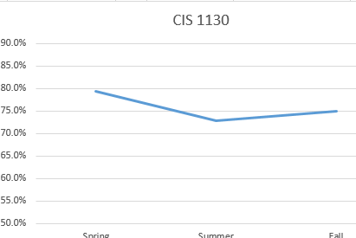  The graph represents final exam scores for Spring, Summer and Fall of 2016.  What did you learn?  To increase the scores, additional labs will be added to the course.
Demonstrate effective oral and written communication skills and teamwork skills in the delivery of customer service, project planning, and project completion in the information technology business environment. | CIS 2170 | 2016 | Student feedback forms.  We cannot use the Employer forms since most employers are very positive on the forms and most survey questions are scored 4 out of 4.  Hopefully, in a year, all feedback forms will be online. The department feels supervisors will give more critical feedback regarding their intern’s performance if they do not need to give it to the student to turn in. Supervisor feedback is shared with program coordinators. An improvement would be a formal method of relying information back to the department. | 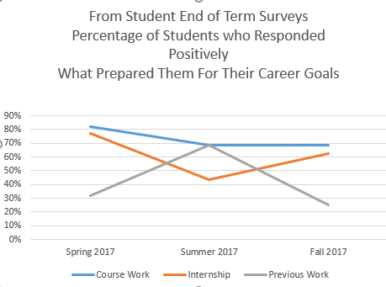  What did you learn?  The graph above shows student responses to the question of what prepared you to meet your educational and career goals.  Students are satisfied with the education they received at Sinclair. The internship instructor physically visits most of the internship sites. During the visit, the instructor meets with the supervisor alone. Qualitative feedback the instructor has received has been very positive. The supervisors feel Sinclair did a good job building a solid foundation of IT skills.
Design, document and implement computer software solutions given a definition of a problem and requirements for a solution. | CIS 1202 | 2016 | The assessment used is the midterm project. Students are required to design and code a program given a set of criteria. | 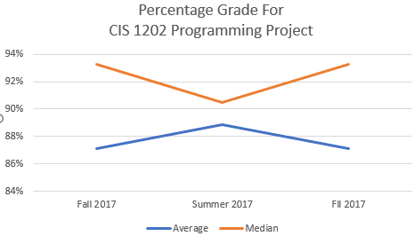  What did you learn?  Students did master the outcomes. The coordinator of the course will be updating content and assignments. This should increase the midterm project scores.
Manage and secure operating systems. | CIS 2640 | 2016 | Lab 5 Incident Response Procedures measures whether students have master the outcome.  Note the course was revised for 2017 to meet the requirements of the National Center of Academic Excellence in Cyber Defense application. | The graph represents Lab 5 scores for Spring, Summer and Fall of 2016.  What did you learn?  That student needs additional hands-on activities to master the outcomes. We had recently changed to a full Linux environment. Previously we were all Windows based. This created a new learning challenge to our students who are used to working in Windows based OS’s.
Design, document and implement computer software solutions and websites given definition of a problem and requirements for a solution. | CIS 1111 | 2017 | CIS 1111 midterm and final project have students identify a problem and then create a program to solve it.  Students program a problem every week. The midterm is different where the student needs to design everything from start to finish. Students are assessed via grading guidelines | 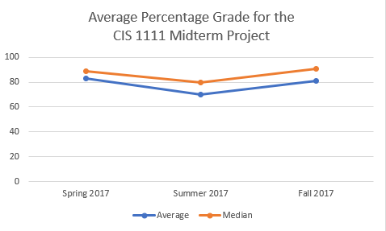  The median is higher than the average since the average includes those students who did not submit a midterm. They didn’t withdraw from the class they just stopped submitting assignments. The scores during the summer tend to be lower since 16 weeks’ worth of content is fit into a 12-week term. Students still need to cover the same material and do the same assessment but in a shorter period.
Design, document and implement computer software solutions given definition of a problem and requirements for a solution. | CIS 2170 Internship | 2016 | In the internship class students complete an end of term feedback form. In addition to the way the instructor for the course visits the internship site. Feedback from students and supervisors is then passed on to the course coordinators. For example, there was feedback that debugging skills are essential and need to be emphasized in our program. CIS 1202 now has a lesson on debugging. | What did you learn?  The graph above shows student responses to the question of what prepared you to meet your educational and career goals.  Students are satisfied with the education they received at Sinclair. The internship instructor physically visits most of the internship sites. During the visit, the instructor meets with the supervisor alone. Qualitative feedback the instructor has received has been very positive. The supervisors feel Sinclair did a good job building a solid foundation of IT skills.
Use operating system commands to manipulate files and directories and perform systems software troubleshooting. | CIS 2550 | 2017 | Assessment was performed using the midterm exam average score. The midterm is comprised of multiple choice questions that assessed the outcome. | 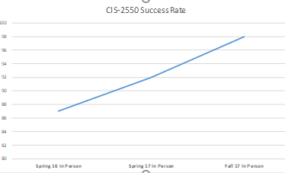  The numbers on the X axes is reflecting the percentage of midterm exam average score from Spring 2016 to Fall 2017.  What did you learn?  Further analysis should be completed for online classes. These changes reflect the increase of number of students taking the class. It also reflects the changes in curriculum to the adoption of Cisco Net Academy’s NDG Linux I. This better prepares students
Demonstrate creative and critical thinking skills in the analysis of digital crimes and cyber security issues, problem-solving strategies, research, analysis, synthesis, evaluation, assessment, adaption and application of computer forensic techniques. | CIS 2630 | 2015-2017 | Students complete a final written paper that demonstrates their understanding of the course information through critical analysis of a real world scenario. | 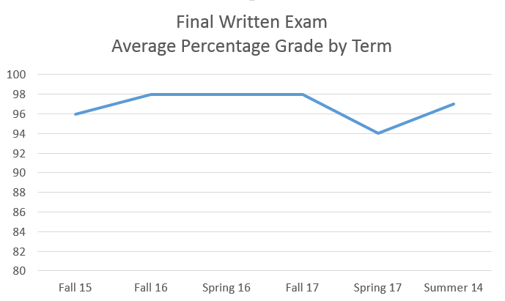  What did you learn?  Student understanding of the material varies a little by class but overall students do well at the end of the course on the real world assessment.
Demonstrate the manner of evidence collection consistent with standard criminal justice chain of custody. Develop programs, databases and business techniques to identify and/or resolve cybercrimes, including the development of plans for incident analysis and avoidance. | CIS 2640 | 2017 | Chapter one's key points cover who attackers are and different legal issues around attacks and defenses. This section also references Appendix C of our text that outlines many different security organizations and legal information. Students complete | In CIS 2640 Lab 1 90% of students were able to demonstrate Implement security configuration parameters on network devices and other technologies and implement common protocols and services.  This section also has a quiz that covers evidence handling.
Demonstrate the manner of evidence collection consistent with standard criminal justice chain of Display professional oral and written communication skills and collaborate with a team to deliver and implement a project plan in the business and criminal justice environment to address cyber security problems. | CJS 2295 | 2014 and 2016 | Students completed written and oral assignments that lead to a final oral project presentation that summarized their semester experiences. | Spring: 14.SP.CJS.2295.Y06 CJS SEMINAR  Class average. Unknown at this time  Spring: 16.SP.CJS.2295.Y04 CJS SEMINAR  Class average: 91%. (only one student and online)
Demonstrate the manner of evidence collection consistent with standard criminal justice chain of evidence procedures to maximize prosecutorial effectiveness while minimizing legal defense challenges and legal liabilities. | CJS 2808 | 2016 and 2017 | Reading, quizzes, and other semester work lead to students demonstrating understanding in Final Practical assignment. | Class Average: 98.25 (final grade)
Demonstrate the process to find and recover data artifacts present, deleted or hidden to preserve the verifiable integrity of digital evidence. | CJS 2808 | 2016 and 2017 | Student lab work culminated in a Final Practical assignment to demonstrate understanding. Students learn how to install, configure, and maintain the use open source and commercial digital forensic tools. | Spring - 16.SP.CIS.2808.N01 INTRO COMPUTER FORENSICS  Class Average: 93.16 (Final Grade)  Spring - 17.SP.CIS.2808.N01 INTRO COMPUTER FORENSICS  Class Average: 98.25 (final grade)
Diagnose and prescribe solutions to hardware, networks, and operating systems problems. | CIS 2510 | 2015 and 2017 | Students complete project work, labs, and several exams. The final exam is over most class concepts and includes multiple choice questions and a hands-on portion to assess usable knowledge. | 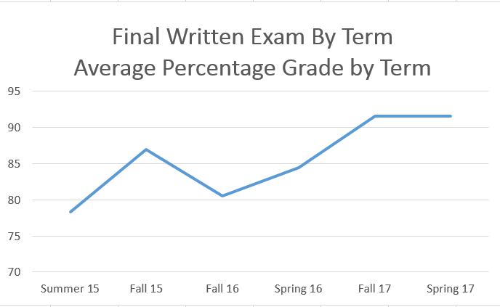  What did you learn?  Student understanding of the material increased over time. This class was redesigned right before the review period. So 2015 student was the first to try it. As students and instructors became more familiar with the expectations, performance improved.

Section III: Overview of Department
- Mission of the department and its programs(s)
What is the purpose of the department and its programs? What publics does the department serve through its instructional programs? What positive changes in students, the community and/or disciplines/professions is the department striving to effect?
The purposes of the CIS Department and its Programs are:
To educate, instruct and train students in the art, science and technology of (1) working with – investigating, securing, engineering, managing, administering, developing, supporting, maintaining, and networking – computer information systems and (2) promoting human and institutional users of computer information systems to help them attain their professional and personal academic and career goals.

Does your department have any departmental accreditations or other form of external review?
____X____ Yes ________ No

If yes, please briefly summarize any commendations or recommendations from your most recent accreditation or external review. Note any issues that the external review organization indicated need to be resolved.
Currently, the department has a designation with the national security administration and the Department of Homeland Security. This designation is a center of academic excellence in cyber defense. The CIS department went through a six-month review process for this designation and received a designation award in November 2017 at the National Institute of Standards and Technology Conference in Dayton Ohio.

Section IV: Overview of Program
- Analysis of environmental factors
Based on your discussion with the Assistant Provost in the Environmental Scan process, how is the department responding to the (1) current and (2) emerging needs of the community? The college?
- The CIS department relies heavily on its relationships with the business advisory teams. Most of the relations of the business advisory teams go beyond our team meetings. Many members of the department meet with multiple companies throughout the year whether it is through site visits or internships the CIS department stays connected to the community. Many business advisory team members will stop in the CIS Department for lunch or coffee many times throughout the year. The Faculty is also attending multiple conferences that happen throughout the Dayton and Cincinnati areas involving technology. Technology First is an excellent organization that the CIS Department is a part of and they hold weekly meetups and conferences throughout the Dayton area.
- The department has excellent relationships with area universities and institutions. These relationships are fostered by the faculty members of the CIS Department staying in close connections with other faculty members and chairs at other schools. Many of the faculty members serve on committees along with these other universities. This relationship has helped further Sinclair’s partnerships when it comes to ensuring that classes are aligned. Most of our local partners will even inform the CIS Department if they make any changes to a class so that we can make the proper adjustments so the credits will transfer.
- By staying involved with business advisory teams and local technology collaborators such as Technology First and Southwestern Ohio Council for Higher Education, the CIS Department can ensure that they are programs meeting the emerging needs of the Dayton region.
- Due to the rising costs of textbooks, the CIS Department has actively started the process of changing multiple classes to open educational resources. Open educational resources will help lower the cost of an overall education at Sinclair Community College.
- Most classes in the CIS Department are updated every three years keeping up with the change industry certifications.

- Department Completion Plans
Below are five milestones that are highly predictive of students graduating in a timely manner.
- Students solidify their choice of major within the first or second term
- Students receive a MAP to completion within the first or second term
- Students complete a college-level Math and English class within the first year
- Student take 30 credits within the first year, including summer
- Students take nine credits in their major area of interest within the first year, including summer
Please describe any work the department has done over the past five years which may have impacted these milestones.

- The CIS Department has heavily involved in the Competency-Based Education Competency-based curriculum which permits students to demonstrate attainment of competencies on a flex-paced schedule rather than the traditional 16-week college semester. This allows students to complete more classes in the 16-week program.
- Embedded in all CIS degrees is a core five classes consisting of a short-term certificate. The classes touch on each degree path in the CIS Department. Once a student takes these classes most students have identified with a major.

What specific strategies or plans does the department have to help more students achieve one or more of these milestones?

- The CIS Department runs about all 32 classes in the department either face to face, online or CBE. If there is a class that is needing to help students graduate that is not offered the class the class is normally ran as an independent study.
- The CIS Department is currently the developmental stages of developing more class to online and CBE platforms. This will help convert entire CIS degrees to online.

Section V: Department Quality

PLEASE REFER TO THE DATA BELOW IN RESPONDING TO THE QUESTIONS IN THIS SECTION OF THE SELF-STUDY

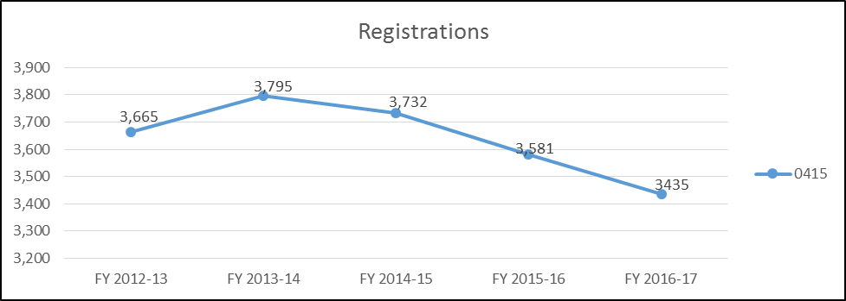

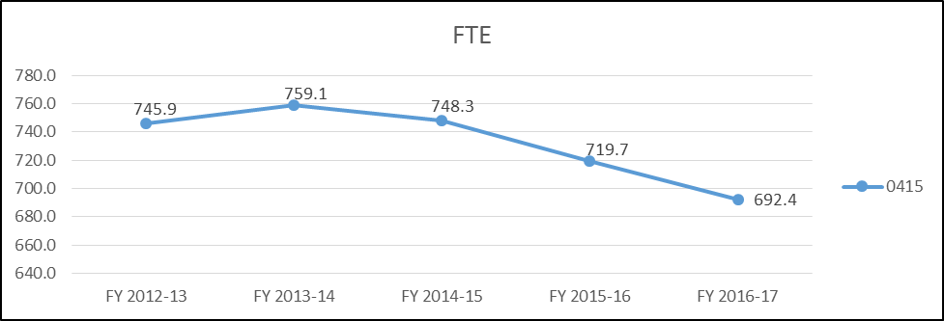

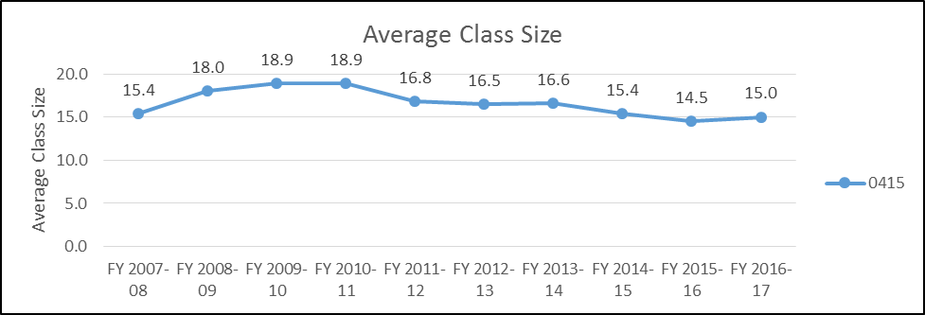

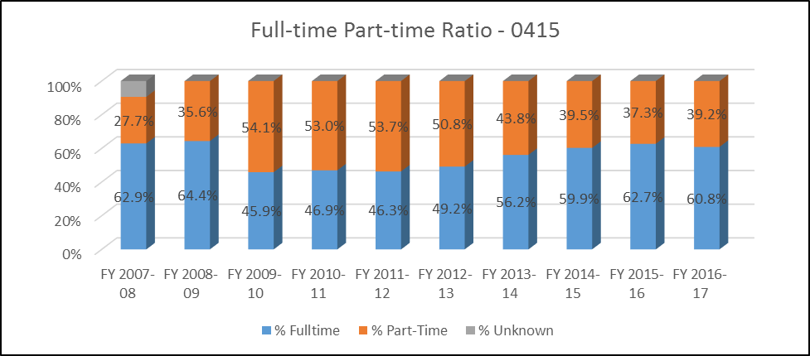

- Evidence of student demand for the program
How has/is student demand for the program changing? Why? Should the department take steps to increase the demand? Decrease the demand? Eliminate the program? What is the likely future demand for this program and why?

- All major employers in the Greater Dayton Region need for IT technicians to work in network engineering, secure system administration, software development, user support, web development, and cyber investigation. Major regional employers hiring IT technicians include Wright-Patterson Air Force Base (Department of Defense and military contractors), four major hospitals (including a large VA Medical Center), LexisNexis (provider of legal, government, business and high-tech information sources), major banks, and manufacturing (automotive, climate control, basic steel). Regional employment projections demonstrate extensive growth potential for IT technicians. In an eight-county area directly surrounding Dayton, Ohio, there are 21,295 IT jobs, with a projected 17% (3,655) increase expected through 2026. In addition to the 3,655 new jobs that will be created, the existing jobs will become vacant in record numbers as the Baby Boomer population is expected to retire before 2026 (EMSI, 2017). Please see table in appendix A3.

- The table below shows the growth expected in 16 IT occupations. Software Developers have the highest projected growth (39%), and Information Security Analysts and Web Developers show a significant projected increase (24%) (EMSI, 2017). Please see appendix A1.

- In addition to the anticipated growth of IT jobs in the Dayton area, another indicator of the need for highly prepared IT graduates is the high location quotient in the three largest of the eight counties surrounding Dayton. The location quotient quantifies how concentrated a particular occupation is in the Dayton region as compared to the nation. Location quotients over “1” indicate that this occupation is more prevalent in our region than the national average. For example, the number of IT jobs in Greene County, Ohio is over 1.5 times more concentrated in the Dayton region than the nation as a whole (EMSI, 2017). Please see table in appendix A4.

- Evidence of program quality from sources outside of the department (e.g., advisory committees, accrediting agencies, other departments on campus, transfer partners, etc.)
What evidence does the department have about evaluations or perceptions of department/program quality from sources outside the department? Who are your stakeholders, and what feedback are you receiving from them about program quality?

- Our stakeholders include employers, internship site providers, advisory committee members, and grant providers. Over the last five years, we have placed students on 193 internship sites. Please see appendix A2.
- The department has several advisory committees that focus on specific skill sets. This allows each committee to focus on certain skill sets. The committees have been very instrumental in identifying career areas and technology trends.

- Evidence of the placement/transfer of graduates
What evidence does the department/program have regarding the extent to which its students transfer to other institutions? What evidence does the department have regarding the rate of employment of its graduates? What data is available regarding the performance of graduates who have transferred and/or become employed? What data is available from RAR graduate surveys?
Please review appendix A5 and A6.
- The summary of the employment questions from the Recent Graduate Survey. 54 students responded to the survey. Please see table in appendix A5.
- The department has articulation agreements with Wright State, University of Cincinnati, Western Governors, and Franklin University. The department is currently working on a one-year certificate with UD.
- 394 Sinclair CIS students transferred to Wright State University in the last two year (2016-2017). Compared to 58 Sinclair CIS students transferring to University of Cincinnati. The transfer data for students from 2011-2015 is summarized in appendix A6.
- Keep track of student through the LinkedIn Alumni group.

- Evidence of the cost-effectiveness of the department/program
What is the department doing to manage costs? What could additional efforts be made to control costs? What factors drive the costs for the department, and how does that influence how resources are allocated? What has the Average Class Size been for the department since the last Program Review, and what are steps that the department could take to increase Average Class Size? If Average Class Size has decreased, what is the explanation?
- Most travel is funded outside of the department and college. Other organizations such as the National Security Agency, The National Science Foundation, and Moraine Valley Community College have all provided funding for travel.
- Grants from the National Science Foundation and the National Security Agency have been a big part of offsetting the cost to the CIS Department. The CIS Department is currently involved in five grants. These grants have offset the cost of equipment and program development by $433,143. We are also waiting on a response for another National Science Foundation Advanced Technical Education grant that will also provide $42,375 for instructional designers and $51,434 for a Navigator that will help with completion. Please see table in appendix A7.
- The contribution margin per FTE has been fluctuating for a few reasons. In the State, Subsidy SSI was remitted higher rate in 2014 and 2015 than 2016 and 2017. Even with all of this happening we are still up $1097 per FTE compared to division average over the past years five years. See Appendix A8
- The CIS Department had a few senior employees staffed at a higher cost, and we were down one Faculty members in 2017. Now the CIS Department is staffed at the right levels. See Appendix A8.
- The CIS Departments tend in Average Class size has been impacted by the offering of the online Competency Based Education (CBE) classes in last 3 years.

Section VI: Department/Program Status and Goals
- List the department’s/program’s strengths, weaknesses, opportunities, and threats (SWOT analysis).
Strengths

- The number of students doing internships has increased. Our internship site supervisors are happy with how well students performed during the internship.
- Our Advisory Committees provide valuable feedback regarding our curriculum and help us judge when we should upgrade coursework.
- We have been successful in winning grants.
- Our relationship with Tech Prep. One of our faculty members, our Tech Prep liaison and faculty, facilitate demonstration sessions to high school students, and many of the faculty are judges for the Tech Prep Showcase every spring term.
- The department has been very instrumental in initiating articulation agreements with local universities.
- The department maintains a LinkedIn group for alumni and internship students. Currently, there are 214 members
- We have a good relationship with our Academic Advisors
- Our Software Degree Advisory Committee is very active and have provided essential feedback
- Our connection with Sinclair Information Technology Services (ITS) has produced a source for qualified adjunct instructors, and they have also for donated retired equipment for classroom use.
- Our Faculty is second to none. Most have industry experience and are leaders in their fields.
Weaknesses

- Not all our degrees have influential advisory committees.
- Students are sometimes not prepared to enter our programs; there is currently, there isn’t a good way to test student’s IT knowledge quickly.
- We do not track most of our graduates. We use our LinkedIn Group to see where students are working but not everyone uses LinkedIn.
- We are limited in what we can do in a class on campus due to constraints placed on us by Sinclair’s Information Technology Services (ITS).
- Facilities and equipment are lacking for most of our programs. We significantly lag behind other leading community colleges in those areas.
- 60% of the faculty in the department have been here four years or under.

Opportunities
- Expand our curriculum to include a Computer Science Applied Associates of Science degree
- Build out our cybersecurity curriculum to incorporate more certifications
- Expand our mobile development curriculum
- Work closely with Workforce Development to provide training for professional development
- Encourage all CIS students to join our LinkedIn Group
- To create an entrance exam to help identify student’s skill level
- Host Meetups connected to our degree programs.
- As the 60% of faculty who have been here four years or under continue to grow they will be able to take on new leadership type responsibilities.

Threats
- The number of grants the department has could be disruptive to the curriculum development and teaching.
- IT is changing so rapidly - can we keep up
- There are so many new pieces of technology we can't cover them all.
- Online competition for Technology degrees is growing.
- Our University partners are starting to encroach on our high schools and career centers.

- What are the department’s/program’s goals and rationale for expanding and improving student learning, including new courses, programs, delivery formats and locations? Are there unmet goals from the most recent Program Review? Please note that the department goals listed in this section will be reviewed for progress on Annual Updates and in your next Program Review.

- Our programs need to match the jobs opportunities and technology trends happening right now. We need to be flexible and adaptive to be able to provide classes that are timely, relevant, and useful to current job-seeking students.
- The CIS Department is currently in the developmental stages of developing more class to online and CBE platforms. This will help convert entire CIS degrees to online.
- The CIS Department host a Hackathon every year with AT&T. This hackathon brings in area high schools that help solve issues with the use of innovative technology innovations
- The Computer Information Systems (CIS) Department has submitted to the state of Ohio a new degree, Data Analytics. The department designed two new courses for the new degree: CIS 2265 Data Visualization and CIS 2266 Data Analytics using Scripting Language.
- The CIS Department is building a true Computer Science AS. This will help students transfer to other colleges especially for students wanting to continue in a computer science related field.

- What resources and other assistance are needed to accomplish the department’s/program’s goals?
- The CIS Department needs coordinators to help strengthen all the current and future department expectations.
- Reassigned time for open labs.
- More resources provided to the eLearn department to help with the upkeep and building of our classes.
- Can the college and IT Department support services provide what we need to provide the innovative and high technology programs that industry and students want? Can our facilities, equipment, and priorities keep up?

Section VII: Appendices: Supporting Documentation

A1

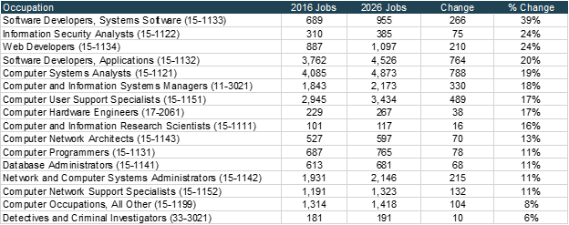

A2

Academic Year | # CIS Interns | # Unique CIS Intern Employers | % CIS Interns who were paid | Average hourly wage | Average hours worked per week
2016-2017 | 72 | 72 | 85% | 12.81 | 28
2015-2016 | 73 | 73 | 88% | 13.38 | 27
2014-2015 | 88 | 88 | 70% | 14.49 | 28
2013-2014 | 68 | 68 | 59% | 12.34 | 25
2012-2013 | 42 | 42 | 31% | 14.57 | 23

A3

2016 Jobs | 2026 Jobs | Change (2016-2026) | % Change (2016-2026)
21,295 | 24,950 | 3,655 | 17.2%

A4

County Name | 2016 Jobs | 2026 Jobs | 2026 Location Quotient
Greene County, OH | 3,901 | 4,568 | 1.55
Warren County, OH | 3,603 | 4,551 | 1.20
Montgomery County, OH | 8,226 | 9,113 | 1.03

A5
INCLUDEPICTURE "https://lh5.googleusercontent.com/MRglOQX0Wx8hp_vY5nkvGHvYGQSAUoexR-BoQgkfwSZoLcCuZdZETBBQLkv2MJUZC5Jq257j-TuMZ75rpv3symLMpS5LQYBi2P5iEA4xuk9w2Ix6l9Y15elVgRrpMvv1_B8FCmjs" \* MERGEFORMATINET 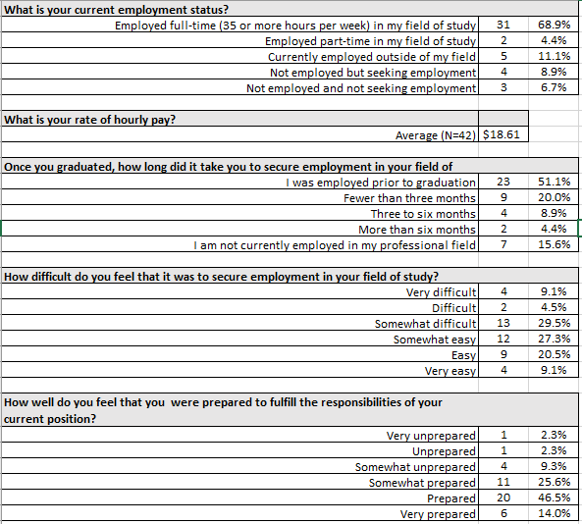

A6
INCLUDEPICTURE "https://lh4.googleusercontent.com/-TIs4t-dxnNQYKOMG-00CEXl5G0OLeEyrqdIezWjkrWUTCnOKvqimtRmCx0amTPvUVV6VofRZY2kiw-CVezdyI6iEnrfxvLVh6GUhj6q84hyKGf9lEI2L0xmNX2f0A2L0yh3Dv0B" \* MERGEFORMATINET 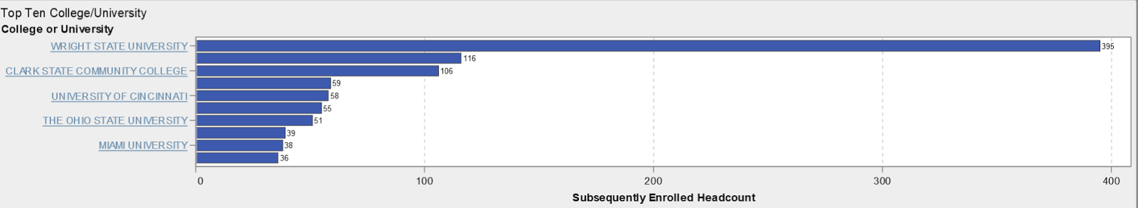

A7
INCLUDEPICTURE "https://lh3.googleusercontent.com/ndQd8rcU3A2T6pVjFMy6FWpd9Kb7XDTipvnjJNiehBTp324g7nCGraw7iqaIAd2iYbhtTiaGd4UveuguJXBx3yWVVfQyOdAr5pUSK_UTz-oMnXDiR2XI_v8OYlhsRpN8UbRBEa0a" \* MERGEFORMATINET 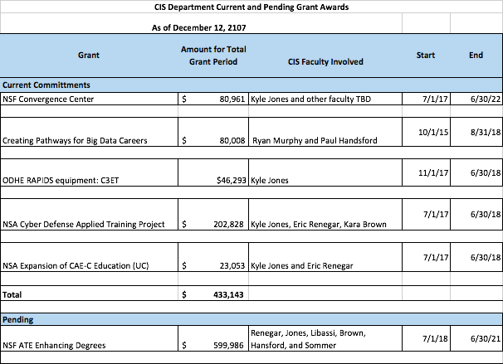

A8
Department | 0415: CIS
Division | Business and Public Services
Table 1: FTE (Annualized) | FY 2014  Actual | FY 2015  Actual | FY 2016  Actual | FY 2017  Actual | FY 2018  Projected | FY14 - FY18  Change
FTE - Department  FTE - Division | 425.7  2,176.0 | 357.5  2,429.8 | 380.4  2,668.9 | 375.8  2,740.7 | 361.2  2,616.9 | -64.4  440.9
Table 2: Revenue per FTE | FY 2014  Actual | FY 2015  Actual | FY 2016  Actual | FY 2017  Actual | FY 2018  Projected | Annualized  Chg.
Department  Division | $ 8,267  $ 6,207 | $ 7,791  $ 6,342 | $ 7,622  $ 6,583 | $ 7,503  $ 6,738 | $ 7,407  $ 6,787 | -2.7%  2.3%
Table 3: Expense per FTE | FY 2014  Actual | FY 2015  Actual | FY 2016  Actual | FY 2017  Actual | FY 2018  Projected | Annualized  Chg.
Department  Division | $ 3,605  $ 3,449 | $ 3,911  $ 3,811 | $ 4,022  $ 3,954 | $ 4,206  $ 4,068 | $ 3,970  $ 3,982 | 2.4%  3.7%
Table 4: Contribution Margin per FTE | FY 2014  Actual | FY 2015  Actual | FY 2016  Actual | FY 2017  Actual | FY 2018  Projected | Annualized  Chg.
Department  Division | $ 4,662  $ 2,758 | $ 3,880  $ 2,531 | $ 3,600  $ 2,629 | $ 3,297  $ 2,670 | $ 3,437  $ 2,805 | -7.3%  0.4%
Table 5: Student FTE per Full-time Faculty FTE | FY 2014  Actual | FY 2015  Actual | FY 2016  Actual | FY 2017  Actual | FY 2018  Projected | FY14 - FY18  Change
Department  Division | 39  40 | 32  43 | 35  48 | 38  52 | 36  51 | (3)  11
Table 6: Faculty Ratio (Actual)* | FY 2014  Actual | FY 2015  Actual | FY 2016  Actual | FY 2017  Actual | FY 2018  Projected | FY14 - FY18  Change
Department
Full-time  Part-time | 67.0%  33.0% | 66.0%  34.0% | 68.1%  31.9% | 60.5%  39.5% | 65.1%  34.9% | -1.9%  1.9%
Division
Full-time  Part-time | 47.9%  52.1% | 48.2%  51.8% | 48.9%  51.1% | 47.0%  53.0% | 48.7%  51.3% | 0.7%  -0.7%
Table 7: Reassigned Hours (Semester Basis)  (Annual Recurring) | FY 2014  Actual | FY 2015  Actual | FY 2016  Actual | FY 2017  Actual | FY 2018  Projected | FY14 - FY18  Change
Department Chair  Other Recurring | 32  - | 32  - | 32  - | 32  - | 32  - | -  -
Total | 32 | 32 | 32 | 32 | 32 | -
Table 8: Faculty FTE per Student FTE Ratio | FY 2014  Actual | FY 2015  Actual | FY 2016  Actual | FY 2017  Actual | FY 2018  Projected | FY14 - FY18  Change
Department | 0.0146 | 0.0268 | 0.0225 | 0.0262 | 0.0300 | 0.0153

