Sinclair Community College
Continuous Improvement Annual Update 2016-17

Please submit to your Division Assessment Coordinator / Learning Liaison for feedback no later than March 1, 2017

After receiving feedback from your Division Assessment Coordinator, please revise accordingly and make the final submission to your dean and the Provost’s Office no later than May 1, 2017

Department: BPS – 0401 – Business Administration
Year of Last Program Review: FY 2008-2009
Year of Next Program Review: FY 2016-2017

Section I: Progress Since the Most Recent Review

Below are the goals from Section IV part E of your last Program Review Self-Study. Describe progress or changes made toward meeting each goal over the last year. Responses from the previous year’s Annual Update are included, if there have been no changes to report then no changes to the response are necessary.
GOALS | Status | Progress or Rationale for No Longer Applicable
With the opening of the new off-site learning centers, traditional business courses found within the transfer degree are in high demand. Entry-level MAN and MRK courses are offered in both day and evening sections. Enrollment in these courses is typically strong. | In progress  Completed  No longer applicable | It is unclear what the goal is to be achieved, however offerings at learning centers are based on minimum student enrollment and the decision to offer a course at a learning center is determined by the learning center. In any case, all courses for this program are offered online. Upon checking all the courses in the transfer program, all but one course (MAT 2180) are offered at various learning centers (MAT 2180 is offered online). It appears that students are able to complete the degree courses through selections at all Sinclair campus locations and through online delivery.
Additionally, the entire BUS.AS degree is fully online, allowing program completion from anywhere in the world. There are some courses required prior to graduation by partnering institutions (WSU and UD) that are currently part of specific transfer requirements. Some of these courses are not yet online, but are in the process of development. By fall 2009 all of the Business courses accepted for transfer by specific institutions will be offered online. | In progress  Completed  No longer applicable | All courses for transfer are offered online. Student transfer to Ohio University’s BTAS program is robust. WSU transfer remains constant. Dual Admission agreements between both WSU and Sinclair and the University of Dayton and Sinclair, which allow students to concurrently enroll in both programs with seamless transfer, are underway.
As the BUS.AS transfer degree program becomes more highly marketed throughout the state of Ohio and as more incoming high school students select Sinclair for their first two years of study, enrollment in the Business program is likely to expand. Additionally, military personnel and their spouses is increasingly a larger market segment of the larger AAS business degree market. This demand can certainly be met via online learning. | In progress  Completed  No longer applicable | All courses in the transfer degree program are offered fully online.

Below are the Recommendations for Action made by the review team. Describe the progress or changes made toward meeting each recommendation over the last year. Responses from the previous year’s Annual Update are included, if there have been no changes to report then no changes to the response are necessary.

RECOMMENDATIONS | Status | Progress or Rationale for No Longer Applicable
A decision should be made about where the locus of responsibility will reside for this program in the future, with clear reporting lines identified within the division. “Ownership” for the continuing assessment and development of this program will be important to its ongoing success. | In progress  Completed  No longer applicable | The BPS divisional dean’s office owns the degree.
Measureable program outcomes should be developed, along with plans for assessing student learning for evidence that outcomes are being met. These outcomes should be consistent with the mission of the program and derived in part from transfer partners’ expectations. | In progress  Completed  No longer applicable | Program outcomes have been developed and are being measured through assessments in TAG courses.
The curriculum should be reviewed to ensure that it supports program outcomes and that the curriculum is well aligned with the first two years of the four year degree. | In progress  Completed  No longer applicable | The program outcomes have been approved and verified through several sources: partnering 4-year institutions, advisory board members, and internal faculty. Additionally, with the signing of articulation agreements with 4-year partners the curriculum is guaranteed to be well-aligned to transfer institutions.
The division is encouraged to evaluate the merits of developing a core curriculum for all Business degree majors, with assessment of learning outcomes implemented systematically in each core course, should a core be developed. | In progress  Completed  No longer applicable | During quarter to semester conversion, the BPS Leadership Team developed a core Business curriculum. The various Business departments included these core Business courses into their programs as appropriate. The assessment measures were developed in the department that owns the core Business course.
Communication plans should be developed to improve students’, parents’ and advisors’ understanding of transfer requirements at various four year institutions. There is currently a lack of understanding of the difference between the Business AS and AAS degrees, resulting in a number of students completing the AAS degree which does not lead to the baccalaureate, when the original goal was to transfer. | In progress  Completed  No longer applicable | This information is communicated at outreach opportunities, such as College, Tech Prep, and High School college and career fairs, and the division has worked with academic advisors to communicate this information to students.
Business faculty should collaborate with the Tech-Prep office to develop clear pathways for transfer to four year institutions. | In progress  Completed  No longer applicable | This has been accomplished through the completion of Pathway documents. Changes in the program are communicated to Tech Prep and reflected in updated Pathway documents.
As Business students who transfer to Wright State University generally have weaker analytic skills and more difficulty with quantitative courses than WSU native students, strategies to improve these skills should be developed. Such strategies might include advising students to take Math courses earlier in the sequence, requiring students to complete DEV courses, and establishing prerequisite courses for the major, if data support these measures. | In progress  Completed  No longer applicable | Various departments have ownership of these courses and have developed their programs to include all needed prerequisites and timing of completion of Math courses. Students make their choices as to when to complete courses in a program regardless of how they are sequenced in the program by the departments.

Section II: Assessment of General Education & Degree Program Outcomes

For the FY 2016-17 Annual Update, departments are asked to provide assessment results for Information Literacy.

General Education Outcomes | Year assessed or to be assessed. | Course identified by the department where this outcome could be assessed | Assessment Methods  Used | What were the assessment results?  (Please provide brief summary data)
Information Literacy | 2016-2017 | NO COURSE PROVIDED | Marketing Plan  In MRK 2101 | Waiting on data from MAN/MRK Department. Not received as of 4/18/17
NEXT YEAR:
Computer Literacy | 2017-2018 | NO COURSE PROVIDED

The Program Outcomes for the degrees are listed below. Responses from previous years are provided below. All program outcomes must be assessed at least once during the 5 year Program Review cycle, and assessment of program outcomes must occur each year.

Program Outcomes | To which course(s) is this program outcome related? | Year assessed or to be assessed. | Assessment Methods  Used | What were the assessment results?  (Please provide brief summary data)
Apply problem-solving skills to mathematical and business problems. | MAT 2160, MAT 2170, MAT 2180, ECO 2160, ECO 2180  ACC 1210  ACC 1220 | 12/FA-13/SU | This data is based on ACC 1220 Financial Statement Analysis Project. | 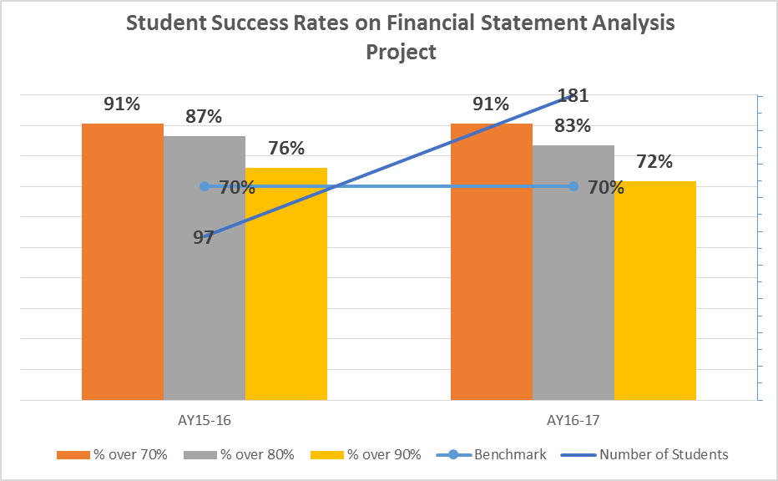  What are your current results?  The chart above reflects that at a minimum 91% of students performed at the minimal acceptable level of 70%. Analysis of the data indicates there are three financial ratios where students performed below 70%. During fall 16, the face-to-face sections added a homework question for the Times-Interest-Earned ratio and did examples in the classroom with students. The success rate went from an average of 61% to 66%. For the Horizontal Analysis ratio, again we made sure there was a homework question and we covered the calculation in the classroom with the students. This ratio showed very little change. The Days Sales in Inventory ratio went from an average of 82% to an average of 55%. Further analysis shows the overall average on the Financial Statement Project for Online sections is 87%, in the face-to-face sections the overall average for MW day sections is 78%, for TR day sections is 89%, and for the evening sections it is 81%. Data in AY15-16 included only online sections, as the Financial Statement Project was not assigned in the face-to-face sections. Beginning AY16-17 the project was assigned in the face-to-face sections.  What did you learn from the results?  The students use an Audited Financial Report for a publicly traded company to compute the financial ratios. In the classroom and in homework, students use a very basic Balance Sheet and additional information to compute the financial ratios. The course will be updated during summer 2017, at that time maybe we can use financial reports for the financial statement project similar to what we use in the classroom and for homework. Then check the data to see if this has an impact.
Apply basic application software skills, file management skills and information research and evaluation skills to business problem solving. | BIS 1120, MAN 2150 | 12/FA-13/SU |  | I am currently having conversations with BIS to determine what activities are done in BIS 1120 to satisfy to basic application software skills and file management skills. Students are not solving business problems. There isn’t any information research and evaluation skills used in BIS 1120.  May need to use the MRK 2101 marketing plan as it is being used to assess information literacy general education outcome.  4/4/17 I met with Jenn Day and Jennifer Romero (BIS faculty who teach BIS 1120) and we looked at data in CengageNow – Pre-Test and Post-Test will be gathered for the four software applications but there isn’t anything for information research and evaluation skills nor for file management skills.
Apply written and verbal communication skills to business applications, including teamwork activities and delivering oral and written presentations. | BIS 1120, MAN 2150, COM 2211, MRK 2101, ENG 1101, ENG 1201, ENG 1131, SCC 1101, LAW 1101, MAN 1107  Arts and Humanities Electives,  Natural Science Electives  Social/Beh Elective | 12/FA-13/SU | This data is based on Marketing Plan developed in MRK 2101. | Students in MRK 2101develop a marketing plan that is used to assess this specific program outcome. The chart above shows that through 15/SP, 93% of students performed at the minimum acceptable level of 70%. Discussion will occur to determine what happened to cause a decline in student performance.  Waiting on updated data from MAN/MRK Department. Not received as of 4/18/17.  Do students do any oral presentations of the marketing plan? Do students do any teamwork?

Are changes planned as a result of the assessment of program outcomes? If so, what are those changes? | Not at this time.
How will you determine whether those changes had an impact?

OPTIONAL:

Please use the space below to keep track of any annual data that your department wishes to maintain. This section is completely optional and will not be reviewed by the Division Assessment Coordinators.

