Department/Program Review
Self-Study Report Template

2025 - 2026

Department: 0375-Psychology
Section I: Innovations and Accomplishments
In the space below please briefly discuss the most noteworthy department innovations and accomplishments in instruction, curriculum and student learning over the last five years. This section should be used for department accomplishments – please provide summary totals for any individual awards. If you wish to list individual faculty accomplishments, please do so in the Appendix.

Responses for this section should not exceed two pages.
- In the last five years, 494 students have graduated with associate’s degrees in psychology with an average of ninety-nine graduates each year.

- Since 2017, every section of General Psychology (PSY 1100) has used open educational resources (OERs). Collectively, Sinclair students have potentially saved over 1.6 million dollars in General Psychology textbook costs in the last five years alone. In addition to General Psychology, all sections of Abnormal Psychology, Drugs and Behavior, Social Psychology, Research Methods, and Behavioral Science Statistical Methods use OERs. Since the last program review Personality Psychology has also converted to the use OERs. Lifespan Psychology is currently being redeveloped with OERs after receiving an OhioLINK OER Course Redesign Grant in fall 2025.

- Since the last program review additional courses have been developed for online delivery including Principles of Counseling and Industrial/Organizational (I/O) Psychology. Twelve program courses are currently offered in an online format. Behavior Modification is currently on the schedule for online development in fall 2026.

- General Psychology classes gathered data for the Cultural Diversity Global Citizenship (CDGC) and critical thinking general education outcomes for programs across campus. Standardized assessments were revised. Currently, the CDGC and critical thinking general education assessments are included in all sections of General Psychology. We are currently incorporating artificial intelligence (AI) assessment into the critical thinking rubric.

- At the time of the last review all General Psychology Prison Education Program (PEP) sections were taught virtually. Currently all sections are in-person classes. The curriculum has also been dramatically improved and is now tailored to the students and setting.

- The department has included additional career-focused programming for psychology students. In addition to our annual Next Steps Program, we also collaborated with the Social Work and Behavioral Health Departments to offer career fairs focused on employment in behavioral and community mental health. In fall 2025, the department was chosen to take part in the President of American Psychological Association (APA) Engaging Psychology’s Future initiative and will host a Psyched for Success event in spring 2026 for high school and community college students.

- Despite a lack of funding, significant improvements were made to the Psychology Laboratory in 4211 since the last review including converting a storage room into a testing/interview room and updating student computers in the room. In coordination with Psychology Club and Behavioral Research Methods and Statistics classes, psychology students have participated in undergraduate research opportunities through the APA and in coordination with other colleges.

- The department continues to have a very engaged student club and honors society on both the main and Courseview campuses. For example, faculty and Psychology Club and Psi Beta students participated in field trips (e.g., the Behavioral Science Museum in Chicago in fall 2025); fundraising events; the Ohio Undergraduate Psychology Research Consortium; Trick or Trunk events; and community programs (e.g., the Dayton Out of Darkness Suicide Walks).

- The Department has increased the amount of student programming offered. In addition to Colloquiums on timely and in demand topics like “Gender and Society,” the annual “Psychology Program Orientation” and “Next Steps” programs, the department has begun hosting additional career exploration opportunities and social events like a welcome back pizza party and finals week destress events.

- Since the last program review, the Department has implemented plagiarism practices and recommendations including an academic integrity inquiry letter template for faculty to use when communicating with students about instances of suspected plagiarism. The Department has also developed late policy recommendations (Appendix F).

- There has been an increase in the number of sections of the Psychology Internship/Service-Learning course. Students have completed variety of experiential learning experiences including internships; job shadowing experiences; research projects and service-learning opportunities.

- Department faculty submitted Ohio Transfer 36 (OT36) applications for eight program courses. New and/or updated articulation agreements were made with several 4-year colleges including Western Governor’s University, Franklin University, the University of Dayton, Ohio University, University of Cincinnati, and Wright State University.

- Development and submission for approval of a new course in forensic psychology, as well as new embedded certificates/tracks in Psy AAS in behavior modification and I/O human factors Research. A certificate in forensic psychology is also in development.
Section II: Mission of the department and its program(s)

What is the mission statement for this department? (If appropriate, please revise the mission statement with involvement by department faculty and provide the revised mission statement below. If you do not currently have a mission statement, please work with your dean to develop one by the time the self-study is submitted).

Anchored in Sinclair’s mission to "find the need and endeavor to meet it", the Psychology Department delivers high-quality education in general and applied psychology while offering focused pathways in behavior modification and behavioral science research. Through partnerships with behavioral-health agencies, research facilities, and 4-year colleges, we prepare students for entry into the workforce and smooth transfer to baccalaureate programs. Through applied coursework, undergraduate research opportunities, field experiences, and community partnerships, we prepare graduates to advance scientific research, mental-health access, and well-being across the Greater Dayton region. We commit to equity, ethical practice, and continual program assessment to ensure our curriculum meets workforce demands and transfer standards.

How does this mission statement support Sinclair’s mission and strategic priorities?

The Psychology Department’s mission statement is explicitly aligned with Sinclair’s priorities, specifically supporting its pillars of "Unlocking Opportunity," regional economic impact, and equity. The department’s mission's focus on smooth transfer to baccalaureate programs, and entry into the workforce directly mirrors Sinclair’s Unlocking Opportunity initiative. By preparing students for behavioral-health agencies and research facilities, the department supports the college's goal to increase the number of students completing credentials that lead directly to living-wage jobs. The commitment to transfer standards and 4-year college partnerships aligns with the priority to double the number of students who earn a credential before transferring to complete a bachelor's degree. The department’s assessment ensures curriculum remains relevant to Greater Dayton region workforce demands, fulfilling a primary strategy driver of community alignment. The department’s commitment to equity and ethical practice reinforces Sinclair's 2026 core values. The mission to advance mental-health access and well-being supports Sinclair’s goal of being a catalyst for regional prosperity.

Specialized Accreditation

Does your department have any specialized accreditations or other form of external review?
☐ Yes ☒ No
If yes, please briefly summarize any commendations or recommendations from your most recent accreditation or external review. Note any issues that the external review organization indicated need to be resolved.

Licensure

Programs that lead to licensures that meet the following criteria require additional review. If any of your programs meet BOTH of the following criteria:

- Programs that meet state educational requirements for a specific professional license or certification.
- Programs that are required for employment in an occupation.

Please ensure a document is available and up to date for the program at

https://sinclaircc.sharepoint.com/:f:/s/elearning541-Compliance/EpDtgdtm3jZIjH7Onys-G_4B4AsKyLf4JQJCqoYasVbs8g?e=k7b16g

Have you reviewed the website to ensure your programs are properly documented?
☐ Yes ☐ No ☒ N/A – no programs in the department meet the above criteria
Have you worked with eLearning to make any appropriate additions, deletions, or changes?
☐ Yes ☐ No ☒ N/A – no programs in the department meet the above criteria
If no, please contact outofstate@sinclair.edu to make the appropriate changes.

Responses for this section should not exceed two pages.

Section III: Assessment of General Education & Degree Program Outcomes

General Education Outcomes
All available General Education Outcome rubric data for your department is provided in Appendix C. This data has been collected in rubrics embedded in courses across the college, summaries of rubric scores for students in your programs has been provided. Please provide a summary and analysis of these assessment results. In addition to this data, please review and briefly discuss any additional General Education assessment work your department might have done in these areas in the past five years. In departments with few students in their programs, there may not be many rubric scores available. Please do the best you can with the available data, and feel free to supplement this section with any additional data you might have on General Education Outcome mastery for your students.
Also, please provide a response to the following questions:
- Are there General Education outcomes where your students may need additional learning experiences in their program of study based on your interpretation of rubric scores? In other words, are there areas where your department should consider adding material supporting the General Education outcomes to curricula?
- General Education outcomes for psychology students have been relatively consistent for the last five years and are in line with average scores for students with the LCS Division and the college overall. While student outcomes in Mathematical Reasoning are lower than in other General Education assessment areas, the outcomes are similar to other LCS program students and students in other divisions.
- Are changes planned as a result of the review of general education outcomes assessment data for your students? Please explain.
- The Department is currently incorporating AI assessment into the critical thinking rubric in General Psychology with assessment of students in this area to begin in fall 2026. The department is also developing an assignment to be used in Abnormal Psychology that would incorporate the college’s new AI General Education rubric in its entirety.
- How will you determine whether those changes had an impact?
- Assignments developed by the department and assessed the college’s General Education rubrics will provide data for analysis.

Responses for this section should not exceed one page.

Degree Program Outcomes
Your department’s most recent Annual Update report on assessment of program outcomes is provided in Appendix D. Please provide a brief summary and analysis of assessment results for your program outcomes since the last Program Review. Please address the following questions in your summary:
- Are there program outcomes where additional support may be needed? In other words, are there areas where your department should make changes to support the program outcomes? Are any changes to your program outcomes or assessment of outcomes appropriate? Please explain.
- The department has made significant changes to the course materials and assessments. We will continue to evaluate the effectiveness of the revised curriculum in improving student learning and course success. We will continue to make plans to share what we are learning with our colleagues once we are better able to assess the course effectiveness. The department is implementing high-impact strategies that can be especially beneficial for under-resourced students. For example, faculty are working to increase program students' participation in undergraduate research opportunities. The department is also participated in the block scheduling pilot in the hopes of creating cohorts among program students.

- How will you determine whether those changes had an impact?

- The Department will continue to assess outcome data from faculty-developed assessments and gather feedback from 4-year colleges and Advisory Board members

Responses for this section should not exceed one page.

Section IV: Department Data Analysis

Degree and Certificate Completion Trend Data – OVERALL SUMMARY

Div. | Dept. | Dept. Name | Program Code | FY Completions
 |  |  |  | 2020-2021 | 2021-2022 | 2022-2023 | 2023-2024 | 2024-2025
LCS | 0375 | Psychology | PSY.S.AAS | 3 | 6 | 3 | 4 | 5
LCS | 0375 | Psychology | PSYE.S.AA | 101 | 106 | 102 | 88 | 76
TOTAL |  |  |  | 104 | 112 | 105 | 92 | 81

Overall completion data for the past five years by budget code for your department is provided above. In the space below, please briefly discuss completion trends in your department. For additional information, please login to the Program Review Dashboard in SAS Visual Analytics and review the “Credential Completion” tab after selecting your division and department.

- What overall trends do you see, and what factors account for them?
- Are any changes planned based on this information? Please explain.
- How will you determine whether those changes had an impact?

Responses for this section should not exceed two pages.

Overall Trends
Between FY 2020–2021 and FY 2024–2025, we have observed broader higher education trends nationally and regionally, where post-pandemic shifts and transfer and enrollment fluctuations have influenced program outcomes. During this period, the Psychology Department experienced a modest overall decline in degree completions, decreasing from 104 to 81, a 22% reduction over the five-year period.

When examining individual programs, the Associate of Applied Science in Psychology (PSY.S.AAS) demonstrated relative stability, with completions fluctuating but ultimately rising slightly from three to five over the period. In contrast, the Associate of Arts in Psychology (PSYE.S.AA), which historically represents most departmental graduates, declined from 101 to 76 completions (25%). The downward movement in this program is the primary contributor to the overall decline in completions and may be linked to external factors such as evolving transfer patterns, shifts in student academic goals, and an inadequate marketing budget relative to other programs.

It is important to note that despite the overall decline in recent years, average annual completions during this review period (99) substantially exceed the average of 77 completions from the previous review cycle, demonstrating meaningful long-term growth and sustained student interest in Psychology programs at Sinclair Community College.

Planned Changes Based on These Trends

The department is pursuing several initiatives designed to enhance student persistence, engagement, and completion. Efforts will focus on strengthening partnerships with four-year institutions to ensure clear and efficient transfer pathways, increasing program visibility through more targeted advising and marketing strategies, continuing to develop certificate pathways for employment ready graduates, and reviewing course delivery formats to better accommodate student needs. Additionally, a review of curriculum content will help ensure the program remains aligned with current developments in psychology, behavioral health, and employer expectations.

The department also continues to support the PSY.S.AAS program, which was identified as a low-enrollment program under Senate Bill 1. A waiver was submitted to the Ohio Department of Higher Education in August 2025, requesting approval for the program to continue. This process presents an opportunity for the department to reaffirm the program’s applied focus and its important role in preparing students for employment and for further academic advancement in
behavioral health and related fields.

Assessment of Impact

The department will employ a data-informed approach to assess the impact of these initiatives. Over the next review cycle, particular attention will be paid to enrollment, retention, and completion data for degree programs and certificates, as well as to student feedback regarding advising, program clarity, and overall satisfaction. Transfer success rates and course-level trends in psychology offerings will be monitored as early indicators of engagement and program vitality. Feedback from faculty, students, alumni, and partner institutions will also be gathered to guide ongoing refinement of departmental strategies.

Through these efforts, the department aims to stabilize and ultimately increase program completions, strengthen student outcomes, and ensure that all Psychology pathways remain responsive to the educational and workforce needs of Sinclair Community College’s student population and the regional community.

Course Success Trend Data – OVERALL SUMMARY

Course Success Year | College Success Rate | Division Success Rate | Department Success Rate
FY2020-21 | 78.8% | 79.5% | 80.7%
FY2021-22 | 79.2% | 78.8% | 78.5%
FY2022-23 | 79.9% | 80.3% | 80.3%
FY2023-24 | 80.0% | 81.4% | 80.2%
FY2024-25 | 80.4% | 81.7% | 80.5%

Overall course success data for the past five years by budget code for your department is provided above. In the space below, please briefly discuss course success trends in your department. For additional information, please login to the Program Review Dashboard in SAS Visual Analytics and review the “Course Success” tab after selecting your division and department.

- What overall trends do you see, and what factors account for them?
- Are any changes planned based on this information? Please explain.
- How will you determine whether those changes had an impact?

Responses for this section should not exceed two pages.

Overall Trends
Over the period of this review, the Psychology Department’s course success rates have demonstrated a pattern of stability and resilience. Beginning at 80.7% in FY2020-21, success rates experienced a modest decline to 78.5% in FY2021–22, likely influenced by pandemic-related challenges and subsequent adjustments in instructional delivery. Since then, the Department has shown a steady recovery, rising to 80.5% in FY2024–25. This small net change of only -0.2 percentage points highlights a consistent level of student achievement across a period marked by ongoing changes in the higher education landscape and in the needs of today’s students

When viewed in context, the Department’s success rate has historically been strong, maintaining levels that initially outpaced both the Division and the College. More recently, the Division and College averages have shown continued improvement. This shift reflects the Department’s long-standing benchmark performance, which helped set a high standard that other areas of the institution are now reaching. Currently, the Department’s success rate remains above the College average and only slightly below the Division average, underscoring its continued strength and longstanding record of academic consistency.

Planned Changes Based on these Trends
Looking ahead, the Department plans to build on this foundation by reviewing instructional practices and support strategies within gateway and high-enrollment courses. Emphasis will be placed on enhancing student engagement, expanding the use of evidence-based teaching practices, and providing timely academic support for those who may struggle early in the term. Faculty collaboration and targeted professional development will continue to play an important role in strengthening teaching effectiveness and fostering student persistence.

Assessment of Impact

To determine the impact of these initiatives, the Department will regularly monitor course success rate trends, both overall and within specific course types, while comparing outcomes to Division and College averages to evaluate relative progress. Disaggregated student data and qualitative feedback from faculty and students will further inform ongoing refinements to instruction and support efforts. Through these measures, the Department remains committed to sustaining its strong performance record and continuing to improve student success across all Psychology courses.

Program Demand Data – OVERALL SUMMARY

 | FY 2022-23 |  | FY 2023-24 |  | FY 2024-25
Program | Enrolled | Not Enrolled | Enrolled | Not Enrolled | Enrolled | Not Enrolled
PSY.S.AAS | 75 | 126 | 76 | 186 | 82 | 243
PSYE.S.AA | 694 | 1,020 | 695 | 1,010 | 592 | 1,106

Note – “Enrolled” students were enrolled at Sinclair during the Fiscal Year. “Not enrolled” students were enrolled in the program, but did not enroll at Sinclair during the Fiscal Year
Student program enrollment by budget code in the most recent fiscal year for your department is provided above. In the space below, please briefly discuss program enrollment in your department. For additional information, please login to the Program Review Dashboard in SAS Visual Analytics and review the “Enrollment” tab after selecting your division and department.
- What overall trends do you see, and what factors account for them?
- What is the department doing to support student enrollment?
- Are any changes planned based on this information? Please explain.
- How will you determine whether those changes had an impact?

Responses for this section should not exceed two pages.

Overall Trends
Enrollment data from FY 2022–23 through FY 2024–25 indicate that both Psychology programs continue to attract significant student interest, as shown by the large number of students connected to each program. In the PSY.S.AAS program, enrollment has gradually increased from 75 to 82 students over three years, suggesting steady interest and incremental growth in the applied psychology pathway. However, the number of students connected to the program but not currently enrolled has risen more sharply, more than doubling during the same period. This widening gap likely reflects multiple factors including scheduling challenges, competing responsibilities, and economic factors.

The PSYE.S.AA transfer program continues to serve a much larger student population. Enrollment was stable for two years before showing a significant decline in FY 2024–25. Although the total number of students connected to this program remains high, the rise in non-enrolled students may indicate emerging barriers to persistence or participation. These barriers could include evolving transfer requirements, financial or personal challenges, or changing student educational goals. Overall, these trends reflect ongoing interest in psychology studies at Sinclair Community College and point to opportunities to enhance persistence and strengthen student engagement across program pathways.

Planned Changes Based on These Trends
Upcoming plans include continued refinement of targeted advising and outreach for connected students who are not currently enrolled, a review of course scheduling patterns to ensure alignment with student needs, and an emphasis on flexible learning options that increase accessibility. Strengthening partnerships with four-year institutions will also remain a focus, ensuring that transfer pathways are well-communicated and match requirements with colleges with articulation agreements. Faculty and staff will continue to work to improve communication and outreach to new and returning students through activities such as the psychology student orientation and next step programs. The department will also focus efforts on highlighting clear academic pathways, helping students understand degree requirements, transfer options, and career outcomes associated with psychology degrees.

Increasing experiential learning opportunities, including research and service learning, will help with student engagement and provide valuable information about what students can do with their credentials. It is also worth noting that variations in how programs are marketed across the college appear to influence enrollment trends. Enhancing the visibility of Psychology through coordinated marketing efforts would go a long way to help close the gap between interest and enrollment. Increased marketing could also provide insights related to career opportunities for Sinclair students with a Psychology credential. These strategies collectively aim to translate the high level of student interest in psychology into sustained enrollment and successful
completions.

Measuring the Impact of Changes

To assess the effectiveness of these initiatives, the department will monitor a combination of enrollment, retention, and completion data over the next review cycle. Yearly tracking of enrolled and connected students will help measure re-engagement success. The department also plans to collect student feedback through surveys and focus groups to better understand motivational and logistical factors affecting enrollment decisions. Collaboration with Institutional Research will help identify trends by demographics and student profile, ensuring that interventions remain targeted and equitable. These evaluative measures will help the department determine whether the strategies implemented are improving student participation and long-term academic progress.

Graduate Outcome Data – OVERALL SUMMARY

0375 - Psychology

Outcome Year | Graduates | Enrolled Two-Year | Enrolled Four-Year | Employed | % Enrolled Two-Year | % Enrolled Four-Year | % Employed
FY2019-20 | 101 | 3 | 60 | 95 | 3.0% | 59.4% | 94.1%
FY2020-21 | 102 | 1 | 70 | 97 | 1.0% | 68.6% | 95.1%
FY2021-22 | 117 | 2 | 78 | 105 | 1.7% | 66.7% | 89.7%
FY2022-23 | 97 | 1 | 53 | 81 | 1.0% | 54.6% | 83.5%
FY2023-24 | 99 | 4 | 55 | 30 | 4.0% | 55.6% | 30.3%

Note – Enrollment data at other institutions comes from National Student Clearinghouse Data. Employment data is from the Ohio Department of Job and Family Services (ODJFS) for any graduate employed anywhere in the state of Ohio other than Wright-Patterson Air Force base. Note that in the most recent year not all ODJFS data is available, and data will be less accurate.

Graduate outcome trend data by budget code for your department is provided above. In the space below, please briefly discuss graduate outcomes for your department. For additional information, please login to the Program Review Dashboard in SAS Visual Analytics and review the “Graduate Outcomes” tab after selecting your division and department.

- What overall trends do you see, and what factors account for them?

- The highest rate of transfer to four-year institutions was in FY2020–21 (68.6%). A declining trend is evident after that, with the percentage dropping to 54.6% in FY2022–23. This may reflect shifts in transfer intent, external barriers to continuing education, or changing job market dynamics. Employment outcomes were very strong (above 94%) in FY2019–20 and FY2020–21. A decline followed, dropping to 83.5% in FY2022–23. This could be due to economic factors, reduced job availability, or shifting student goals (e.g., delaying workforce entry).

- Are any changes planned based on this information? Please explain.

- While Psychology graduates continue to show strong employment and transfer outcomes, the data reveals a declining trend in both four-year enrollment and employment rates since FY2020–21. These changes suggest the need to:
- Re-examine transfer advising and articulation support,
- Explore career services or internships to reinforce workforce alignment, and
- Investigate whether recent changes in the job market or program structure are impacting student outcomes.

- How will you determine whether those changes had an impact?

- The Department will continue to monitor graduate outcomes in employment and transfer outcomes.

Responses for this section should not exceed two pages.

Section V: Department Assessment of Program Outlook

Each of your department’s programs are listed below. Based on all factors, please provide an assessment of the program’s outlook by indicating “Grow,” “Maintain,” or “Sunset” for each. Please discuss your assessments of these programs in the column on the far right.

Div | Dept | Program | Grow | Maintain | Sunset | Discussion
LCS | 0375 | PSY.S.AAS | x |  |  | The AAS degree is well-positioned to support entry-level employment in high-demand mental health fields.  Curriculum will continue to prepare students for both immediate workforce entry and transfer opportunities.  OER adoption will address cost-related enrollment and completion barriers. Certificate offerings will be used to strengthen graduate employment outcomes and students’ access to tuition support.
LCS | 0375 | PSYE.S.AA |  | x |  | Course delivery includes multiple flexible modalities, supporting student access and enrollment needs.  Collaboration with Academic Advising provides students with clear, consistent guidance toward program completion and transfer planning.  The AA in Psychology functions as a foundational degree for continued study in psychology and related fields.  Established articulation agreements with four-year institutions provide robust student transfer pathways.

The Psychology Department will focus on maintaining the PSYE.S.AA (Associate of Arts in Psychology - Transfer) degree within the current climate of higher education. Consistent with national trends, enrollment in four-year psychology transfer programs declined following the COVID pandemic; however recent data from March 2025 indicate enrollment is beginning to increase (National Student Clearinghouse). ¹

The department will continue offering courses in several flexible modalities (i.e., in-person, hybrid, online, and online with scheduled meeting times) to support student success and overall program demand. It should be noted that a portion of “non-enrolled” students includes those in College Credit Plus (CCP) and the Prison Education Program (PEP), who take psychology courses without formally declaring the degree and are not reflected in enrollment or completion metrics. The Psychology Department makes a significant contribution to serving these respective populations at Sinclair, which supports access and early exposure to psychology as an academic and career pathway.

To increase degree completion, the department will strengthen collaboration with Academic Advising to ensure psychology students receive clear, consistent guidance regarding transfer pathways and degree requirements. Refining coordination around degree mapping, course sequencing, and articulation agreements will support student persistence and timely completion.

The department will emphasize the PSYE.S.AA as a foundational degree for bachelor’s and graduate-level study in psychology and related fields, which will ensure continued transfer and workforce relevance. Psychology aligns with the U.S. Department of Education’s proposed criteria for professional degree designation (National Association of Student Financial Aid Administrators, 2025), ² supporting the program’s long-term outlook. Labor market projections from the U.S. Bureau of Labor Statistics (2025) ³ indicate rapid growth in mental health-related occupations, reinforcing the importance of maintaining a psychology transfer degree that prepares students for continued education.

The department will continue leveraging established articulation agreements with regional four-year institutions. Sinclair’s was the first local community college psychology department to establish an articulation agreement with The Ohio State University and holds agreements with other institutions (e.g., Wright State, University of Dayton, etc.), maintaining long-term transfer opportunities.
__________________________________________________________
1 National Association of Student Financial Aid Administrators. (2025). You have questions; we have answers: Making sense of student loan.
changes from OBBBA’s RISE committee. Retrieved from https://www.nasfaa.org/news-item/37700/
2 National Student Clearinghouse. (2025). Data dive: The two-to-four-year college pathway makes a comeback. Retrieved from
https://www.studentclearinghouse.org/nscblog/data-dive-two-to-four-year-pathway- comeback/
3 U.S. Bureau of Labor Statistics. (2025). Occupational outlook handbook: Psychologists. Retrieved from https://www.bls.gov/ooh/life-physical-and-social-science/psychologists.htm

In addition, Ohio Revised Code 3345.454 requires that “A state institution of higher education shall eliminate any undergraduate degree program it offers if the institution confers an average of fewer than five degrees in that program annually over any three-year period.” Any programs in your department that have been identified as meeting these criteria are listed below. If one or more programs are listed below, please describe whether the department plans to deactivate the program, and if not, please briefly describe the grounds for seeking a waiver for the program from the Ohio Department of Higher Education.

Division | Department | Program Code | Program Title | Decision
LCS | PSY | PSY.S.AAS | Applied Psychology | Waiver

Responses for this section should not exceed two pages.

The job outlook over the next decade is strong for those holding an associate's degree in the mental health field, such as an Associate of Applied Science (AAS) degree in psychology (Bureau of Labor Statistics, 2025).¹ The psychology department’s AAS degree prepares students for immediate employment in various roles, including behavioral analysis technicians, psychiatric and mental health technicians, research assistants, and animal behaviorists. This AAS degree also includes several Ohio Transfer courses and general education requirements, facilitating transfer to a four-year college for students who may not wish to seek immediate employment.

Market demand for individuals with an AAS in psychology is projected to rise; for example, psychiatric technicians are the 11th fastest-growing occupation in the U.S. (Bureau of Labor Statistics, 2025)^{1.} Data indicates a 69 percent increase in the number of agencies seeking behavioral analysis technicians in Ohio from 2023 to 2024, with further growth anticipated (Behavioral Analysis Certification Board, 2025).²

The psychology department’s AAS degree has experienced slow growth over the past three years. This may be due to decrease in overall community college enrollment by 11 percent in Ohio from 2019 to 2023 and ongoing economic factors related to the pandemic (State of Ohio, 2025^{).3} Rising college costs may also contribute to slow enrollment growth. However, in 2024, Ohio community college enrollment increased by 6 percent, giving the department potential opportunities for growth. (Ohio Association of Community Colleges, 2025^{).4}

The department's development of certificate programs in forensic psychology, behavior modification, and industrial-organizational psychology and its development of student research opportunities should create additional opportunities for graduates. Also, the introduction of Pell grant opportunities for certificate holders presents further support for program expansion.

Data shows that the number of students not enrolled in the AAS program has increased. Factors contributing to this rise, according to a recent survey of former community college students, include economic challenges, family obligations, and a perceived lack of academic success (Inside Higher Ed, 2025).⁵ Additionally, a 2024 study from the University of Mississippi found a decline in student learning, as measured by exam scores, over the past decade, affecting student retention (Davison et al., 2025^{).6}

The department's development of Open Educational Resources (OER) for several of its course offerings along with current government initiatives funding mental health workers and certificate programs may help address these barriers to student completion. Additionally, the departments development of student retention efforts such as student orientation programs, psychology club, and honor society as well as activities such as student trips and other community and college wide events may increase retention rates.

There has also been a decrease in employment rates for graduates with AAS degrees in psychology. This decline may have reflected the job losses during the COVID-19 pandemic (Center for Budget and Policy Priorities, 2024)^{.7} The psychology department could meet market demand for new workers holding certificates through its newly developed certificate programs. Additionally, the department is using service learning and an advisory board to foster community partnerships. Actively pursuing community internships could further connect the department to employment opportunities.

- U.S. Bureau of Labor Statistics. (2025). Occupational outlook handbook: Psychologists. Retrieved from https://www.bls.gov/ooh/life-physical-and-social-science/psychologists.htm
- Behavior Analyst Certification Board. (2025). US employment demand for behavior analysts: 2010–2024.https://www.bacb.com/wp-content/us_employmentdemand_ba/.
- ‌Headcount Enrollment at Ohio Public Institutions. (2025). Ohio.gov. https://highered.ohio.gov/data-reports/key-topic-areas/dr-enrollment
- Walsh, T., & Walsh, T. (2025, February 12). Ohio Community Colleges Enrollment Estimates Ahead of National Average - Ohio Association of Community Colleges. Ohio Association of Community Colleges. https://ohiocommunitycolleges.org/ohio-community-colleges-enrollment-estimates-ahead-of-national-average/
- ‌Weissman, S. (2025). Why Community College Students Stop Out. Inside Higher Ed | Higher Education News, Events and Jobs. https://www.insidehighered.com/news/quick-takes/2025/11/18/why-community-college-students-stop-out
- ‌Davidson, G. R., Xiao, H., & Davidson, K. (2024). Collapse of Pre-COVID-19 Differences in Performance in Online vs. In-Person College Science Classes, and Continued Decline in Student Learning. Education Sciences, 14(11), 1268–1268. https://doi.org/10.3390/educsci14111268
- Center on Budget and Policy Priorities. (2023, April 13). Tracking the Recovery from the Pandemic Recession. Center on Budget and Policy Priorities; Center on Budget and Policy Priorities. https://www.cbpp.org/research/economy/tracking-the-recovery-from-the-pandemic-recession

Section VI: Progress Since the Most Recent Review

Goals from the last Program Review

Your department’s most recent Annual Update report on goals from the last Program Review is provided in Appendix A. Please provide a brief summary of your department’s progress on goals from the last Program Review Self-Study.

Responses for this section should not exceed one page.
Since the last Program Review, the Psychology Department has made substantial progress toward the majority of its self-identified goals, with several goals fully achieved and others advanced meaningfully. One of the department’s primary areas of focus has been the development and expansion of Open Educational Resources (OERs). This objective has been fully achieved for PSY 1100 (General Psychology) across all modalities, including online, face-to-face, CCP, and PEP sections. The department has continued to refine these resources and has expanded their use to additional psychology courses, increasing accessibility and affordability while maintaining instructional quality.

The department has also met its objective related to curriculum standardization, particularly in high-enrollment courses such as PSY 1100. To support the college’s commitment to educational inclusivity, Black Psychology, Psychology of Gender, and Social Psychology have been consistently offered and updated to meet state requirements. While the expansion of these courses to Learning Centers was explored, this goal was ultimately determined to be no longer applicable.

The department made notable progress in promoting psychology and informing students about potential career pathways, particularly through the Orientation and Next Steps programs. These initiatives increased student awareness of applied skills, transfer options, and employment opportunities associated with psychology degrees. Significant progress was also made toward the goal of expanding articulation agreements beyond the Miami Valley, with the department establishing and revising multiple transfer agreements and integrating both AA and AAS degrees into structured university pathways. The development and expansion of the Associate of Applied Science in Psychology directly addressed recommendations related to workforce preparation and marketable skills.

Finally, the department expanded career-related opportunities through service learning, undergraduate research, and internship partnerships with WPAFB and other organizations prior to COVID-19-related interruptions. Exploration of non-credit course offerings continued; however, regulatory and licensure requirements limited implementation. Overall, the department has demonstrated clear alignment between its stated goals and outcomes, particularly in the areas of student success, equity, affordability, and transfer and career readiness.

Recommendations from the last Program Review

Your department’s most recent Annual Update report on Review Team recommendations from the last Program Review is provided in Appendix B. Please provide a brief summary of your department’s progress on recommendations from the last Program Review Self-Study.
Responses for this section should not exceed one page.

The Psychology Department has thoroughly and thoughtfully addressed the Review Team’s recommendations, providing clear evidence of implementation and positive institutional impact.
One major recommendation—sharing best practices from the Orientation and Next Steps programs—was actively fulfilled. Faculty leaders highlighted these initiatives at college events, national conferences, and other institutions. Former students were engaged as peer role models, and department leadership contributed to broader college-level efforts focused on pathways and retention.

In response to assessment and standardization recommendations, the department updated program outcomes for both AA and AAS degrees and expanded the use of common assessments, especially in PSY 1100. These changes promote consistent evaluation across sections and offer structure for adjunct faculty. Assessment processes continue to be refined in line with updates to the LMS and curriculum systems.

The Review Team’s focus on marketable skills was addressed through the creation of the AAS degree, which emphasizes applied research and workforce-ready competencies. The department developed advising materials to clearly differentiate AA and AAS pathways and incorporated career discussions into student programming.

Recommendations on articulation agreements were exceeded, with the department forming or expanding multiple transfer partnerships and embedding its degrees into structured university pathways such as the UD Sinclair Academy and Wright Pathway. Sinclair College Department of Psychology is the only institute in the country to have an articulation agreement with the Ohio State University.

Lastly, the Advisory Board was successfully re-established, including internal and external stakeholders. The board has resumed regular meetings and plans ongoing engagement following COVID-related disruptions.

Overall, these actions show that the department not only met the Review Team’s recommendations but did so in ways that strengthen collaboration, improve student outcomes, and ensure long-term program sustainability.

Section VII: Analysis of Strengths/Weaknesses/Opportunities/Threats
- Based on the data discussed in this review, please list the department’s/program’s Strengths, Weaknesses, Opportunities, and Threats (SWOT analysis). Please list as many as appropriate in each category.
Summary:
On 10/24/2025 a department session focused on conducting a SWOT analysis for the psychology program, with team members discussing various aspects of the program's status.

The Chair initiated the analysis by outlining its components and emphasizing the strengths of community connections and potential short-term certificate programs. Faculty stressed the importance of supporting students through new initiatives. However, challenges were also addressed, particularly the difficulty in hiring qualified teachers, exacerbated by a new policy against hiring out-of-state adjuncts, which could further complicate staffing.

Concerns regarding declining enrollment and completion rates were raised, and a discussion took place around how these issues may be influenced by external factors rather, or in addition to, internal circumstances. Faculty noted the lasting academic impact of COVID-19 on incoming students, which poses a threat to the program's success. The discussion also touched on the perception of psychology degrees as less viable career options, leading advisors to recommend more technical fields.

Additionally, the group acknowledged the increasing bureaucratic challenges in course development and the impact of faculty retirements on service offerings. The shift towards online classes was noted, with 68% of students are now enrolled in fully online courses, while course coordinators expressed some frustration over the lack of support from the e-learning department, highlighting the growing responsibilities placed on faculty.
Strengths:
- Serve a large population of CCP and PEP students. Kristin Kwasny has done a great deal of work to improve the curriculum for those students. And now we've got almost all those classes are offered face-to-face instead of online.
- Many opportunities for student engagement include colloquiums, student orientation, next steps program, Psi Beta, Psychology club, Student research opportunities and student field trips.
- The department has made connections in the community including an advisor board, has hosted community events such as the trunk or treat event for community members, and Sinclair students and their families, as well as participation in community walks such as the NAMI and Walk out of Darkness. A new service-learning option will be added in the spring of 2026 for Abnormal Psychology students.
- Strong connections with students. And those connections have continued even after they've graduated. We support our students, and they recognize it, and they appreciate it. So then in turn, they want to maintain those connections even after graduation.
- Most clubs on campus don't survive in an ongoing way for decades the way that psych club has. And all the things that the clubs do to engage students outside of the classroom, including a student trip to Chicago.
- The Psychology department has continued to use and update open educational resources (OERs) in General psychology in addition to several other department courses, including the development of Psychology 2217 in 2024 using OER’s. Saving, Sinclair students cost as well as increasing access for all students to the course curriculum.
- The department continues to incorporate General Education assignments into General Psychology to help the college with its assessment efforts. As well as adding new curriculum to foster oral and written communication skills. Psychology department is by far the number one provider collegewide of gen ed assessment information, especially the CDGC.
- Curriculum delivered in a variety of formats, online, in person, and hybrid.
- The department has developed short-term certificate programs to help with student employment opportunities. This is consistent with the national trend that shows a growth in certificate programs. Development of degree pathways for work or transfer.
- An effective leader as Chair.
- Highly effective full-time faculty
- Multiple faculty have continued to have connections with alumni
- AI Team participation
- Experiential learning with Brandon Jablonski’s research is a strength
- Articulation Agreements that bridge Sinclair to other Universities has increased inter-school participation in student retention. Psychology Department was the van guard edge for articulation agreements, and the only agreement made with The Ohio State University.
Weaknesses:
- COVID learning loss continues to be an issue. At least there's one study from Mississippi, it looked at their incoming first-year students and they're still behind academically. And they suggest that two years basically was lost for a lot of high school students that the kids that show the most difficulty were the kids that were high school students during COVID. Anecdotally, I talked to my intro class yesterday about COVID. Many of them report that they received no education at all online because their teachers were not able to get curriculum together. So, we have some incoming students who have some real preparation.
- The department continues to face issues around the hiring of full-time tenure positions as the department losses tenured faculty to retirement.
- The department still struggles with the marketing of its curriculum and its program offerings.
- The inability to create additional course offerings quickly and easily. There seems to be an increasing amount of red tape in getting courses in place and proposing new degree pathways
- Overworked faculty (burnout) due to lost tenure (track) positions
- Taking courses towards a degree has its purpose, but it diminishes our scope for other growth opportunities for community individuals that are searching for growth. And we can't offer classes that don't fit into the degree path, which narrows our skill set, like self-awareness, self-growth, other areas that might help the community.
Opportunities:
- Growing Job opportunities- There are a growing number of jobs in Applied Behavior Analysis. Sites like LinkedIn show several jobs in the Dayton and Cincinnati area for people with associate degrees in psychology. One example is a Behavioral Health Specialist, Adolescent Psychiatry.
  - Other job opportunities for people with associate degrees in psychology include mental health technicians. The Bureau of labor statistics lists psychiatric technicians as the 11th fastest-growing occupation in the U.S. (See chart below)
  - The Bureau of Labor Statistics lists substance use, behavioral disorder, and mental health counselors as the 19th fastest-growing occupation in the U.S.
  - According to the bureau of labor statistics, Overall employment of psychologists is projected to grow 6 percent from 2024 to 2034, faster than the average for all occupations.
- Increase in community college enrollment, especially for the awarding of short-term certificates.
- Communicate with Academic Advising, particularly as it pertains to our Associate of Applied Science.
- Mental Health Technicians:
  - Projected Change in Employment, 2024-2034: +20%
  - Median Annual Salary, May 2024: $42,200120
- Increasing work-based experiences and internships for students
- Continued progress of the Psychology Lab; Brandon has done a good job of making a useable space for the lab
- Our Next Steps program is an opportunity we're creating by partnering with organizations to expand employment and further education opportunities for our students.
- Elaine Isbell's collaboration with the Castle is an important internship and service-learning opportunity
- Opportunity for increased adjunct faculty connections
- Opportunity for expanded research with the psych lab

Threats:
- There seems to be a move in higher ed to push students into technical degree program. Maybe the college is being successful in pushing students towards what they perceive as better opportunities for students than a psychology degree. There is a misconception regarding the lack of opportunities for graduates with psych degrees. But the Bureau of Labor Statistics has data saying that even people with associate's degree have an opportunity for job growth. The state of Ohio has some data about community colleges and how the enrollment has been up 6%, and Sinclair specifically, is up 10%.
- High turnover in Advising means we must continuously create new working relationships, so they are advising students on the benefits of a psychology degree
- Tech support for faculty from the eLearning Division has dropped dramatically, especially as we migrate to Canvas.
- A threat is the focus on the student survey results
- The Student Clubs and Organizations office seems to provide more barriers than assistance to student club advisors. These barriers are poor communication, unclear instructions to complete required paperwork for approval of club activities resulting in frustration and disappointment.
- Ramifications of SB1 especially pertaining to Black Psychology and Psychology of Gender courses. Concerned about the increased workload caused by this legislation
- Financial aid formulas are potentially changing to cap how much a student can borrow for education
- Negative attitudes and perceptions about higher education
- Students who have been socially isolated have extra challenges including presenting their work to the class; also learning loss from COVID years while students were in high school
- More Marketing of the Psychology programs and the entire Liberal Arts division would be extremely helpful

Section VIII: Goals for the Next Five Years

Based on the narrative to this point in the document, what are three to five department goals for expanding and improving student learning, including new courses, programs, delivery formats and locations? Please note that the department goals listed in this section will be reviewed for progress on Annual Updates and in your next Program Review.
Increase support and engagement of adjunct faculty members in the department including improving onboarding practices, offering additional department training materials and programming, and opportunities for social and professional engagement with other psychology faculty.

Increase enrollment and completion rates for the Psy.AAS degree (e.g., offering certificate pathways in forensic psychology, behavior modification, and I/O psychology and behavioral science research)

Increase the number of opportunities for experiential and work-based learning for students through activities such as internships, service-learning opportunities, and undergraduate research opportunities.

What resources and other assistance are needed to accomplish the department’s/program’s goals?
Adequate number of fulltime tenure-track faculty
Funds for an upgraded Psychology Laboratory
Marketing Department support
Internship/Work-based Learning Department support
Academic Advising Support

Section IX: Appendices: Supporting Documentation

- Appendix A: Progress on goals from the last Program Review
- Appendix B: Progress on recommendations from the last Program Review
- Appendix C: General Education Rubric Data
- Appendix D: Program Outcome Assessment Data from the last Annual Update
- Appendix E: Faculty Accomplishments

- Appendix F: Psychology Department Academic Integrity Inquiry Letter Template and Late Policy Recommendations
Please click below to access the .pdf with information for Appendices A, B, and D:
https://www.sinclair.edu/www/assets/File/Hom-AboSin-OffPro/program-review/Continuous%20Improvement%20Annual%20Update%202024%20Psychology%20Department.pdf
Information for Appendix C is below:
General Education Rubric Data - 0375 Psychology.xlsx
Information for Appendix E and Appendix F are below
Appendix E: Faculty Accomplishments
Jaclyn Tyler was named Cincy Magazine Outstanding Educator (2020)
Kristin Kwasny was named Psychology Club Advisor of the Year Award (2024)
Psychology Club received the Club Pioneer Award (2024)
Jaclyn Tyler was awarded Annually Contracted Faculty of the Year (2023-2024)
Brandon Jablonski was awarded a sabbatical (2024-2025)
Kristin Kwasny was named Psychology Club Advisor of the Year Award (2025)
Jessica Turpin received an OhioLINK OER Course Redesign Grant for Lifespan Psychology (2025)
Mary Wells received an American Psychological Association (APA) Engaging Psychology’s Future initiative mini-grant to host a Psyched for Success event (2025)
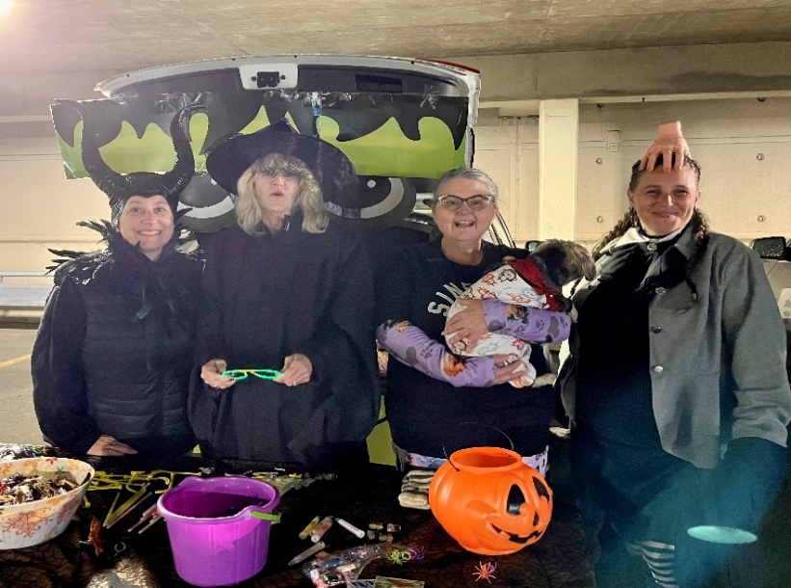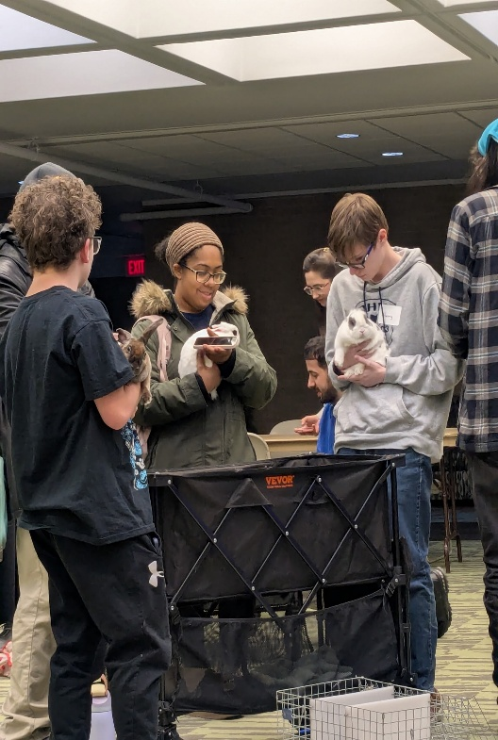

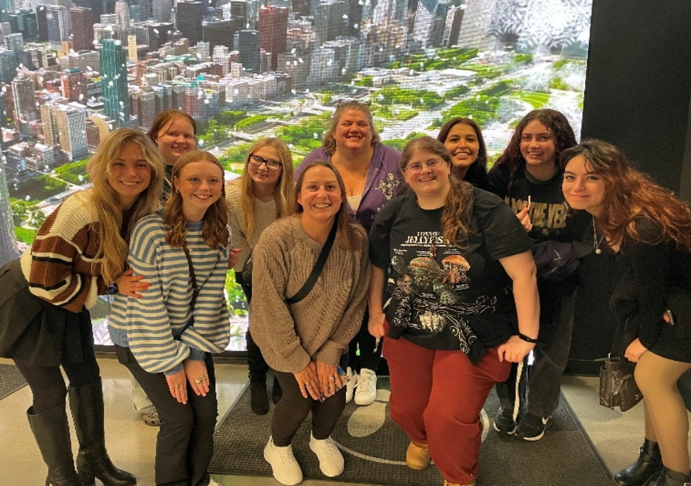

Appendix F: Psychology Department Academic Integrity Inquiry Letter Template and Late Policy Recommendations

Academic Integrity Inquiry Letter Template



[INSERT DATE MONTH DATE, YEAR]

[STUDENT NAME/ID
[STUDENT EMAIL ADDRESS]
[COURSE NAME AND NUMBER] (if applicable)

Sent via email: Academic Integrity Letter of Inquiry – Response Requested

Dear [FULL NAME] ,

Sinclair College’s Code of Conduct outlines expectations regarding students’ work and considers Academic Integrity to be essential for each student’s intellectual development. Sinclair’s Academic Integrity policy prohibits the following conduct (including but not limited to): plagiarism, cheating, use of artificial intelligence, and/or providing false information. In evaluating your [STATE HOW THIS AROSE, for example: Week 6 Assignment] , I have identified a potential violation of Sinclair’s Academic Integrity policy.

Alleged Violation of Academic Integrity Summary

Formal Request for Information and/or Response
This letter serves as a formal request for information and/or written response to the allegations referenced above. Please submit your written response via email within three business (3) days of the date of this letter, and no later than [INSERT DATE DUE] . Your response should address the alleged conduct and include any information that explains the process or procedure you used to complete the assignment or content.

Based on the information I have presented in this letter, and the response you provide, academic leadership will determine how the matter will best be resolved. If we do not hear from you by [INSERT DATE DUE] , the decision will be based on the information available.

For more information regarding our Academic Integrity policies and process, please refer to the Code of Conduct found in the Student Handbook at the link below. https://www.sinclair.edu/services/conduct-safety/student-judicial-affairs/academic-integrity-policy/?_ga=2.233207070.1290670640.1724113637-1691662907.1672733049

Please feel free to contact me if you have any questions.

Sincerely,

(NAME), [TITLE,EX: FACULTY]
[EMAIL ADDRESS]

Cc: Dr. Mary Wells, Chairperson, Sinclair Psychology Department

Late Policy Recommendations

Sinclair Psychology Department
Recommended Late Grading Policy

Assignments
Assignments, projects, journals, presentations, and other written assignments submitted past the due date will receive a grade reduction of 10% off the total assignment points for each day late up to 7 days past the due date. Points will not be awarded for assignments submitted more than 7 days late without prior approval of the instructor (and documentation when appropriate).

Discussions
Assignment Post: Discussion assignment posts submitted past the due date will receive a grade reduction of 10% off the available assignment post points for each day late up to 7 days past the due date. Points will not be awarded for discussion assignments posted after 7 days.
Reply to a Colleague’s Assignment (Response post): Peer response posts submitted past the due date without approval of the instructor will not earn points.

Quizzes/Tests
Online quizzes and tests, with assigned due dates, submitted past the due date will receive a grade reduction of 10% off the total points for each day late up to 7 days past the due date. Points will not be awarded for quizzes/tests taken more than 7 days late without prior approval by the instructor. For quizzes/tests that should have been completed during in-person classes, students must request permission from the instructor to take a make-up exam in the Testing Center (with 10% late penalty applied unless the absence is excused by the instructor).

All Final Week Coursework
Because instructors must submit final grades within 3 days after the term ends, any coursework submitted after the last day of the course will only be accepted with prior instructor approval. Late deductions will be applied.

