Sinclair Community College
444 West Third Street
Dayton, Ohio 45402

Dietetic Technician (DIT) Program Specific Information Packet

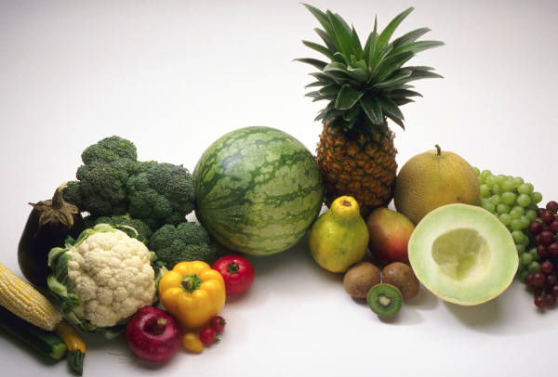
Dietetic Technician Program
Associate of Applied Science Degree Dietetics & Nutrition Department
(DIT.S.AAS)

Building 14, Room 311
(937) 512-2756
(800) 315-3000

Thank you for your interest in the Dietetic Technician (DIT) Program. You can obtain information on the program application process by downloading the Health Science Applicant Information packet located at: http://www.sinclair.edu/academics/divisions/hs/

This packet of information addresses the following:

- Requirements and Process for Entry Into Limited Enrollment Courses
2. DIT Program Curriculum and Outcomes
3. DIT Program Features
4. Estimated Cost of Program
Please contact the DIT program for specific information regarding enrollment dates or possible waiting lists. For additional program information, please see our website at: https://www.sinclair.edu/academics/divisions/hs/dit/

Requirements for Entry into Limited Enrollment Courses

- The DIT curriculum consists of “open” and “limited-enrollment” courses. DIT “limited- enrollment” courses are those with designated directed practice and laboratory hours.

- Requirements for “limited-enrollment” DIT courses are as follows:

Subject  Code | Course  Number | Course Title | Credit  Hours | Non-  Tech | Tech
DEV | 0028 | Introduction to Algebra (if needed) | 3
DEV | 0035 | Dev Reading & Writing (if needed) | 4
DIT | 1105 | Introduction to Dietetics | 1 |  | 1
DIT | 1210 | Medical Terminology | 1 |  | 1
DIT | 1525 | Human Nutrition | 3 |  | 3
HMT | 1107 | Sanitation & Safety | 2 | 2
MAT | 1130 (or)  1470 | Allied Health Math (or)  College Algebra | 3 | 3
CHE | 1111/1151 | Introduction to Chemistry I  Lab for Introduction to Chemistry I | 4 | 4
 |  | Totals | 14 | 9 | 5
Cumulative grade point average of 2.0 or better

- Due to the limited number of directed practice sites, there is an eligibility list. Approximately 30 students are permitted to enroll in the limited enrollment courses beginning second semester (spring). Students that meet the requirements to qualify for limited enrollment courses are assigned to a cohort on a space-available basis.

Process for Entry into Limited Enrollment Courses

- Prospective dietetics students are required to attend a mandatory orientation session embedded in the DIT 1105, Intro to Dietetics course.

- At the orientation session, students are presented with an overview of the DIT program including a synopsis of the types of facilities and healthcare settings that the student will experience. Each student will have their current Sinclair transcript evaluated and a MAP (My Academic Plan) developed to guide the student through successful completion of the DIT program.

- Once a student has DIT added to his/her transcript as an active program of study, he/she is recognized as a DIT student as of that date.

Full Time Track
DIETETIC TECHNICIAN (DIT.S.AAS)
 |  | First Semester (Fall) |  | Credits | Lecture | Lab  Per Week | Directed Practice  Per Week | Directed Practice  Per Semester
DIT | 1105 | Intro to Dietetics |  | 1 | 1
DIT | 1210 | Medical Terminology |  | 1 | 1
DIT | 1525 | Human Nutrition |  | 3 | 3
HMT | 1107 | Sanitation & Safety |  | 2 | 2
MAT | 1130 | Mathematics for Health Sciences ~OR~ |  | 3 | 3
MAT | 1470 | College Algebra |  | (3) | (3)
CHE | 1111 | Introduction to Chemistry I |  | 4 | 3
CHE | 1151 | Lab for Introduction to Chemistry I |  |  |  | 2
 |  |  |  | 14 | 13 | 2 | 0 | 0
 |  | Second Semester (Spring)
DIT | 1630 | Nutrition in the Life Cycle |  | 3 | 2 |  | 2 | 30
DIT | 1635 | Community Nutrition |  | 3 | 2 |  | 3 | 45
HMT | 1101 | Basic Culinary Skills |  | 2 | 1 | 2
CHE | 1121 | Introduction to Chemistry II |  | 4 | 3
CHE | 1161 | Lab for Introduction to Chemistry II |  |  |  | 2
 |  |  |  | 12 | 8 | 4 | 5 | 75
 |  | Third Semester (Summer)
HMT | 1112 | Food Principles and Basic Preparation |  | 4 | 1 | 6
ALH | 1101 | Introduction to Healthcare Delivery |  | 2 | 2
PSY | 1100 | General Psychology |  | 3 | 3
ENG | 1101 | English Composition I |  | 3 | 3
 |  |  |  | 12 | 9 | 6 | 0 | 0
 |  | Fourth Semester (Fall)
DIT  DIT | 2101  2240 | Eating Matters for Dining Assistants  Education Methods & Materials |  | 1  2 | 1  2
DIT | 2510 | Institutional Foodservice Systems |  | 3 | 3
DIT | 2515 | Foodservice Practicum I |  | 1 |  |  | 5 | 75
DIT | 2520 | Lab for Foodservice Systems |  | 1 |  | 2
DIT | 2625 | Medical Nutrition Therapy I |  | 3 | 3
DIT | 2630 | Medical Nutrition Therapy Clinical I |  | 3 |  |  | 8 | 120
 |  |  |  | 14 | 9 | 2 | 13 | 195
 |  | Fifth Semester (Spring)
DIT | 2305 | Food, Culture, & Cuisine |  | 2 | 1 |  | 2 | 30
DIT | 2310 | Lab for Food, Culture & Cuisine |  | 1 |  | 2
DIT | 2735 | FS Organization & Management |  | 3 | 3
DIT | 2740 | Foodservice Practicum II |  | 1 |  |  | 5 | 75
DIT | 2845 | Medical Nutrition Therapy II |  | 3 | 3
DIT | 2850 | Medical Nutrition Therapy Clinical II |  | 2 |  |  | 6 | 90
DIT | 2855 | Dietetics Seminar |  | 1 | 1
 |  |  |  | 13 | 8 | 2 | 13 | 195
Total: 65 credits 465 directed practice hrs 255 lab hrs |  |  |  | 65 |  | 16 |  | 465

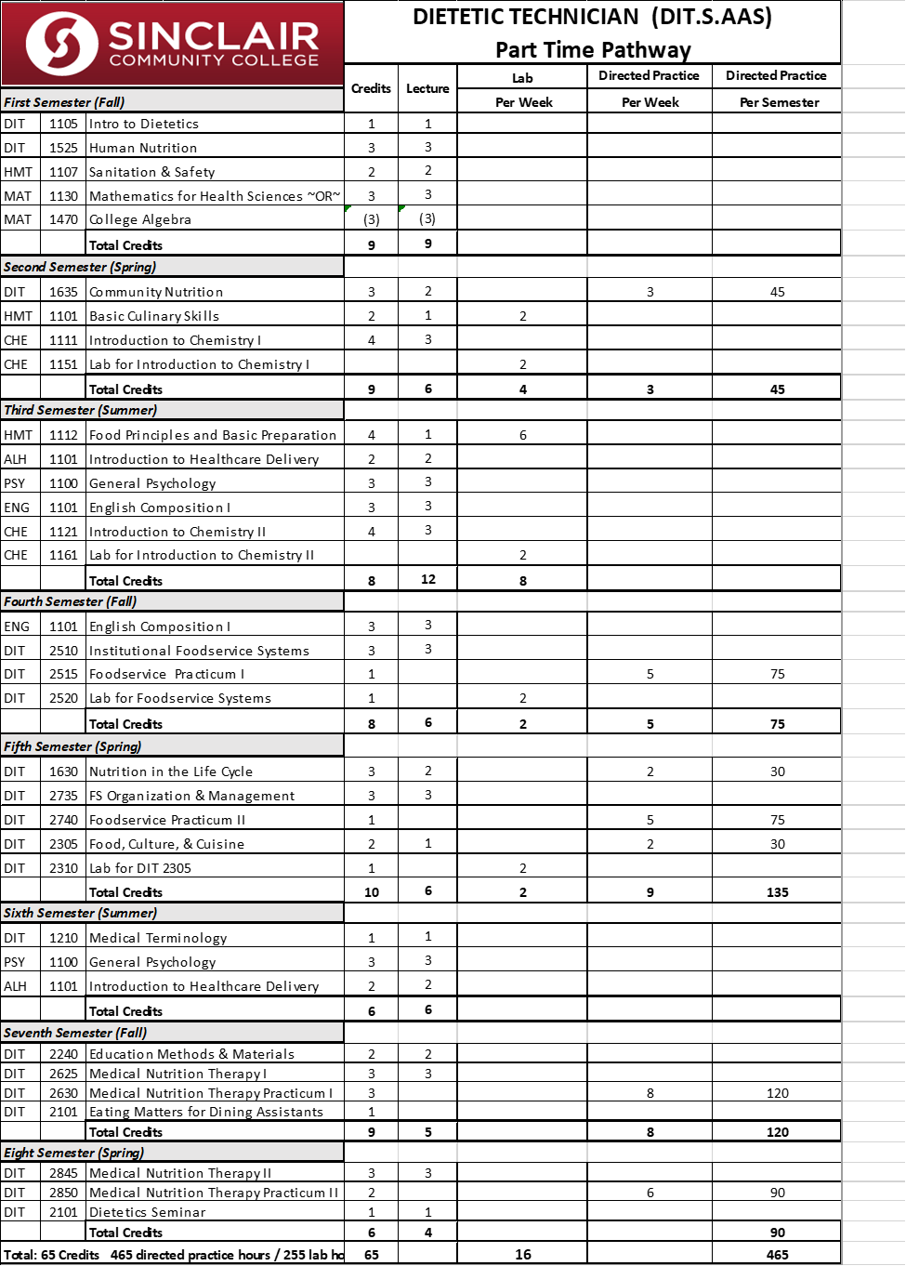

Background Check Requirements

Students must participate in a state and federal background check for criminal convictions prior to attending supervised practice rotations during the fourth semester within the DIT curriculum. Additional costs will be incurred by the student to cover these expenses. Depending on the outcome of the background check, it is possible that the student will be denied access to the clinical/management environment and therefore be unable to complete the program.

Immunization & Vaccination Requirements

To qualify for DIT limited-enrollment/restricted courses you will be required to have the following:
Examinations:
General physical examination by your medical doctor. Must be completed preceding your first day of starting DIT limited-enrollment courses with clinical/management rotations (2nd year - 4th semester).
Immunizations: Mandatory
Influenza: recommend one dose of influenza vaccine annually
Measles-Mumps-Rubella (MMR): vaccination or positive antibody titers
PPD Skin Test: A two-step PPD skin test should be completed within one to two months prior to starting DIT limited-enrollment courses with clinical & management rotations. Once initiated, the two-step process is to be completed within a 14 - 21 day time frame A positive reaction requires documentation of physician evaluation. Please send proof, if you have already completed the initial 2-step process and currently receive annual PPD skin tests.
Tetanus: within the past 10 years
Varivax (Varicella): Two doses required or positive titer

Immunizations: Optional
Hepatitis B: vaccination or positive antibody titer (Anti-HBs)
The first injection should be completed prior to the first day of starting DIT limited-enrollment courses with clinical rotations. The second injection is due 30 days after the first injection and the third is due five months after the second injection was completed.
If you have already had the three injection series, please send in proof. If the injection was 10 years ago or more, an antibody titer (Anti-HBs) needs to be completed. If any injections were significantly beyond the specified time frame, a titer is also recommended.
A Medical/Immunization packet containing forms is distributed to students at the completion of their 1st year/2nd semester in the DIT curriculum. Students are required to complete these requirements over summer term/3rd semester.
Please note the time restrictions on the examinations and immunizations.
If they are done too early, you will be required to repeat!
Mental and/or Physical Requirements
Minimum acceptable mental and physical qualifications of a student for the profession of nutrition and dietetics include the following abilities:
A. | Ability to stand for long periods of time. Walk intermittently throughout the working day and do frequent slow- and fast-paced walking. Being able to negotiate stairs when required.
B. | Ability to reach, stoop, bend, lift, carry and manipulate various food products, dietary supplies and equipment.
C. | Ability to lift and/or carry 30-40 pounds and withstand exposure to temperature and humidity changes as in entering refrigerated storage areas, working at ovens, ranges, dishwashing machines, and at steam tables.
D. | Ability to work with chemicals and cleaning agents.
E. | Must not be physically dependent on non-prescribed drugs. Student may be required to pass drug screens at clinical sites.
F. | Perform mathematical calculations for clinical and management assessment.
G. | Communicate effectively, both orally and in writing, using appropriate grammar, vocabulary, and word usage.

Students entering the Dietetic Technician Program are responsible for determining their own eligibility in light of these qualifications, for informing the college of any potential problem areas and for identifying to the Dietetic Technician Program any particular accommodations they may need. Students with disabilities are encouraged to register with the Office of Disability Services and may utilize these services to determine appropriate accommodations. Students with disabilities who enter the program do so with the understanding that they will be expected to meet course requirements with any REASONABLE accommodation that may be provided by the College.
Meeting the mental and physical requirements of the Dietetic Technician Program does not guarantee that the student will meet the mental and physical requirements of the institutions that employ dietetic technicians, registered.
Students enrolled in Sinclair health care programs are expected to have in effect personal health insurance prior to enrolling in any course which includes a clinical experience requirement. This requirement for having health insurance is in place because most clinical sites that accept Sinclair students require it. If a student does not have health insurance, he/she may not be admitted into a clinical course, and therefore, not be able to complete the program. Sinclair provides accident insurance for students injured in clinical settings. However, the insurance carrier decides what treatment is eligible for reimbursement, and any treatment denied for reimbursement is the responsibility of the student, not Sinclair or the clinical site. Information about obtaining health insurance can be found at: http://www.hhs.gov/healthcare/rights/index.html or http://medicaid.ohio.gov/FOROHIOANS/GetCoverage.aspx

Program Outcomes

Apply principles of management and systems in the provision of clinical and customer services to individuals and organizations at the dietetic technician level of practice.

Describe and apply scientific information and research related to the dietetic technician level of practice.

Develop beliefs, values, attitudes and behaviors for the dietetic technician level of practice in accordance with the Academy of Nutrition and Dietetics Code of Ethics.

Develop and deliver information, products and services to individuals, groups and populations at the dietetic technician level of practice.

Dietetic Technician Program Features

Mission and Vision
The DIT program mission is to empower students with food and nutrition knowledge, skills, and competencies in preparation for immediate employment as entry-level dietetic technicians, registered or pursue a baccalaureate degree while endeavoring to find the need and serve the community.
The vision is for students to embrace progressive career and lifelong learning attitudes as they positively influence food choices and lifestyles within their community.
DTRs are trained food and nutrition practitioners who work under the supervision of a registered dietitian. As an integral part of the healthcare and foodservice management team, they influence food choices and lifestyles to promote optimal health.

DTR Job Responsibilities
Clinical dietetic technicians, with the guidance and/or consultation from registered, licensed dietitians, perform nutritional screening and assessment; develop and implement care plan goals; evaluate the effect of nutrition intervention; and communicate with clients/patients and the medical staff. They also provide nutrition education and counseling to individuals and groups. Foodservice dietetic technicians work as nutrition directors and design menus; supervise personnel, food procurement, food production and service; participate in budget and equipment planning; and monitor food safety, sanitation and quality improvement. Community dietetic technicians reach out to the public and direct individuals to information networks and agencies related to nutritional care. Main responsibilities include teaching, monitoring, and advising individuals and groups in their efforts to prevent disease and promote good health.

Accreditation
The Dietetic Technician (DIT) program at Sinclair is accredited by the Accreditation Council on Education for Nutrition and Dietetics (ACEND) located at 120 South Riverside Plaza, Suite 2190, Chicago, IL 60606, Phone: (800) 877-1600. ACEND serves the public by establishing standards for educational preparation of dietetic professionals and recognizes dietetic education programs that meet these standards. The US Department of Education requires that ACEND review its standards at least once every five years and revise them as necessary. ACEND requires core knowledge & competencies in five domains of practice to ensure proficiency as entry-level dietetic technicians. Aggregate data is collected annually to ensure that core knowledge and competencies are being achieved. Program outcomes data is available on request.

Directed Practice Experiences
Students begin directed practice experience during spring second semester completing 2 hours weekly (30 hours total) in DIT 1630, Nutrition in the Lifecycle, and 3 hours weekly (45 hours total) in DIT 1635, Community Nutrition. During fall forth semester students complete 5 hours weekly (75 hours total) in DIT 2515, Foodservice Practicum I and 9 hours weekly (120 hours total) in DIT 2630, Medical Nutrition Therapy Clinical I. During spring six semester students complete an additional 5 hours weekly (75 hours total) in DIT 2740, Foodservice Practicum II, 9 hours weekly (90 hours total) in DIT 2850, Medical Nutrition Therapy Clinical II and one hour weekly (30 hours total) in DIT 2305, Food, Culture & International Cuisine. Upon completion of the program, students will have completed 465 hours of directed practice.
Directed Practice Documentation. Directed practice hours in the DIT 1630, DIT 1635, DIT 2515, DIT 2305, DIT 2630, DIT 2740 and DIT 2850 courses are tracked for student completion and accreditation compliance. Supervised directed practice tracking forms must be turned in by the student the final week of each semester completed. Practicum hours are verified by the associated preceptor and faculty for each course and a copy placed in the student’s permanent file as documentation of hours completed.

Areas of Directed Practice
Directed practice experiences fall into four areas. Lifecycle experiences are conducted on campus with invited guests. Community experiences are completed at a variety of community and wellness sites including but not limited to; Women Infant Children clinics, Head Start centers, Senior Resource Center/ Meals on Wheels/Congregate Meal sites, School Lunch programs, Food Bank/Soup Kitchens/Food Pantries, YMCA centers, Drug Rehabilitation programs, Boys & Girls Club, Job Center, and Correctional facilities. Foodservice Management experiences are completed in health care and school institutionalized kitchens. Clinical experiences are completed in a variety of hospital and extended care facilities.

Degree Awarded
The DIT program awards an Associate of Applied Science degree. The curriculum consists of 65 semester credit hours and integrates didactic instruction with 465 hours of directed practice in health care, community and management settings. Because the number of students is limited, the faculty/student ratio is small. Faculty is able to provide personal and individual attention to student needs. Courses in nutrition, dietetics, and food science are taught by registered/licensed dietitians and chefs with post-baccalaureate education/credentials and/or extensive practitioner experience. Articulation information is available for students interested in earning a baccalaureate degree.

Length of Program
Students attending full-time complete the DIT program in two years, equivalent to five (5) full-time semesters. Some students elect to attend on a part-time basis extending the length of study to three academic years over eight (8) part-time semesters. Students have a maximum of five years to complete the entire program. Students exceeding this five-year limit will be required to repeat math and science courses and ServSafe certification. Students may also be required to repeat dietetic courses to ensure competence as determined by the Program Director.

Dietetic Technician, Registered (DTR) Credential
Graduates of the program are eligible to take the national credentialing examination for dietetic technicians administered by the Commission on Dietetic Registration (CDR). Upon successful completion, students earn the credential of dietetic technician, registered (DTR). They are eligible to join the Academy on Nutrition and Dietetics (AND) as well as the Association of Nutrition and Food Professionals (ANFP). Benefits include networking, professional growth, educational enrichment, and developing leadership skills. Continuing education upon successful completion of a national examination is required by these organizations.

Career Opportunities
Positions are available in a variety of work settings, including health care, business and industry, community and public health, foodservice, and research. DTR’s most commonly work in hospitals and clinics, extended care facilities, hospices, home health-care agencies, schools, community and wellness sites.

Estimated DIT Program Costs

Information on the fees to attend Sinclair College can be found in the College Catalog and on line at: http://www.sinclair.edu/services/basics/bursar/current-tuition-cost-and-fee-schedule/. Currently these are:

Fee Per Semester Credit Hour:
Montgomery County Residents  Ohio Residents  Out-of State Residents | $121.03  $168.28  $314.40
Other fees may include:
Registration Fee  Late registration Fee  Auxiliary Services Fee  On-line Classes (per credit hour beyond tuition)  Graduation Ceremony  Transcript (each)  Transcript (same day)  Returned check penalty | $20.00  $30.00  $85.00  $7.50  $10.00  $5.00  $10.00  $25.00
In addition to the above, the following approximate
expenses may be incurred:
Laboratory fees:  Lab coat/uniforms  HMT 1101 supplies  Program Fees  Transportation (sites/events)  Attendance at meetings  Medical/physical check-up  Immunizations  Background check  Books, papers, supplies  Food (conferences/trips)  Miscellaneous  Total: | $350.00  $145.00  $150.00  $125.00  $250.00  $100.00  $100.00  $125.00  $65.00  $2000.00  $200.00  $250.00  $3,860.00

Thank you for your interest in the Dietetic Technician Program. Please contact the Dietetics & Nutrition Office at (937) 512-2756, for questions regarding the enrollment process into DIT courses.

