Sinclair Fire Academy
Student Packet

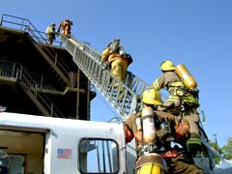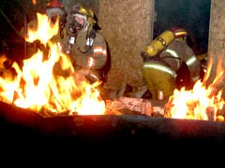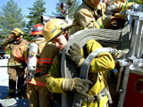

November 10, 2016
Sinclair Fire Science Academy
Student Packet Contents

WELCOME TO SINCLAIR FIRE ACADEMY
“GETTING STARTED”

- All students will meet with the Fire Academy Coordinator prior to the first day of class. Students may resister with advising, but will still be required to meet with the Academy Coordinator prior to the first day of class and being fitted for their fire gear.
- First Day of Class Check List
- Fire Academy Basic Screening Exam: aka Doctor Release/Physical *
- EMS Student Health Certificate**
- Personal Protective Clothing Requirements
- Boots and Gloves Vendor List
- Emergency Vehicle Operation Class (EVOC) options list***
- General Fire Academy Expectations
- Fire Academy Student Agreement
*Students who are on fire departments who have undergone a fire department physical to screen for medical issues do not have to have the Doctor Release/Physical completed. They will need a letter from their fire department confirming that they have undergone a medical screening/physical.
** Students who are going to be taking the Sinclair Community College EMT Basic class are encouraged to contact Ms. Cathy Rohde in building 19 at (937) 512-5338 from the department of Emergency Medical Services (EMS) to obtain the EMS physical form. Please note the EMS physical cannot be used in place of the Fire Academy physical.
** This activity needs to be completed before the second week of class or before any practical skill training whichever comes first.

Sinclair Fire Academy
#2 First Day of Class Check List
It is the responsibility of the student on the first day of class to have:
___Essentials of Firefighting and Department Operations (6th Edition)
___Essentials of Firefighting and Department Operations Workbook (6th Edition)
___Personal Protective Equipment (Turnout Gear) including Boots and Gloves
___Fire Academy Basic Screening Exam (aka Doctor Release/Physical)
___Paper and Pen (state forms require ink)
___Copy of a valid driver’s license
___Proper Class Attire
Long pants (dark)
Dark color work shirt or T-Shirt (no inappropriate material on shirts)
No ear rings or visible face jewelry
Comfortable work or gym shoes

___ Males will be clean shaven in the Self-Contained Breathing Apparatus (SCBA) face piece seal area.
(Mustaches and sideburns are acceptable if neatly trimmed to the corner of the mouth and the
bottom of the ear)

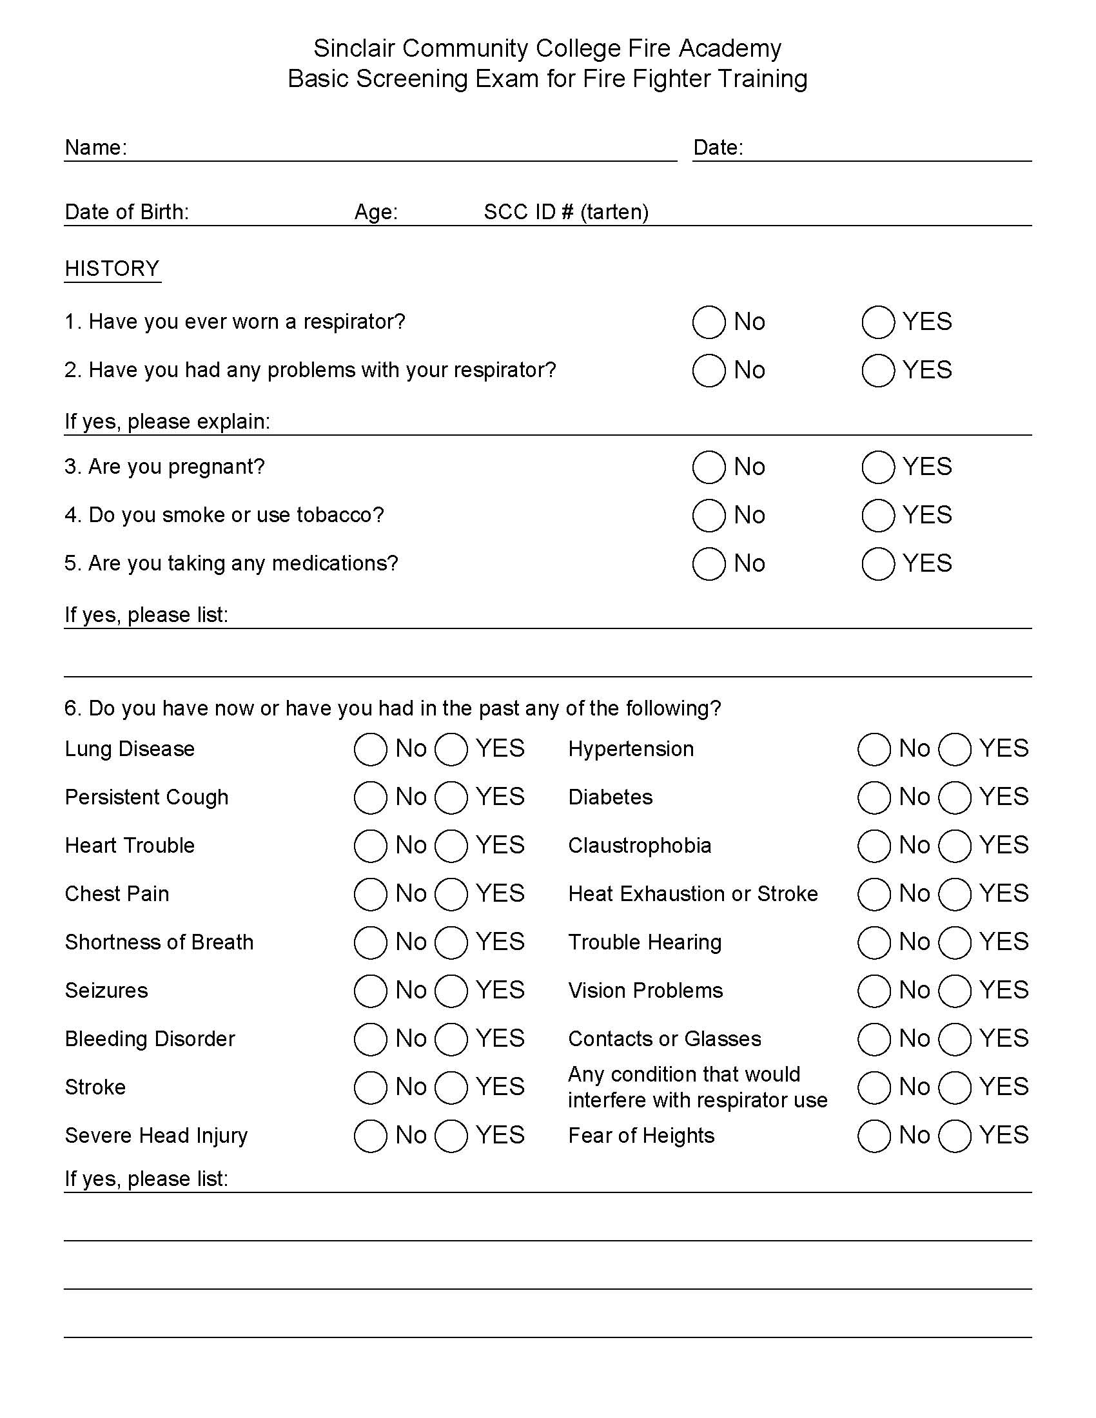
NOTE: Sinclair does not provide insurance for students. Health care is the responsibility of the individual student.
#3
Tartan Card
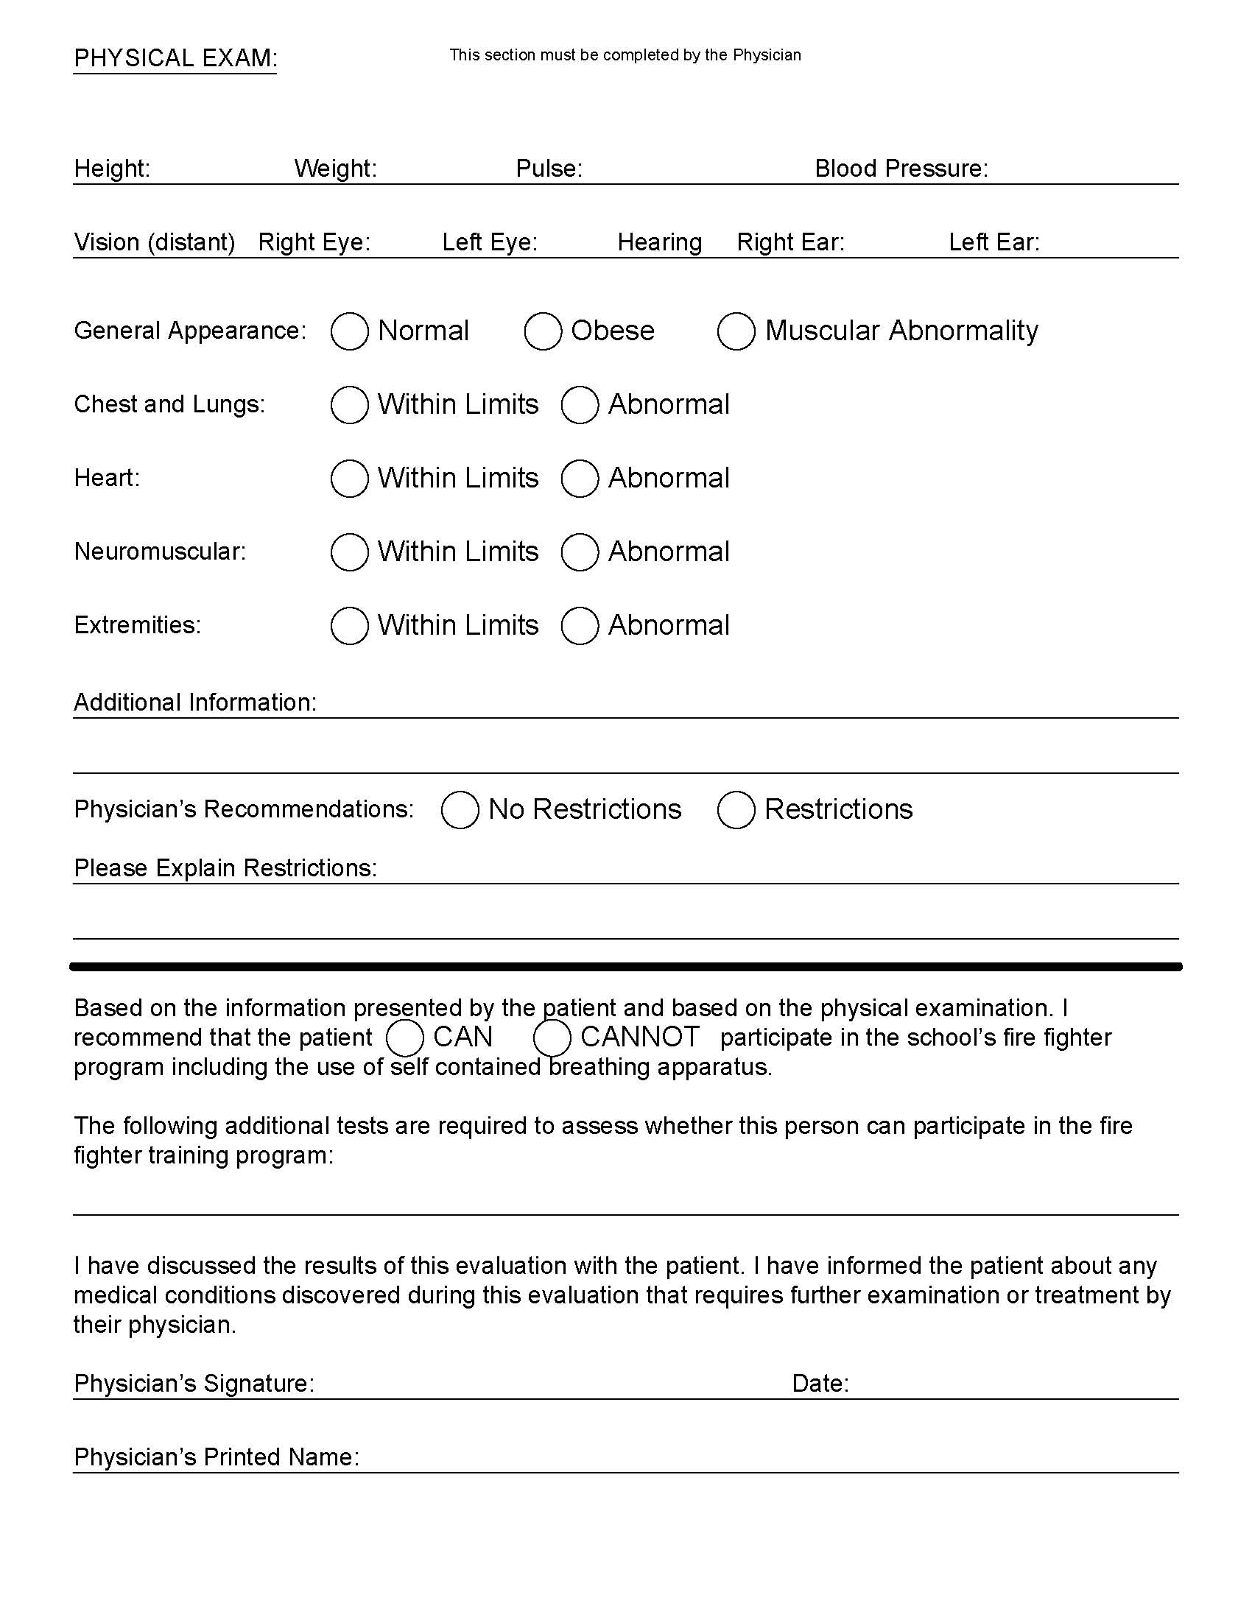
Based on the information presented by the patient and based on the physical examination. I recommend that the patient CAN CANNOT participate in the school’s “Firefighter” program including the use of self-contained breathing apparatus.
The following additional tests are required to assess whether this person can participate in the “Firefighter” training program:

I have discussed the results of this evaluation with the patient, and I have informed the patient about any medical conditions discovered during this evaluation that requires further examination or treatment by their physician.
Physician’s Signature:__________________________________________Date:_______________
Physician’s Name Printed:__________________________________________________________

#5 Sinclair Fire Academy
Personal Protective Equipment (PPE) Requirements
The student will be required to have proper protective equipment. This equipment includes:
- Turnout coat
- Turnout pants with suspenders
- Helmet
- Protective Hood
- Self-Contained Breathing Apparatus (provided by SFA with equipment voucher)
- Boots
- Gloves
If a student does not have Personal Protective Equipment (PPE), they can arrange to borrow these items from the Sinclair Community College Fire Science Technology program, minus boots and gloves.
Students will be charged a PPE deposit of $50.00 by the Sinclair Bursar. Once the student has their $50 receipt from the Bursar’s Office, they are to call Ms. Carrie Lair at 512-3242 to schedule an appointment to be “fitted” for the Sinclair PPE. This must be completed before the first day of class. Class time on the first day WILL NOT BE USED to address PPE issues unless a replacement or substitution (e.g. safety issue) is needed. Remember, this is a deposit which will be returned. The student will be refunded the voucher fee when he/she returns the Sinclair PPE that has been properly cared for and cleaned.
The student is required to provide their own boots and gloves. These can be purchased from a variety of vendors. The only requirement is that the boots and gloves are to be approved for structural firefighting, NFPA (National Fire Protection Association) compliant. A list of possible vendors is included in this packet.
A student who is currently on a fire department is encouraged to use their own PPE instead of Sinclair Community College PPE. An appointment in this case will still be necessary due to the fact that the student is using their departmental equipment and it must be inspected prior to the start of class to ensure it is 1403 compliant.
The state of Ohio Division of EMS requires that all live fire training be conducted in accordance with NFPA 1403, the standard for live fire training. NFPA 1403 requires that turn out gear be 1403 compliant, which states that it may not exceed 10 years of service life.
To ensure that students use gear that meets the standard, students will be provided with the name and contact information of a vendor (see attachment Phoenix Safety Outfitters back of packet) from which they may rent 1403 compliant turn out gear for their live fire training. Level one and Level two transition student will need gear for one month. Level one and two students will need gear for two months.
#6 Sinclair Fire Academy
Fire Boots and Glove Vendors*
Local
Crouch Fire and Safety Products
Ken McKinney
8210 Expansion Way
Dayton, Ohio 45424
937-223-8801

Premier Safety & Services Inc.
Ed Gilbert
3063 Dryden Road
Dayton, Ohio 45439
866-693-8339 ext. 705

Phoenix Safety Outfitters
William Casey
19 South Fostoria Ave.
Springfield, Ohio 45505
800-257-1875

Mail/Phone Order
CHIEF Supply
Dawn Rumpza
800-733-9281 ext. 2248
PO Box 481912
Charlotte NC, 28269

Students can expect to pay between $150.00 to $200.00 for boots and gloves

*This is not a comprehensive list, but is a list of vendors that have indicated an interest in providing products to Sinclair Fire Academy students
#7 Sinclair Fire Academy
Emergency Vehicle Operations Course (EVOC) Options
The State of Ohio requires all students taking a firefighter certification exam to obtain 16 hours of emergency vehicle operations training. The Sinclair Fire Academy provides in house EVOC training, and it may be scheduled as part of the class. It may also be scheduled as an independent stand-alone class. If the student is not able to attend the Sinclair Fire Academy EVOC training, either as part of their class or in a stand-alone setting, it will be the student’s responsibility to obtain this training outside the class schedule. The possible options are:
- Provide EVOC Certificate from an approved driving school and a completed Sinclair EVOC driving packet
- Provide an EVOC Certificate from Volunteer Fire Insurance Services (VFIS) and a completed Sinclair EVOC driving packet
- Provide EVOC Certificate from the Ohio State Fire Academy, Reynoldsburg, Ohio and a completed Sinclair EVOC driving packet
  - 614-752-8200
http://www.com.state.oh.us.sfm/sfmac/
- Provide EVOC Certificate from student’s home fire department and a completed Sinclair EVOC driving packet
- Provide EVOC Certificate from a previous employer that meets state requirements and a completed Sinclair EVOC driving packet
- Provide EVOC Certification from a Host Fire Department and a completed Sinclair EVOC driving packet
- Provide EVOC Certificate from a Vocational/Technical School (i.e. Miami Valley CTC, Warren County CTC, Greene County CTC, Butler Tech CTS, etc. and a completed Sinclair EVOC driving packet
- Provide EVOC Certificate from another two year academic institution, i.e. Clark State, Cincinnati State and a completed Sinclair EVOC driving packet
- Other EVOC Certifications may be submitted and will be evaluated on a case by case basis
A student can expect to pay anywhere from $180.00 to $300.00 for an EVOC class outside of the SFA.
Most EVOC driving school vendors have the following requirements:
- Students must have and present a valid operator's license, the first day of the EVOC class
- Students must have a personal vehicle which they can inspect before driving, or a vehicle they are insured to drive the first day of EVOC class
- Students must provide proof of insurance the first day of EVOC class
- Students must provide a copy of their driver abstract from the BMV the first day of EVOC class
- Students must pay the full fee which includes the book, the first day of EVOC class

CRITICAL: The student must present the certification to the class instructor before being allowed to take the class final examination. This is a “State of Ohio” requirement.
#8 Sinclair Fire Academy
General Fire Academy Expectations
In the course of the fire academy, the student will be expected to:
Be on time: Early is on time, on time is late, and late is unacceptable. When class starts the candidate is expected to be signed in and ready to go to work. (Attendance will be taken)
Be Prepared: Always bring all your equipment and related materials to every class every day.
Work in teams. The fire service is a team profession. We function within units known as “companies” which are usually between 3 to 5 firefighters each. Many tasks and functions on an emergency scene take extensive teamwork in order to accomplish.
Follow orders promptly and completely: The title of a firefighter’s immediate supervisor is either lieutenant or captain. This is for a reason. The fire service is a paramilitary organization that depends on the chain of command. The ability of officers to maintain command and control is critical for a safe outcome of an incident.
Perform extremely taxing physical activities: The candidate, while wearing PPE, will be expected to:
- Carry and raise ladders, one Firefighter carry, spot, and raise a 24’ extension ladder
- Hoist equipment a minimum of four (4) stories
- Carry/drag a 165 pound (plus weight of PPE) rescue dummy
- Climb aerial ladders (up to 100 feet)
- Function in tight (claustrophobic) environments
- Deal with extreme temperatures, sub-freezing to heat index over 100 degree F
- Other firefighting related activities

The student will be expected to pass certain physical practical skills in order to successfully complete the class.
IMPORTANT: Individuals with felonies (of any type), misdemeanors involving moral turpitude and related convictions will be investigated on a case by case basis and may not be able to obtain an Ohio certification.

Any questions please call the Fire Science Technology Department at 937-512-2496 or 512-2073

#9 Sinclair Community College
Fire Academy Student Agreement

I, (print) _____________________________________________, hereby agree to the terms and conditions of the Sinclair Community College Fire Academy Student Packet. I understand that it is my responsibility to have all of the required /necessary items listed in the Student Packet by the first day of class. I understand that if I fail to complete or address these issues and/or activities required within the packet by the first day of class, I could be Administratively Withdrawn from the class.

__________________________________________ ___________
(Student Signature) (Date)

__________________________________________ ____________
(Advisor Signature) (Date)

Course and Section Student was registered in _______________________

Return this form to the Fire Science Technology Department 20-240 or
FST Department Fax Number: 937-512-2279

