TABLE OF CONTENT

SELF-STUDY REPORT Page

Section I: Overview of Department 1
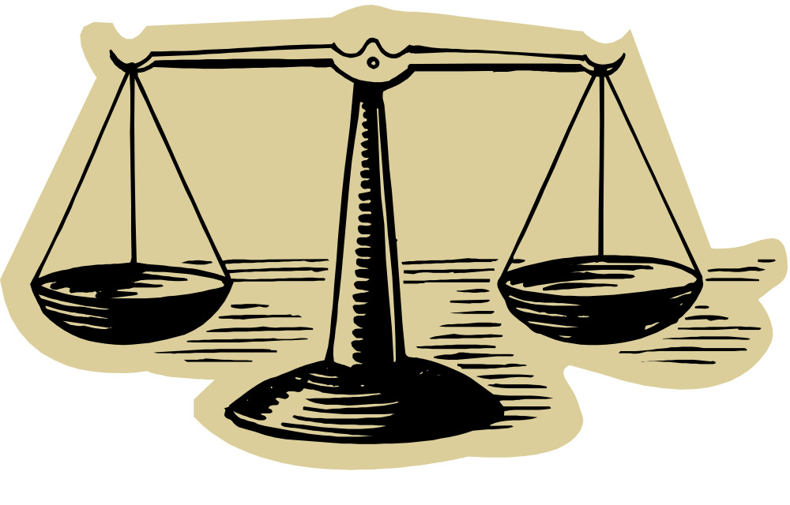
Section II: Overview of Program 3

Section III: Student Learning 6

Section IV: Department / Program 9
Status and Goals

APPENDIX I
Progress on issues/ recommendation since the last review

APPENDIX II
Department Members

APPENDIX III
2001 Department Review: Program Learning Outcomes Assessments

APPENDIX IV
2005 Responses to the Paralegal Program Employer Survey

APPENDIX V
2005 Responses to the Paralegal Program Graduate Survey

APPENDIX VI
Internship Supervisor Evaluations Summary

APPENDIX VII
Analysis of Environmental Factors

APPENDIX VIII
Paralegal Program Student Planning Guide

Department/Program Review
Self-Study Report Template

2005 - 2006

Department: Paralegal

Program: Paralegal
Section I: Overview of Department
Mission of the department and its programs(s):
What is the purpose of the department and its programs? What public does the department serve through its instructional programs? What positive changes in students, the community and/or disciplines/professions is the department striving to effect?
1. Department Mission

The purpose of the Paralegal Program is reflected in our mission statement: “Sinclair Community College Paralegal Program helps individuals to turn dreams into achievable goals through accessible, high quality, affordable learning opportunities.”

The department does this by providing practical, student-centered learning opportunities for students. Upon graduation from the program, graduates are prepared to function effectively and ethically in the legal community and meet the community’s need for paralegals with broad legal knowledge and technology skills.

2. Public served through the instructional program
Students are served through the program by being well prepared for the work force. The program offers a simulated law firm environment with a hands-on approach to learning. The program also requires two internships in the legal community prior to graduation. These internships give graduates the ability to enter the profession with the confidence that they can do the job required.
The department serves the legal community by providing competent, entry level paralegals for law firms, corporations, insurance companies, title companies, financial institutions, and the courts. In addition, the general public is served by the use of paralegals, which makes legal services more affordable.
The department also provides continuing legal education for graduates working in the legal community.
The Sinclair Paralegal Program hosts an annual Paralegal Day Celebration in May. This event showcases the paralegal program for local employers and gives the local community a forum for recognizing the invaluable contribution of paralegals to the legal profession. A top paralegal and law firm from the community receive awards based on nominations from the general legal public.
In addition, the department is involved in service learning which allows students to take part in service opportunities and begin the life-long habit of community service. Students are encouraged to participate in Sinclair’s annual Make a Difference Day , as well as other service opportunities during the school year.
3. Positive Changes to the student, community, discipline
The program strives to change students by helping them to not only learn legal concepts but how to apply them. Using critical thinking skills in an ethical manner enhances both the paralegal profession and the discipline of law.
The community is improved by cost-effective legal services through the valuable assistance paralegals provide to attorneys. Providing well-trained, professional paralegals improves the image of the discipline.
- Description of the self-study process
Briefly describe the process the department followed to examine its status and prepare for this review. What were the strengths of the process, and what would the department do differently in its next five-year review?
- Process of the self-study
The faculty of the paralegal program engage in continual self-assessment. All faculty members bring their thoughts on department improvement to the annual department retreat.
The faculty have attended all day retreats every summer since 2002 in order to assess the current condition of the department and to determine what improvements were needed. A five year plan was developed in 2002 and it has been reviewed and updated each year. One outcome of the 2002 retreat was the review of current curriculum by the Paralegal Advisory Board. The Board members, along with faculty and ad hoc members from the legal community, were divided into four teams, each covering different areas of law. Recommendations from the teams resulted in modification of several required courses and the development of many short term electives.
For this self-study, the department first reviewed the annual retreat minutes and the outcomes of the last department review. In addition, since the paralegal program is approved by the American Bar Association (ABA), the department used the extensive self-study that was required for the ABA interim reports, completed in 2002 and 2004. The department also used the documentation currently being gathered for the ABA Reapproval report and site visit due in 2007.
After reviewing all of the items listed above, and the data set provided by the college, the department chair developed a rough draft responding to the template questions. Each of the faculty then took responsiblility for completing a section of the report. The final report was then reviewed, discussed, and edited by the entire faculty.

2. Strengths of the process and what could be done differently

Assessments by the paralegals, faculty, and advisory board as well as input from the legal community were very helpful. This, along with the work done toward the stringent ABA reapproval process, helped us get a good look at where we are. The data provided was extremely useful in showing us strengths and areas for improvement.

The process worked well. It might be helpful to have the empirical data earlier. It could also be helpful to have a formal survey by the advisory board.
Section II: Overview of Program
A. Analysis of Environmental Factors
This analysis, initially developed in a collaborative meeting between IPR and the department chairperson, provides important background on the environmental factors surrounding the program. Department chairpersons and faculty members have an opportunity to revise and refine the analysis as part of the self-study process.
1. Key stakeholders of the paralegal program include paralegal and BIS (legal secretary program) students, faculty, administrators, and graduates. External stakeholders include members of the legal community: attorneys in private practices and in corporate legal departments, courts, law libraries, financial institutions, title companies, legal aid and public defender offices, prosecutors’ offices, victim witness programs, insurance agencies, and consumers. Organizations include the Greater Dayton Paralegal Association, four year institutions, (particularly those with whom we have articulation agreements), the American Association of Paralegal Educators (AAfPE), the Dayton Bar Association, and our program approval entity, the American Bar Association.

2. The department assesses how stakeholder needs are being met through:
- Annual graduate and employer survey data
- Faculty evaluations
- Self-assessment feedback from current students
- Advisory board feedback
- One-on-one meetings and evaluations from internship supervisors
- Faculty department meetings and the annual department retreat
- American Bar Association reapproval process

3. Challenges/concerns
a. Identified challenges and concerns:
- Identifying weaknesses of program applicants and how to improve needed skills (particularly written and oral communication and technology skills)
- Identifying skills needed by new students and how to improve them
- Assessing student progress at midpoint in the program, prior to internships, and providing resources for any deficiencies
- Locating college resources and support for the above items
- Effective marketing/advertising
- Maintaining up-to-date technology with personnel support for students
- Ensuring we maintain a strong faculty, full and part-time
- Improving institutional support for Distance Learning courses development and implementation
- Improving support for student technology needs

b. Who feeds your program?
- Local high schools; warehouse data indicates a higher percentage of paralegal students come from outside of Montgomery County than do from the college-wide population
- Internal and external transfer students

c. Reliance on other departments
- Communication department to improve oral communication skills
- English department to improve written commutation skills, including the text editing class
- BIS department to assist with technology skills
- Other departments include Economics, Accounting, Math, Humanities, Psychology, and Government
- IT for student technology support
- Distance Learning for online course support

4. Opportunities
- Create assessment tools and resources for applicants, new students in the program, and mid-program students
- Effective marketing:
  - Recent surveys of incoming students reveal that almost 50% of new applicants learn about the program on the web. A stronger college and department web page is needed
  - Warehouse data indicates that while 75% of students in the college and in the business division come from Montgomery County, only 65% of paralegal students do. We need to improve marketing to counties that surround Montgomery County.
- More collaboration with other departments
- Hire a part-time MIS person to address the program’s technology needs, including legal specific software

5. Data used for decision making
- Statistics and recommendations from the American Bar Association reapproval process
- Feedback from graduate and employer surveys
- One-on-one meetings with internship supervisors
- Internship supervisors’ evaluations
- Surveys from external professional organizations
- Student assessments
- Average class size data
- FTE reports
- Registration and admissions data
Data is weakest on:
- Assessing skills needed for entry level students
- Graduates transferring to four year institutions
- Determining student success with other departments as it relates to needed paralegal skills

6. Actions to take if data available
- We could accurately increase our focus on weak skills
- We could work more closely with applicable four year institutions to ensure our students courses are all transferable

(See Appendix VII. for chart developed with IRP)

B. Statement of program learning outcomes and linkage to courses
Complete attached Program Learning Outcomes Form, identifying where in the curriculum each program learning outcomes is addressed.

Learning Outcomes | Related Courses
1. Competently analyze substantive and procedural issues which arise in the law to prepare and interpret documents. | PAR 131, 201, 202, 205, 211, 212, 213, 215, 235, 240, 241, 242, 244, 245, 246, 291, 292
2. Exemplify a high standard of ethical and professional behavior as a member of a legal team. | PAR 105, 220, 291, 292
3. Competently conduct factual and legal research and communicate the results clearly and concisely. | PAR 111, 112, 121, 122, 243, 291, 292
4. Demonstrate fluency in information technology. | PAR 106, 113, 247, 292

- Admission requirements
List any admission requirements specific to the department/program. How well have these requirements served the goals of the department/program? Are any changes in these requirements anticipated? If so, what is the rationale for these changes?
Admission requirements for the paralegal program exceed those of the college. Applicants must have scores on Accuplacer that indicate the student is ready for college English and math. Students must pass any needed development course before they are eligible for the program. No immediate changes are expected in this policy. However, the department is in the beginning stages of investigating other pre-assessment tools. There is a concern that poor writing, technology and/or professional skills will hinder the success of paralegal students and graduates. The department is exploring ways to assess this problem and locate resources for improvement. (See Section IV.)
Section III: Student Learning
- Evidence of student mastery of general education competencies
What evidence does the department/program have regarding students’ proficiency in general education competencies? Based on this evidence, how well are students mastering and applying general education competencies in the program?
The general education writing and communication checklists are used to assess student skills in most paralegal classes. For example, in Ethics, PAR 220, groups of students role-play ethical scenarios. The class then assesses the role-play with a variety of criteria, including the communication checklist.
Paralegal students are required to write numerous letters and memos, draft many documents, and create written analyses of problems. This builds upon skills learned in general education courses. All written work is evaluated by the professors and some is assessed by fellow students. When students assess the quality of other students’ work, they learn how to analyze their own work.
Technology skills acquired in general education coursework are put to the test in every PAR course. Students must be proficient in a variety of technological skills in the modern law office. To assist the full-time professors with this important aspect of student learning, the program employs the services of a part-time technology instructor. This skilled individual works with the faculty in many PAR courses to help expand students’ general technology education in common computer functions, including word processing, spreadsheets, and presentations. She also trains students in the use of specialized legal software for research, document preparation, calendaring, timekeeping, and electronic case filing.
Student work reveals there are still many areas of improvement needed, particularly in written communication skills. At the annual department retreat in June, 2005, the faculty decided to develop a project that would improve needed skills, including written communication skills. This project will be discussed in more detail in section IV A. (Opportunities)

- Evidence of student achievement in the learning outcomes for the program
What evidence does the department/program have regarding students’ proficiency in the learning outcomes for the program? Based on this evidence, how well are students mastering and applying the learning outcomes? Based on the department’s self-study, are there any planned changes in program learning outcomes?
Students’ proficiency is monitored throughout their learning experience in the Paralegal Program. All students must acquire a C grade, or better, in every course. Quality standards, including good grammar, spelling, and punctuation, of all student work product must be met.
An innovative procedure that ensures students master all material is the requirement of course notebooks. This feature mandates that every student correct every assignment and present the accurate versions in a class notebook for a grade at the end of the quarter. Thus, errors must be corrected, not just forgotten.
In addition, prior to graduation, students are required to submit a portfolio. These portfolios consist of the class notebooks that were prepared throughout the program. All work must be accurate and presented in a professinal manner. This evidence of proficiency documents student accomplishment and becomes a display of competency for employment interviews, as well as a resource for professional paralegal work.
- Evidence of student demand for the program
How has/is student demand for the program changing? Why? Should the department take steps to increase the demand? Decrease the demand? Eliminate the program? What is the likely future demand for this program, and why?
Students can be accepted into the program in the fall (three sections) and in the winter (two sections) quarters. Demand continues to be high. Enrollment in fall, 2005, was down slightly. The reasons for this are unknown. Possible reasons could be the earlier than normal start of the fall quarter (enrollment was down for the entire college), the fact that a major competitor obtained ABA approval, heavy investment by competitors in television advertising, or other factors we have not been able to determine. However, winter, 2006, enrollment was high and both classes were filled.

The demand for well-qualified paralegals should continue. The U.S. Department of Labor Bureau of Labor Statistics Occupational Outlook Handbook projects an increase of 27 percent, or more, for the paralegal profession. Employers are trying to reduce costs and increase the availability and efficiency of legal services by hiring paralegals to perform tasks formerly carried out by lawyers. (See http://www.bls.gov/oco/ocos114.htm#outlook for more information.)
The program provides valuable, well-educated paralegals and, as indicated above, that is a benefit to the legal profession and to the community.
- Evidence of program quality from external sources (e.g., advisory committees, accrediting agencies, etc.)
What evidence does the department have about evaluations or perceptions of department/program quality from sources outside the department? In addition to off-campus sources, include perceptions of quality by other departments/programs on campus where those departments are consumers of the instruction offered by the department.
The American Bar Association first approved the paralegal program in 1990. Sinclair’s program was the first in the Miami Valley to attain ABA approval. The program has been reapproved two times since that date and we anticipate reapproval in 2007. ABA approval is voluntary, and is an indicator that the program has successfully met rigorous national standards.
Sinclair's paralegal program has an excellent reputation in the Miami Valley. Graduates are sought after, hired, and retained. Surveys by employers reveal high approval. (See Appendix IV)
- Evidence of the placement/transfer of graduates
What evidence does the department/program have regarding the extent to which its students transfer to other institutions? How well do students from the department/program perform once they have transferred? What evidence does the department have regarding the rate of employment of its graduates? How well do the graduates perform once employed?
Transferability: The paralegal program AAS is a "terminal" degree and not a transfer module. Most graduates do not seek to immediately transfer to four year colleges. However, students are encouraged to continue their education and those who do have been very successful as evidenced that four year paralegal programs have sought to develop articulation agreeements with us.
Employment: The program attempts to keep in touch with all recent graduates, in compliance with ABA requirements. Graduates are encouraged to keep in touch with the deparment since they will be asked to complete a survey. Because of the prestige derived from being a graduate of an ABA approved college program, former students respond favorably to information requests. As stated above in section D, employer surveys reveal a high degree of satisfaction with Sinclair paralegal graduates.
- Evidence of the cost-effectiveness of the department/program
How does the department/program characterize its cost-effectiveness? What would enhance the cost-effectiveness of the department/program? Are there considerations in the cost-effectiveness of the department/program that are unique to the discipline or its methods of instruction?
The department uses customized texts and internet resources in an effort to keep down costs. The cost of paralegal texts is considerably lower than most other college programs.
The department has been successful in negoiating with many software developers to provide software at no cost, or at a very reduced rate. Most software companies recognize the value of a paralegal workforce trained to use their proprietary products. LexisNexis, for example, has been generous in its support for the Sinclair Paralegal Program.
The program cost per FTE for the PAR Department exceeds the Business Division average. This is to be expected, considering the specialized requirements of maintaining American Bar Association approval, and the additional costs of maintaining professional status of the professors as licensed attorneys. ABA requirements prescribe that paralegal educators must be licensed attorneys. Despite these financial demands, careful budgeting by the PAR in recent years has allowed the department to reduce its program cost per FTE from 71% in excess of the Business Division average to under 1%. New state burdens on attorney license requirements and new ABA demands upon paralegal educators may force additional costs upon the PAR department in order to maintain professional licensure and ABA approval.
Section IV: Department/Program Status and Goals
- List the department’s/program’s strengths, weaknesses and opportunities

Strengths:

Faculty
All full-time faculty members are attorneys and all of them possess practical legal experience. Mike Brigner served as a Domestic Relations judge for the Montgomery County Court of Common Pleas and writes and lectures nationally on the issue of domestic violence. Darlene Dunn had her own domestic relations practice in Florida. Bonnie Shane and Debbie Badonsky worked as staff attorneys for the Legal Aid Society of Dayton, representing low-income clients in a variety of areas.

Full and part-time faculty teach all substantive areas of law, such as family law, business organizations, litigation, real estate, and probate. In addition, in all of these courses attorneys are aided in the classroom by paralegal assistants. These experienced paralegals are Sinclair graduates who work in the paralegal profession and bring the practical aspect to the classroom. Student evaluations show that students appreciate the knowledge they gain from these paralegal team teachers.

Another paralegal graduate, Marina Dodaro, acts as our simulated law firm MIS person. She has worked as a paralegal and runs her own small technology consulting firm. She has also written and given presentations on a variety of technology related topics. She teaches a required technology course to new students. She also assists faculty with legal software selection and maintenance, and team teaches with faculty. Additionally, she works closely with IT personnel to ensure that our legal software works in the labs and in the classroom. She has led the department in the development of a technology manual, which is a reference guide for using billing and case management software. If a student has a problem with this software, our mantra is, “Contact Marina.”

Each summer, the full-time faculty and Marina Dodaro, our MIS person, and our department secretary, Jane Moix, meet off campus for a day-long department retreat. This retreat allows us to share concerns, revisit curriculum, and brainstorm about areas for improvement. Each participant is open to others’ ideas and there is much good discussion. Four years ago, we developed a five-year plan, focusing on curriculum review and revisions. The plan has strengthened our curriculum.

Curriculum
All full-time faculty members are committed to student-centered learning. They have developed, and continue to revise, activities that promote active, rather than passive, learning.

Part-time faculty are also dedicated to student -centered learning. Several have worked with full-time faculty to develop, as well as to teach, courses. These attorneys see teaching at Sinclair as an opportunity to contribute to the community and are a tremendous asset to the program.

The curriculum for the paralegal program has always had a strong practical approach since it was first designed, with the assistance of the Advisory Board, in 1978. Courses are constantly reviewed and updated to keep current with the changes in law and technology.

Beginning in 2002, the department worked with the Advisory Board to review the curriculum. Revisions were made in all curricula to align course work with the real-world demands of the legal community. A few of the courses, such as Probate, were completely redesigned and, based on the committee’s recommendations; new short-term courses were added. In addition to the courses previously mentioned (Appellate Procedures and Attorney Client Privilege and Work Product), the program has also added short-term courses in Juvenile Law, Administrative Law, Ohio Protection Orders, and Employment Discrimination, and will offer Litigation Presentations in summer, 2006.

In addition to content based learning, there is a strong emphasis on skill building in such areas as writing, critical thinking, and team building. Full-time faculty members have developed activities that require work in teams or pairs and a number of courses also require the completion of team assignments.

Both content knowledge and skills are required for the completion of internships. Students spend a minimum of 160 hours over the course of two quarters in two different legal settings. These internships provide an opportunity for students to apply what they’ve learned at Sinclair as well as to develop and refine their skills. Some of the internships have turned into full-time jobs.

At the end of their second internship, students prepare a portfolio of the assignments completed in substantive courses. This valuable professional resource contains completed and corrected assignments and is a great tool to use on job interviews.

Technology
When the CIL opened, the paralegal department received a grant to create a “fictitious law firm.” This grant incorporated the use of legal software into the curriculum as well as the development of skills in internet research. In the introductory technology course, students are introduced to billing and case management software and then are required to use that software in most other paralegal courses throughout their time at Sinclair.

All students are also required to purchase a Lexis ID, generously provided at a substantial student discount by Lexis-Nexis. Also, thanks to the generosity of the Ohio State Bar Association, students have free access to Casemaker, a subscription service with access to a variety of legal resources. Also, all students use the Internet for legal and factual research, and many courses include software specific to the area of law. For example, legal specific software is used in probate, bankruptcy, family law, and litigation. Students gather a variety of information from public web sites, such as the Ohio Supreme Court web site, the Montgomery County Clerk of Courts’ office, and the Secretary of States Office, to name but a few.

Student/college services
The department has partnered well with various college support systems. Career Services collaborates with the program by working with students to enhance resumes and interview skills. IPR has worked with the department to create legal specific graduate and employee surveys that are required by the ABA. These surveys have been used to identify and improve any weaknesses.

The Learning Resources Center has worked with the program from the beginning, helping us select and update legal resources for the program. The faculty and students use the library facilities for the introductory course as well as Legal Research & Writing I. During the relocation process, the library staff sought input about what would be needed in the temporary LRC and has worked with us to find space to hold classes during this time. In addition, the paralegal department painstakingly reviewed the LRC collection to significantly trim unnecessary legal materials to save costs.

The Financial Aid office has also worked with us in providing information to use in the awarding of the Estabrook scholarship awarded to paralegal students. IT provides us with much support for the legal software mentioned above.
Distance learning has worked with the program by assisting us in offering several paralegal courses on the web. Currently, we offer contracts, legal research and writing III, Ohio protection orders, and legal technology resources on the web.

Weakness (The department uses the term “Areas of improvement”.)

College resources
Until the paralegal program was located in the CIL, there was no lab/computer room available for paralegal classes, except those rooms open because of other departments’ non-usage. The program now has a “home” in the CIL, but the configuration of the rooms needs to be improved to enhance student learning. We were asked to use 14-306 E and the desks installed were supposed to be “temporary”. They are the old flattop type and have been replaced in building 12. Because of the glare off the glass and the smudges on the glass, the monitors are difficult for students to see. It is hard for students to effectively do team work because of the configuration of the room. Further, because these units are so large, the room is crowded and it is difficult for the instructor to move around when facilitating a class. New computer stations are needed. Also, the monitors in 14-114 are the old large style. Flat screens would improve visibility for students in the back of the room and thus improve student learning.

The use of disks is becoming obsolete. Students are being encouraged to use, and are switching to, thumb/j drives. In some of the classrooms, the port for the shared drive is on the back of the computer which makes it difficult for students to use. All computers in Building14, in the lab and in the classrooms, should have the shared drive port in the front for easier access.

Institutional support for the development of distance learning courses has been solid, but significantly declined in recent years with declining resources. If the paralegal program is to expand its distance learning offerings, renewed distance learning support will be needed.

Technology support personnel
The paralegal graduate who assists us as our MIS person, (see above), is not staff. She is compensated as a team teacher under “other hourly wages” and is grossly underpaid for all that she does. If we were able to hire her as a part-time support person, it would add an ever stronger dimension to the department since she would be available more hours and would be able to strengthen our technology curriculum.

Marketing
Our program has two local competitors, RETS Tech and Capital University. Both advertise extensively, which has adversely affected our enrollment. We lack funds to promote the program in such a way that would show we are the only two year accredited NCA program. (The ABA is a voluntary approval process, not an accreditation, since the ABA is not an educational institution.) We need to be able to effectively market our short-term courses to graduates and other qualified paralegals, as well as to attract new full-time students. A college-wide marketing strategy that is adequately funded would be beneficial.

Assessment
Students sometimes choose the paralegal program because of what they see on television and in the movies. They see only the glamorous side of the law and do not realize the demands of the profession. We need to provide easy access to those resources that will help them get a realistic view of the profession.

We do require that students complete placement tests in English, reading, and math before they enter the program. We also send a letter to all those students who register for the introductory class informing them of the technology skills needed. However, despite our best efforts, students sometimes lack basic skills that are necessary to be successful paralegals. As a program, we need to develop tools for assessment – we do have tools for evaluation - so that we can help students identify needed skills early in the program. We also need methods to assist the students in self-assessment and provide them access to resources that will help them improve their skills. This assessment would also improve retention. Additionally, we need a method to assess students prior to their internships to insure they have the needed skills, and if not, to assist them in locating resources that will help them improve. Additionally, we need to find a way to help some students realize that the paralegal career is not the right fit for them and refer them to resources that can help find them other options.

Opportunities
The extensive list of short-term courses provides us with the opportunity to attract working paralegals for continuing education courses. In addition, outside attorneys are more willing to assist in the development and teaching of courses that are only five weeks long.

We also have the opportunity to develop a strong assessment program in our department. Our goal is to develop a pre-assessment checklist that will assist students in making the right career choice, and give them resources that will help them improve their skills. This approach will promote students’ responsibility for their own growth.

We began work last summer with a mandatory orientation for students to help better prepare them for their course work at Sinclair. We continued with a storyboarding session conducted by Karla Hibbert-Jones of the Grants’ Office to develop a more specific plan for assessment. Part of that plan is the production of two videos. Darlene Dunn and Debbie Badonsky are working with Greg Dye on a video about the paralegal profession that prospective students could view, as well as a video containing student tips that incoming students could use. We are also in the exploration stages of the development of checklists for prospective students so they can be adequately prepared for the first PAR course, as well as checklists for ongoing students so they can find resources that will help them succeed in particular areas.

This is an exciting opportunity to help students become more responsible for their learning and growth.

The department has worked on transfer options so students have an opportunity to grow by earning a Bachelors Degree. A new articulation agreement with the four-year paralegal program at the University of Cincinnati gives graduates a good opportunity to obtain a four year paralegal degree. The program also has an articulation agreement with Wright State University. The students can transfer all of their paralegal credits towards a leadership degree and can start there as juniors.

- Progress on issues/recommendation since the last review.
See Appendix I
C. Based on feedback from environmental scans, community needs assessment, advisory committees, accrediting agencies, Student Services, and other sources external to the department, how well is the department responding to the (1) current and (2) emerging needs of the community? The college?
Community needs: With the assistance of Institutional Research and Planning, surveys are submitted to the employers of paralegal graduates. (See Appendix IV.) The surveys reveal a high degree of satisfaction as do evaluations completed by internship supervisors. (See Appendix VI). The internship director follows up on these evaluations with one-on-one meetings to address, not just how the intern performed, but what additional skills are needed.
The survey results reveal that the department is meeting current needs. Areas of improvement that constantly need to be addressed are written communication skills. The department’s assessment project, discussed above, hopes to help students improve those necessary skills.
Emerging needs are occurring in the area of technology. Federal courts recently started requiring documents be electronically filed. The department has scheduled trainings spring quarter with the federal court IT trainer to work with second year students. Real estate records are now available on-line. With the cooperation of the Montgomery County Recorder’s Office, students are now trained in electronic records retrieval rather than hard-copy searching at public offices.
College needs: The department, with the invaluable help of the admissions coordinator, is working hard to ensure projected enrollment figures are met. New brochures have been developed for marketing. Paralegal graduates assist by attending high school fairs. Also, costs are closely monitored to ensure the department stays within budget.
D. List noteworthy innovations in instruction, curriculum, and student learning over the last five years
The “simulated law office” environment continues to be expanded. The department now has two rooms available for classes in the CIL. A new copier has expanded students’ ability to track “client” copies. A new server and a new version of Amicus, our case management software, and updated versions of Timeslips, now allow us to require that all students calendar and keep time for their “clients”, just as they would in a law firm. The paralegal program has added a mini-law library – primarily publisher promotion copies – in 14-114.
Short-term electives (1.5 credit hours) have provided students with expanded opportunities to obtain skills in a variety of areas of law. This gives them an edge when applying for jobs.
E. What are the department’s/program’s goals and rationale for expanding and improving student learning, including new courses, programs, delivery formats, and locations?
The department continues to evaluate its required and elective courses. Based on input from the Advisory Board, internship meetings, and community surveys, the department is committed to expanding its short-term, 1.5 credit hour electives, when appropriate. These courses give current students the basics for expanding their knowledge of specialty areas of the law and also provide opportunities for graduates to upgrade skills.
There is currently no plan to offer paralegal courses at other locations. The software requirements and faculty limitations do not make that feasible at this time.

F. What are the department’s goals and rationale for reallocating resources? Discontinuing courses?
There is no plan to discontinue any course. They all have appropriate enrollment numbers. Courses are constantly reviewed to ensure that they are still relevant.
As an ABA approved program, the department must meet specific staffing requirements. There is currently sufficient faculty to satisfy the ABA.
The faculty has worked with vendors to locate reasonable software and the college has provided sufficient hardware. As long as budgets stay fairly constant, there are no plans to reallocate resources.

G. What resources and other assistance are needed to accomplish the department’s/program’s goals?
Improved marketing would ensure that enrollment projections are met. An expanded distance learning department would give us more opportunities to offer distance learning classes and class enhancements. And, as addressed above, the “simulated law firm” rooms, 14-114, and particularly room 14-306E, need to be updated.

APPENDIX I

Appendix I
Progress on issues/recommendation since the last review.

2004 Actions to be taken | 2004 Anticipated outcomes | 2006 Review: Status
New/continuing CITS to other actions resulting form review | Outcomes expected from the actions to be taken
- Continue to expand and revise curriculum with an emphasis on short-term electives | PAR 114 reduced to 1.5 credit hours, developed for web;  PAR 113 developed for web; short-term juvenile law and a real estate course developed in 2004 | PAR 114 changed, web, completed;  PAR 113 completed;  Juvenile law completed;  Real estate elective to be offered Spring, 2006
- Use keyfile in 1/2004 to change LAP to PAR and revise syllabi, as needed | Program will conform to ABA & Ohio Bar definitions; in-coming students will better understand what the profession is about | Completed
- Explore community service | Discuss possibility of assisting the community by working with student services on-campus and the local legal profession | In progress; students given extra credit for Make a Difference Day in Oct. 2005;  Meetings held with Director of the Greater Dayton Volunteer’s Project to explore how paralegal students could be of assistance
- Strengthen coordinator role in recruitment | Maintaining and Increasing enrollment is essential to keep a healthy program and to continue to meet job demands | Ongoing; new coordinator has developed charts to monitor enrollments
- Prepare for ABA Interim report, due February, 2005 | Compiling documentation as it is available means reporting will be accurate and thorough | Completed; 2007 Reapproval in progress

APPENDIX II

APPENDIX II
Paralegal Faculty and Support

Full Time Faculty

Deborah K. Badonsky, J.D.
B.A. Valparaiso University
J.D. University of Toledo
- Recipient of NISOD Teaching Excellence Award
- League of Innovation Innovator of the Year
- President of Faculty Senate
- Presenter at Sinclair faculty trainings on Process Learning
- Recipient, Innovative Project Grant, 2005

V. Michael Brigner, J.D.
B.A. Wright State University
J.D. Salmon P. Chase College of Law
- Former careers: journalist, reporter (WHIO-TV), lawyer, and judge
- Leading Ohio expert in the field of Domestic Violence
- Author of two domestic violence books
- Chaired and helped develop the Ohio Supreme Court Domestic Violence Advisory Committee
- Trained judges, lawyers, police officers, and prosecutors on domestic violence issues
- Produced a set of national domestic violence training videos
- Appeared in the award-winning “City of Shelter” video series
- Teaches Research & Writing, Bankruptcy, Criminal Law, Real Estate Law, and Business Organizations

Darlene E. Dunn, J.D.
B.A. University of Florida
J.D. University of Florida College of Law
- Former careers: Private and firm law practices; Florida Supreme Court certified Family Law Mediator
- Co-authored “Family Mediation in Florida” and an article “Enforcement by Contempt” in The Family Law Commentator
- Awards received: Fifth Judicial Circuit Richard D. Custureri Pro Bono Service Award; American Jurisprudence Award for Appellate Advocacy;
- Pro Bono with the Greater Dayton Volunteers Project
- Chair, Paralegal Day
- Recipient, Innovative Project Grant, 2005

Bonnie S. Shane, J.D.
B.A. Kent State University
J.D. University of Baltimore
- Recipient of NISOD Teaching Excellence Award
- League of Innovation Innovator of the Year
- Innovative Excellence in Teaching, Learning and Technology Award
- Miami Valley Association of Women Attorneys Annual Service Award
- Presenter at numerous conferences and seminars, including national and regional American Association of Paralegal Educator’s conferences, Dayton Bar Association seminars
- Pro bono with the Greater Dayton Volunteers Project

Department Secretary:

Jane Moix
B.S. Maryville University of St. Louis
Retired, Manager SWBT Co.

Part-time Faculty:

Christopher Bazeley, J.D., B.S., M.S., Private Law Practice
Legal Research & Writing I

Stacey Benson-Taylor, J.D., B.A. A.A.S. Paralegal, AFSCME Ohio Council 8
Juvenile Law

Marina Dodaro, A.A.S.Paralegal, B.A., Andes Design Group
Paralegal Principles Technology, Legal Technology Resources, Litigation Presentations

Gary Froelich, J.D., B.A. Froelich & Weprin Co LPA
Real Estate Transactions

Bree Langemo, J.D., B.S. Second District Court of Appeals of Ohio
Intellectual Property

Richard Malone, J.D., B.A, M.B.A. E.S..Gallon & Associates
Social Security, Ohio Workers’ Compensation, & Administrative Law

William Miller, J.D., B.A. Private Law Practice
Probate Law I and II

Lorraine Search, J.D., B.S. LexisNexis, formerly
Legal Research & Writing III, Contract Law, Business Organization II

David Stenson, J.D., B.A. M.B.A. Stenson & Associates
Employment Discrimination

Mary Wiseman, J.D, Cooledge Wall Womsley & Lombard
Intellectual Property; Attorney-Client Privilege & Work Product

Elizabeth Wright, A.A.S, Paralegal NCR Corporation
Interviewing Skills

Paralegal Team Teachers:

Karen Brumit, A.A.S. Paralegal, Paralegal Porter Wright Morris Arthur
Business Organizations I and II

Karen Cramer, A.A.S. Paralegal, B.A. Reynolds & Reynolds
Intellectual Property

Heidi Gasper, A.A.S. Paralegal,
Probate I and II

Margaret Shipp, A.A.S. Paralegal
Family Law

Susan Witherspoon, A.A.S Paralegal, B.S. MeadWestvaco Corporation
Litigation II

Barbara Zappe, A.A.S. Paralegal, Coolidge Wall Womsley & Lombard
Real Estate Transactions

APPENDIX III

DEPARTMENT REPORT
OF

PROGRAM LEARNING OUTCOMES ASSESSMENT

Department: Law and Legal Assisting

Program (Degree): Legal Assisting

Type of Degree: | X | AAS |  |  | AA |  |  | AS |  |  | ATS |  |  | AIS

Chairperson: Garnett McDonough Date: April 30, 2001

Person(s) Interviewed: Garnett McDonough

I. Program Curriculum: A description of the basis for the program curriculum (i.e., how it is derived and validated). Include accreditation organizations, advisory committees or external groups that influence curriculum. Describe curriculum review activities including the review of course master syllabi*.

The American Bar Association, which accredits the program, has broad guidelines for paralegal programs, and the department follows these guidelines, as well as the national Paralegal Educator’s Association recommendations for updating the curriculum.

Locally, the advisory board meets twice per year and the department meets with sub-committees on an as-needed basis. The advisory committee includes graduates of the program, a student, a member of the public at large, a prosecuting attorney, and a local judge. Internship opportunities for students also allow us to get feedback from local employers, some of whom are on our advisory board.

The department’s curriculum review is in line with the program review requirements established by the college; however, curriculum review is an on going process and not specific to the two-year program review cycle. A site visit by the American Bar Association is scheduled for the first week in June 2001.

* Note: Every department is required to review Master Syllabi and Program Learning Outcomes a minimum of every two years.

II. Program Learning Outcomes: A description of what you intend for students to know (cognitive), think/feel (affective), or do (psychomotor), when they have completed your degree program. A suggested manageable number of outcomes should be in the range of five to ten. Describe Program Learning Outcomes review activities*.

The program is a very applied program for legal assistants. This program takes a very practical perspective with respect to accessing information electronically. The introductory course has changed from a four credit hour course to a five credit hour course in order to facilitate introduction to course specific computer technology. A course in Legal Ethics has been added to the curriculum. The program learning outcomes for this degree have not been revised since the last interview.

An entry-level graduate with an Associate Degree in Legal Assisting from Sinclair Community College will be able to:

Learning Outcomes | Related Courses
1. Analyze substantive and procedural issues which arise in the litigation, real estate, business organizations, probate, criminal, family and other areas of the law. | LAP 105, 115, 121, 122, 131, 132, 201, 202, 205, 211, 212, 213, 215, 220, 225, 235, 245
2. Conduct legal research. | LAP 111, 112, 113
3. Prepare and interpret legal documents. | LAP 105, 115, 121, 122, 131, 132, 201, 202, 205, 211, 212, 213, 215, 220, 225, 235, 245
4. Apply critical thinking skills. | LAP 105, 115, 121, 122, 131, 132, 201, 202, 205, 211, 212, 213, 215, 220, 225, 235, 245
5. Communicate clearly and concisely. | ENG 111, 112; COM 206; SOC 111 or PSY 121
6. Serve as a member of a legal team. | LAP 105, 115, 121, 122, 131, 132, 201, 202, 205, 211, 212, 213, 215, 220, 225, 235, 245
7. Exemplify a high standard of ethics as a legal professional. | LAP 105, 115, 121, 122, 131, 132, 201, 202, 205, 211, 212, 213, 215, 220, 225, 235, 245

III. Assessment Method(s): A measurable indicator of success in attaining the stated learning outcome(s). The methodology should be both reliable and valid. Please describe in detail.

a. Formative Assessment Methods(s) and Description: a measurable indicator of student in-progress success in attaining the stated learning outcome(s).

Formative assessment is completed on a course-by-course basis. Students must receive a ‘C” or better in each course in order to progress to the next class. Department faculty have meet to discuss and ensure consistency in using this method of assessment. The department has added some classroom assessment instruments. Specified performance criteria for each assignment are being considered. Faculty members have team taught the introductory course and the research and writing class allowing for the cooperative development of assessment criteria.

As students progress through the program, they compile a notebook of assignments in each course. These assignments are corrected, and then saved. In that way, both formative and summative assessment is on going.

Students have access to computer workstations through the CIL lab which allows for group work and individual work. Students are able to receive immediate feedback and perform student self-assessment as well as assessment of the group process.

b. Summative Assessment Method(s) and Description: a measurable indicator of end-of-program success in attaining the stated program learning outcome(s).

Summative assessment is completed in LAP 291 and 292, both internship courses, lead by a full-time faculty member. The notebooks, which students have prepared throughout their program, are compiled into a portfolio which is a requirement for LAP 292. This portfolio becomes both a record of student performance (competency-based) and a tool for students to use to take to the workplace.

LAP 291 and 292 students complete an internship in a law office and are evaluated by their supervisor at the site. In addition, students in the 291 class complete a unit on career skills which includes resume writing and interviews with local attorneys. Videotaping of job interviews has been added to this course.

LAP has departmental-specific employer and graduate surveys. Results of the surveys indicate that students are well prepared for the workplace and are very likely to be promoted.

IV. Results: A description of the actual results of overall student performance gathered from the summative assessment(s). (see III.b.)

Extraordinary effort has gone into creating a realistic workplace situation. The placement rate in LAP is excellent. Students are well received by employers and many are placed before the internship experience. Others continue full-time employment at the internship site.

Student and supervisor feedback about the internship experience is very positive. Many indicate that the notebooks prepared in LAP 292 become office manuals upon placement. Real world experience builds confidence in students and assures that their skills are adequate for employment.

The department actively uses process education as a teaching/learning strategy. That methodology is a useful approach to this content area. This pedagogy is being implemented across all aspects of courses including distance learning. The intentional sequencing of courses appears to have a positive impact on student success.

Advisory committee feedback is also highly supportive and views the program as the premier program in the Miami valley.

V. Analysis/Actions: From analysis of your summative assessment results, do you plan to or have you made any adjustments to your program learning outcomes, methodologies, curriculum, etc.? If yes, describe. If no, explain.

Changes at the state and national level will impact offering in the legal field. The department is anticipating a revision of the bankruptcy law course upon passage of the upcoming federal bankruptcy laws (anticipated Fall 2001). Some consideration is being given to the creation of additional modules for the upper level LAP courses.

The department is constantly on the alert to changes that need to be made in the curriculum. Reports from students and employers prompt changes in curriculum. LAP follows a continuous improvement cycle.

VI. General Education: A description of where and how within the major the three primary general education outcomes* (communication, thinking, values/citizenship/community) are assessed.

- Where within the major do you assess written communication? Describe the assessment method(s) used. Describe assessment results if available.

Writing skills are constantly evaluated. Faculty and students work together to determine the quality standards of the written communication for each course, then use those standards consistently. Writing skills are mandatory for success as a paralegal. Students are required to take ENG-199 to help hone technical writing skills.

- Where within the major do you assess oral communication? Describe the assessment method(s) used. Describe assessment results if available.

Process learning requires that students take turns with oral communication presentations. The department also conducts mock trials and requires peer reviews of oral presentations. The faculty use a modified version of the oral communication checklist geared specifically for the program.

- Where within the major do you assess thinking? Thinking might include inventing new problems, seeing relationships and/or implications, respecting other approaches, demonstrating clarity and/or integrity, or recognizing assumptions. Describe the assessment method(s) used. Describe assessment results if available.

There is on going emphasis of critical thinking skills. Process exercises, case studies and writing activities are used as a means of assessing and improving thinking skills. A variety of assessment tools are used to assist in this effort.

- Where within the major do you assess values/citizenship/community? These activities might include behaviors, perspective, awareness, responsibility, teamwork, ethical/professional standards, and service learning or community participation. Describe the assessment method(s) used. Describe assessment results if available.

Legal ethics, the Bill of Rights, and values clarification are built into the introductory classes. The role of legal ethics as it is part of professional behavior is part of every course in the program and a specific part of the 291 and 292 internship classes. Additionally, a course in Legal Ethics has been introduced to the curriculum. We are having an increased emphasis on teamwork and peer and self-assessment throughout the curriculum.

Internships are placed with area agencies and student deal with local issues and agencies including both private and public agencies.

* Note: The oral communication checklist and the written communication checklist developed by the General Education Committee were adopted for college-wide use during the 1997-98 academic year by Academic Council. Thinking Guidelines developed by the General Education Committee are being piloted by faculty during the 1998-99 academic year.

APPENDIX IV

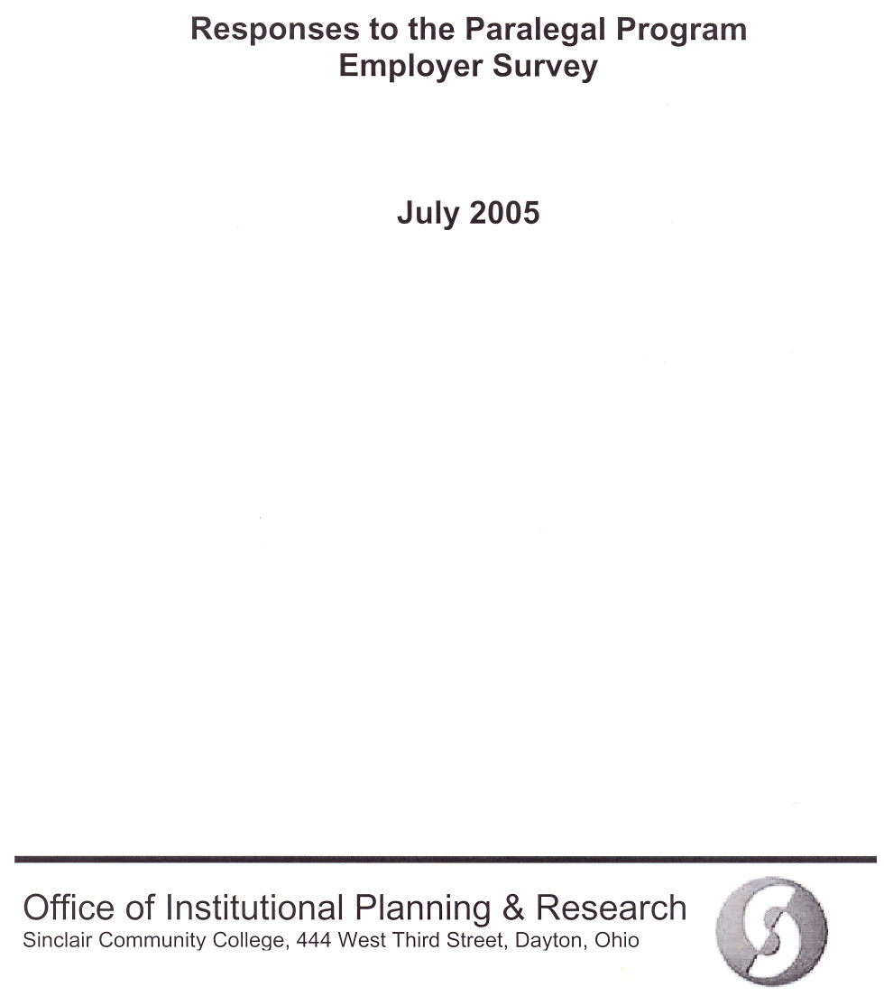
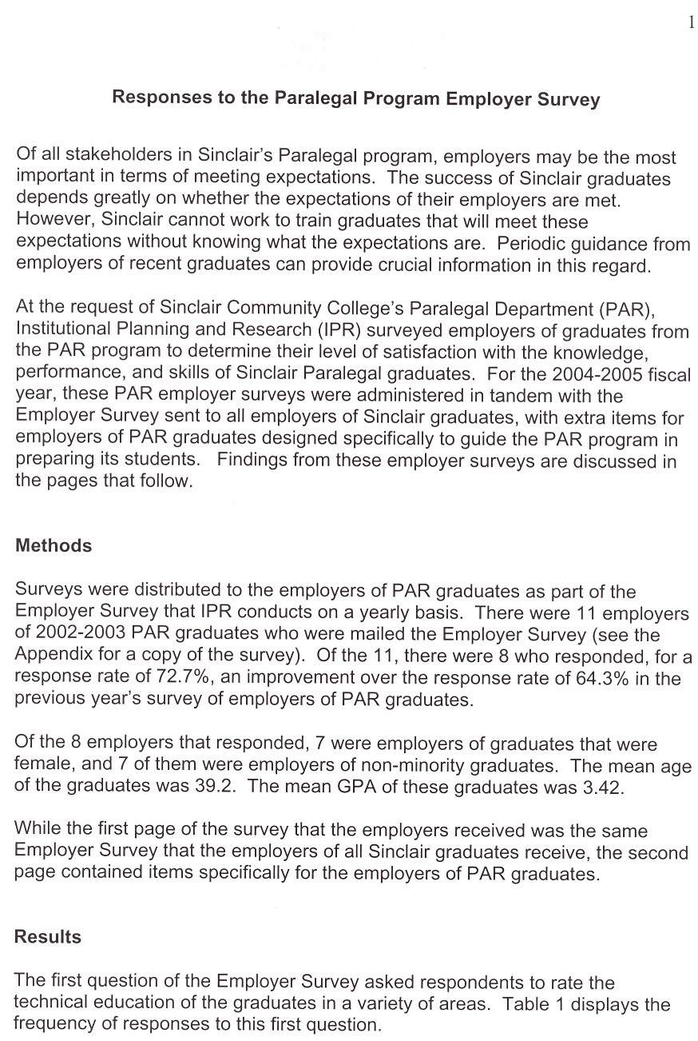
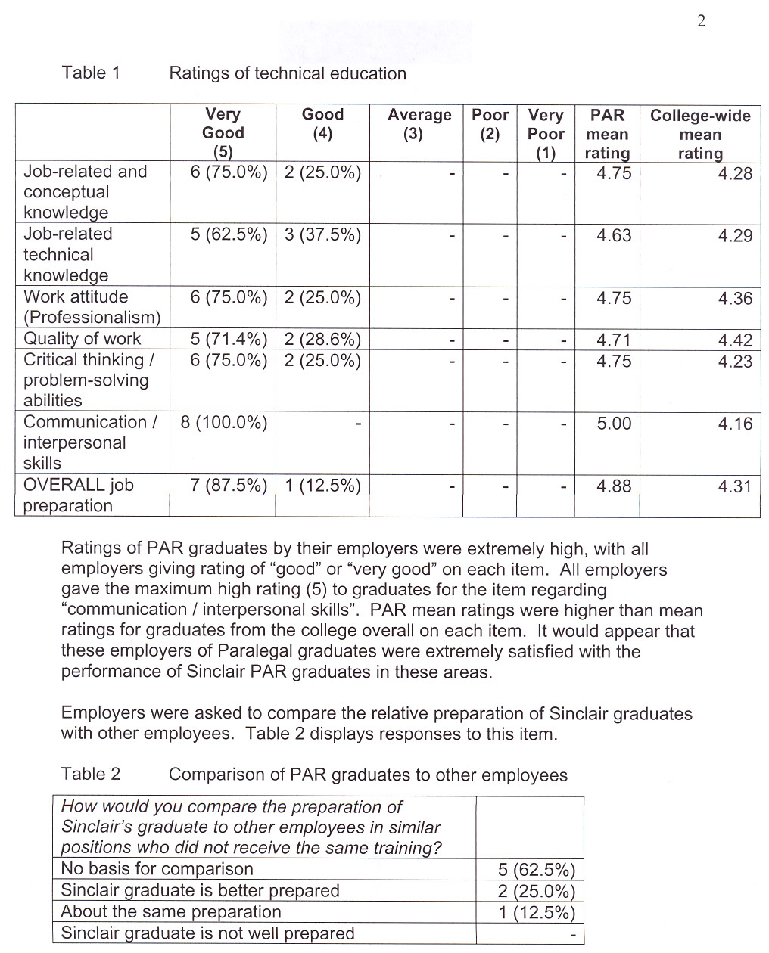
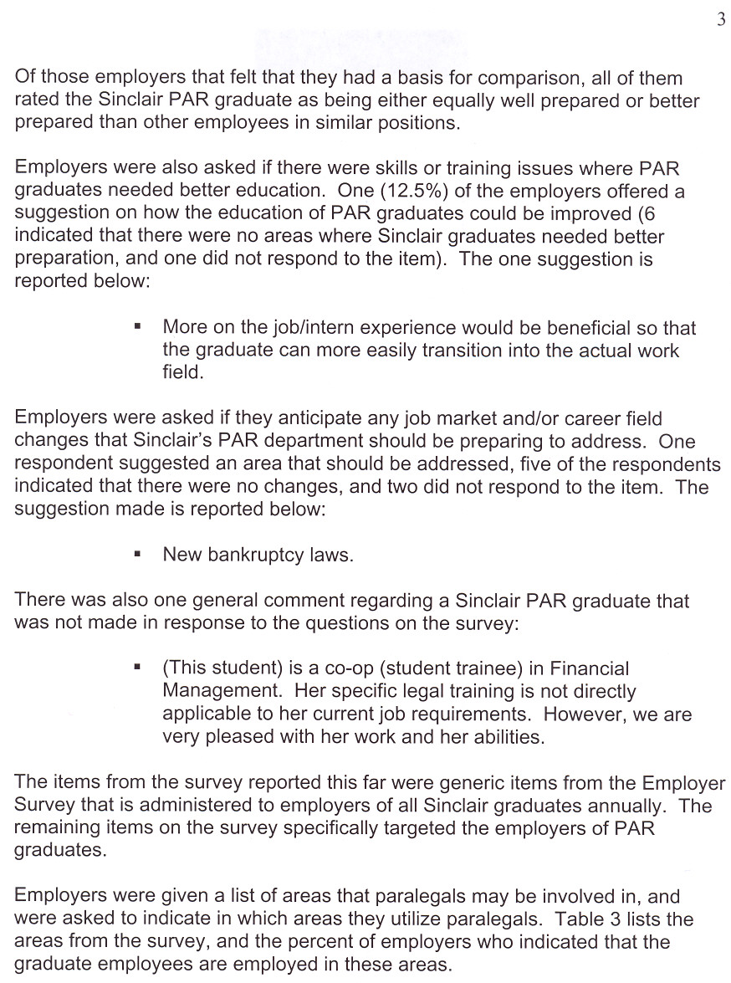
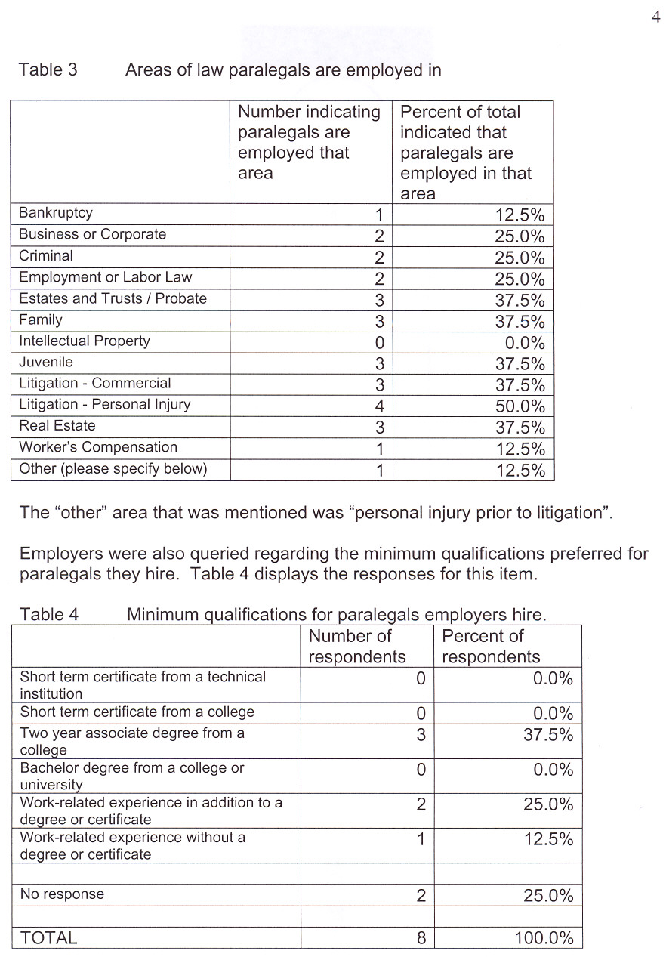
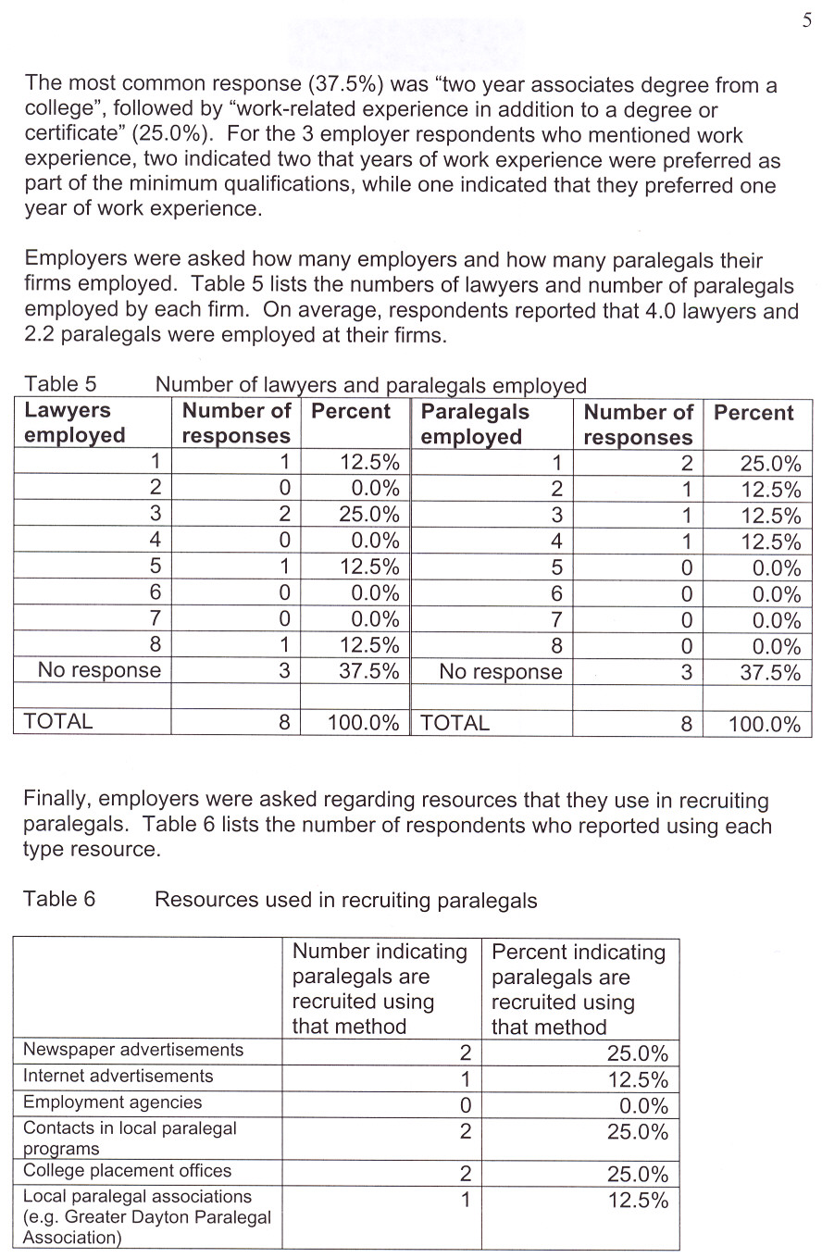
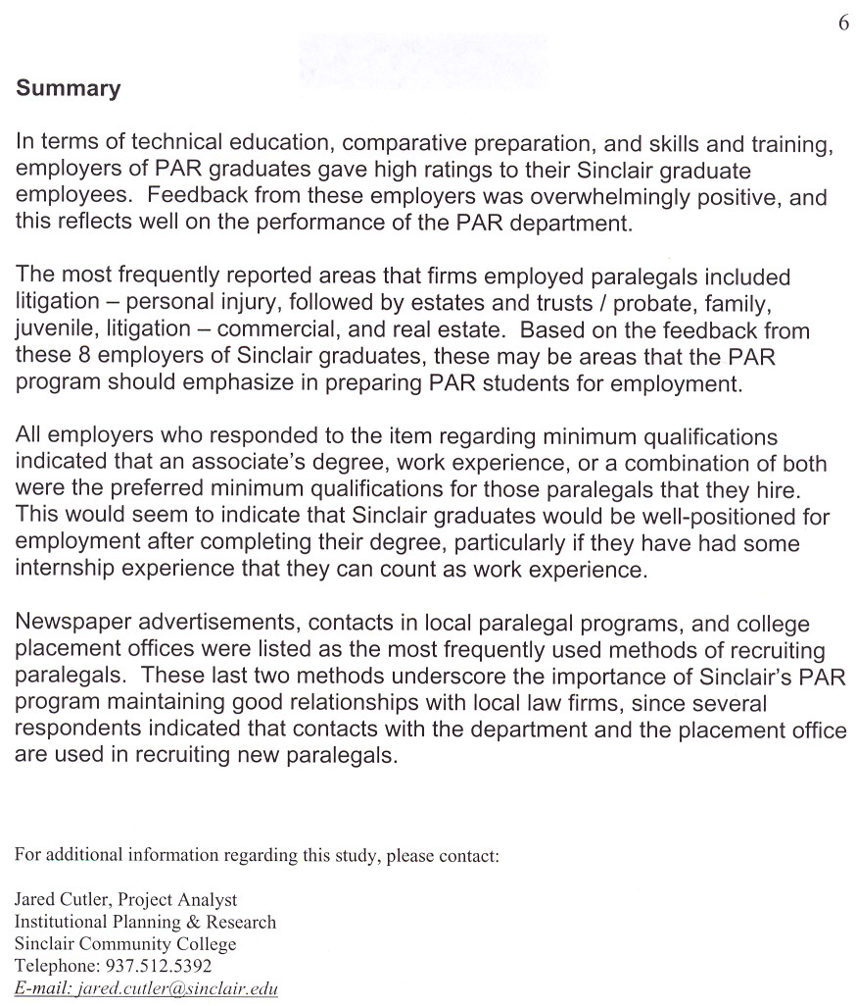
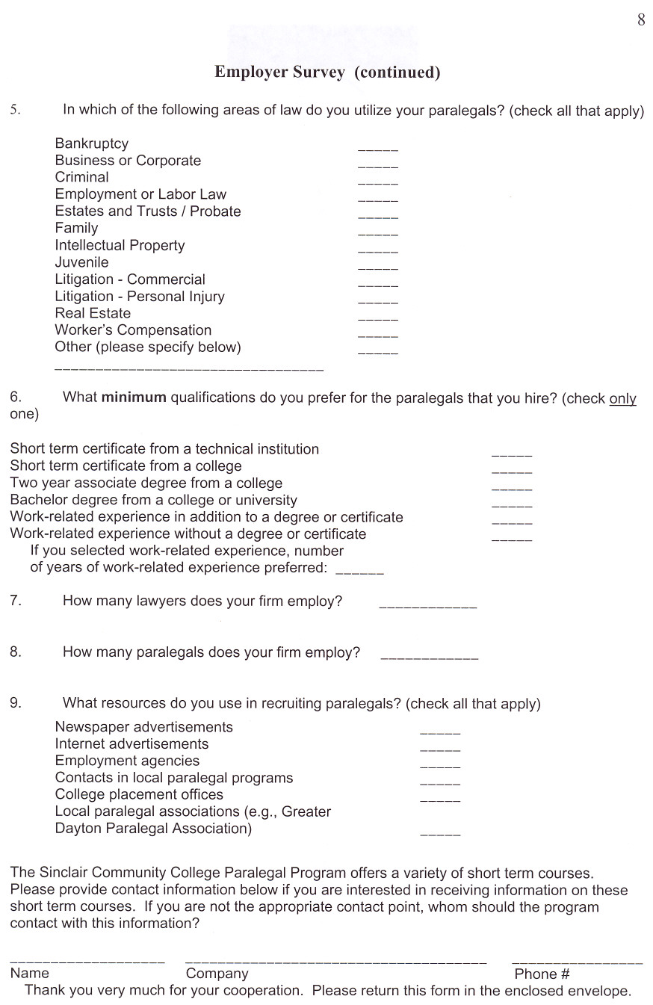

APPENDIX V

Responses to the Paralegal Program Graduate Survey -

Spring 2005

Office of Institutional Planning & Research
Sinclair Community College, 444 West Third Street, Dayton, Ohio 45402-1460



Responses to the Paralegal Program Graduate Survey

The Paralegal Program (PAR) at Sinclair Community College takes an active interest in preparing students for jobs in the legal field. Realizing that students who have recently graduated are an important source of information regarding the strengths and weaknesses of the PAR program, for the second consecutive year the PAR program requested that Institutional Planning and Research (IPR) assist them in the development and implementation of an on-line survey of recent graduates for feedback regarding areas where the program does a good job of preparing graduates for the workplace, and areas where improvements could be made.

Methods

E-mail messages were sent to the 20 recent graduates of the Paralegal Program from the 2003-2004 academic year. Each e-mail message contained an embedded link, and graduates who clicked on the link were directed to an internet survey. A reproduction of the internet survey can be found in the Appendix. A second e-mail was sent to non-respondents to encourage them to participate in the internet survey. Twelve of the 20 students responded for a response rate of 60%.

Results

Graduates were first asked to provide contact information, and were asked to provide the year that they graduated. Of the 12 graduates who responded, 2 (16.7%) had graduated in 2003, and 10 (83.3%) had graduated in 2004. Students were then given a number of possible employment statuses, and were asked to select as many as were applicable. The number of respondents who selected each option is presented in Table 1. Because respondents were allowed to select more than one option, the total will not sum to 100%.

Table 1 Number of Respondents Selecting Employment Status Options

 | Number | Percent
Working as a paralegal | 8 | 66.7%
Working in another capacity in the legal field | 1 | 8.3%
Continuing education | 2 | 16.7%
Still seeking employment | 1 | 8.3%
Working in another field | 2 | 16.7%
Other (please specify) | 1 | 8.3%

Two-thirds of respondents indicated that they were employed as a paralegal, while one worked in another capacity in the legal field, one was still seeking employment, and two were continuing their education. The one respondent who responded “other” for this item was “working for a temp agency”.

Graduates were then asked regarding their education plans. Responses are displayed in Table 2.

Table 2 Education Plans of Respondents

 | Number | Percent
I am currently seeking a bachelor’s degree | 2 | 16.7%
I plan to seek a bachelor’s degree in the future | 8 | 66.6%
I have no plans to obtain additional degrees | 2 | 16.7%

Eight of the 12 respondents planned on getting a bachelor’s degree, while two were currently pursuing one. Two of the twelve students had no plans to pursue a bachelor’s degree.

Table 3 lists the employers of the graduates, as indicated on the survey. Two graduates did not list employer’s names, one of whom was pursuing a bachelor’s degree and presumably wasn’t in the workforce.

Table 3 Employers of PAR Graduates
PAR Graduate Employers
Speedway SuperAmerica
Hammond, Stier & Stadnicar
Jablinski, Folino, Roberts & Martin
Miami Valley Fairhousing
Statman, Harris, Siegel & Eyrich
Utrecht & Young
Richard P. Arthur
Montgomery County Common Pleas Court
Wright Patterson Air Force Base
Gibney, Stephan, Barrett & Root

Table 4 lists the reported salaries of the 9 graduates who reporting working as paralegals or “working in another capacity in the field”. Five of these PAR graduates had salaries in the $25,000 to $29,999 range, and 2 had salaries in the $30,000 or higher range.

Table 4 Salaries of Graduates
 | Number | Percent
Less than $17,000 | 0 | 0.0%
$17,000-$19,999 | 0 | 0.0%
$20,000-$24,999 | 2 | 22.2%
$25,000-$29,999 | 5 | 55.6%
$30,000 or higher | 2 | 22.2%
Total | 9 | 100.0%

Respondents were then asked which areas of law they covered in their current position. Table 5 lists the different areas of law, and the number of graduates who were involved in each for those 9 students who were employed in the field. Note that since respondents were allowed to select more than one response, totals will not sum to 100.0%.

Table 5 Areas of Law Graduates Were Involved With

 | Number | Percent
Bankruptcy | 2 | 22.2%
Business or Corporate | 4 | 44.4%
Criminal | 2 | 22.2%
Employment or Labor Law | 1 | 11.1%
Estates and Trusts/Probate | 6 | 66.7%
Family | 3 | 33.3%
Intellectual Property | 0 | 0.0%
Juvenile | 3 | 33.3%
Litigation - Commercial | 3 | 33.3%
Litigation - Personal Injury | 5 | 55.6%
Real Estate | 5 | 55.6%
Worker's Compensation | 0 | 0.0%
Other, please specify:
Other – Civil Law | 1 | 11.1%
Other - Foreclosures | 1 | 11.1%

The most frequently cited areas of law that graduates were involved in included estates and trusts/probate (66.7%), litigation – personal injury (55.6%), and real estate (55.6%).

Graduates were then asked to indicate which tasks they perform as part of their current positions. Table 6 lists the responses for this item for those 9 graduates who were employed in the field. Once again, since graduates were allowed to select more than one option, totals will not sum to 100%. Legal research (100.0%), draft letters (100.0%), file organization (100.0%) and computer research (100.0%) were the four tasks most frequently selected by respondents.

Table 6 Tasks Performed by Paralegal Graduates
Tasks | Number | Percent
Legal Research | 9 | 100.0%
Interview clients/witnesses | 6 | 66.7%
Title Searches | 5 | 55.6%
Draft letters | 9 | 100.0%
File court papers | 8 | 88.9%
Draft pleadings | 8 | 88.9%
Trial preparation/assistance | 6 | 66.7%
Draft discovery | 5 | 55.6%
Digest medical records/depositions | 2 | 22.2%
Draft memoranda | 5 | 55.6%
File organization | 9 | 100.0%
Computer research | 9 | 100.0%
Computer timekeeping | 6 | 66.7%
Computer case management | 7 | 77.8%
Other (please specify)
Draft estate planning documents/probate estates | 1 | 11.1%
Electronic filing | 1 | 11.1%

Table 7 lists the number of the 9 graduates working in the field who indicated that they receive certain types of benefits at their current place of employment. A little over 55% of respondents indicated that they receive medical insurance, and two-thirds indicated that they receive life insurance. All respondents who were employed indicated that they receive paid vacation.

Table 7 Benefits that Graduates Receive
 | Number | Percent
Medical insurance | 5 | 55.6%
Life insurance | 6 | 66.7%
Retirement | 2 | 22.2%
Paid vacation | 9 | 100.0%

Table 8 lists the number of the 9 graduates working in the field whose employers provide support for continuing education or for professional memberships. While just over 40% of employers supported continuing education, few supported professional memberships.

Table 8 Continuing Education or Professional Memberships
 | Number | Percent
Continuing education | 4 | 44.4%
Membership in the Ohio Bar Association | 2 | 22.2%
Membership in the Dayton Bar Association | 1 | 11.1%
Membership in the Greater Dayton Paralegal Association | 2 | 22.2%
Table 9 lists many of the same professional organizations as were found in Table 8, but reports the number of graduates who indicated that they pay for their own membership. Of these professional organizations, only one respondent paid for a membership, and that was a membership in the Greater Dayton Paralegal Association.

Table 9 Graduates Paying for Professional Memberships
 | Number | Percent
Ohio Bar Association | 0 | 0.0%
Dayton Bar Association | 0 | 0.0%
Greater Dayton Paralegal Association | 1 | 8.3%
Other | 0 | 0.0%

Graduates were then asked how they found their current position, and were provided with a number of response options. Table 10 lists the number of the 9 graduates working in the field who selected each response. By far the most frequent response was “contacts at Sinclair Community College”.

Table 10 How Graduates Found their Current Position
Tasks | Number | Percent
Contacts at Sinclair Community College | 6 | 66.7%
Job advertisements in the local newspaper | 1 | 11.1%
Job advertisements on the internet | 0 | 0.0%
Professional associations (e.g. Greater Dayton Paralegal Association) | 0 | 0.0%
Word of mouth from friends or acquaintances | 2 | 22.2%
Other (please specify)
Legal Aid | 1 | 8.3%

Graduates were asked to rate their satisfaction with their current position. Responses are displayed in Table 11. All respondents in the legal field who responded to the item indicated that they were “very satisfied” with their current position.

Table 11 Satisfaction Ratings for Graduates
 | Number | Percent
Not at all satisfied | 0 | 0.0%
Somewhat satisfied | 0 | 0.0%
Very satisfied | 9 | 75.0%
Not currently employed in the paralegal field | 2 | 16.7%
No response | 1 | 8.3%
Those graduates who indicated that they were employed in the paralegal field were asked what factors contribute most to their job satisfaction. Responses for the 8 respondents who provided an answer can be found in Table 12.

Table 12 Factors Contributing to Job Satisfaction
The knowledge that I attained while attending Sinclair CC.
Family orientation/flexibility are high contributors to job satisfaction. I also enjoy the variety of work I perform.
The people I work with are all very friendly and treat you like family. I also enjoy being able to use the skills and knowledge I learned from earning my degree.
I am most dissatisfied with the starting salary for paralegals.
My supervising attorney is great to work with. The program at Sinclair has prepared me for just about anything in the legal field and has given me much confidence in knowing I can get the job done. I have even used my paralegal portfolio to assist an attorney in preparing a probate estate!
I am very satisfied with my current position. I really enjoy this area of the law and find that each case is different with its own challenges.
Having a legal background definitely helps in my current position.
I enjoy the client contact. It's a time in their lives when you usually see people at their worst. However, it's very satisfying to know that I can answer their questions with confidence and help them through the process. One of the most gratifying things is an adoption that is complete and being able to see the end result.

Graduates were provided a list of skill outcomes, and were asked to rate each in terms of its importance on a scale of 1 (not important), 2 (somewhat important) and 3 (very important). Table 13 lists the percent of the 9 PAR graduates working in the field giving each rating and the mean rating for the item. All of the 9 respondents felt that the ability to communicate clearly and concisely and the ability to exemplify a high standard of ethics and professionalism were “very important”. In addition, 7 of the respondents felt that the ability to apply critical thinking skills and the ability to utilize technological skills were “very important”.

Table 13 Importance of Various Skills in Current Position
 | Not important (1) | Somewhat important (2) | Very important (3) | Mean Rating
Prepare and analyze legal documents (i.e. family law, real estate, probate, business organization) | 0 (0.0%) | 1 (11.1%) | 8 (88.9%) | 2.89
Conduct legal research | 0 (0.0%) | 3 (33.3%) | 6 (66.7%) | 2.67
Apply critical thinking skills | 0 (0.0%) | 2 (22.2%) | 7(77.8%) | 2.78
Communicate clearly and concisely | 0 (0.0%) | 0 (0.0%) | 9 (100.0%) | 3.00
Utilize technological skills | 1 (11.1%) | 1 (11.1%) | 7 (88.9%) | 2.67
Exemplify a high standard of ethics and professionalism | 0 (0.0%) | 0 (0.0%) | 9 (100.0%) | 3.00

The remaining items on the PAR Graduate Survey were open-ended items where students were encouraged to discuss how the PAR program helped them and how improvements in the program could be made. Table 14 lists the 8 responses to the question “What are some specific ways that the PAR program helped in the above areas” (referring to the areas mentioned in Table 13). Some of the respondents mentioned the hands on nature of the instruction that they received while at Sinclair, while others mentioned the role that the development of critical thinking played in preparing them for their current jobs.

Table 14 Ways that the PAR Program Helped
Critical Thinking skills allow you to broaden your views on how things can be perceived.
The Probate and Litigation classes helped prepare me on how to prepare pleadings. Real Estate classes helped me to know how to prepare HUD-1s.
The PAR program gave me actual experience in completing the different task such as preparing legal document that would be prepared in an actual law firm, doing actual legal research and using the technology that is used in a law firm. The classroom environment was similar to an office environment in that you had to communicate with your instructors and you had to maintain a high standard of ethics and professionalism with them as you would in an actual law firm.
All of the areas mentioned above helped me.
I have to constantly do research and I know how to find my answer with no problems. It might take me a little longer on some tasks but eventually I find what I am looking for. All of the clients I come into contact with tell Tom how great I am to work with and how professional I am. Even the attorneys I do not work directly with come to me to help on research.
The PAR program helped in the hands on training. We were not just reading in a book what tasks we would be performing, we actually drafted pleadings and letters, and went to the library to do research.
I believe that the hands on exercises, homework, and projects that had to be completed were the best teaching tool. I benefited from learning these tasks knowing that the projects given were actually what we would one day being doing as paralegals.
I truly believe that the critical thinking questions and self-assessments were the most important in helping me to understand the legal field and what is required in each task. You begin to look at each task in a way that makes you think, "What is it that I need to do, find, prepare, look at, etc., and how am I going to accomplish the task as hand."

Table 15 displays the 8 responses to the item “what are some specific things that the PAR program can do to improve in the above areas?”. Several of the respondents felt that the PAR program is doing a great job and had no suggestions for improvement. Specific suggestions for improvement included training in Westlaw, more emphasis on ethics and professionalism, more training on how to draft a pleading in the correct way, and more training in family law.

Table 15 Ways that the PAR Program Can Be Improved
More hands on work that is directly related to the paralegal.
Split the Lexus class to also teach Westlaw.
I don't have any specific improvements just keep up the good work and continue to give the students the hands on experience.
None.
Stress more to the students the importance of ethics and professionalism. I do not think that many of the students know how serious ethics and professionalism are in the legal field. Maybe you can have more days where students have to dress up and maybe even show them real examples of paralegals that have gotten into trouble for not being ethical or maybe even stressing how important it is to keep files and document out of the sight of other clients.
I believe the program was very good. Since there are so many different areas paralegals work in it is hard to say that what could have been covered more closely without being on the job and seeing what specifically I could have used.
After working for the courts I would encourage everyone to know how important it is to draft a pleading in the correct way for that particular court/Judge. I am amazed at how many pleadings that come across my desk that are incorrect.
I believe that the family law program needs to be extended. There are so many entities within the scope of that field. It could easily be developed into a I and II course. (Okay, not "easily" developed, but the possibilities are there).

Table 16 lists the 8 responses for the item “Are there any additional courses or topics that would have benefited you in your current position?”. Each of the 8 responses to this item listed a different topic that would have been helpful.

Table 16 Additional Courses and Topics that would have Helped
Teach more on Annuities and 1099/1041 for Probate issues.
In my current position I would have benefited more from a more detailed class on taxes, estate and income.
The Real Estate II course I took in 2001 was horrible. I understand it has been revamped, I may have to audit the course.
No, the program was excellent. There are 2 other paralegals here that did not get degrees at Sinclair and everyone comes to me for questions!!!!
I would be interested in learning more about Probate. The course I took seemed to pack too much info for me to digest and apply. Also, minor's settlements and wrongful death scenarios.
Estate Planning and a class for QDRO preparation.
At the present time there are not any additional courses that would have been beneficial.
Refer to question 17 (I believe that the family law program needs to be extended. There are so many entities within the scope of that field. It could easily be developed into a I and II course. (Okay, not "easily" developed, but the possibilities are there)).

There were no responses to the item “if you perform work as a paralegal on a freelance or independent contractor basis, please answer the following questions”. Since apparently none of the PAR graduates worked on a freelance or independent contractor basis, there were no responses to the options that followed.

Finally, PAR graduates were given the opportunity to provide any comments that they wanted to make. Table 17 lists the responses to this item. All of the 6 respondents who answered this question expressed positive feelings regarding the PAR program and the level of preparation that they received.

Table 17 Additional Comments
Sinclair has an excellent program, and helpful instructors.
It is a great program. It really prepared me for the future. I now take everything seriously and always try to do my best, even if it does not matter.
I believe I was very well prepared by the Sinclair Paralegal Program. The internships are an invaluable part of this program. Thank you!
I think the paralegal program is an excellent program. I am not sure if the Consumer Law class is offered as an elective, but that class would be an interesting class to have had.
Thanks for everything the program has taught me!
All I remember is being terrified and totally confused in PAR105. The time you spent helping me and even making it tough (many, many times) is what has prepared me. I thank all of you - you restored my confidence in me. What a wonderful gift!

The on-line survey in its entirety is reproduced in the Appendix.

APPENDIX
PAR GRADUATE SURVEY

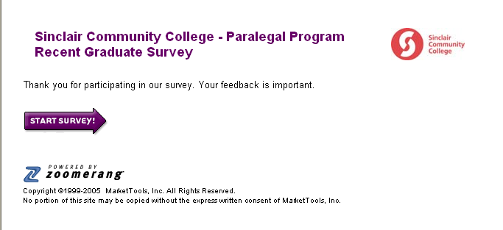

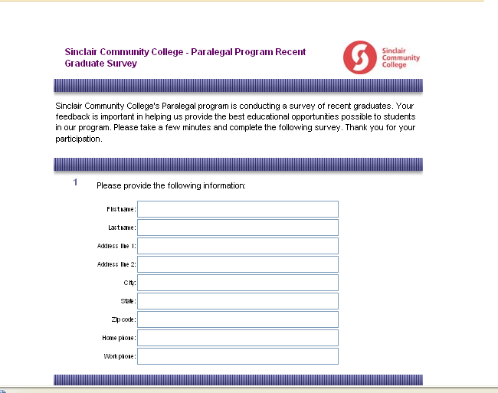

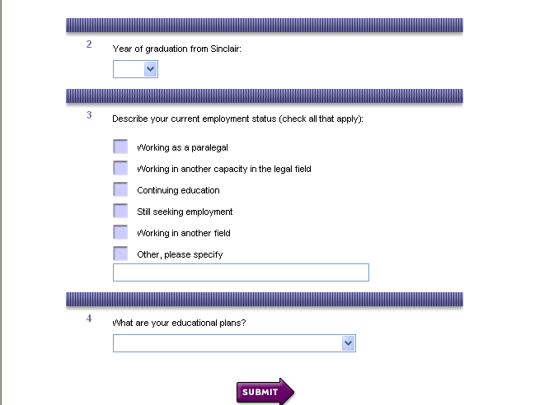

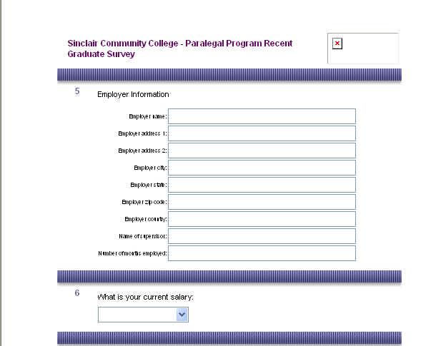

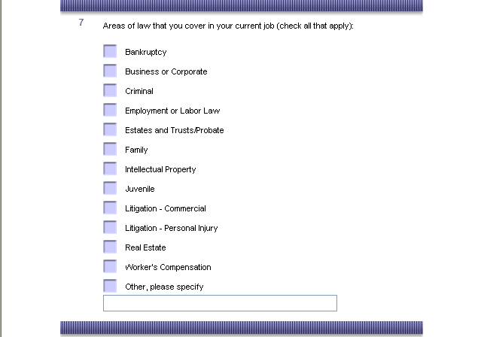

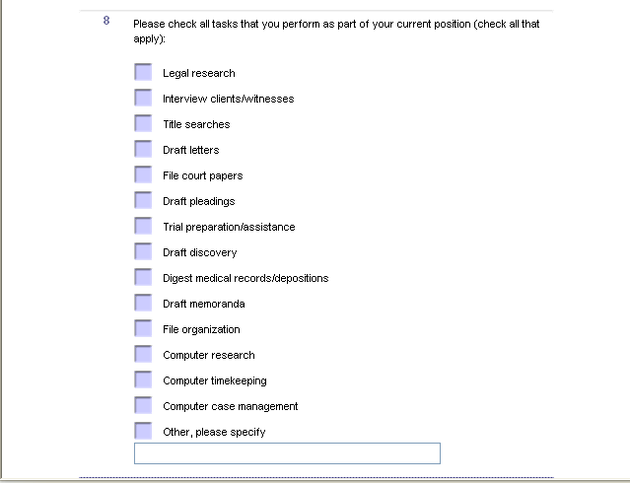

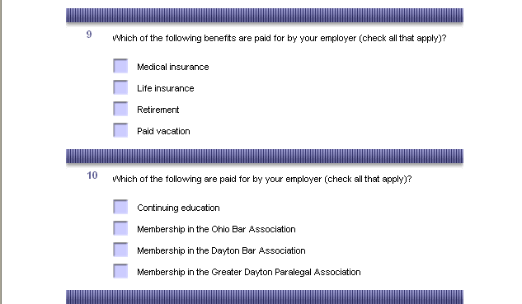

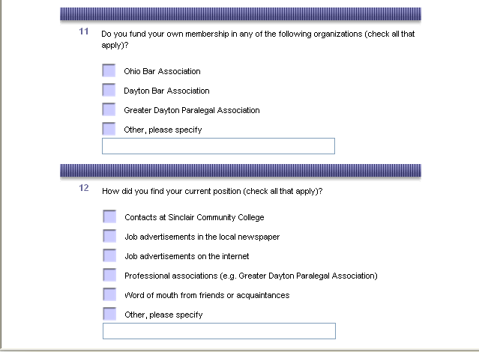

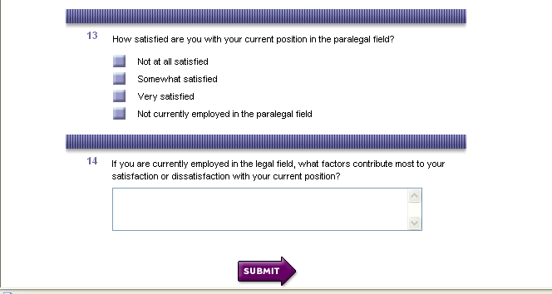

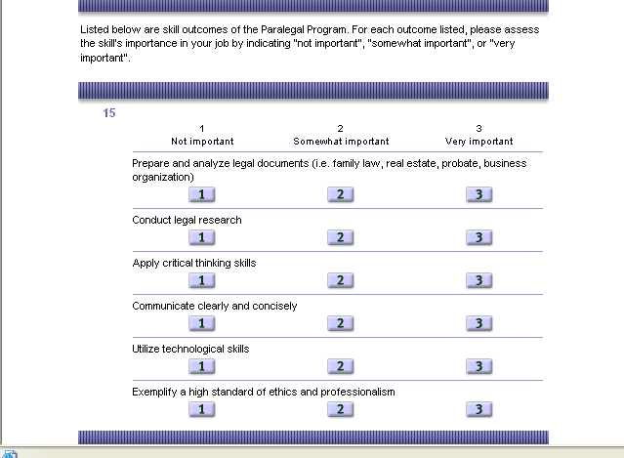

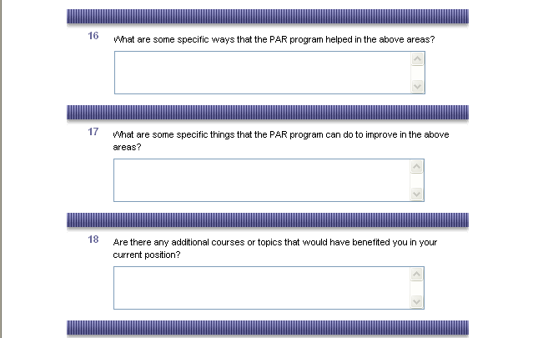

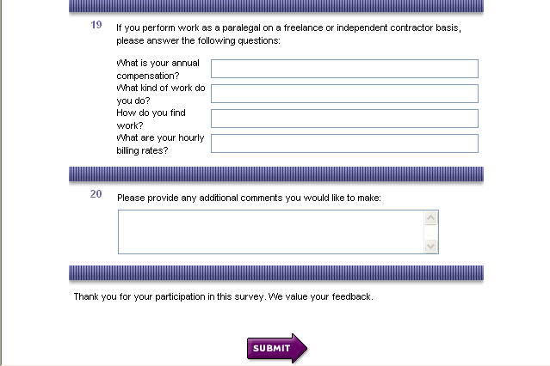

APPENDIX VI

Internship Supervisor Evaluations
PERSONAL CHARACTERISTICS
Fall 2002
 | 0 | 1 | 2 | 3 | 4 | 5
 | Doesn’t apply | Poor | Fair | Satisfactory | Good | Excellent
Professional Appearance | 0 | 0 | 1 | 1 | 2 | 10
Punctuality | 0 | 0 | 0 | 4 | 1 | 9
Professional Demeanor | 0 | 0 | 0 | 4 | 1 | 9
Dependability | 0 | 0 | 0 | 3 | 2 | 9
Spring 2003
 | 0 | 1 | 2 | 3 | 4 | 5
 | Doesn’t apply | Poor | Fair | Satisfactory | Good | Excellent
Professional Appearance | 0 | 0 | 0 | 0 | 7 | 18
Punctuality | 0 | 0 | 0 | 0 | 4 | 21
Professional Demeanor | 0 | 0 | 1 | 0 | 5 | 18
Dependability | 0 | 1 | 0 | 0 | 3 | 19
Fall 2003
 | 0 | 1 | 2 | 3 | 4 | 5
 | Doesn’t apply | Poor | Fair | Satisfactory | Good | Excellent
Professional Appearance |  |  |  | 1 | 3 | 3
Punctuality |  |  | 1 |  | 2 | 4
Professional Demeanor |  | 1 |  | 1 | 1 | 4
Dependability |  | 1 |  |  | 3 | 3
Summer 2003
 | Doesn’t apply | Poor | Fair | Satisfactory | Good | Excellent
Professional Appearance | 0 | 0 | 0 | 1 | 2 | 3
Punctuality | 0 | 0 | 0 | 0 | 0 | 6
Professional Demeanor | 0 | 0 | 0 | 0 | 1 | 5
Dependability | 0 | 0 | 0 | 0 | 0 | 6
Spring 2004
 | 0 | 1 | 2 | 3 | 4 | 5
 | Doesn’t apply | Poor | Fair | Satisfactory | Good | Excellent
Professional Appearance | 0 | 0 | 0 | 0 | 7 | 18
Punctuality | 0 | 0 | 0 | 0 | 4 | 21
Professional Demeanor | 0 | 0 | 1 | 0 | 5 | 18
Dependability | 0 | 1 | 0 | 0 | 3 | 19
Summer 2004
 | 0 | 1 | 2 | 3 | 4 | 5
 | Doesn’t apply | Poor | Fair | Satisfactory | Good | Excellent
Professional Appearance |  |  |  | 1 | 4 | 9
Punctuality | 1 |  |  |  | 1 | 12
Professional Demeanor |  |  |  | 1 | 4 | 9
Dependability |  |  |  |  | 2 | 12
Fall 2004
 | 0 | 1 | 2 | 3 | 4 | 5
 | Doesn’t apply | Poor | Fair | Satisfactory | Good | Excellent
Professional Appearance | 0 | 0 | 0 | 0 | 4 | 4
Punctuality | 1 | 0 | 0 | 0 | 1 | 6
Professional Demeanor | 0 | 0 | 0 | 1 | 2 | 5
Dependability | 0 | 0 | 1 | 0 | 2 | 5
Winter 2005
 | Doesn’t apply | Poor | Fair | Satisfactory | Good | Excellent
Professional Appearance | 1 | 0 | 0 | 0 | 1 | 21
Punctuality | 0 | 0 | 0 | 0 | 3 | 20
Professional Demeanor | 1 | 0 | 0 | 0 | 5 | 17
Dependability | 0 | 0 | 0 | 0 | 4 | 19
Spring 2005
 | Doesn’t apply | Poor | Fair | Satisfactory | Good | Excellent
Professional Appearance | 2 | 0 | 1 | 1 | 6 | 12
Punctuality | 3 | 1 | 1 | 1 | 2 | 14
Professional Demeanor | 0 | 0 | 2 | 1 | 5 | 14
Dependability | 1 | 1 | 1 | 0 | 2 | 17
Summer 2005
 | Doesn’t apply | Poor | Fair | Satisfactory | Good | Excellent
Professional Appearance | 3 | 0 | 0 | 0 | 9 | 6
Punctuality | 3 | 0 | 0 | 2 | 1 | 12
Professional Demeanor | 1 | 0 | 0 | 1 | 9 | 7
Dependability | 0 | 0 | 0 | 1 | 6 | 11
Fall 2005
 | 0 | 1 | 2 | 3 | 4 | 5
 | Doesn’t apply | Poor | Fair | Satisfactory | Good | Excellent
Professional Appearance |  |  |  |  | 1 | 8
Punctuality |  |  |  |  | 1 | 8
Professional Demeanor |  |  |  |  | 3 | 6
Dependability |  |  |  |  | 1 | 8
 | Doesn’t apply | Poor | Fair | Satisfactory | Good | Excellent
TOTAL | 17 | 6 | 10 | 25 | 127 | 473

Internship Supervisor Evaluations
PROFESSIONAL CHARACTERISTICS.
Fall 2002 | 0  Doesn’t apply | 1  Poor | 2  Fair | 3  Satisfactory | 4  Good | 5  Excellent
Ability to follow instructions | 0 | 0 | 1 | 3 | 1 | 8
Relationship with staff | 0 | 0 | 2 | 1 | 5 | 7
Ability to understand legal concerns | 0 | 0 | 0 | 1 | 4 | 9
Willingness to accept delegation of tasks | 0 | 0 | 0 | 2 | 3 | 9
Spring 2003 | 0  Doesn’t apply | 1  Poor | 2  Fair | 3  Satisfactory | 4  Good | 5  Excellent
Ability to follow instructions | 0 | 0 | 1 | 1 | 5 | 17
Relationship with staff | 0 | 0 | 0 | 0 | 6 | 19
Ability to understand legal concerns | 0 | 0 | 1 | 0 | 11 | 13
Willingness to accept delegation of tasks | 1 | 0 | 0 | 0 | 4 | 20
Fall 2003 | 0  Doesn’t apply | 1  Poor | 2  Fair | 3  Satisfactory | 4  Good | 5  Excellent
Ability to follow instructions | 0 |  |  | 2 | 1 | 4
Relationship with staff | 0 | 1 |  | 1 | 1 | 4
Ability to understand legal concerns | 0 |  |  | 1 |  | 6
Willingness to accept delegation of tasks | 0 |  |  |  | 3 | 4
Summer 2003 | 0  Doesn’t apply | 1  Poor | 2  Fair | 3  Satisfactory | 4  Good | 5  Excellent
Ability to follow instructions | 0 | 0 | 0 | 0 | 1 | 5
Relationship with staff | 0 | 0 | 0 | 0 | 0 | 6
Ability to understand legal concerns | 0 | 0 | 0 | 0 | 2 | 4
Willingness to accept delegation of tasks | 0 | 0 | 0 | 0 | 0 | 6
Spring 2004 | 0  Doesn’t apply | 1  Poor | 2  Fair | 3  Satisfactory | 4  Good | 5  Excellent
Ability to follow instructions | 0 | 0 | 0 | 1 | 7 | 6
Relationship with staff | 1 | 0 | 0 | 0 | 5 | 8
Ability to understand legal concerns | 0 | 0 | 0 | 1 | 5 | 8
Willingness to accept delegation of tasks | 0 | 0 | 0 | 0 | 5 | 9
Summer 2004 | 0  Doesn’t apply | 1  Poor | 2  Fair | 3  Satisfactory | 4  Good | 5  Excellent
Ability to follow instructions | 0 | 0 | 0 | 1 | 7 | 6
Relationship with staff | 1 | 0 | 0 | 0 | 5 | 8
Ability to understand legal concerns | 0 | 0 | 0 | 1 | 5 | 8
Willingness to accept delegation of tasks | 0 | 0 | 0 | 0 | 5 | 9
Fall 2003 | 0  Doesn’t apply | 1  Poor | 2  Fair | 3  Satisfactory | 4  Good | 5  Excellent
Ability to follow instructions | 0 | 0 | 1 | 1 | 2 | 4
Relationship with staff | 0 | 0 | 0 | 1 | 1 | 6
Ability to understand legal concerns | 0 | 0 | 0 | 2 | 3 | 3
Willingness to accept delegation of tasks | 0 | 0 | 0 | 1 | 0 | 7
Winter 2005 | 0  Doesn’t apply | 1  Poor | 2  Fair | 3  Satisfactory | 4  Good | 5  Excellent
Ability to follow instructions | 0 | 0 | 0 | 2 | 5 | 14
Relationship with staff | 1 | 0 | 0 | 0 | 3 | 17
Ability to understand legal concerns | 0 | 0 | 0 | 2 | 5 | 14
Willingness to accept delegation of tasks | 1 | 0 | 0 | 0 | 1 | 19
Spring 2005 | 0  Doesn’t apply | 1  Poor | 2  Fair | 3  Satisfactory | 4  Good | 5  Excellent
Ability to follow instructions | 1 | 0 | 0 | 0 | 6 | 14
Relationship with staff | 3 | 0 | 0 | 2 | 6 | 11
Ability to understand legal concerns | 2 | 0 | 0 | 0 | 10 | 12
Willingness to accept delegation of tasks | 2 | 0 | 0 | 0 | 6 | 16
Summer 2005 | 0  Doesn’t apply | 1  Poor | 2  Fair | 3  Satisfactory | 4  Good | 5  Excellent
Ability to follow instructions | 1 | 0 | 1 | 1 | 4 | 10
Relationship with staff | 3 | 0 | 0 | 0 | 4 | 10
Ability to understand legal concerns | 1 | 0 | 0 | 2 | 5 | 9
Willingness to accept delegation of tasks | 1 | 0 | 0 | 0 | 7 | 9
Fall 2005 | 0  Doesn’t apply | 1  Poor | 2  Fair | 3  Satisfactory | 4  Good | 5  Excellent
Ability to follow instructions | 0 | 0 | 0 | 1 | 0 | 8
Relationship with staff | 0 | 0 | 0 | 1 | 3 | 5
Ability to understand legal concerns | 0 | 0 | 0 | 0 | 5 | 4
Willingness to accept delegation of tasks | 0 | 0 | 0 | 0 | 1 | 8
TOTAL | Doesn’t apply | Poor | Fair | Satisfactory | Good | Excellent
TOTAL | 19 | 1 | 6 | 28 | 168 | 403

Internship Supervisor Evaluations
QUALITY OF WORK
Fall 2002 | 0  Doesn’t apply | 1  Poor | 2  Fair | 3  Satisfactory | 4  Good | 5  Excellent
Written communication Skills | 0 | 0 | 1 | 3 | 4 | 6
Oral communications skills | 0 | 1 | 0 | 3 | 3 | 7
Accuracy and thoroughness of work | 0 | 0 | 1 | 3 | 3 | 7
Initiative | 0 | 0 | 1 | 0 | 4 | 9
Ability to apply legal concepts | 0 | 0 | 1 | 2 | 2 | 9
Spring 2005 | 0  Doesn’t apply | 1  Poor | 2  Fair | 3  Satisfactory | 4  Good | 5  Excellent
Written communication Skills | 1 | 0 | 1 | 2 | 9 | 10
Oral communications skills | 1 | 0 | 0 | 2 | 9 | 12
Accuracy and thoroughness of work | 0 | 0 | 1 | 1 | 9 | 11
Initiative | 1 | 0 | 1 | 1 | 4 | 21
Ability to apply legal concepts | 0 | 0 | 1 | 1 | 8 | 12
Fall 2003 | 0  Doesn’t apply | 1  Poor | 2  Fair | 3  Satisfactory | 4  Good | 5  Excellent
Written communication Skills | 0 | 0 | 0 | 0 | 2 | 5
Oral communications skills | 0 | 0 | 0 | 1 | 2 | 4
Accuracy and thoroughness of work | 0 | 0 | 0 | 0 | 4 | 3
Initiative | 0 | 0 | 0 | 1 | 2 | 4
Ability to apply legal concepts | 0 | 0 | 0 | 0 | 1 | 6
Summer 2003 | 0  Doesn’t apply | 1  Poor | 2  Fair | 3  Satisfactory | 4  Good | 5  Excellent
Written communication Skills | 0 | 0 | 0 | 0 | 0 | 5
Oral communications skills | 0 | 0 | 0 | 0 | 1 | 4
Accuracy and thoroughness of work | 0 | 0 | 0 | 0 | 2 | 4
Initiative | 0 | 0 | 0 | 0 | 2 | 4
Ability to apply legal concepts | 0 | 0 | 0 | 0 | 2 | 4
Spring 2004 | 0  Doesn’t apply | 1  Poor | 2  Fair | 3  Satisfactory | 4  Good | 5  Excellent
Written communication Skills | 1 | 0 | 1 | 2 | 9 | 10
Oral communications skills | 1 | 0 | 0 | 2 | 9 | 12
Accuracy and thoroughness of work | 0 | 0 | 1 | 1 | 9 | 11
Initiative | 1 | 0 | 1 | 1 | 4 | 21
Ability to apply legal concepts | 0 | 0 | 1 | 1 | 8 | 12
Summer 2004 | 0  Doesn’t apply | 1  Poor | 2  Fair | 3  Satisfactory | 4  Good | 5  Excellent
Written communication Skills | 1 | 0 | 0 | 1 | 7 | 5
Oral communications skills | 1 | 0 | 0 | 1 | 9 | 3
Accuracy and thoroughness of work | 1 | 0 | 0 | 1 | 6 | 6
Initiative | 1 | 0 | 0 | 1 | 5 | 7
Ability to apply legal concepts | 1 | 0 | 0 | 2 | 7 | 4
Fall 2004 | 0  Doesn’t apply | 1  Poor | 2  Fair | 3  Satisfactory | 4  Good | 5  Excellent
Written communication Skills | 1 | 0 | 0 | 1 | 4 | 2
Oral communications skills | 0 | 0 | 0 | 0 | 4 | 4
Accuracy and thoroughness of work | 0 | 0 | 2 | 0 | 3 | 3
Initiative | 0 | 1 | 0 | 1 | 0 | 6
Ability to apply legal concepts | 2 | 0 | 1 | 1 | 1 | 3
Winter 2005 | 0  Doesn’t apply | 1  Poor | 2  Fair | 3  Satisfactory | 4  Good | 5  Excellent
Written communication Skills | 2 | 0 | 0 | 0 | 8 | 11
Oral communications skills | 3 | 1 | 0 | 1 | 5 | 11
Accuracy and thoroughness of work | 1 | 0 | 0 | 0 | 10 | 10
Initiative | 0 | 0 | 0 | 2 | 3 | 16
Ability to apply legal concepts | 1 | 0 | 1 | 0 | 5 | 14
Spring 2005 | 0  Doesn’t apply | 1  Poor | 2  Fair | 3  Satisfactory | 4  Good | 5  Excellent
Written communication Skills | 2 | 0 | 0 | 1 | 6 | 14
Oral communications skills | 0 | 0 | 0 | 1 | 9 | 14
Accuracy and thoroughness of work | 0 | 0 | 1 | 2 | 10 | 11
Initiative | 1 | 0 | 0 | 3 | 6 | 14
Ability to apply legal concepts | 3 | 0 | 0 | 0 | 10 | 11
Summer 2005 | 0  Doesn’t apply | 1  Poor | 2  Fair | 3  Satisfactory | 4  Good | 5  Excellent
Written communication Skills | 3 | 0 | 0 | 0 | 5 | 8
Oral communications skills | 2 | 0 | 1 | 1 | 8 | 4
Accuracy and thoroughness of work | 1 | 0 | 0 | 1 | 8 | 6
Initiative | 1 | 0 | 0 | 1 | 3 | 11
Ability to apply legal concepts | 4 | 0 | 0 | 1 | 4 | 7
Fall 2005 | 0  Doesn’t apply | 1  Poor | 2  Fair | 3  Satisfactory | 4  Good | 5  Excellent
Written communication Skills | 0 | 0 | 0 | 0 | 3 | 6
Oral communications skills | 0 | 0 | 0 | 0 | 3 | 6
Accuracy and thoroughness of work | 0 | 0 | 0 | 1 | 3 | 5
Initiative | 0 | 0 | 0 | 0 | 2 | 7
Ability to apply legal concepts | 0 | 0 | 0 | 0 | 5 | 4
TOTAL | Doesn’t apply | Poor | Fair | Satisfactory | Good | Excellent
 | 38 | 3 | 18 | 51 | 274 | 446

Internship Supervisor Evaluations
Specific Tasks
Spring 2003 | 0  Doesn’t apply | 1  Poor | 2  Fair | 3  Satisfactory | 4  Good | 5  Excellent
Legal research | 5 | 0 | 1 | 0 | 8 | 10
Client interviews | 15 | 0 | 0 | 1 | 3 | 5
Record documents | 10 | 0 | 0 | 2 | 2 | 10
Correspondence | 7 | 0 | 1 | 1 | 8 | 7
Draft documents | 9 | 0 | 0 | 1 | 4 | 10
Factual research | 6 | 0 | 1 | 1 | 4 | 11
Trial notebook preparation | 16 | 0 | 0 | 0 | 4 | 4
Summarize depositions | 18 | 0 | 0 | 1 | 3 | 2
Organize files | 7 | 0 | 0 | 1 | 4 | 12
Fall 2003 | 0  Doesn’t apply | 1  Poor | 2  Fair | 3  Satisfactory | 4  Good | 5  Excellent
Legal research | 1 | 0 | 0 | 0 | 1 | 4
Client interviews | 4 | 0 | 0 | 0 | 1 | 1
Record documents | 2 | 0 | 0 | 1 | 1 | 2
Correspondence | 0 | 0 | 0 | 2 | 1 | 3
Draft documents | 0 | 0 | 0 | 1 | 1 | 4
Factual research | 2 | 0 | 0 | 0 | 1 | 3
Trial notebook preparation | 4 | 0 | 0 | 0 | 0 | 2
Summarize depositions | 5 | 0 | 0 | 0 | 0 | 1
Organize files | 3 | 0 | 0 | 0 | 0 | 4
Summer 2003 | 0  Doesn’t apply | 1  Poor | 2  Fair | 3  Satisfactory | 4  Good | 5  Excellent
Legal research | 1 | 0 | 0 | 0 | 1 | 5
Client interviews | 6 | 0 | 0 | 0 | 0 | 1
Record documents | 5 | 0 | 0 | 0 | 1 | 1
Correspondence | 4 | 0 | 0 | 0 | 1 | 2
Draft documents | 3 | 0 | 0 | 0 | 0 | 4
Factual research | 2 | 0 | 0 | 0 | 0 | 5
Trial notebook preparation | 4 | 0 | 0 | 0 | 2 | 1
Summarize depositions | 6 | 0 | 0 | 0 | 0 | 1
Organize files | 3 | 0 | 0 | 0 | 1 | 3
Spring 2004 | 0  Doesn’t apply | 1  Poor | 2  Fair | 3  Satisfactory | 4  Good | 5  Excellent
Legal research | 5 | 0 | 1 | 0 | 8 | 10
Client interviews | 15 | 0 | 0 | 1 | 3 | 5
Record documents | 10 | 0 | 0 | 2 | 2 | 10
Correspondence | 7 | 0 | 1 | 1 | 8 | 7
Draft documents | 9 | 0 | 0 | 1 | 4 | 10
Factual research | 6 | 0 | 1 | 1 | 4 | 11
Trial notebook preparation | 16 | 0 | 0 | 0 | 4 | 4
Summarize depositions | 18 | 0 | 0 | 1 | 3 | 2
Organize files | 7 | 0 | 0 | 1 | 4 | 12
Summer 2004 | 0  Doesn’t apply | 1  Poor | 2  Fair | 3  Satisfactory | 4  Good | 5  Excellent
Legal research | 5 | 0 | 0 | 2 | 3 | 4
Client interviews | 9 | 0 | 0 | 0 | 4 | 1
Record documents | 9 | 0 | 0 | 0 | 0 | 5
Correspondence | 6 | 0 | 0 | 0 | 2 | 6
Draft documents | 2 | 0 | 0 | 0 | 6 | 6
Factual research | 4 | 0 | 0 | 0 | 6 | 4
Trial notebook preparation | 12 | 0 | 0 | 0 | 0 | 2
Summarize depositions | 11 | 0 | 0 | 0 | 0 | 3
Organize files | 3 | 0 | 0 | 1 | 2 | 8
Fall 2004 | 0  Doesn’t apply | 1  Poor | 2  Fair | 3  Satisfactory | 4  Good | 5  Excellent
Legal research | 2 | 0 | 0 | 1 | 2 | 3
Client interviews | 7 | 0 | 0 | 0 | 0 | 1
Record documents | 5 | 0 | 0 | 0 | 0 | 3
Correspondence | 3 | 0 | 0 | 2 | 0 | 3
Draft documents | 1 | 0 | 1 | 1 | 1 | 4
Factual research | 1 | 0 | 0 | 1 | 0 | 6
Trial notebook preparation | 7 | 0 | 0 | 0 | 0 | 1
Summarize depositions | 7 | 0 | 0 | 0 | 0 | 1
Organize files | 1 | 0 | 1 | 1 | 0 | 5
Winter 2005 | 0  Doesn’t apply | 1  Poor | 2  Fair | 3  Satisfactory | 4  Good | 5  Excellent
Legal research | 3 | 1 | 0 | 3 |  | 15
Client interviews | 8 | 2 | 0 | 0 | 5 | 6
Record documents | 10 | 0 | 0 | 0 | 3 | 8
Correspondence | 4 | 0 | 0 | 0 | 5 | 12
Draft documents | 3 | 0 | 0 | 1 | 3 | 14
Factual research | 4 | 1 | 0 | 0 | 1 | 15
Trial notebook preparation | 16 | 0 | 0 | 0 | 0 | 5
Summarize depositions | 18 | 0 | 0 | 0 | 0 | 3
Organize files | 4 | 0 | 0 | 2 | 1 | 14
Spring 2005 | 0  Doesn’t apply | 1  Poor | 2  Fair | 3  Satisfactory | 4  Good | 5  Excellent
Legal research | 6 | 0 | 0 | 0 | 6 | 12
Client interviews | 22 | 0 | 0 | 0 | 1 | 1
Record documents | 17 | 0 | 0 | 0 | 3 | 4
Correspondence | 12 | 0 | 0 | 2 | 5 | 5
Draft documents | 5 | 0 | 0 | 2 | 8 | 9
Factual research | 9 | 0 | 0 | 2 | 2 | 11
Trial notebook preparation | 17 | 0 | 0 | 1 | 1 | 5
Summarize depositions | 22 | 0 | 0 | 1 | 1 | 0
Organize files | 10 | 0 | 0 | 1 | 2 | 11
Summer 2005
MISSING DATA
Fall 2005 | 0  Doesn’t apply | 1  Poor | 2  Fair | 3  Satisfactory | 4  Good | 5  Excellent
Legal research | 1 | 0 | 0 | 0 | 2 | 6
Client interviews | 7 | 0 | 0 | 0 | 1 | 0
Record documents | 4 | 0 | 0 | 1 | 1 | 3
Correspondence | 2 | 0 | 0 | 1 | 3 | 2
Draft documents | 1 | 0 | 0 | 0 | 3 | 5
Factual research | 5 | 0 | 0 | 0 | 1 | 3
Trial notebook preparation | 8 | 0 | 0 | 0 | 0 | 1
Summarize depositions | 8 | 0 | 0 | 0 | 0 | 1
Organize files | 2 | 0 | 0 | 0 | 1 | 5
TOTAL | Doesn’t apply | Poor | Fair | Satisfactory | Good | Excellent
TOTAL | 251 | 1 | 4 | 14 | 60 | 169

APPENDIX VII

ANALYSIS OF ENVIRONMENTAL FACTORS
Department: | PAR
Who are your key stakeholders (internal/external) | How do you know if you are meeting their needs? | What challenges or support concerns do you have? Who feeds your program? Which courses departments outside of your own are you reliant on for educating students in your programs? | What opportunities exist to help your stakeholders that you are not currently exploring? How do you know? | What data are you currently using to inform your decision making? Where is your data weakest? | If you had this info, what actions could you take as a result of collecting this data?
MEMBERS OF LEGAL COMMUNITY INCLUDING ATTORNEYS | DIRECT ONE-ON-ONE WITH INTERNSHIP SUPERVISORS | IDENTIFYING ENTRY LEVEL STUDENTS AREAS FOR IMPROVEMENT | STUDENT PLANS THROUGHOUT PROGRAM (IN PROGRESS) | ABA | PERSONAL FILING SYSTEM
PRIVATE PRACTIIONERS
CORPORATE LEGAL DEPTS | SURVEYS - EMPLOYER | IDENTIFYING NEW STUDENTS AREAS OF IMPROVEMENTS | WANT TO MARKET TO STUDENTS IN OTHER AREAS RE: CE OPPORTUNITIES - COSTS | FEEDBACK FROM SURVEYS
TITLE COMPANIES
TRUST COMPANIES | BAR ASSOCIATION MEETINGS | ASSESSING STUDENT PROGRESS PRIOR TO INTERNSHIPS | MARKETING | ONE-ON-ONE MEETINGS WITH INTERN SUPERVISORS
NON PROFIT AGENCIES
LEGAL AID | PRESENTATIONS (LEARN FROM FEEDBACK) | CHALLENGE - COLLEGE SUPPORT FOR IDENTIFYING ABOVE | WORKING WITH OTHER DEPTS (ENG/MATH/COM) | REPORTS FROM STUDENTS AFTER INTERNSHIPS
PUBLIC DEFENDERS
PROSECUTOR'S OFFICES |  | COLLEGE SUPPORT (FINANCIAL IF NECESSARY) FOR PROCEDURES TO IDENTIFY THESE ISSUES, AND COLLEGE SUPPORT FROM IPR | HIRE MIS PERSON TO RUN TECHNOLOGY | FEEDBACK FROM FACULTY/BAR ASSOCIATIONS/CONFERENCES & SEMINARS
VICTIM WITNESS PROGRAMS
INSURANCE AGENCIES |  | COMPETITOR ADVERTISING | GIVE PT FACULTY SAME BENEFITS AS FT FACULTY IN TRAINING | MAGAZINES (SURVEYS OTHERS DO)
GDVLP
 |  | WORKING WITH COM, ENG DEPTS. STUDENT'S GRAMMAR ISSUE. MATH DEPT. | ALL THINGS AS CHALLENGES ARE ALSO OPPORTUNITIES | IPR AWESOME
STUDENTS | SURVEYS - STUDENTS
 | SELF ASSESSMENTS, STUDENT ASSESSMENTS IN CLASSROOM | TECHNOLOGY - FUNDING FOR CURRENCY, TRAININ FACULTY, THEN STUDENTS | AVERAGE CLASS SIZE | USE ADMISSIONS, TESTING CENTER PEOPLE, ET AL. DATA FROM ADMISSIONS RE: HOW IDENTIFYING PEOPLE TO SPEAK TO US; USING ACCUPLACER INFO FROM TESTING CENTER
LEGAL/PROFESSIONAL ORGANIZATIONS
 |  | SPOKE WITH GLORIA GOLDMAN RE: ISSUES ASSOCIATED WITH ADMISSIONS PROCESS | FTE REPORTS | STATS FOR ABA REPORT
FACULTY/ADMINISTRATORS | FRP; REGULAR DEPT MEETINGS, E-MAIL COMMUNICATION, ANNUAL RETREAT, CONTINUING EDUCATION
 |  | WORRIED ABOUT WRITTEN COMMUNICATION SKILLS OF APPLICANTS/STUDENTS
ADVISORY COMMITTEE | ADVISORY BOARD MEETINGS
 |  | BIS
GRADUATES | SURVEYS; E-MAIL CONTACTS
 |  | WANT TO MARKET TO STUDENTS IN OTHER AREAS RE: CE OPPORTUNITIES - COSTS
4-YEAR INSTITUTIONS | TAG; AAfPB
 |  | PROVIDING SUPPORT OF TRAINING OF PT FACULTY
ACCREDITATION | APPROVAL PROCESS
 |  | DATES FOR PURGING - NEED TO KNOW BEFORE QUARTER BEGINS WHO ISN'T GOING TO PAY |  | DATA FOR PURGING - NEED TO KNOW BEFORE QUARTER BEGINS WHO ISN'T GOING TO PAY
AAfPB
 |  | FURNITURE INCOMPATABLE WITH STUDENT LEARNING WITHIN CIL
BIS, LEGAL SECRETARY PROGRAM STUDENTS
 |  | MUST HAVE SPECIFIC SPACE, SO MUST GET INTO THAT SPACE FIRST - COURSE SCHEDULING

APPENDIX VIII



