Sinclair Community College
Continuous Improvement Annual Update 2016-17

Please submit to your Division Assessment Coordinator / Learning Liaison for feedback no later than March 1, 2017

After receiving feedback from your Division Assessment Coordinator, please revise accordingly and make the final submission to your dean and the Provost’s Office no later than May 1, 2017

Department: BPS - 0415 - Computer Information Systems
Year of Last Program Review: FY 2008-2009
Year of Next Program Review: FY 2017-2018

Section I: Progress Since the Most Recent Review

Below are the goals from Section IV part E of your last Program Review Self-Study. Describe progress or changes made toward meeting each goal over the last year. Responses from the previous year’s Annual Update are included, if there have been no changes to report then no changes to the response are necessary.
GOALS | Status | Progress or Rationale for No Longer Applicable
In light of designation as a Center of Academic Excellence in Information Assurance 2-Year Education, explore, research and prioritize courses on Cyber Security and Information Assurance (CSIS). | In progress  Completed  No longer applicable | Note: The name of the designation has been changed to National Center of Academic Excellence in Cyber Defense  The department applied for renewal of certificate spring 2017. Curriculum has been updated in order to meet the requirements of the certificate, specifically CIS 2640, Network Security. . The short term certificate ISSC.STC courses are in imbedded in 3 degrees.
In view of increasing demand for “Big Data” skill sets among practitioners, explore, research and prioritize courses on Data Analysis and Analytics (DAA). | In progress  Completed  No longer applicable | The CIS Department is working with the BIS Department to add data courses and update the current curriculum. Three faculty members are part of a grant to survey industry and update curriculum given the needs of industry.
Considering the continued demand for Game Development skills, explore, research and prioritize courses on Games, Graphics and Visualization (GGV). | In progress  Completed  No longer applicable | There is not enough demand in this region for game developers  The department is focusing our efforts on mobile programming and technology.
Noting growth in “baby-boom generation” demand for healthcare, explore, research and prioritize courses on Health Care Information Technology (HCIT) – in conjunction with Allied Health Department. | In progress  Completed  No longer applicable | The department collaborated in 2012 with the HIM department to create a 2 + 2 articulation agreement with Miami University/Regional. The result was the Health Information Technology. ATS degree.
In light of the high and increasing demand for Mobile Device Software and Web Developers, explore, research and prioritize courses on Mobile Computing Devices (MCD). | In progress  Completed  No longer applicable | Solid progress has been made to add mobile development to the CIS curriculum. Spring 2016, one CIS faculty member and a practitioner wrote a mobile app course. The course is scheduled to be taught B term spring 2017 as a 2297. The course, CIS 2240 was approved spring 2017. There are plans to create additional courses to go into more depth.
Considering the increased need for Cyber Security, explore, research and prioritize the inclusion in Software and Web Development courses of Writing Secure Software Development Applications and Writing Secure Web Development Applications. | In progress  Completed  No longer applicable | Even though the department recognizes the importance of secure code and websites it has not been able to allocate resources to the development of content in this area.  Network security was added to the web degree.
Given the increased emphasis both internationally and at Sinclair Community College on the “Cloud,” explore, research and prioritize the inclusion in courses of Virtualization, and especially VMWare and Microsoft Hyper-V. | In progress  Completed  No longer applicable | A capital request was approved to have our own servers to support virtualization or cloud environment. Cloud and virtualization has been added to our curriculum
Considering the increasingly competitive nature of the network hardware and software marketplace, explore, research and prioritize Network Engineering courses on Enterasys and Juniper Equipment. | In progress  Completed  No longer applicable | Additional vendors (Extreme, Palo Alto, and Juniper) have been added to the Network Engineering curriculum. This will provide valuable hands on experience for students.
In view of the increased automation of system administration tasks and duties, explore, research and prioritize course material on Microsoft Windows PowerShell Task Automation Framework. | In progress  Completed  No longer applicable | Two classes, CIS 2630 and 2510 added power shell and automation.  This was part of revising our curriculum in order to meet the requirements of CAE2Y application.

Below are the Recommendations for Action made by the review team. Describe the progress or changes made toward meeting each recommendation over the last year. Responses from the previous year’s Annual Update are included, if there have been no changes to report then no changes to the response are necessary.

RECOMMENDATIONS | Status | Progress or Rationale for No Longer Applicable
Most of the data provided in the self-study regarding assessment were course success rates. While this can be a valuable data point, assessment data needs to be more focused and targeted. Course success rates do not provide much data regarding how well specific outcomes in the course are being met. Other assessment strategies need to be developed. As the department noted in its self-study, “A consistent assessment for every faculty to use for all courses is needed for general education outcomes. Consistent collection of these results would be helpful to identify areas of improvement.” The department is encouraged to develop a formal assessment plan that specifies the exams, assignments, and activities in classes that will be used to demonstrate that students are achieving general education and program outcomes. Thought will need to be given to how data will be collected, analyzed, and reported. It was mentioned in the review team meeting that the department is talking about developing pre/post measures for program outcomes – it is also recommended that the department move toward development of these measures. | In progress  Completed  No longer applicable | Each course in our department has been assigned a course coordinator. The coordinator has worked to standardize all course assessment. The course coordinators provide the chair with data that assesses specific outcomes.  The CAE2Y application required the department to focus and analyze four classes: CIS 1130, 2510, 2630, 2640. Within this analysis 110 knowledge units were analyzed. This allowed the department to standardize content and assessment within these classes.
The department is responsible for overseeing a large number of academic programs. Where possible, it is beneficial to students for degree programs to be as short as possible without sacrificing quality and the ability to prepare students for transfer or employment. It is recommended that the department review its academic programs to explore whether there are opportunities for trimming credit hours, although it is emphasized that lowering program credit hours should never be done in a way that would compromise the preparation of our graduates. | In progress  Completed  No longer applicable | All degree hours have been decreased to be below 63 hours.
Related to exploring whether degree programs should be shortened, it is also recommended that the department work to be sure its programs are current and are preparing students adequately for the types of jobs they will be applying for at the time they leave Sinclair. | In progress  Completed  No longer applicable | The department is aware of the importance of keeping the curriculum current with industry needs.  Twice a year the department holds Advisory Committee meetings in order to obtain feedback from industry.  In addition, feedback from internship visits is provided to the chair and appropriate faculty member.  It takes time to update curriculum and unfortunately the department does not have the person power to devote to constantly updating curriculum.
The adjunct mentoring program that the department has under development has the potential to have a great impact on adjuncts. It is recommended that the department pursue this program and provide updates through the Annual Update process every year on how well it is working. | In progress  Completed  No longer applicable | All adjuncts are mentored normally by the course coordinator. Usually the bond formed between adjunct and faculty member continue beyond the term they are mentored. The program has been very successful.
There are a number of higher education competitors for this department – the department should carefully examine these competitors and think about ways that they could increase their market share by attracting students to Sinclair instead of these competitors. This would be beneficial for both the department and the students who would be recruited who would have otherwise gone to other educational providers. | In progress  Completed  No longer applicable | Unfortunately the department does not have its own marketing dollars.
The department has an aggressive Action Plan – however, given that there are constraints in terms of the resources that can be devoted to its activities, it is recommended that the department formalize priorities that it will focus on in terms of implementation of the Action Plan. This is also true of the degree programs that the department is considering developing – since new degree development is a time consuming process, it is recommended that the department prioritize development of one or two degree programs it feels would be most likely to lead to gainful employment for students in areas where there are great opportunities for employment. | In progress  Completed  No longer applicable | In recent years 2 transfer degrees were negotiated with Miami University/Regional and WSU. The software curriculum was revised in order to transfer to WSU.  The department has also requested grant funds in order to physically update our classrooms with up-to-date equipment.
The department has done a good job of keeping up with trends in the field, and the department is encouraged to continue to look at emerging technologies and trends and to explore developing courses and programs in response where appropriate. | In progress  Completed  No longer applicable | Currently the focus in our department is mobile, big data, and network/data security curriculum.
With the current emphasis on completion at the institution, the department is encouraged to make sure that its activities are well aligned with Sinclair’s and the state’s completion goals, and that the department is actively working to increase completion rates. | In progress  Completed  No longer applicable | The department recently removed 5 math credits from the degree. This lowered the degree hours to 63 and lower. In addition, the department has several programs in College Credit Plus.

Section II: Assessment of General Education & Degree Program Outcomes

For the FY 2016-17 Annual Update, departments are asked to provide assessment results for Information Literacy.

General Education Outcomes | Year assessed or to be assessed. | Course identified by the department where this outcome could be assessed | Assessment Methods  Used | What were the assessment results?  (Please provide brief summary data)
Information Literacy | 2016-2017 | CIS1107 - Introduction to Operating Systems | This assignment assess whether a student can organize a file system and answer several questions based on research | 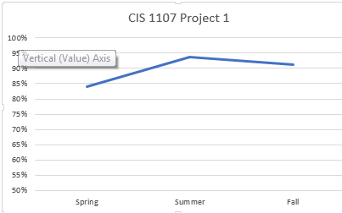
NEXT YEAR:
Computer Literacy | 2017-2018 | NO COURSES PROVIDED

The Program Outcomes for the degrees are listed below. Responses from previous years are provided below. All program outcomes must be assessed at least once during the 5 year Program Review cycle, and assessment of program outcomes must occur each year.

Program Outcomes | To which course(s) is this program outcome related? | Year assessed or to be assessed. | Assessment Methods  Used | What were the assessment results?  (Please provide brief summary data)
Apply medical terminology and other common healthcare language in the delivery of customer service, project planning, and project completion in the information technology business environment. | HIM 1101 Medical Terminology | 2015-2017 | Note: this class is not in our department. HIM department supplied the information. The outcome is from the HIT.ATS transfer degree. | 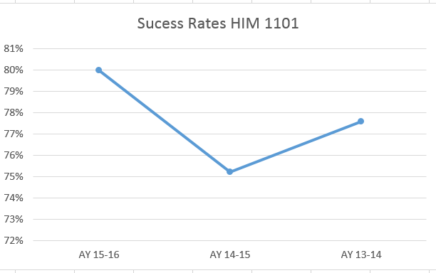  Student success rate increased from 77.59% in AY 13-14 to 80% in AY 15-16.  What did you learn  Assessments required updating (required by switch from ANGEL to eLearn). For future terms, the course material will be more “engaging” for students by updating the graphics and pictures in eLearn. We are currently in the process of making these changes. With the advancement in medical technology in the past few years, some of the lessons contain images of medical equipment that are now replaced with newer, more technology-efficient medical-equipment.
Apply policies and procedures concerning release of medical information, protecting patient confidentiality, HIPAA regulations and ethical issues in healthcare settings. | HIM 1204 Medicolegal/Ethics in Healthcare Records | 2015-2017 | Note: this class is not in our department. HIM department supplied the information. The outcome is from the HIT.ATS transfer degree. | 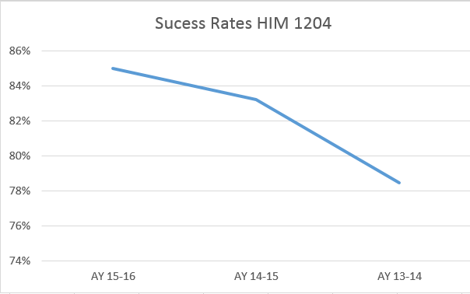  Student success rate increased from 78.49% in AY 13-14 to 85% in AY 15-16.  What did you learn  Students required clearer instructions for release of information scenarios. Providing increased resources for assessments improved student success.There are no plans for any major changes in this course at the current time. There are plans to update the course material in two of the online discussion forums.
Apply programming, database, operating systems and business application skills to solve and troubleshoot business and information technology problems related to area of concentration. | CIS 2165 | 2016 | Database project that consisted of 7 assignments. The culmination was well thought out database.  The course coordinator will be updating content which should result in greater mastery of the outcome. | 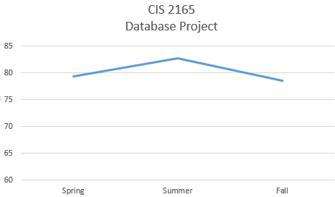  What did you learn?  The scores could be higher. The course coordinator convened a meeting in April to get feedback and direction from instructors teaching the course. Grading guidelines and more assignment instruction will be added.
Configure client and server machines, using a variety of operating systems, to exist in a networked environment with the highest possible degree of security. | CIS 2640 | 2016 | Lab 5 Incident Response Procedures measures whether students have master the outcome.  Note the course was revised for 2017 to meet the requirements of the CAE2Y application. | 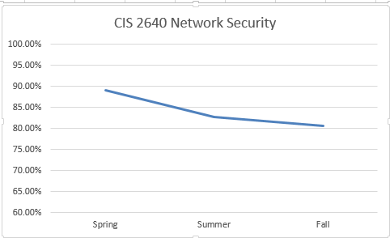  What did you learn?  That students need additional hands-on activities in order to master the outcomes.
Configure routers and switches and networks, troubleshoot network components and connections. | CIS 1411 and CIS 2426 | 2016 | CIS 1411 Final Hands on Skills Exam  CIS 2426 Final Hands on Skills Exam  Direct (Labs & PTs),  Indirect (Course Feedback & Student Survey), Formative (Chapter Tests), Summative (Final Exam),  Comparative | 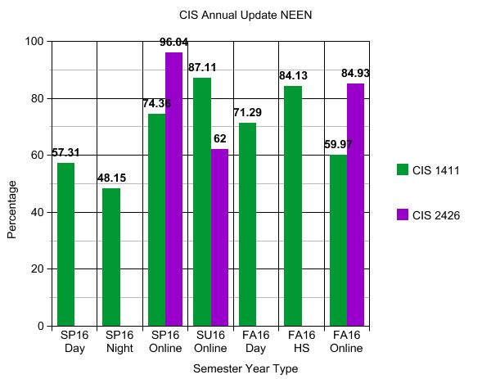  What are your current results?  The current results indicate 60% of students in CIS 1411 earned 60% or better. This is down from the prior academic year. The percentage of students in CIS 2426 earning 60% or better is also down from the prior academic year.  What did you learn from the results?  The number of students failing to complete each course attributes to the low percentage. The data indicates that students stop communicating with the instructor at various times during the semester. Also the number of students enrolled in each class varied from 3 to 14. This outcome contains two areas to observe with assignment completion and score. We learned that we need to determine the area where students are having difficulties.
Demonstrate ability to research, select, use and troubleshoot hardware and network components or connections appropriate to area of concentration. | CIS 2731 | 2016 | Test Out scores. The department subscribes to a testing service. We only have one term of data and next year we will have 3 terms of data. | 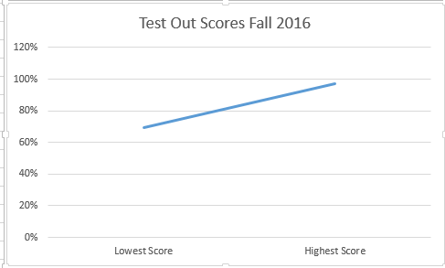  What did you learn?  There is a wide range in scores. The instructor is moving away from lecture and adding more hands-on labs. This will help the lowest performing students increase their scores.
Diagnose and prescribe solutions to hardware, networks and operating systems problems. | CIS 1130 | 2016 | The final exam for this course assesses the student's understanding of the core material of the class. It includes multiple choice sections to assess content learning and also a short essay section to assess deeper understanding of the concepts and application of knowledge. | 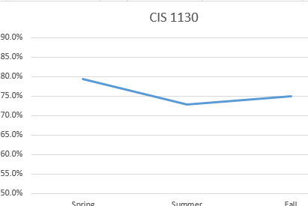  What did you learn?  The exam results were expected. In order to increase the scores additional labs will be added to the course.
Demonstrate effective oral and written communication skills and teamwork skills in the delivery of customer service, project planning, and project completion in the information technology business environment. | CIS 2170 | 2016 | Student feedback forms.  We cannot use the Employer forms since most employers are very positive on the forms and most survey questions are scored 4 out of 4. | 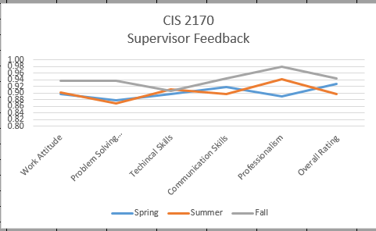  What did you learn?  Students are satisfied with the education they received at Sinclair. Employers are also satisfied with student’s skills sets. Currently the supervisors fill out the form and then give to the student to upload to the dropbox. Hopefully in a year, all feedback forms will be online. The department feels supervisors will give more critical feedback regarding their intern’s performance if they do not need to give it to the student to turn in. Supervisor feedback is shared with program coordinators. An improvement would be for a formal method of relying information back to the department.
Design, document and implement computer software solutions given definition of a problem and requirements for a solution. | CIS 1202 | 2016 | The assessment used is the final project. Students are required to design and code a program given a set of criteria. | 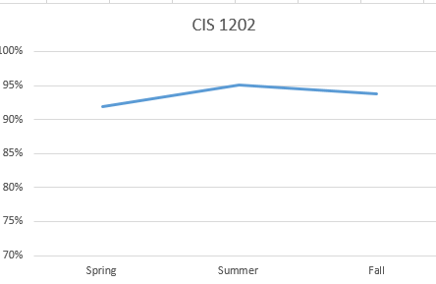  What did you learn?  Students did master the outcomes. What is not measured is the retention rate for the class. The department should research the retention rate for this class and the pre-req CIS 1111. The assignments in both classes are difficult and build from the previous assignments. If a student does not master the skills taught early in the class then they will not complete the class.
Manage and secure operating systems. | CIS 2640 | 2016 | Lab 5 Incident Response Procedures measures whether students have master the outcome.  Note the course was revised for 2017 to meet the requirements of the CAE2Y application. | What did you learn?  That students need additional hands-on activities in order to master the outcomes. We had recently change over to a full Linux environment. Previously we were all Windows based. This created a new learning challenge to our students who are used to working in Windows based OS’s.
Design, document and implement computer software solutions and websites given definition of a problem and requirements for a solution. | CIS 2731 | 2016 | Test Out scores. The department subscribes to a testing service. We only have one term of data and next year we will have 3 terms of data. | What did you learn?  There is a wide range in scores. The instructor is moving away from lecture and adding more hands-on labs. This will help the lowest performing students increase their scores.
Design, document and implement computer software solutions given definition of a problem and requirements for a solution. | CIS 2170 Internship | 2016 | In the internship class students complete an end of term feedback form. In addition to the form the instructor for the course visits the internship site. Feedback from students and supervisors is then passed on to the course coordinators. For example there was feedback that debugging skills are important and need to be emphasized in our program. CIS 1202 now has a lesson on debugging. | 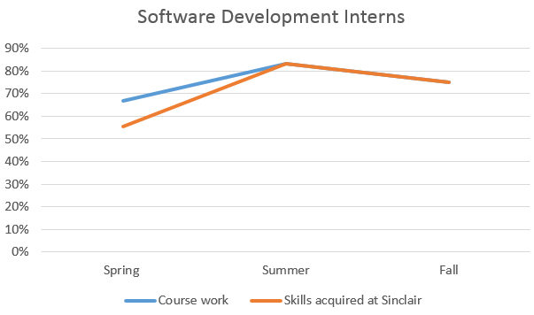  What did you learn?  Students are satisfied with the education they received at Sinclair. Employers are also satisfied with student’s skills sets. Currently the supervisors fill out the form and then give to the student to upload to the dropbox. Hopefully in a year, all feedback forms will be online. The department feels supervisors will give more critical feedback regarding their intern’s performance if they do not need to give it to the student to turn in. Supervisor feedback is shared with program coordinators. An improvement would be for a formal method of relying information back to the department.
Use operating system commands to manipulate files and directories and perform systems software troubleshooting. | CIS 2550 | 2016 | The assessment was performed using the Mid-term. The mid-term is made up of various multiple choice questions covering these topics that assessed the outcome.  The content was revised prior to fall with more emphasis on hands on activities. Better scores on the midterm reflex the improvements. | What did you learn?  From theses scores, we can clearly see students learn the material best when the content is presented in both lecture and hands-on activities on in class activities. Further work needs to be done in finding which hands-on activities have the highest impact on student learning.

Are changes planned as a result of the assessment of program outcomes? If so, what are those changes? | Not at this time.
How will you determine whether those changes had an impact?

OPTIONAL:

Please use the space below to keep track of any annual data that your department wishes to maintain. This section is completely optional and will not be reviewed by the Division Assessment Coordinators.

