Sinclair Community College
Continuous Improvement Annual Update 2017-18

Please submit to your Division Assessment Coordinator / Learning Liaison for feedback no later than March 1, 2018

After receiving feedback from your Division Assessment Coordinator, please revise accordingly and make the final submission to your dean and the Provost’s Office no later than May 1, 2018

Department: BPS - 0410-Accounting / 0440-Economics
Year of Last Program Review: FY 2015-2016
Year of Next Program Review: FY 2020-2021

Section I: Progress Since the Most Recent Review

Below are the goals from Section IV part E of your last Program Review Self-Study. Describe progress or changes made toward meeting each goal over the last year. Responses from the previous year’s Annual Update are included, if there have been no changes to report then no changes to the response are necessary.
GOALS | Status | Progress or Rationale for No Longer Applicable
The principles level courses for both accounting and economics are offered in the classroom on the main campus and off-campus sites. They are also offered as web courses every semester. Principles of economics courses are offered on the main campus in a hybrid format. Due to the success with the hybrid format in economics, we believe it would be advantageous to develop a hybrid course for ACC 1210. | In progress  Completed  No longer applicable | Application was made to elearning division for development in Jan – June 2019 cycle.
The addition of ACC 1100 as a non-TAG accounting option for AAS degree programs should improve the success rate of students completing degrees at Sinclair. The department will be closely monitoring the success rates of ACC 1100 as the new web format is launched in Spring 16. | In progress  Completed  No longer applicable | Data shows the overall success rate in ACC 1100 for AY16-17 is 74% (compared to the average overall success rate for ACC1210 of 58%).  The success rate in ACC 1100 online sections for AY16-17 is 79% for 16-week sections and 72% for 12-week sections.  The success rate for Dayton campus face-to-face sections for AY16-17 is 72%. The success rate for Courseview location for AY16-17 is 86%.  In FA16, a new textbook was adopted and the course began using a web-based QuickBooks software (so students do not have to install software on their computer).  For ACC 1100 in AY16-17 the overall withdrawal rate was 11.58% (compared to the average overall withdrawal rate for ACC 1210 of 25%).
There are no plans to change the upper level courses required in the career degree. As was previously discussed, accounting is a standard curriculum. However, we are continually revising the content of classes. For example, new accounting rules regarding when businesses record revenue and how that revenue is measured have been finalized and will become effective in the next couple of years. The new rules are part of a long-term process of bringing unity in US and global accounting standards. We will need to rework the curriculum in our current courses to address the changes in revenue recognition. Tax laws are also constantly changing and software is continuously being updated. These outside forces keep us in a constant state of curriculum development. | In progress  Completed  No longer applicable | In summer 2017, the ACC 1100 and ACC 1210 courses were updated for changes in revenue recognition. In fall 2017, the ACC 1100 course was updated for changes to QuickBooks software.  Each summer ACC 2321, Federal Taxation, course is updated for changes to the tax law.  Each fall ACC 2322, Advanced Taxation, course is updated for changes to the tax law.
One area we plan on investigating is the market for new short term certificates. We currently offer a Tax Certificate. Based on input from our advisory committee, we will be evaluating potential new certificates such as Internal Systems Auditing which could lead to a CISA (Certified Information Systems Auditor) certification. | In progress  Completed  No longer applicable | Two new one-year certificates have been entered into CMT and will be in effect Fall 2017 - CPA Exam Eligibility: Accounting Component and CPA Exam Eligibility: Business Component. For students who come to Sinclair with a four-year or higher degree in a business area, they can complete the Accounting Component only to be eligible to sit for the CPA Exam. For students who come to Sinclair with a four-year or higher degree in a non-business area, they will need to complete both components to be eligible to sit for the CPA Exam.

Below are the Recommendations for Action made by the review team. Describe the progress or changes made toward meeting each recommendation over the last year. Responses from the previous year’s Annual Update are included, if there have been no changes to report then no changes to the response are necessary.

It should be noted that the majority of the recommendations from the Review Team in this Program Review originated from self-recommendations generated proactively by the department itself and shared at the conclusion of the meeting. The Review Team was very impressed at the insight and self-awareness the department displayed in preparing and sharing these recommendations.

RECOMMENDATIONS | Status | Progress or Rationale for No Longer Applicable
The quality of this Program Review was such that this self-study should serve as a model of a well-done self-study that other departments can emulate. The chair and faculty of the department should be willing and available to serve as mentors in helping other departments develop their own self-studies and to prepare for the meeting with the Review Team. | In progress  Completed  No longer applicable | The Accounting Instruction Department is available and willing to meet with other departments as requested.
The department noted that they had developed a review test for ACC 1210 that their students find extremely helpful, and suggested that they could develop a similar review test for ACC 1100 and 1220. The Review Team encourages the department to develop and implement these review tests for the other courses. | In progress  Completed  No longer applicable | The online reviews were completed in SP17 for both ACC 1210 and 1220. The online reviews for ACC 1210 have also been incorporated into the face-to-face sections. ACC 1100 does not have the testing used in ACC 1210 and 1220.
The department noted the success of the hybrid format in the ECO courses, and suggested expanding that format to ACC 1210. The Review Team agreed that this is an excellent suggestion worth pursuing. | In progress  Completed  No longer applicable | See 1st goal:  Application was made to elearning division for development in Jan – June 2019 cycle.
The department offers three paths for those students interested in Accounting - referring students whose goals are best accomplished through higher degree attainment to the division's transfer program, offering CPA education for those who already possess a bachelor's degree, and then offering the AAS degree to those students whose career goals are best served by the associate degree. Each brings distinct marketing challenges - when the transfer degree is appropriate, how can students best be routed in that direction? How can the advantages of the AAS degree be marketed to area employers so that they are aware of the opportunities and benefits and become more likely to hire program graduates? How can more bachelor and master degree holding students become aware of the CPA opportunities that the department offers, which for the most part are not currently mentioned in the college academic catalog or other promotional materials? The department is strongly encouraged to develop strategies to address these marketing needs, particularly in regards to the latter two. These strategies will need to be developed within the parameters of existing marketing resources. | In progress  Completed  No longer applicable | For the students whose goals are best accomplished through higher degree attainment by completing the Business Administration AS transfer program:  - The Accounting Instruction Department chairperson meets with students individually to help them decide the best program path. We see these students early on in either ACC 2321, Federal Taxation, or ACC 1510, Computerized Accounting, as these are the first two Accounting AAS program courses the students will take. This allows the student to make a decision on which degree path suits their purpose and prevents the student from taking classes that would not transfer to a four-year school.  - For the online students in ACC 1210 or ACC 1220, an Introduction forum the first week of class also helps faculty identify students who intend to major in accounting and gives us the opportunity to discuss their chosen degree path and make sure they are on the path best suited for their future goals.  For the students whose goals are best accomplished through the post-bachelor certificate(s):  - With the help of Sinclair’s Strategic Marketing & Communication Department, the Accounting Instruction has developed three distinct social media videos, two of which are complete, that targets the post bachelor student.
The department offers a course that provides training in Quickbooks, which meets a high demand need in the field, but it may not be readily apparent to potential students that the course provides this software training. The department should explore ways of promoting the Quickbooks training that is provided in this course, whether that is best accomplished through a change in the course name, promotion through local organizations, or other approaches. It would appear that this is an opportunity for enrollment growth that the department should take advantage of. | In progress  Completed  No longer applicable | This is something probably best accomplished through Workforce Development. New Horizons of Dayton offers QuickBooks training in one-day or two-day sessions depending on the level of training wanted (for $800 a day).  The department will meet with Workforce Development to determine if this is something Workforce Development wants to pursue.
The department noted that challenge of sending students to Tutoring Services only to find that tutoring is not available for its courses. The faculty already go above and beyond in staffing the department's open lab, and it is not reasonable to expect that additional faculty time could be devoted to tutoring students. The department is encouraged to explore devoting resources to development of a Master Tutor position to fill this need. The department is encouraged to explore its options in this regard and develop a proposal to be submitted to the Provost. This proposal should include approaches to meet the needs of not only the Dayton Campus, but the Courseview Campus and Learning Centers as well. | In progress  Completed  No longer applicable | The day time is covered by Tutorial Services currently offering group sessions from 9AM-3PM M-R and 10AM-2PM on F.  Beginning FA18, the Accounting/Economics Department will move the current day sessions to evening sessions.

Section II: Assessment of General Education & Degree Program Outcomes

For the FY 2016-17 Annual Update, departments are asked to provide assessment results for Information Literacy.

General Education Outcomes | Year assessed or to be assessed. | Course identified by the department where this outcome could be assessed | Assessment Methods  Used | What were the assessment results?  (Please provide brief summary data)
THIS YEAR’S ASSESSMENT RESULTS
Computer Literacy | 2017-2018 | ACC 2211 - Cost Accounting; | Excel Project (PC2) Assignment | 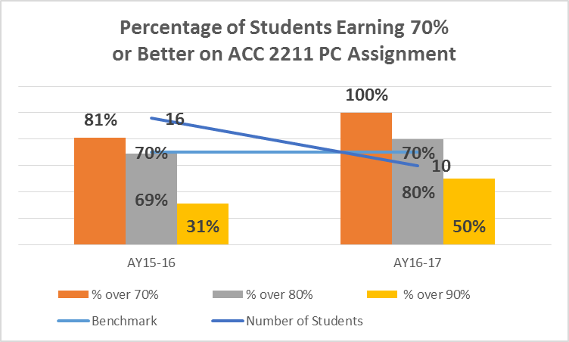  What are your current results?  What did you learn from the results?  What are your next steps?
LAST YEAR’S ASSESSMENT RESULTS
Information Literacy | 2016-2017 | ACC 2435 - Auditing | Ethics Research Paper | 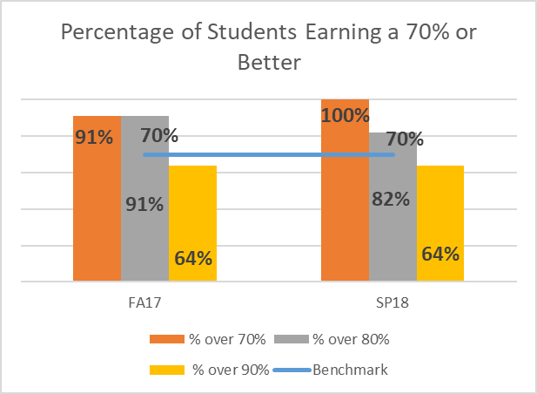  What are your current results?  Data was not collected at the individual criterion level (3 criterion). The oversight was the result of a novice collector of the data. This ommission is addressed in next steps below. As an aggregate score, students are doing very well.  What did you learn from the results?  The students are competent or better as compared to the 70% benchmark. There is a need for more detailed data in future periods. This is addressed in the next steps.  What are your next steps? Development and piloting of a criterion based rubric for data collection.
NEXT YEAR:

The Program Outcomes for the degrees are listed below. Responses from previous years are provided below. All program outcomes must be assessed at least once during the 5 year Program Review cycle, and assessment of program outcomes must occur each year.
Program Outcomes | To which course(s) is this program outcome related? | Year assessed or to be assessed. | Assessment Methods  Used | What were the assessment results?  (Please provide brief summary data)
Apply mathematical skills to formulas and solve problems. | ACC 2211 -  Cost Accounting | 2016 - 2017 | Breakeven Computation on test | What are your current results?  What did you learn from the results?  What are your next steps?
Apply principles of human creativity and its relation to society. |  |  |  | Where did this outcome come from? Looks like it came in from 2016 program change in CMT. This needs to be removed from the ACC Program.
Apply the principles of financial, managerial, cost and tax accounting. | ACC 2101 - Intermediate Accounting;  ACC 2211 - Cost Accounting;  ACC 2321 - Federal Taxation | 2016 - 2017 | ACC 2101 - Practice Set  ACC 2211 – Variance Analysis test question  ACC 2321 - Comprehensive Tax Return Assignment | 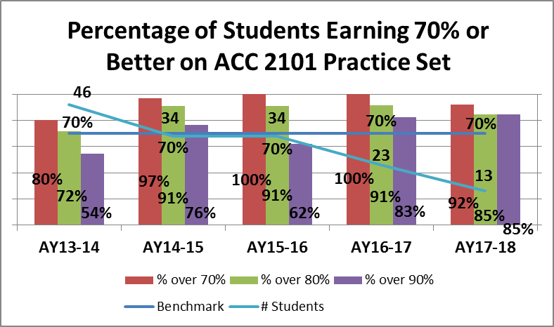  What are your current results?  From ACC 2101 Practice Set:  92% of students are performing above the 70% minimum acceptable level. While this is a slight decrease from the last two years, we did see an increase in the percentage of students performing at the over 90% level.  What did you learn from the results?  A majority of our students are demonstrating a solid understanding of the accounting cycle and principles of financial accounting by their performance on the practice set. This continues to be an excellent learning and assessment activity for our students.  What are your next steps?  Identify students who are at risk for not performing at the minimum level on the assignment based on homework and test scores for the first part of 2101. Ask these students to meet with the instructor at the mid-point of the practice set for additional help if needed.  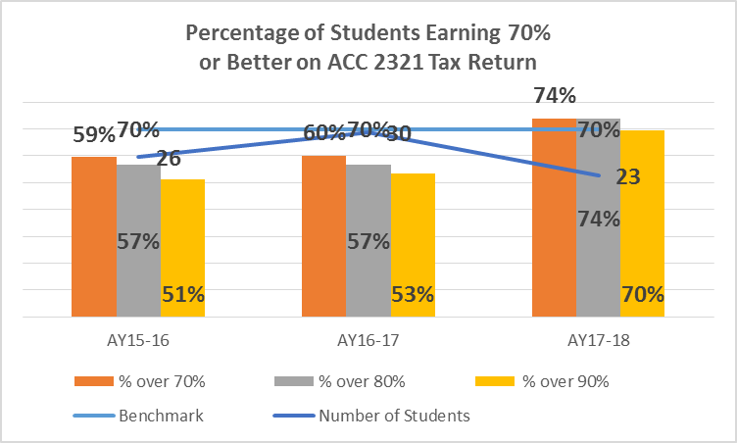  What are your current results?  From ACC 2321 Tax Return:  The data indicates an upward trend in the percentage of students performing at the minimum level of 70% or better. Students do have two opportunities to complete the assignment. On the first attempt students are provided with feedback and allowed to make changes before submitting for an improved grade. Approximately 49% of the students did not take advantage of the second attempt.  About 14% of the students earn 100% on the first attempt while approximately 16% earn 100% on their second attempt. Approximately 20% of the students who take advantage of the second attempt earn less than 100%.  What did you learn from the results?  Data shows there has been an increase in the percentage of students earning 100% on their first attempt from 14% in AY 16-17 to 20% in AY 17-18. This may be due to the change to an online tax return preparation through the online homework system from the manually prepared paper forms in past years.  Data also indicates that there has been a decrease in the percentage of students who score 100% on the second attempt.  Data indicates that half of the students are not completing the second attempt. The instructor needs to ask students why they are not using the second attempt to improve their score, encourage students to use second attempt, and then look at the data.  What are your next steps?  Talk with students to find out why they do not use the second attempt to improve scores.  What are your current results?  From ACC 2211 – Variance Analysis test question – Rick?? Comments??  What did you learn from the results? Rick?? Comments??  What are your next steps?
Demonstrate effective verbal and written communication. | ACC 2435 - Audit |  |  | What are your current results? Students are generally competent or better for the written communication metric. We did not collect information on verbal communication skills.  What did you learn from the results? Students are demonstrating competence in their written communication skills, relavent to the field of accounting. There is a need for further development of an oral communication assessment tool.  What are your next steps? While there is a need for the development of an oral communications assessment, there is no time in the ACC 2435 Audit curriculum for such an activity. The department will need to discuss either dropping this metric, or determining the proper place for assessment.
Describe and apply general business knowledge skills and computer skills. | ACC 1510 -  Computerized Accounting |  | Final Project | 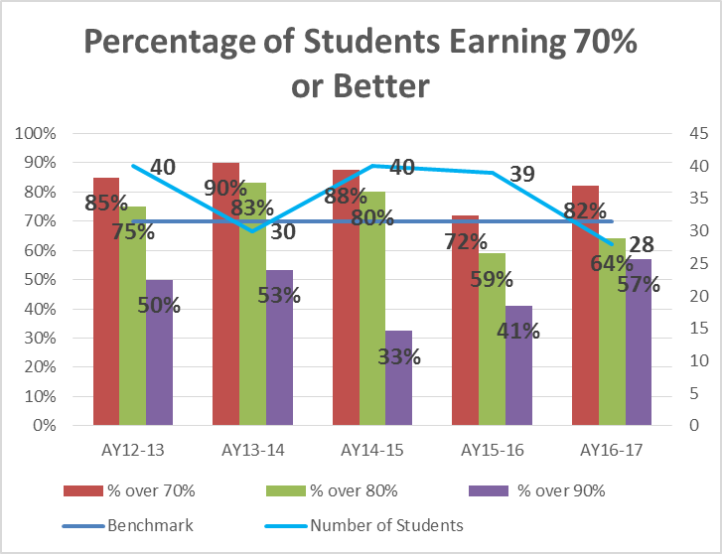  What are your current results?  The current results indicate 86% of students earned 70% or better. This is an increase over the prior year yet still down from past academic years. The percentage of students earning 80% or better increased in the current year but is still down from the prior academic years. The percentage of students earning 90% or better has increased over the prior academic years.  What did you learn from the results?  The final project requires students to apply general business knowledge skills using Microsoft Excel software. The data indicates that students are not performing as well as in the past.  Since this outcome contains two areas: business knowledge skills and computer skills, we learned that we need to determine the area where students are having difficulties.  What are your next steps?  We need to amend the rubric to separate these two areas.
Use analytical problem-solving skills. | ACC 2212 - Finance |  | Case | What are your current results? Jeff Vance?? Comments??  Almost all students perform at the 70% or better level. There has been an increase in the number of students performing at the 90% or better level also. We are missing FA13 data as I failed to collect data before moving to new learning management system. There isn’t any data yet for SP17. There was a change to a new online homework system in FA16. Need to continue to check results to see if this may have had an impact on success.  What did you learn from the results? Jeff Vance?? Comments??  Need to continue to check results to see if this may have had an impact on success.  What are your next steps?

Are changes planned as a result of the assessment of program outcomes? If so, what are those changes? | See each outcome for next steps.
How will you determine whether those changes had an impact?

OPTIONAL:

Please use the space below to keep track of any annual data that your department wishes to maintain. This section is completely optional and will not be reviewed by the Division Assessment Coordinators.

Sinclair Community College
Continuous Improvement Annual Update 2017-18

Please submit to your Division Assessment Coordinator / Learning Liaison for feedback no later than March 1, 2018

After receiving feedback from your Division Assessment Coordinator, please revise accordingly and make the final submission to your dean and the Provost’s Office no later than May 1, 2018

Department: BPS – 0497-Real Estate
Year of Last Program Review: FY 2015-2016
Year of Next Program Review: FY 2020-2021

Section I: Progress Since the Most Recent Review

Below are the goals from Section IV part E of your last Program Review Self-Study. Describe progress or changes made toward meeting each goal over the last year. Responses from the previous year’s Annual Update are included, if there have been no changes to report then no changes to the response are necessary.
GOALS | Status | Progress or Rationale for No Longer Applicable
The department should give consideration to opportunities for continuing education offerings, for Real Estate program. | In progress  Completed  No longer applicable | The Real Estate program received approval of RES 1402 Property Management for 17.5 hours of continuing education credit. Beginning Fall 2017, students will receive both course and CE credit. The approval is valid for three calendar years.  The Real Estate program is working to gather from adjunct faculty the materials necessary to apply for approval of RES 1302 Real Estate Investing and RES 1102 Abstracting.
There are several recommendations specific to the RES program:  - Continue the excellent ongoing work on stackable short-term certificates  - Continue the development of articulation agreements  - Explore online options once approval is given to do so by the state  - As mentioned above, explore continuing education opportunities | In progress  Completed  No longer applicable | Legislation passed permitting online delivery of pre-licensing courses. By April 2017, the Division of Real Estate will enact rules that we will need to follow to offer online courses. We are hopeful we will be able to begin offering all the pre-licensing courses online beginning Summer 2017. RES 1101 and 1201 are already developed and RES 1301 and 1401 are in development Spring 2017.  The previous program coordinator looked into articulation agreements with the University of Cincinnati and Miami University for real estate finance and determined our program may not contain enough math.  In 2015, the RES Advisory Committee recommended that the program not pursue offering a Broker Short Term Certificate.

Below are the Recommendations for Action made by the review team. Describe the progress or changes made toward meeting each recommendation over the last year. Responses from the previous year’s Annual Update are included, if there have been no changes to report then no changes to the response are necessary.

It should be noted that the majority of the recommendations from the Review Team in this Program Review originated from self-recommendations generated proactively by the department itself and shared at the conclusion of the meeting. The Review Team was very impressed at the insight and self-awareness the department displayed in preparing and sharing these recommendations.

RECOMMENDATIONS | Status | Progress or Rationale for No Longer Applicable

Section II: Assessment of General Education & Degree Program Outcomes

For the FY 2016-17 Annual Update, departments are asked to provide assessment results for Information Literacy.

General Education Outcomes | Year assessed or to be assessed. | Course identified by the department where this outcome could be assessed | Assessment Methods  Used | What were the assessment results?  (Please provide brief summary data)
THIS YEAR’S ASSESSMENT RESULTS
Computer Literacy | 2017-2018
LAST YEAR’S ASSESSMENT RESULTS
Information Literacy | 2016-2017 | Click here to enter text.
NEXT YEAR:

The Program Outcomes for the degrees are listed below. Responses from previous years are provided below. All program outcomes must be assessed at least once during the 5 year Program Review cycle, and assessment of program outcomes must occur each year.
Program Outcomes | To which course(s) is this program outcome related? | Year assessed or to be assessed. | Assessment Methods  Used | What were the assessment results?  (Please provide brief summary data)
Demonstrate correct and appropriate use of oral and written communication, mathematics, and computer technology in real estate activities. | BIS-1410 COM-2206 ENG-1101 ENG-1131 RES-1101 RES-2301 RES-2302 | RES 1101  RES 2301 Note RES 2301 was deactivated and replaced with RES 1301 and RES 1401 | In RES 1301 Real Estate Finance (which replaced RES 2301), the final exam includes questions related to mathematics, finance and computerized underwriting of mortgage loans. | The grade distribution for the pre-license courses:  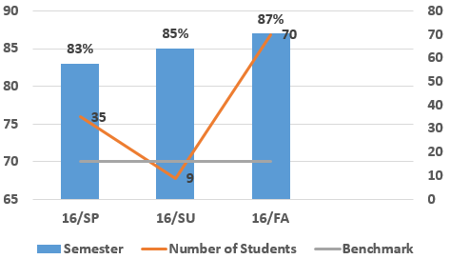  Grades for the final exam ticked upwards over the last three semesters. This can be attributed to a strong, stable core of instructors for this class.
Exemplify a high standard of ethics as a real estate professional. | RES-1201 RES-2401 | RES 1201 | In RES 1201 Real Estate Law, this exam includes ethics questions to prepare students for the real estate salesperson licensure exam. . | Average grade for the exam:  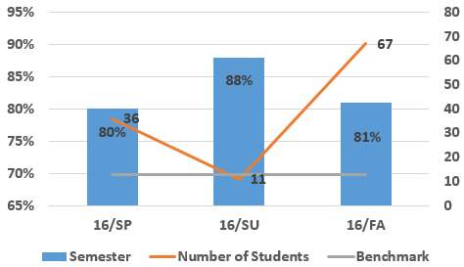  Grades peeked during the summer, but returned back to a normal range come Fall. With the Summer enrollment being smaller, the instructor was able to give more individualized attention to each student.
Demonstrate knowledge in managing real estate, investing in real estate, real estate contracts, valuing real estate and real estate financial instruments. | ACC-1210 ACC-1220 ECO-2180 LAW-1101 MAT-1120 PLS-1120 PLS-1232 PSY-1100 RES-1101 RES-1102 RES-2301 SOC-1145  Note RES 2301 and RES 2302 were deactivated and replaced with RES 1301 and RES 1401 | RES 1101 | In RES 1101 Real Estate Principles, the final exam tests students’ knowledge of all of these topics. | Average grade for the exam  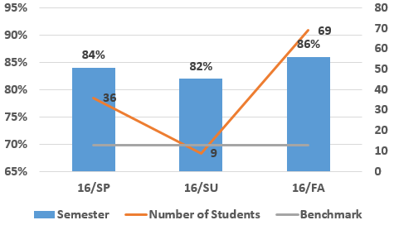  Grades for the final exam ticked upwards over the last three semesters. This can be attributed to a strong, stable core of instructors for this class.

Are changes planned as a result of the assessment of program outcomes? If so, what are those changes?

How will you determine whether those changes had an impact?

OPTIONAL:

Please use the space below to keep track of any annual data that your department wishes to maintain. This section is completely optional and will not be reviewed by the Division Assessment Coordinators.

