Department/Program Review
Self-Study Report Template

2017 - 2018

Department: Rehab Services Department: 0681-Physical Therapist Assistant (PTA), 0685-Occupational Therapy Assistant (OTA)
Section I: Innovations and Accomplishments
Please list noteworthy innovations in instruction, curriculum and student learning over the last five years (including student awards, faculty awards, etc.).
- New faculty:
  - OTA program: New program director, Heidi McGohan, and a new academic fieldwork coordinator, Katie Walker.
  - PTA program: New annually contracted faculty member, Kalette Hittle.
- Curriculum redesign: The OTA and PTA programs both completed curricula redesigns due to the state-mandated total credit reduction for associate degree programs. OTA reduced total credits from 73 to 65. PTA reduced total credits from 70 to 65. For both programs, the curriculum redesign process included:
  - Review of curricular assessment data, student feedback, and program advisory committee feedback to inform curricular decision-making.
  - Identification of strengths and gaps/areas needing improvement in the previous curriculum.
  - Review of current best practices and evidence-research in related professional areas.
  - Establishment of new missions, goals, and outcomes.
  - Review of student, faculty, and course coordinator workload per academic term.
  - Repackaging of curricular and course content in a more logical, sequential, and organized format to facilitate teaching and learning.
  - Analysis of credit hour and lecture/lab time requirements for each course.
  - Creation of 18 new courses in the OTA program and 23 new courses in the PTA program.
  - Development of new course descriptions.
  - Creation of new course objectives and learning outcomes based on accreditation standards and Sinclair general education outcomes.
  - Alignment and mapping of instructional methods, assessment/evaluation methods, course objectives and learning outcomes to accreditation standards and Sinclair general education outcomes.
  - Implementation of new instructional methods to facilitate teaching, learning, critical thinking, and problem solving.
    - PTA: Dr. Jim Cropper has pioneered the implementation of team-based learning in PTA 1135, 1140/1145, 1220, and 1230/1235. Dr. Cropper created videos to enhance instruction of palpation (PTA 1135). Dr. Deb Belcher created videos to enhance instruction of total body movement (PTA 1125), gait (PTA 1215), and tests/measures (PTA 1245).
    - Interprofessional education: The OTA and PTA programs have developed several activities to promote better understanding of the roles/responsibilities, values/ethics, communication, and teamwork among healthcare professionals.
      - Lunch ‘N Learn with OTA/PTA
      - Co-Treatment with OTA/PTA
      - Intensive Care Unit Day with Nursing/OTA/PTA/Respiratory
      - Culture Day with OTA/PTA
      - Activities of Daily Living Training with Nursing/OTA
      - Assistive Device Training with Nursing/PTA
      - Collaboration Day with PTA/University of Dayton DPT
  - Creation of new/improved assessment methods to better assess and evaluate learning outcomes/accreditation standards.
    - OTA: The final lab practical used in all lab courses was redesigned to improve assessment of mastery of clinical skills. The capstone project that spans three lab courses was redesigned.
    - PTA: The service learning component of the Portfolio Assignment was expanded to directly benefit children in the community with Muscular Dystrophy (i.e. Wheelchair Costume Clinic) and the Countryside YMCA (i.e. Health Fair). The service learning rubric was revised to align with Sinclair’s Cultural Diversity and Global Citizenship general education outcome.
  - Review of existing and/or establishment of new textbooks.
  - Entry of new course/program information into the Curriculum Management Tool.
  - Creation of new course shells in eLearn.
- Partnerships with external stakeholders to facilitate student learning.
  - Prevent Blindness Ohio Vision Screening Certification: Ms. McGohan and Ms. Walker have become certified vision screeners for adults and preschool-age children. Vison screening has been incorporated into the OTA curriculum, and now all OTA students graduate with this certification.
  - Rebuilding Together Dayton: OTA students perform home assessments as part of volunteer hours associated with the program curriculum.
- Faculty involvement in continuing education of external stakeholders.
  - Ms. McGohan and Ms. Walker presented on Ethics and Fieldwork for West Central Ohio Occupational Therapy Association (OOTA).
  - Dr. Belcher completed training through the American Physical Therapy Association (APTA) to become a Credentialed Clinical Trainer. This credential allows her to train clinical instructors with the skills and information needed to provide students with high quality clinical education experiences.
- Data-driven decision-making: Dr. Cropper created an electronic database to facilitate tracking, analysis, and reporting of data for the PTA program. The database streamlined the Transcript Review process used to determine which students are offered enrollment in PTA-specific courses, assisted in the determination of a minimum achievement score for the Test of Essential Academic Skills (TEAS), and informed numerous reports for Academic Advising, Sinclair Annual Updates, as well as annual accreditation reports.
- Student awards/accomplishments:
  - OTA: The OTA faculty created three student awards distributed at their Pinning Ceremony – The Kay Ashworth Creativity Award, The Shelby Lovelace Therapeutic Use of Self Award, and the Critical Thinking Award.
  - PTA:
    - During 2015-16, the PTA program was awarded the Ohio Physical Therapy Association (OPTA) School of the Month based on an application completed by the PTA Student Leadership Team. PTA Student Leadership Team members are afforded the opportunity to attend the OPTA Leadership Meeting.
    - Seventeen PTA students have been awarded a total of $17,000 in scholarship money through AMBUCS.
- Faculty awards/accomplishments:
  - Dr. Belcher was awarded the Ohio Magazine Excellence in Education Award.
  - Dr. Cropper, Dr. Emily Garber, and Ms. Heather Stoner were awarded the Southwestern Ohio Council for Higher Education (SOCHE) Faculty Excellence in Teaching Award.
  - Dr. Belcher, Dr. Garber, Ms. McGohan, and Ms. Walker have received College-wide Merit.
  - Ms. Stoner completed a master’s degree in Public Health.
  - Dr. Garber completed a Ph.D. in Industrial and Organizational Psychology.
Section II: Annually Reviewed Information

A: Department Trend Data, Interpretation, and Analysis

Degree and Certificate Completion Trend Data – OVERALL SUMMARY

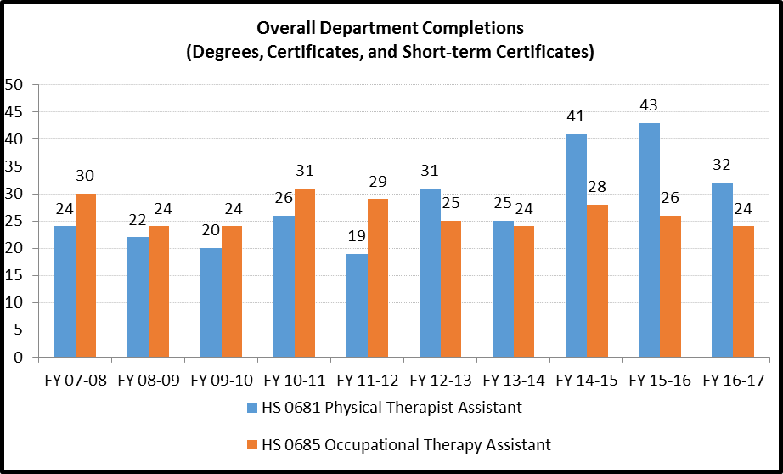

Please provide an interpretation and analysis of the Degree and Certificate Completion Trend Data: i.e. What trends do you see in the above data? Are there internal or external factors that account for these trends? What are the implications for the department? What actions have the department taken that have influenced these trends? What strategies will the department implement as a result of this data?

Please be sure to address strategies you are currently implementing to increase completions of degrees and certificates. What plans are you developing for improving student success in this regard?

OTA: Please see Appendix R for OTA Graduation & Completion Data. During this time the OTA Program has transitioned to admitting 50% of cohort students from the eligibility/waiting list and 50% from an Accelerated Admission (AAAA) process. Since Fall 2012 admissions 80% of students from the waitlist and 90% of the students admitted through AAAA have successfully completed the program. Please see Appendix T for details.

Beginning Summer 2016, another change the OTA Program has made is to increase the rigor of science courses required (BIO 1141, BIO 1242 & ALH 2220). With the increase in science demands, the thought is the Program Completion Rate and the Certification Exam Pass Rate will both increase. As of now, there is no data on the impact of increasing the general education rigor.

Lastly, with meeting the state mandate of reducing credit hours from 73 to 65, the OTA Program took advantage of this time of restructure, to restructure the whole program. Topics are covered in completion (typical, atypical, assessments of and treatment for) within the same semester in order for the students to better synthesize the information.

PTA:
Please see Appendix C for PTA Graduation Rate Data. The PTA graduation rate increased between the years of 2012/2013 to 2016. During this time the PTA program transitioned from an admission process that utilized a waitlist to a competitive selection process. Initially, the competitive selection process benefitted the PTA program by promoting the selection of academically prepared students into the program. In 2017, the graduation rate dropped for both campuses. This drop is being attributed to early attrition due to academic failure and withdrawal from the program for personal reasons. Please see Appendix B for PTA Attrition Data. Actions the PTA program has taken that have influenced this trend includes:
- Implementation of a redesigned 65-credit hour curriculum: While the curriculum redesign was prompted by a state mandate to reduce total program credits, the faculty took advantage of the opportunity to restructure the curriculum to deliver content in a more logical, organized, and sequential manner.
- On-campus PTA 1000 presentations: The PTA 1000 Introduction to Physical Therapy course is an online prerequisite course. As an optional assignment associated with the course, the PTA program director hosts four on-campus sessions (two at Dayton, two at Mason) to provide Intro students with a greater understanding of the competitive selection process and program expectations.
A strategy the PTA program is currently implementing to increase degree completions includes:
- Early Alert/Remediation Policy and Process: This process includes identifying at-risk students and implementing remediation plans as appropriate.
During this program review period, the PTA program decided to implement a change in the timing of the competitive selection process, which has occurred in January of each year (to determine who enrolls in Fall). The PTA program thought students would benefit from having this long time frame to prepare for the financial and time commitments associated with the program. However, this additional time may actually allow more opportunities for “life” to present various barriers to success (i.e. family obligations, personal/health reasons). As a result of the data, the PTA program plans to implement the following strategy:
- Changing the timing of the competitive selection process: The process will occur following the Spring term. The PTA program believes this change will assist in improving retention and decreasing attrition by allowing students more time to complete general education courses prior to having their transcript reviewed, less time for personal and/or life barriers to arise, and improved accountability for students completing and submitting required documentation in a timely manner (i.e. health records, background checks).

Course Success Trend Data – OVERALL SUMMARY

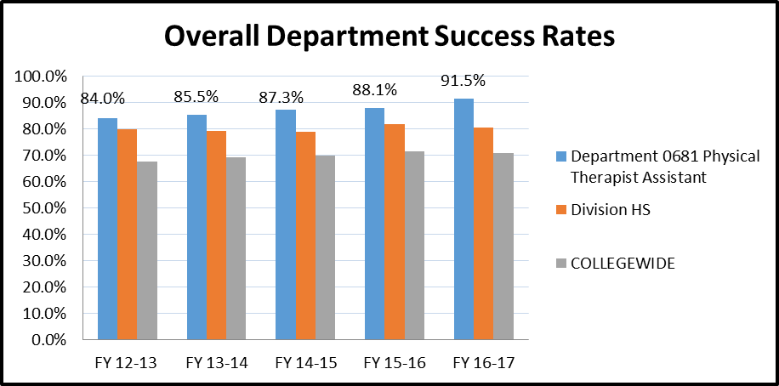

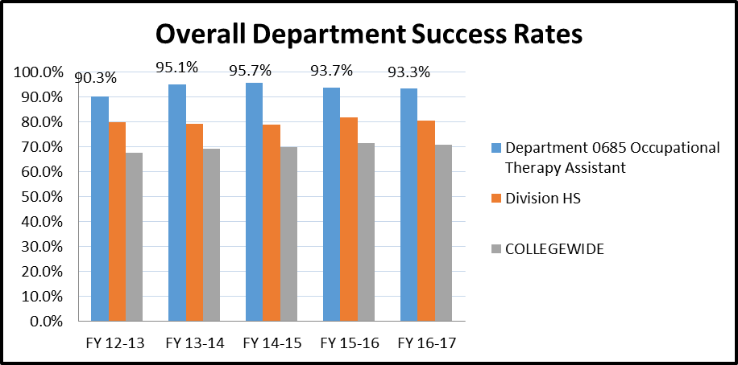
Please provide an interpretation and analysis of the Course Success Trend Data. Please discuss trends for high enrollment courses, courses used extensively by other departments, and courses where there have been substantial changes in success.
Please be sure to address strategies you are currently implementing to increase course success rates. What plans are you developing for improving student success in this regard?

OTA: According to the Overall Department Success Rates for OTA, the program has maintained invariability and is consistently above both the Health Science and the college as a whole. Early program attrition has been a question for the OTA program. The majority of students that we lose either by attrition or by personal choice occurs during the 1st Semester in the program. This is contributed to multiple factors including the rigor of the program, the time commitment required by the program, the number of group assignments required the 1st semester and the percentage of critical thinking components of the program combined with the creative aspects. Please see attachment Appendix S. Some of the activities that are employed to prevent attrition include: both group and individual meetings with new OTA students prior to start of limited enrollment courses to orient them to the curriculum, rigor, and expectations; matching of new students with 2nd-year mentors beginning at orientation; and internal student advising by full-time faculty throughout the curriculum.

To improve the retention rate and the overall success of the OTA students, the science requirements have increased considerably. The students now are required to complete BIO 1141 Principles of Anatomy & Physiology 1, BIO 1242 Principles of Anatomy & Physiology 2 and ALH 2220 Pathophysiology as general education requirements. Prior to this change, the students were only required to complete BIO 1107 Human Biology. This change took effect Summer 2016 so the data to demonstrate the positive effects on attrition is not yet available. The OTA program also requires a minimum overall score of 50 (in addition to subtests Science, Reading, English) on the Test of Essential Academic Skills (TEAS) to be placed on OTA Eligibility List & scores of 55 to qualify for Accelerated Admission selection process.

PTA:
According to the Overall Department Success Rates for PTA, the program has experienced an upward trend of success, and continues to perform above the Health Science Division, and the college as whole. Please see Appendix D for First-Term Anatomy and Kinesiology Course Data. As previously mentioned, early program attrition has been a challenge for the PTA program. In particular, students struggle with passing the first-term Anatomy and Kinesiology course. Attrition has been related to academic failure and personal reasons. Some of the activities that PTA employs to prevent attrition include: both group and individual meetings with new PTA students prior to start of limited enrollment courses to orient them to the curriculum, rigor, and expectations, internal student advising by full-time faculty throughout the curriculum, and opportunities for 1st year students to meet with 2nd year students for mentoring purposes.

Strategies the PTA program is currently implementing to increase course success rates include:
- The Test of Essential Academic Skills (TEAS): As a prerequisite to the competitive selection process, students must complete the TEAS. As of January 2017, students are required to obtain a minimum overall achievement score of 50. As part of her doctoral research, Dr. Garber completed a dissertation on the Investigation of Student Inputs on Academic Performance in a Physical Therapist Assistant Program (Appendix E) to better determine the relationship between the TEAS and academic success. A small, positive, and statistically significant correlation was found between overall TEAS score and final percentage grade in the first-term Anatomy and Kinesiology course. Therefore, the PTA program will continue to utilize the TEAS; however, continued analysis will occur to determine whether or not an appropriate minimum achievement score has been established.
- Cumulative GPA: Currently, students are required to have a minimum cumulative GPA of 2.5 to be eligible for competitive selection. Based on GPA data for the most recent incoming class (Appendix A) and trends in attrition, the PTA program is considering increasing the required minimum cumulative GPA.

Please provide any additional data and analysis that illustrates what is going on in the department (examples might include accreditation data, program data, benchmark data from national exams, course sequence completion, retention, demographic data, data on placement of graduates, graduate survey data, etc.)

PTA: Please see Appendix C for PTA Licensure and Employment Data. An analysis of the data is included in the “Recommendations for PTA” section. See Appendix N for Exit Interview Data for the class of 2017.
- College Resources: Students perceive all of the College Resources in question as meeting their needs/expectations, except for the Writing Center, Counseling Services, the Ombudsman, and Sinclair Talks.
- PTA Program Provisions: Students perceive all of the PTA Program Provisions in question as meeting their needs/expectations.
- Curriculum/Teaching and Learning: Students perceive the Curriculum and Teaching and Learning items in question effectively preparing them for the PTA Program courses/curriculum or to become a licensed PTA.
- Instructional Methods: Students perceive all of the Instructional Methods in question as effective in maximizing their learning, except for On-Line Discussions, Reading Assignments, and Literature Reviews.
- Students perceive all of the Experiential Learning activities in question as effective in maximizing their learning.
- Students perceive all of the Assessment and Evaluation Methods in question as effective in providing them feedback on their level of knowledge and skill in related content areas.
- Program Outcomes: Analysis is discussed in the “Recommendations for PTA” section.
B: Progress Since the Most Recent Review
Below are the goals from Section IV part E of your last Program Review Self-Study. Describe progress or changes made toward meeting each goal over the last year.
GOALS FOR PTA:

Below are the goals from Section IV part E of your last Program Review Self-Study. Describe progress or changes made toward meeting each goal over the last year. Responses from the previous year’s Annual Update are included, if there have been no changes to report then no changes to the response are necessary.
GOALS | Status | Progress or Rationale for No Longer Applicable
Improve alignment and allocation of services/supplies/equipment at Courseview to ensure equitable resources and manageable workloads to meet accreditation standards and to facilitate a working and learning environment focused on continuous improvement. | In progress  Completed  No longer applicable | Alignment:  -Health Sciences (HS) Center: The Dayton campus PTA program moved into the new Health Sciences Center in Summer/Fall 2017. The Dayton campus PTA program was able to purchase/upgrade equipment to outfit the PTA lab (and eventual rehabilitation clinic). The HS strategy heavily emphasizes interprofessional education and includes a Simulation Center, surgical suite, and numerous shared resources that are at the fingertips of the students who attend the Dayton campus. PTA students attending the Mason campus are not able to readily access the facilities, state-of-the-art equipment, and other HS program faculty and students as easily as Dayton students.  -Curriculum: Interprofessional education opportunities continue to be expanded and/or enhanced in the new curriculum. PTA students attending the Mason campus are required to drive to the Dayton campus for most, if not all, interprofessional education activities, as there is neither the space nor equipment to implement these learning experiences at the Mason campus.  -Schedule: No changes.  -Enrollment: The competitive selection process will now occur once the Spring term is completed (previously, this process began in January).  -Faculty: No changes.  -Budget: No changes.  -Allocation of services: Discrepancy still exists between the two campuses in terms of availability of counseling services and career services. Efforts have been made to ensure Mason students have the same access to services via phone and/or email; however, Mason students generally have to travel to the Dayton campus if face-to-face meetings are needed.  -Allocation of supplies/equipment: Mason continues to be at capacity in its ability to store PTA supplies and equipment.  -Equitable resources:  -Classroom/lab space: No changes.  -Large meeting space: No changes.  -Faculty office space: No changes.  -Manageable workloads:  -Faculty: No changes.  -Administrative assistants:  -Eileen Trentman is now the one (and only) full-time administrative assistant for the Rehabilitation Services Department (covering both OTA and PTA programs).
Monitor the success of the competitive admission process to ensure the program is admitting qualified candidates for improved retention and achievement of personal and professional goals. | In progress  Completed  No longer applicable | See Appendix E. A small, positive, statistically significant correlation was found between overall Test of Essential Academic Skills (TEAS) scores and final percentage grade in the first-term Anatomy and Kinesiology (A&K) course. Additionally, having a prior academic degree was associated with a higher final percentage grade in a first-term A&K course. While additional factors most likely play a part in whether a student is successful in the PTA program, the TEAS and prior academic achievement may assist in identifying qualified candidates. Additional research is needed related to the predictive abilities of these student inputs, as well as whether these inputs contribute to late program success (i.e. graduation, licensure).
Improve data collection to measure program and general education outcomes in a qualitative and quantitative way to ensure the program is promoting social responsibility, critical thinking, communication, and innovation. | In progress  Completed  No longer applicable | -The PTA program mission, goals, and outcomes were recently revised to facilitate assessment and measurement of outcomes (see Appendix F). Additionally, several assignments in the PTA program have been modified to incorporate general education outcome rubric language. This will facilitate the PTA program’s ability to measure general education outcomes. However, the PTA program believes general education outcomes are best measured in general education coursework that is completed outside of the PTA program technical curriculum.

GOALS FOR OTA:

GOALS | Status | Progress or Rationale for No Longer Applicable
The effectiveness of revised assessment techniques to evaluate individual student performance will be evaluated on a course by course basis as well as overall student outcomes. | In progress  Completed  No longer applicable | The OTA Program continues to assure there is a balance of the sciences and the creativity required for an entry level OTA.  OTA 1st Year limited enrollment courses:  - Group Assignments: 18.73%  - Individual Assignments: 81.27%  - Creative Assignments: 32.3%  - Non-Creative Assignments: 67.7%  OTA 2nd year limited enrollment courses:  - Group Assignments: 10%  - Individual Assignments: 90%  - Creative Assignments: 29%  - Non-Creative Assignments: 71%
New accreditation Standards were established in 2011 and become effective July 31, 2013. The department is currently in the process of ensuring compliance with any new or changing Standards. | In progress  Completed  No longer applicable | - The OTA Interim Report was accepted by ACOTE with 1 error (Plan of Correction) found where the Suite # of the mailing address was left off of the address included in the SCC Course Catalogue. The Plan of Correction report was submitted 10/20/17, but the error is unable to be corrected until Summer 2018 when the catalogue is updated. The address has, however, been corrected in CMT.
With the semester conversion all courses are effectively taught for the first time during the academic year 2012-2013. Each course will be evaluated for effectiveness and revised accordingly. Effectiveness will be determined by retention, grade spread, and student feedback. | In progress  Completed  No longer applicable | The new OTA curriculum went into effect Fall 2016.  New Curriculum Courses:  - Foundations1: 29/29 students successful  - Functional Anatomy: 28/29 students successful  - Adults with Physical Dysfunction: 29/29 students successful  - Lab for Adults with Phys Dys: 28/29 students successful  - Lab Skills Competency: 29/29 students successful  - Lab Practical: 28/29 students successful  - Foundations 2: 28/28 students successful  - OT & Human Development: 28/28 students successful  - OT & Adults with Neuro Dysfunction: 28/28 students successful  - Lab for Adults with Neuro Dysfunction; 28/28 students successful  - Lab Skills Competency: 28/28 students successful  - Lab Practical: 28/28 students successful  - Therapeutic Use of Self: 28/28 students successful  2nd Year (FA 17 New Policy in place: 77% average on midterm/final to pass course so students are not moving forward by group grades only)  - OT & Pediatrics: 25/27 students successful  - Lab for OT & Pediatrics: 25/27 students successful  - Lab Skills Competency: 27/28 students successful  - Lab Practical: 25/27 students successful  - OT & Psychosocial Dysfunction: ongoing  - Lab for OT & Psychosocial Dysfunction: ongoing  - OTA Level 1 FW: ongoing
Below are the Recommendations for Action made by the review team. Describe the progress or changes made toward meeting each recommendation over the last year.

RECOMMENDATIONS FOR PTA:

RECOMMENDATIONS | Status | Progress or Rationale for No Longer Applicable
It is recommended that the department prioritize its excellent suggestion to improve the Program Review process the next time around by developing “a data collection method that addresses these components and maintain the data through the years”. Often good intentions are lost to competing priorities once the Program Review process is completed for the next five years – care should be taken to ensure that the department follows through with this plan, which should result in an even more impressive self-study in five years’ time. The department has the opportunity to take its already substantial assessment work to the next level with strategic and systematic collection, analysis and use of data, and the review team hopes that the department will act on this opportunity. | In progress  Completed  No longer applicable | -Data collection: The PTA Program continues to collect data related to the following areas: enrollment, course assignments/assessments (i.e. lab practicals), grades, graduation, licensure, etc. Additionally, the PTA program has revised its End-of-First-Year and Exit Interview Surveys to collect relevant data for accreditation purposes. The program continues to work with RAR with data collection/analysis needs.  -Analysis:  -The PTA program continues to analyze potential relationships between student enrollment data (i.e. Transcript Review scores, GPA, TEAS scores) with student performance data (Grades in the first-term Anatomy and Kinesiology course).  -Transcript Review scores: Weak correlations have been found between Transcript Review scores (labeled as Total Review Points in the data chart below) and A&K grades.  -GPA: Science GPA was found to be moderately correlated (r = .52 and r = .55, p < .05) with A&K grades (under the new curriculum).  -TEAS scores: Overall TEAS scores were found to correlate with first-term A&K grades.  -Prior academic degree: Having a prior academic degree was associated with higher first-term A&K grades.  -Continued research is needed to look at the predictive value of student inputs, as well as the relationship between student inputs and late program success (i.e. graduation, licensure).
While the department has a solid history of serious efforts to reduce attrition, it continues to be something that the department should seek to address. The implementation of selective admissions holds great promise for lowering attrition, and it is recommended that the department carefully track the impact that these admissions changes have on subsequent student attrition and completion. Hopefully selective admissions will lead to substantial decreases in attrition, although even if they do the department should continue to explore other strategies that might increase retention of students in the program. | In progress  Completed  No longer applicable | -Attrition (See Appendix B):  -First Semester:  -Interestingly, the PTA program continues to experience an increase in first-semester attrition related to academic failure and/or personal reasons. A suggested explanation is that students who have a strong academic profile, but who are not necessarily passionate about the prospect of a PTA career, are advantaged by the competitive selection process. Their academic standing makes for a relatively quick and easy offer for enrollment; however, acceptance may be based on the availability of immediate entry into a program, regardless of ultimate career goals.  -In order to further inform students of program expectations, the PTA 1000 Introduction to Physical Therapy prerequisite online course continues to offer on-campus presentations hosted by the PTA program director. These presentations allow students to meet the program director, ask questions, and learn more about the competitive selection process, the PTA program curriculum, and additional program-specific information.
The challenges of expanding the program to the Courseview Campus were discussed at length during the meeting with the review team, and while the department has truly done an excellent job of managing this expansion, there are still challenges with consistency in processes and procedures between the two locations that need to be addressed. At some point there will need to be contemplation and long-term planning regarding the eventual relationship between the two locations – will Courseview’s PTA program always be subordinate to the one at the Dayton Campus, or at some point will it eventually achieve a measure of independence? And what would the implications be institutionally and for accreditation? | In progress  Completed  No longer applicable | -Inconsistency in processes and procedures: The following inconsistencies continue to exist between the two campuses: scheduling of courses, scheduling of classroom/large meeting space, counseling services, textbook availability in the bookstore. Now that the Dayton PTA program has moved into the new Health Sciences Center, the Dayton students have greater access to equipment (i.e. simulation lab), increased opportunities for interprofessional collaboration, and a greater potential to engage in patient care (i.e. rehabilitation clinic) than the Mason students. The Dayton students even have the opportunity to benefit from the informal discussions and peer-to-peer interactions with other Health Science faculty and students just by being in the same building. Ensuring the Mason students have a similar educational experience to that of the Dayton students is a significant challenge, and it may not be achievable, nor sustainable.  -Therefore, it has been decided to not admit a cohort of students to the Mason campus in the upcoming Transcript Review cycle. The Mason campus will teach out the current cohort of students though graduation in May 2019. Courseview faculty will then move up to the Dayton campus to begin implementation of an Athletic Trainer to PTA program.
The Courseview Campus overall is still young and growing, and is in a position where decisions will frequently need to be made regarding priorities and allocation of resources. The department will need to be proactive in articulating its needs to help with prioritization of limited resources. | In progress  Completed  No longer applicable | -Health Sciences Strategy: The following concerns continue to exist with regard to the Health Sciences Strategy.  -The PTA program is concerned that accreditation issues may arise now that the Health Sciences Center (and eventually the rehabilitation clinic) has come to fruition if the program remains on two separate campuses.  -Mason students do not have the same opportunity…  -To collaborate with OTA students, or other health science students.  -To utilize and benefit from use of new equipment and technology (i.e. simulation lab, home health apartment).  -To participate in education or patient care that may occur in the rehabilitation clinic.
At the present time the chair of the department is heavily involved in Completion by Design, which provides some real benefits in terms of aligning the department’s goals with this initiative and positioning the department at the forefront of the institution’s efforts to increase completion. This connection should be leveraged in a synergistic way to both allow the department to support the Completion by Design initiative and allow Completion by Design to enhance the department’s efforts to increase student success. The department is uniquely positioned to support and be supported by this institutional initiative . | In progress  Completed  No longer applicable | No change.
It was noted in the self-study that not much data was reported for assessment results for program outcomes – while no doubt some data is currently collected, and more will be collected as the department increases its data collection and analysis efforts, in future self-studies – and in the Annual Updates the department submits in coming years - the department should make a point of explicitly reporting results of assessment of program outcomes. These results may include both quantitative and qualitative data. | In progress  Completed  No longer applicable | -See Appendix C for Graduate/Licensure and Employment Data. The Graduation Rate in 2017 showed a decline, which is in part due to early program attrition. However, graduates ultimately pass the national licensure exam and find employment.  -See Appendix G for Program Outcome Data. Student perception of the importance of the Program Outcomes is down overall; however, data is missing for the class of 2017. Student satisfaction with the preparation received at Sinclair with regard to each Program Outcome has varied over the years; however, with the class of 2017, the PTA Program is seeing an upward trend.  -See Appendix F for the Revised Mission, Goals, and Outcomes. See Appendices H, I, J, K, L, and M for further data related to the revised Program Outcomes.

RECOMMENDATIONS FOR OTA:

RECOMMENDATIONS | Status | Progress or Rationale for No Longer Applicable
One of the most pressing challenges facing the department is the upcoming change in the chair position. While the department has been very thoughtful in its approach to anticipating the change, the review team recommends formal documentation of policies and processes so that these are not lost with the transition to a new chair. A formal repository of knowledge should be developed to document current processes that will allow the person who steps into the role to benefit from the years of experience of the current chair. Process documentation is going to be important to this department in the future. | In progress  Completed  No longer applicable | New Program Director is in place as of August 2014. Limited formal documentation of policies and processes were available for the new OTA faculty. However, process documentation has already started and will be ongoing from now on.
Once the new chair has been selected, it is strongly recommended that the department develop goals to guide its direction. These goals should be clear and explicit about where the department intends to go in the future. | In progress  Completed  No longer applicable | Goals for the 2016-17 academic year include:  - Completion of accreditation reports  - Implementation of new course curriculum  - Ongoing communication and collaboration with Southwest Ohio OT Practitioners  - Emphasis on best practice education for future OTAs through participation on listservs, discussions with community stakeholders and advisory committee, and staying current with professional organization materials  - Inter-professional Education
While it appears that there is a considerable amount of qualitative data that is used by the department and that leads to some important improvements based on informal assessment, the department’s assessment practices could be strengthened considerably by a greater incorporation of quantitative data also. A robust, detailed plan for assessment of both General Education outcomes and program outcomes needs to be developed, and it is strongly recommended that the department work with their division Learning Liaison in developing a plan and determining activities that would provide the needed data. There is no question that this quantitative data is currently being generated in the everyday activities of the faculty and students, but the department needs to capture and analyze this data and then document the results. Not only would this provide evidence for assessment that is already occurring, it would likely lead to additional assessment that may have benefits to student learning that are currently unrealized. | In progress  Completed  No longer applicable | Please see attachment 2016 OTA Graduates for up-to-date information on enrollment into the OTA Program (Waitlist vs. AAAA), completion, national certification success, and employment.  - 82% of students accepted into 2016 OTA cohort graduated  - 17% of Graduates have Passed the Certification Exam  - 61% of Graduates who have Passed the Certification Exam are currently employed  The OTA Program has begun collecting data for General Education Outcomes. This information can be found in Section C, below.
In addition to partnering with the division Learning Liaison to bolster assessment efforts, the department is also strongly encouraged to partner with RAR to increase its knowledge regarding employment and transfer of graduates. RAR has access to Ohio Department of Jobs and Family Services wage data that could provide valuable information on the employment and wage status of program graduates, and National Student Clearinghouse data could provide more comprehensive data regarding graduates who transfer to other institutions. By the next Program Review the department should have several years’ worth of data developed in collaboration with RAR. This and the recommended work on assessment should be priorities for the department, and the incoming department chair should have a clear understanding that these are priorities. | In progress  Completed  No longer applicable | In addition to the above, the OTA Faculty worked with RAR to create a survey for Fun Night clients and/or their caregivers. OTA hosts a Fun Night 3 nights a week for Miami Valley Adults with Developmental Disabilities. The 1st Year students each work 1 night/week for 8 weeks each semester of 1st Year. This hands-on experience is used as a non-traditional Level 1 Fieldwork placement.  - Average years of attendance: ~5 years  - On average ~30-45 clients attend each week  - Average of how much the client looks forward to Fun Night & how much fun is had each night (1-6 scale): 5.86  - Cooking activities & Socialization were stated to be the best part of Fun Night by the majority of the clients!
Given the excellence of the department’s work on cultural competence education, the department is strongly encouraged to share their approach with other departments at the college. Perhaps a session at Fall Faculty Professional Development Day could be one means of demonstrating the department’s approach to cultural competence to other entities at the college. There may be other ways of informing the rest of the college that would also be effective. The department is doing such superb work in this regard, it would be a shame if other departments didn’t have the opportunity to learn about it and develop similar efforts. | In progress  Completed  No longer applicable | - The 3rd Annual OTA/PTA Cultural Day was held on 2/16/17.  - 87% of students reported having a better understanding of the central issues of cultural diversity and various cultures present in the Miami Valley  - 54% of students felt more was gained by the inter-professional aspect of the Culture Day  - OTA Program has shared with PTA Program current and past assignments/activities that the OTA students participate in that relate to cultural competency
There was discussion in the review team meeting regarding the development of an associate to master’s degree program in occupational therapy at the University of Cincinnati. While it is too soon to begin at the present time, when the program is developed at UC the department is strongly encouraged to move forward with its plans to develop an articulation agreement with UC that would provide a seamless transition pathway from Sinclair’s program to the higher degree level in the field. | In progress  Completed  No longer applicable | Recent OTA program efforts have been geared toward curriculum reduction and redesign, and accreditation. Once the new curriculum has been implemented entirely, efforts toward this recommendation will be renewed. At this time our accreditation agency (ACOTE) has mandated Doctorate Level OT entry effective 2027 and is pushing for Bachelor’s entry for OTAs. A 3rd Draft of accreditation standards for BS OTAs was recently released for review.
It was not clear from the self-study whether adjuncts were given an opportunity to inform the development of the self-study – in the next Program Review, it is recommended that adjunct faculty be given the opportunity for input. | In progress  Completed  No longer applicable | New OTA director is in regular communication with adjunct faculty for input. The next Program Review will reflect this. An Adjunct Faculty meeting is held annually (at least-if not each semester) to provide program updates and obtain feedback.
The department is in the process of adjusting admission requirements – the review team strongly recommends that the department use appropriate data in evaluating whether the new admission requirements are improving students’ success and report on what they find in their Annual Update submissions each year until the next Program Review. | In progress  Completed  No longer applicable | Changes to the admission process for incoming Fall 2014 students. Not enough data at this point to evaluate student success. Please see attachment (Accelerated Admissions Process Effective 2014). The 1st cohort admitted under this new process will finish the program Summer 2015.  This new process takes into consideration:  - GPA  - prerequisite completion  - general education courses completion  - knowledge of the health care system  - prior academic degree(s) and  - time on the waiting list  Quantitative data will be available at the next Annual Review.

C: Assessment of General Education & Degree Program Outcomes

Sinclair General Education Outcomes are listed below. Please report assessment work that has been done in these areas since the last Program Review. It is recommended that General Education assessment work that has been reported in department Annual Updates for the past several years form the basis for this section, although departments are strongly encouraged to include any General Education assessment that was not previously reported in Annual Update reports.

General Education Outcomes | To which degree(s) is this program outcome related? | Assessment Methods  Used | What were the assessment results?  (Please provide brief summary data)
Critical Thinking/Problem Solving - PTA | All programs | Group debates on ethical issues related to physical therapy | PTA program assessment results are for 2017 graduates. All students captured in the assessment met the 75% threshold set by the program. See Appendix P for General Education Outcome Data.
Critical Thinking/Problem Solving - OTA | All programs | Evidence Based Practice Presentation & EBP Powerpoint | Spring 2017. 19 2nd Year Students. Presentation assignment with an average score of 95% (scores ranging from 85→100%)  PowerPoint assignment with an average score of 98.26% (scores ranging from76→100%) 18/19 students passed 95%  Topics included:  - Home modifications & Fall Prevention  - Using a Multifaceted Approach to Working With Children who have differences in sensory processing and integration  - Hand Therapy & Injuries from Cell Phone Use  - Dyspraxia in Autism  - Functional Electrical Stimulation Therapy for Grasping in Spinal Cord Injury  - Effective Interventions for Stroke Recovery  - Zones of Regulation  - Early Mobilization Improves Functional Outcomes in Critical Patients  - School-based Telerehabilitation in OT  - Crafts & Mental Health  - Using Gardening as an Intervention in Inpatient Rehab  - Handwriting Without Tears  - Self-Regulation  - Mirror Therapy Box  - Effectiveness of OT Interventions for Lower Extremity Musculoskeletal Disorders  - Benefits of Exercise for Seniors  - Therapeutic Listening  - Kinesiology Taping Reduces Lymphedema of the Upper Extremity in Women after Breast Cancer Treatment
Cultural Diversity and Global Awareness – PTA | All programs | Service Learning | While in the PTA Program, students are required to perform both a a Self-Selected Service Project. This Service Learning Project must be approved by their PTA Program Advisor, as the students must demonstrate in their approval application that the project they chose allows them to participate in a diverse community and work in the service of others.  Students complete a reflection paper about their experience, answering questions related to how they participated in a diverse community and how they demonstrated respect and empathy for divergent world views. 2017 assignment data: Participation in a Diverse Community: 89.4% avg (75% threshold); Demonstrate Respect & Empathy: 90% avg (75% threshold), with 80% of students scoring above threshold on each objective. Appendix P
Cultural Diversity and Global Awareness - OTA | All programs | Cultural Poster Presentation  Service Learning | During the 1st 3 semesters of the OTA Program, the students are required to complete 10-12 volunteer hours. These hours can be completed in any setting/for any person or group. 100% of students are successful with this assignment.  Spring 2017. 27 1st Year Students. Presentation assignment with an average score of 97.37% (scores ranging from 87.2→100%)  100% students were successful with this assignment.  Cultures included those represented in SouthWest OH:  - Jehovah Witness  - Muslim  - African American  - German  - Russian  - 7th Day Adventist  - Baptist  - American Indian  - Latino/Hispanic  - Appalachian  - Amish  - Hindu  - Catholicism  - Judaism  - Middle Eastern/Indian
Computer Literacy - PTA | All programs | Clinical Performance Instrument (CPI) | Students must be trained in use of a nationally utilized electronic self-assessment tool for utilization during clinical rotations (Clinical Performance Instrument [CPI]). Students must independently go online, find the training website and complete the training (Computer Literacy Competency 1—use of hardware), complete an affidavit verifying they personally completed the training (Computer Literacy Competency 3—ethical use of technology), and utilize the CPI tool at least 4 times during clinical rotations for self-assessment purposes (Computer Literacy Competency 2—use of software). 100% of students, since 2012 have completed all components of this task successfully.
Computer Literacy - OTA | All programs | ALH 1101  (OTA 1312 and OTA 2512—In progress) | Currently, ALH 1101 is performing a general assessment of basic computer skills for all Health Science students. Unfortunately, results are aggregated and not program-specific. ALH 1101 assessment data from Summer 2016-Summer 2017 demonstrates that 77% of aggregate Health Science students were rated “Developing to Proficient” in all 3 Computer Literacy criteria by completion of ALH 1101.  Due to the desire to assess 100% of OTA students’ Computer Literacy, the OTA Program has initiated (Spring 2018) assessment of Criteria 1 (Hardware) and Criteria 2 (Software) in OTA 1312 via Current Events Assignment, and all 3 Criteria in OTA 2512 via Fieldwork Performance Evaluation for the OTA Student
Information Literacy - PTA | All programs | Group debates on ethical issues related to the physical therapy. | PTA program assessment results are for 2017 graduates. All students captured in the assessment met the 75% threshold set by the program. Program data provided by Sinclair is limited (n=3); however, the data is in line with program data. See Appendix P and Appendix Q for General Education Outcome Data.
Information Literacy - OTA |  | OTA: Group debate on Hot Topics in OT. See attachment: Capstone Syllabus for details. This semester the topics include:  - OT & treatment of bariatric patients  - OT & the use of therapeutic exercise  - The use of sensory integration with mental health patients  - OT & Point of Care Documentation | OTA: 2nd Year students complete a Debate based on professional peer-reviewed information. This assignment took place in OTA 2501: OTA Capstone course.  The debates are completed in small groups. 4 different debate topics were assigned with a ”pro-topic” & a “con-topic” group. The 4 topics this year:  - OT’s Role in the Treatment of Adult Obesity  - Point-of-Service Documentation  - Sensory Approaches to Mental Health  - Is exercise therapeutic?  The cohort of 2017 consisted of 21 students at the beginning of Spring 2017 semester.  - 1 student withdrew for personal reasons mid-semester.  - 1 student was not successful in 2 courses that semester and chose to not participate in this last assignment.  - 19 students completed the debate assignment as assigned during A Term. 19/19 2nd year students were successful with completion of this assignment.  - The student who withdrew for personal reasons did complete the assignment during a self-study version of OTA 2501 B Term of Spring 2017 Semester.  *Please see OTA Information Literacy
Oral Communication - PTA | OPTIONAL | Group debates on ethical issues related to physical therapy | PTA program assessment results are for 2017. All students captured in the assessment met the 75% threshold set by the program. Program data provided by Sinclair is in line with program data, with the majority of students performing at a Competent or Exemplary level. See Appendix P and Appendix Q for General Education Outcome Data.
Oral Communication - OTA | OPTIONAL | OT Public Service Announcement Presentation | Spring 2017. 27 1st Year Students. Presentation assignment with an average score of 90.91% (scores ranging from 90→100%)  100% students were successful with this assignment.  For National OT Month (April), students are required, in small groups, to create a PSA video educating the public on occupational therapy.
Written Communication - PTA | OPTIONAL | ENG 1101 | The PTA program utilizes data provided by Sinclair from assessments in ENG 1101 for this outcome. Utilizing the program’s threshold of 75%, all students captured in the assessment met the threshold for all criteria. See Appendix Q for General Education Outcome Data.
Written Communication - OTA | OPTIONAL | Ethics Paper | Spring 2017. 27 1st Year Students. Written assignment with an average score of 97.76% (scores ranging from 91.1→100%)  100% students were successful with this assignment.  In Therapeutic Use of Self course, students were asked to write a paper answering the following questions:  - Do you think you are an ethical person?  - Do you think there is an absolute right that should be used in making ethnical decisions?  - What do you think of the concept that if the end result is “just” or “right”, it doesn’t matter how you got the end result?  - Within your personal life, describe two ethical principles that you think everyone should follow.  - Briefly, describe an incident in your life in which you feel you behaved ethically.  - Briefly, describe an incident in your life in which you feel you did not behave ethically.
Are changes planned as a result of the assessment of general education outcomes? If so, what are those changes? | OTA/PTA: General education outcome assessment should begin in general education courses. However, due to the program curriculum format, not all students enter the technical courses having completed all general education courses. Therefore, the program plans to implement a data collection policy to ensure all faculty are following the appropriate process(es) to facilitate the gathering, tracking, and analysis of data.
How will you determine whether those changes had an impact? | OTA/PTA: Both programs will determine whether the data collection policy had an impact by looking at the total number of students captured in each assessment. It is the programs’ goals to capture data for 100% of students in the OTA or PTA program for those general education outcomes or outcome criteria that are assessed in the technical course components.
The Program Outcomes for the degrees are listed below. All program outcomes must be assessed at least once during the 5 year Program Review cycle, and assessment of program outcomes must occur each year.
PTA PROGRAM OUTCOMES:

Program Outcomes | To which course(s) is this program outcome related? | Year assessed or to be assessed. | Assessment Methods  Used | What were the assessment results?  (Please provide brief summary data)
Demonstrate effective use of oral, written, and nonverbal communication and appropriate use of technology to enable the coordination, provision, and documentation of caring and compassionate services, assist with the education of consumers and other health care professionals, and find a shared language and meaning to manage and resolve conflict with integrity and professionalism.  Revised Goal/Outcomes (as of November 2017): Students/graduates will demonstrate professionalism.  - Outcome (1): Students will participate in a minimum of four interprofessional education experiences.  - Outcome (2): Students/graduates will demonstrate Professional Behaviors and Values-Based behaviors for the Physical Therapist Assistant as evidenced by minimum average ratings of 75% on assessments. | PTA 1215, PTA 2315, PTA 2335, PTA 2435  Revised:  PTA 2315  PTA 2435 |  | -Functional Mobility Lab Practical (PTA 1215)  -Triple Jump Lab Practical (PTA 2315)  -Clinical Performance Instrument (CPI) (PTA 2335 and 2435)  Revised:  Outcome (1)  -Course syllabi, Clinical Site Visit Form  Outcome (2)  -Triple Jump Lab Practical (Professionalism component),  -Clinical Performance Instrument (Clinical Behavior, Accountability, Cultural Competence, Communication, Self-Assessment and Lifelong Learning, and Resource Management components)  -Employer/Co-Worker Survey | Outcome (1):  -The PTA program has been increasing the number of interprofessional education (IPE) activities that students participate in.  - Lunch ‘N Learn with OTA/PTA  - Co-Treatment with OTA/PTA  - Intensive Care Unit Day with Nursing/OTA/PTA/Respiratory  - Culture Day with OTA/PTA  - Assistive Device Training with Nursing/PTA  - Collaboration Day with PTA/University of Dayton DPT  -Additionally, students are expected to participate in interprofessional collaboration during clinical experiences. On both clinical experiences, the majority of students do participate, or have the opportunity to participate, in interprofessional patient care. See Appendix H for Interprofessional Education Data.  Outcome (2):  -Professionalism is assessed during the Triple Jump, the final lab practical prior to the first clinical. On average, students on both campuses exceeded the threshold for Professionalism for the 2015-2017 assessments. See Appendix I for Triple Jump Data.  -The Clinical Performance Instrument (CPI) is the assessment tool used by clinical instructors to evaluate PTA students during clinical education experiences. On average, students on both campuses exceeded the threshold for all components associated with Professionalism (i.e. Clinical Behavior, Accountability, Cultural Competence, Communication, Self-Assessment and Lifelong Learning, and Resource Management) on the final clinical assessment for Spring 2013-Spring 2017. See Appendix J for CPI Data.  -Professionalism is assessed on the Employer/Co-Worker Survey. On average, students exceeded the threshold for Professionalism based on survey data received in Fall 2017. See Appendix K for Employer/Co-Worker Survey Data.
Participate in the health care environment in an ethical and legal manner that demonstrates an understanding of the values, roles, and responsibilities of a physical therapist assistant in order to deliberatively work in collaboration with patients and members of the health care team with respect for diversity, culture, and the human experience.  Revised goal/outcomes (as of November 2017): Students/graduates will engage in effective communication.  - Outcome: Students/graduates will demonstrate effective written, oral, and nonverbal communication and interpersonal interactions as evidenced by minimum average ratings of 75% on assessments. | PTA 1215, PTA 2315,  PTA 2335, PTA 2435  Revised:  PTA 2315  PTA 2435 |  | -Functional Mobility Lab Practical (PTA 1215)  -Triple Jump Lab Practical (PTA 2315)  -Clinical Performance Instrument (CPI) (PTA 2335 and 2435)  Revised:  -Triple Jump Lab Practical (Communication component)  - Clinical Performance Instrument (Communication and Documentation components  -Employer/Co-Worker Survey | Outcome:  -Communication is assessed on the Triple Jump Lab Practical. On average, students on both campuses exceeded the threshold for Communication for the 2015-2017 assessments. See Appendix I for Triple Jump Data.  -The CPI assesses Communication and Documentation. On average, students on both campuses exceeded the threshold for these components on the final clinical assessment for Spring 2013-Spring 2017. See Appendix J for CPI Data.  -The Employer/Co-Worker Survey assesses Communication and Interpersonal Interactions. On average, students exceeded the threshold for Communication and Interpersonal Interactions based on survey data received in Fall 2017. See Appendix K for Employer/Co-Worker Survey Data.
Provide quality patient-centered care as outlined in the plan of care developed by the physical therapist and use critical thinking, problem solving, and current evidence to demonstrate competence in administering appropriate tests and measures and selecting safe and effective interventions in order to meet expected outcomes in a fiscally responsible manner.  Revised goal/outcomes (as of November 2017): Students/graduates will provide high quality patient care under the direction and supervision of a physical therapist.  - Outcome (1): Students/graduates will demonstrate quality, safe patient care as evidenced by minimum average ratings of 75% of assessments.  - Outcome (2): Students/graduates will demonstrate sound critical thinking and problem solving as evidenced by minimum average ratings of 75% on assessments.  - Outcomes (3): Students/graduates will demonstrate evidence-based decision-making/practice as evidenced by minimum average ratings of 75% on assessments. | PTA 1215, PTA 2315, PTA 2335, PTA 2435  Revised:  PTA 2315  PTA 2405  PTA 2335/2435 |  | -Functional Mobility Lab Practical (PTA 1215)  -Triple Jump Lab Practical (PTA 2315)  -Clinical Performance Instrument (CPI) (PTA 2335 and 2435)  Revised:  Outcome (1)  -Triple Jump Lab Practical (Safety component)  Clinical Performance Instrument (Safety component)  -Patient Satisfaction Surveys  -Employer/Co-Worker Survey  Outcome (2)  -Triple Jump Lab Practical (Clinical Problem Solving component  -Clinical Performance Instrument (Clinical Problem Solving component)  -Employer/Co-Worker Survey  Outcome (3)  -PTA 2405 Modalities II Assignment  -PTA 2335/2435 Clinical Practicum Inservice  -Employer/Co-Worker Survey | Outcome (1):  -The Triple Jump assesses Safety. On average, students on both campuses exceeded the threshold for Safety on the 2015-2017 assessments. See Appendix I for Triple Jump Data.  -The CPI assesses Safety. On average, students on both campuses exceeded the threshold for this component on the final clinical assessment for Spring 2013-Spring 2017. See Appendix J for CPI Data.  -The Employer/Co-Worker Survey assesses Quality, Safe Patient Care. On average, students exceeded the threshold for Quality, Safe Patient Care based on survey data received in Fall 2017. See Appendix K for Employer/Co-Worker Survey Data.  Outcome (2):  -The Triple Jump Lab assesses Clinical Problem Solving. On average, students on both campuses exceeded the threshold for Clinical Problem Solving on 2015-2017 assessments. See Appendix I for Triple Jump Data.  -The CPI assesses Clinical Problem Solving. On average, students on both campuses exceeded the threshold for this component on the final clinical assessment for Spring 2013-Spring 2017. See Appendix J for CPI Data.  -The Employer/Co-Worker Survey assesses Critical Thinking and Problem Solving. On average, students exceeded the threshold for Critical Thinking and Problem Solving based on survey data received in Fall 2017. See Appendix K for Employer/Co-Worker Survey Data.  Outcome (3):  -The PTA 2405 Modalities II Assignment is a new assignment. The PTA program had not yet collected data for this.  -Students may complete a Clinical Practicum In-service in either PTA 2335 (Fall Term) or PTA 2435 (Spring Term). Therefore, for AY 17-18, only partial data is available. Current data has students’ average ratings well above threshold at 92.5% (n=8) for Courseview and 96.25% (n=16) for Dayton students.  -The Employer/Co-Worker Survey assesses Evidence-Based Decision-Making/Practice. On average, students exceeded the threshold for Evidence-Based Decision-Making/Practice based on survey data received in Fall 2017. See Appendix K for Employer/Co-Worker Survey Data.
Utilize informatics in the process of continual assessment to identify appropriate personal growth and professional development activities and lifelong learning opportunities for the purpose of striving for excellence in achieving goals, meeting outcomes, and responding to the evolving nature of education, research, and practice.  Revised goal/outcomes (as of November 2017): The program will engage in assessment for the purpose of continuous improvement.  - Outcome (1): Full-time faculty will engage in a minimum of three appropriate professional development activities annually to enhance teaching/learning and program improvement.  - Outcome (2): Adjunct faculty will engage in a minimum of one appropriate professional development activity annually to enhance teaching/learning and program improvement.  - Outcome (3): The program will review, analyze, and utilize evidence to respond to the evolving nature of education, research, and practice as evidenced by assessment meetings with follow-up action plans occurring semi-annually. | PTA 1100, PTA 1145, PTA 1245, PTA 2430  Revised:  This is a program goal vs a student goal, so it is not associated with a class. |  | -Faculty advising  Revised:  Outcome (1)  -CV  -FPR,  -Professional Development Plan  Outcome (2)  -Course Objectives Self-Assessment  -Lab Assistant End-of-Term Student Survey  -Lab Assistant End-of-Term Lead Instructor Survey  -CV  -Adjunct Faculty Professional Development Plan  Outcome (3)  -Meeting minutes (Advisory Committee, Assessment Meetings),  -End-of-First Year Survey  -Record of Clinical Experience  -Exit Interview | Outcome (1):  -All full-time faculty have met or exceeded the minimum number of professional development activities.  Outcome (2):  -The PTA program is in the process of finalizing and implementing an Adjunct Faculty Professional Development Plan that will identify areas needing improvement and suggested professional development activities.  Outcome (3):  -The program continues to review, analyze, and utilize evidence as demonstrated in this Department Review document.

OTA PROGRAM OUTCOMES:

Program Outcomes | To which course(s) is this program outcome related? | Year assessed or to be assessed. | Assessment Methods  Used | What were the assessment results?  (Please provide brief summary data)
Students will acknowledge and appreciate the inherent value of all people and each individualâ€™s right to participate in meaningful occupations. Students will demonstrate this through professional and ethical behaviors in the classroom and clinical settings. Students will demonstrate values, attitudes and behaviors congruent with the occupational therapy profession's philosophy, standards and the OT Code of Ethics. | - OTA 1111: Intro to OTA  - OTA 1211 OT Foundation1  - OTA 1311 OT Foundation2 |  | - (Group) Practice Setting Presentations (1111)  - Level 1 Fieldwork Evaluation (1211)  - Level 1 Fieldwork Evaluation (1311) | These program outcomes are associated with the new curriculum, which was implemented Fall 2016. Therefore, the program does not yet have assessment data to report.
Students will demonstrate a core understanding of and an appreciation for human occupation and the domain of occupational performance, whereby health and participation in life are supported through engagement in occupation. | - OTA 1214 Lab for Adults & Physical Dysfunction  - OTA 1314 Lab for Adults w/ Neuro Dysfunction  - OTA 2413 OT Peds Lab  - OTA 2415 OT Mental Health Lab |  | - LLab Practical on hands-on skills learned for specific populations/ specific practice areas (1214, 1314, 2413, 2415) | These program outcomes are associated with the new curriculum, which was implemented Fall 2016. Therefore, the program does not yet have assessment data to report.
Students will demonstrate the ability to deliver occupational therapy services at occupational therapy assistant (OTA) entry-level competency under the supervision of an occupational therapist (OT) in a variety of settings. | - OTA 2511 OTA Level 2 Fieldwork A  - OTA 2512 OTA Level 2 Fieldwork B |  | - AOTA Fieldwork Performance Evaluation (2511 & 2512) | These program outcomes are associated with the new curriculum, which was implemented Fall 2016. Therefore, the program does not yet have assessment data to report.
Students will earn an Associates of Applied Science degree in Occupational Therapy Assistant demonstrating readiness to successfully pass the National Certification Exam in order to obtain employment as an OTA. | - OTA 2524 Clinical Issues B |  | - Completion of Practice Certification Exam  - Successful Completion of Licensure & Certification Self-Study & Exam | These program outcomes are associated with the new curriculum, which was implemented Fall 2016. Therefore, the program does not yet have assessment data to report.
Students will effectively use Occupational Therapy Practice Framework language, technology, professional literature and evidence-based research to make informed practice decisions and to communicate in a professional manner. | - OTA 1211 Foundations 1  - OTA 1311 Foundations 2  - OTA 2416 OTA Level 1 Fieldwork |  | - Written Final Exams (1211 & 1311)  - SOAP Notes (2416)  - Level 1 Fieldwork Evaluation (2416) | These program outcomes are associated with the new curriculum, which was implemented Fall 2016. Therefore, the program does not yet have assessment data to report.

Are changes planned as a result of the assessment of program outcomes? If so, what are those changes? | PTA: The PTA program recently implemented a change to the mission, goals, and outcomes to facilitate tracking and reporting of outcomes. This was done in consultation with the program’s accrediting organization.  OTA: The PTA program recently implemented a change to the mission, goals, and outcomes to facilitate tracking and reporting of outcomes. This was done as part of the Curriculum Reduction in 2016 and the Accreditation Interim Report Due to ACOTE in 2017.
How will you determine whether those changes had an impact? | OTA/PTA: Both programs are already finding the changes to be beneficial, as the outcomes are more measureable. Therefore, the programs are better able to determine if thresholds are being met or whether we have encountered a trigger for change.

Section III: Overview of Department
- Mission of the department and its programs(s)
What is the purpose of the department and its programs? What publics does the department serve through its instructional programs? What positive changes in students, the community and/or disciplines/professions is the department striving to effect?
Rehabilitation Services Department Mission/Purpose: To provide high quality innovative education that prepares students for the future of healthcare and to offer services that benefit the community.
- OTA Mission/Purpose: The Sinclair Community College Occupational Therapy Assistant Program provides high quality, innovative, and evidence-based occupational therapy education to individuals seeking the opportunity to practice as an Occupational Therapy Assistant facilitating participation in life activities thus improving the health, well-being, and quality of life of clients and the community.
- PTA Mission/Purpose: To provide high quality education to students seeking the opportunity to practice as a physical therapist assistant under the direction and supervision of a physical therapist.
Publics the department serves:
- Students who meet eligibility to participate in the Accelerated Admissions for Academic Achievement (AAAA) and waitlist processes (OTA). Students who meet eligibility to participate in the Transcript Review process (PTA).
- Practicing clinicians and clinical instructors (CIs):
  - The Academic Fieldwork Coordinator (AFWC) for the OTA program and Academic Coordinator of Clinical Education (ACCE) for the PTA program both provide education to practicing clinicians and CIs supervising program students.
  - Ms. McGohan presented “OT Practice Framework Language” to Fidelity Healthcare.
- Employers:
  - Both program graduate entry-level clinicians prepared to enter the workforce.
  - Faculty are often sought after to provide consultation regarding current trends, laws, rules, and regulations related to their respective professions.
- Other healthcare professions: Through the implementation of interprofessional education (IPE), both program are better preparing students/graduates to work effectively in a healthcare team. Ms. McGohan serves as a Health Science IPE Leader and Ms. Stoner is a member of the Health Science IPE Committee.
- Community: Students in both programs participate in volunteering (OTA) and service learning (PTA) as part of the curriculum.
- Professional organizations:
  - Ms. McGohan and Ms. Walker have presented to the OOTA West Central District on “Ethics and Fieldwork” as well as “Back to Basics” (a presentation on physical dysfunction assessments).
  - Ms. Stoner serves as the Vice Chair, and Dr. Cropper serves as the Treasurer, for the OPTA West Central District.
- Involvement in consortia:
  - Ms. Walker served as the Coordinator of the Ohio Fieldwork Consortium (OTA) for two years. Dr. Belcher served as the Liaison from the Ohio PTA Educators’ Consortium to the OH-KY PT Educators’ Consortium for three years.
  - Faculty from both programs regularly attend annual Educators’ Consortia meetings for their respective programs.
Positive changes:
- The department is striving to graduate clinicians who are better prepared to work effectively and efficiently within the healthcare team through implementation of interprofessional education activities. Graduates with these skills and abilities will be more sought after by employers, will be able to obtain better patient outcomes, and ultimately help to reduce the cost of health care for the community.
- Through an increased use of evidence to guide the curriculum, the OTA and PTA programs are striving to ensure students are acquiring the most current information.
- Through the use of quality data to drive decision-making, the department is striving to continuously engage in assessment, evaluation, and process improvement. T
- Through formal faculty advising, both the OTA and PTA programs are striving to promote professional development and continuous improvement of students.

Does your department have any departmental accreditations or other form of external review?
____X____ Yes ________ No
If yes, please briefly summarize any commendations or recommendations from your most recent accreditation or external review. Note any issues that the external review organization indicated need to be resolved.
OTA: The OTA program is accredited by the Accreditation Council for Occupational Therapy Education (ACOTE).
- The last visit for accreditation occurred in September 2013. The next site visit will occur in Fall 2020.
  - Commendations from the last site visit include:
    - Administration: Commitment to development and growth of the OTA program; support of collaborative spirit of the OTA program; innovation and vision to develop a state-of-the-art building to support the life and health science programs.
    - Program director: Long-term relationships within the community; new initiatives and community outreach programs; strong focus on culture, accessibility, and community integration.
    - Academic fieldwork coordinator: Solid foundation rooted in the program and community; accessibility, timely resolution of student and fieldwork educator issues and concerns; sustaining and fostering strong relationships with site educators and community collaborators.
    - Faculty are commended for diversity, current roles as clinicians in the community, insightfulness, and practical and innovative presence within the OTA program.
    - Students are commended for their passion, professionalism, maturity, and commitment to learning; resourceful, creative, active learners, and participants in the educational process; strong reflections and role models of the college, program, and profession of OT.
  - Citations:
    - Improve graduate and employer survey response – resolved.
    - Revise statement of philosophy of the OTA program to include wording of the current published philosophy of the profession – resolved.
    - Document collaboration between academic fieldwork coordinator and fieldwork educators in establishing fieldwork objectives – resolved.
- Annual Accreditation Reports are submitted.
- An Interim Report was submitted 4/20/17.
- Compliance Reports are submitted as needed.

PTA: The PTA program is accredited by The Commission on Accreditation in Physical Therapy Education (CAPTE).
- The last visit for accreditation occurred in Spring 2009. The next site visit will occur in Spring 2019.
- Annual Accreditation Reports are submitted.
- Compliance Reports are submitted as needed.

Section IV: Overview of Program
- Analysis of environmental factors
Based on your discussion with the Assistant Provost in the Environmental Scan process, how is the department responding to the (1) current and (2) emerging needs of the community? The college?
Response to current needs of the college related to:
- Students:
  - Both the OTA and PTA programs host Program Orientations, as well as follow-up meetings to provide incoming students with program expectations and costs. Second-year students participate in the Program Orientations to provide the valuable student perspective.
  - Both the OTA and PTA programs require students participate in mandatory faculty advising meetings to assist with professional development, identifying areas needing improvement, and providing strategies for success.
  - Faculty in both programs provide information on additional resources offered at Sinclair (i.e. Counseling Service) or externally.
  - An open door policy for students seeking assistance is adhered to throughout the department.
  - Feedback (i.e. Mid-Course Surveys, Open Forums, First-Year End-of-Year Surveys, Exit Interviews, Record of Clinical Education, Clinical Debrief, Graduate Surveys) is obtained from students/graduates. Feedback is reviewed by faculty, and changes are implemented as appropriate.
- Faculty (OTA and PTA):
  - Regular communication between full- and part-time faculty occurs via email, phone, text, and face-to-face.
  - Full-time faculty are engaged in regular department and program meetings.
  - Adjunct faculty meetings are held as needed.
- Faculty (SCC): Through informal and formal communication and collaboration, all OTA and PTA faculty are involved in assisting and meeting various needs of other faculty working at Sinclair.
- Staff:
  - Both program directors, and all faculty, regularly communicate with Ms. Eileen Trentman, the full-time administrative assistant for the Rehabilitation Services department. Ms. Trentman attends Rehabilitation Services department meetings, and can optionally attend OTA/PTA program meetings.
  - Dr. Garber regularly communicates with Ms. Trese Dvorsky, the part-time administrative assistant for the PTA program at the Mason campus. Additionally, Dr. Cropper, as the PTA program coordinator at the Mason campus, regularly communicates and provides on-site supervision/direction of Ms. Dvorsky.
  - Dr. Garber, Ms. Trentman, and Ms. Dvorsky regularly communicate regarding responsibilities to ensure distribution of responsibilities/tasks is effective and efficient.
- Other departments/programs (SCC)
  - Physical Activity Center (PAC): A tremendous partnership continues to thrive between the PTA program and Mr. Travis Beetley, PAC Manager, and Ms. Mary Coleman, PAC Supervisor. Mr. Beetley assists the PTA program by providing use of various spaces within the PAC (i.e. weight room, swimming pool) for instruction of PTA students. Ms. Coleman assists the PTA program by doing PTA’s laundry and ensuring clean linens are available.
  - Interprofessional education (IPE) partners: Both the OTA and PTA programs solicit/respond to other programs regarding IPE opportunities/needs. Example: The Nursing (NUR) program solicited the PTA program to assist with teaching students about bed mobility, transfers, and gait. Dr. Garber worked with Ms. Tammy Czyzewski and Ms. Michelle Reynolds of the NUR program to create and implement an IPE activity in which second-year PTA students teach first-year NUR students about bed mobility, transfers, and gait.
  - Divisional collaboration: Dr. Garber and Ms. McGohan regularly collaborate with other programs in the division to meet needs as appropriate. Example: Other programs are regularly allowed to utilize the OTA and PTA classrooms for instructional use and/or meetings.
- Academic Advisors: Dr. Garber and Ms. McGohan annually meet with Academic Advisors to review program updates, answer questions, and solicit feedback. Throughout the year, the program directors communicate with Academic Advisors via email/phone regarding specific student questions/situations, as needed.
- Counseling Services/Disability Services/Ombudsman: Dr. Garber and Ms. McGohan communicate with representatives from various student services to facilitate resolution of problems, ensure adherence to Sinclair policies, and solicit advice regarding best practice.
- SCC Administration: Dr. Garber is a member of the Department Chair Council (DCC) Executive Committee, and regularly participates in DCC meetings to learn and about and respond to needs of SCC administration. Dr. Garber and Ms. McGohan regularly attend Leadership and Leadership Alignment meetings to learn about and respond to needs of the Health Science division and college.
Response to current needs of the community related to:
- Alumni: The OTA program faculty regularly communicate with alumni via Facebook. The PTA program is in the process of creating a Facebook page to facilitate similar communication. Email is regularly used to inform recent graduates of job postings and other relevant information.
- Employers: Both the OTA and PTA programs solicit feedback from employers via an Employer Survey. Employers are represented on Advisory Committees for both programs.
- Students’ peers/family: The needs of students’ peers/family are addressed indirectly via the information students receive at orientation (i.e. it is recommended that students communicate with friends/family regarding the changes they are going to experience upon entry into program courses), faculty advising meetings (i.e. stress management, time management, and communication are regular topics of discussion), and through informal meetings/interactions on campus.
- Clinical instructor/clinical sites: The AFWC and ACCE engage in regular communication with CIs and clinical sites throughout the process to obtain sites, place students, and post-clinical follow-up. Clinical Information Packets are provided to all clinical sites. Site visits occur for all students in the OTA and PTA programs. During these visits, questions are answered, feedback is solicited, and education/information is provided as needed. The PTA program utilizes a CI Survey to obtain information/feedback and identify needs. The OTA program utilizes bulletin boards to communicate information related to Fun Night.
- Patients: The PTA program utilizes Patient Satisfaction Surveys to ensure students are providing quality care.
- Fun Night clients/caregivers (OTA): The OTA program utilizes Fun Night Surveys to obtain information from Fun Night clients.
- OTA/PTA Educators’ Consortia: As previously mentioned, both OTA and PTA faculty have been integrally involved in consortia leadership roles and regularly attend meetings.
- Accrediting organizations (i.e. ACOTE, CAPTE): Maintenance of accreditation for both programs occurs through completion of Annual Accreditation Reports and Compliance Reports. Additionally, the OTA program completes an Interim Report.
- Professional organizations (i.e. AOTA, OOTA, APTA, OPTA): As previously mentioned both OTA and PTA program faculty are involved in providing education or leadership to professional organizations.
- Other organizations (i.e. Ohio Prevent Blindness, Dayton Public Schools, Rebuilding Dayton, Montgomery County Developmental Disabilities, Muscular Dystrophy Association): Through collaboration with various organizations, both the OTA and PTA programs assist with meeting the needs of various populations within the community.
Response to emerging needs of the college:
- Collaboration: Both the OTA and PTA programs are committed to engaging in collaborative activities that will increase efficiency and/or effectiveness of the college. Example: Contribution to division funds for office and cleaning supplies.
Response to emerging needs of the community:
- Interprofessional education: Both the OTA and PTA programs are committed to enhancing existing interprofessional education activities to further meet the needs of the healthcare community. New interprofessional education opportunities will be implemented when feasible and deemed necessary.
- Rehabilitation clinic: Both the OTA and PTA program are committed to implementing a Rehabilitation Clinic to serve the rehabilitation needs of the community. This endeavor is very much in the planning stages, but the ultimate goal is to collaborate with multiple schools (i.e. University of Dayton, Kettering College) and disciplines (i.e. occupational therapy, physical therapy, nursing, physician assistant, respiratory, dietetics, human services and behavioral health, paralegal) to provide comprehensive pro-bono services to the community provided by students under the direction and supervision of faculty and/or licensed clinicians/personnel.

- Department Completion Plans
Below are five milestones that are highly predictive of students graduating in a timely manner.
- Students solidify their choice of major within the first or second term
- Students receive a MAP to completion within the first or second term
- Students complete a college-level Math and English class within the first year
- Student take 30 credits within the first year, including summer
- Students take 9 credits in their major area of interest within the first year, including summer
Please describe any work the department has done over the past five years which may have impacted these milestones.

For both the OTA and PTA Programs, the five milestones are generally something a student would complete prior to entering the limited enrollment/restricted technical courses. However, both programs perform program orientations with students prior to the start of limited enrollment/restricted classes. At that time, course curriculum is defined so they are aware of the curriculum, since all courses are only taught one time per year, in sequence. In addition, students’ individual program Advisors discuss with students any requisites still required for graduation to assure they are completed no later than when listed in the curriculum plan.

For PTA, if the students are traditional full-time student, following the curriculum MAP, they should have completed at least 11 credits (prerequisites) in their first semester of study and 29 credits in their major area of interest within the first 2 semesters of study. In addition, although Math & English credits are not required until after initiation of technical courses, students are encouraged to take their Math & English early in their college experience through receiving extra points on Transcript Review for having these courses completed.

For OTA, if the students follow the curriculum MAP as set, they should have completed at least 11 credits in their first semester and 28 credits in their major area of interest within the first 2 semesters. In addition, although Math & English credits are not required until after initiation of technical courses, students are encouraged to take their Math & English early in their college experience through receiving extra points on Transcript Review for having these courses completed. OTA, working with Academic Advising, is in the process of moving ENG 1101 to first semester of study as a prerequisite.

What specific strategies or plans does the department have to help more students achieve one or more of these milestones?

The OTA and PTA programs plan to continue to advise students before and during the program about requisite completion. The PTA program does plan to look at the predictive value of the current prerequisite and general education courses in relation to student success. In particular, the program would like to gather data related to the potential benefit of making English 1101 a prerequisite.

Section V: Department Quality

PLEASE REFER TO THE DATA BELOW IN RESPONDING TO THE QUESTIONS IN THIS SECTION OF THE SELF-STUDY

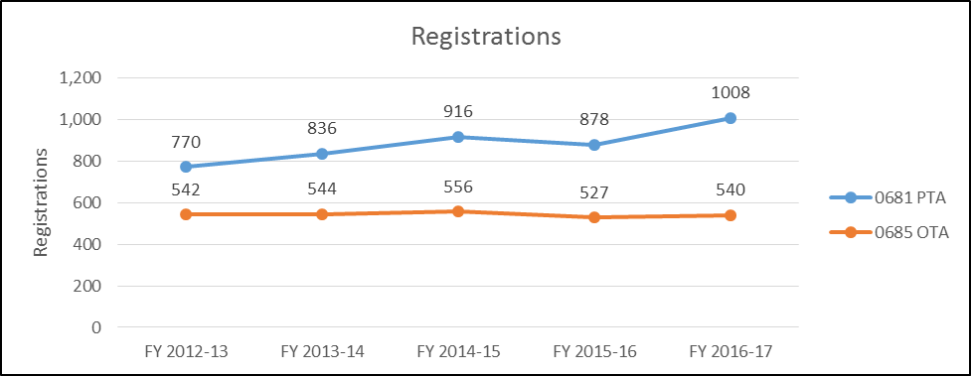

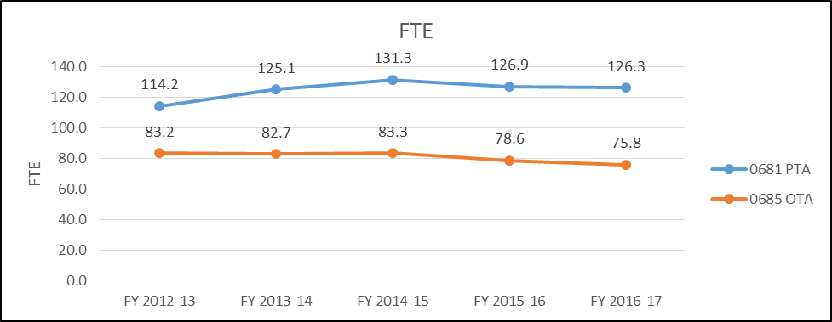

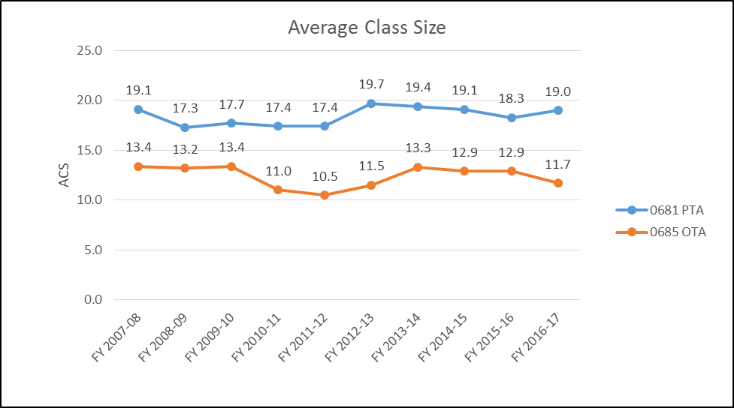

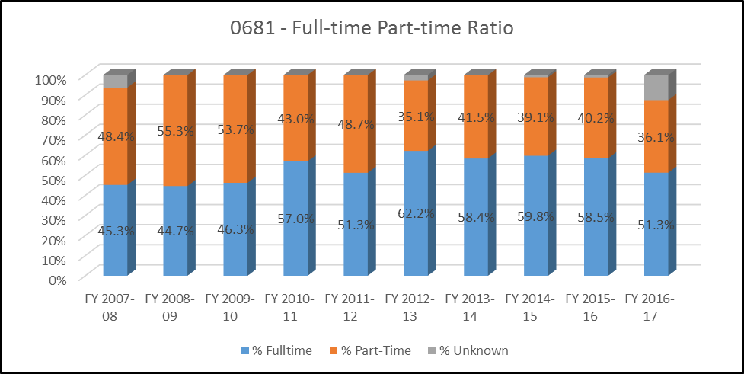

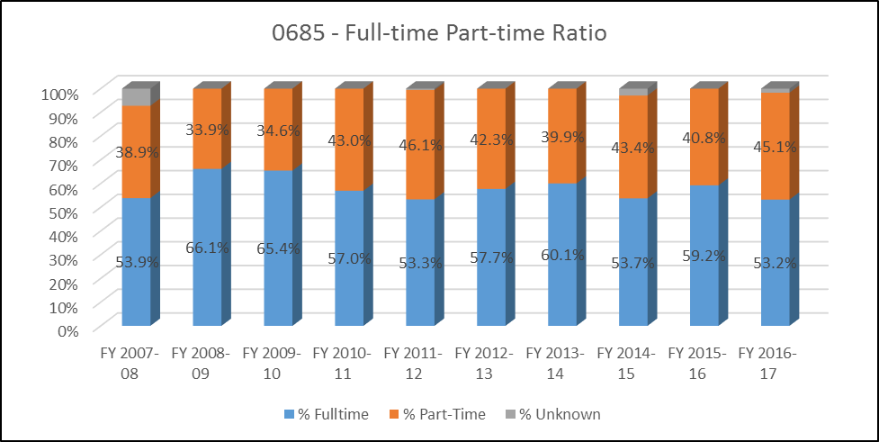
- Evidence of student demand for the program
How has/is student demand for the program changing? Why? Should the department take steps to increase the demand? Decrease the demand? Eliminate the program? What is the likely future demand for this program and why?
OTA:
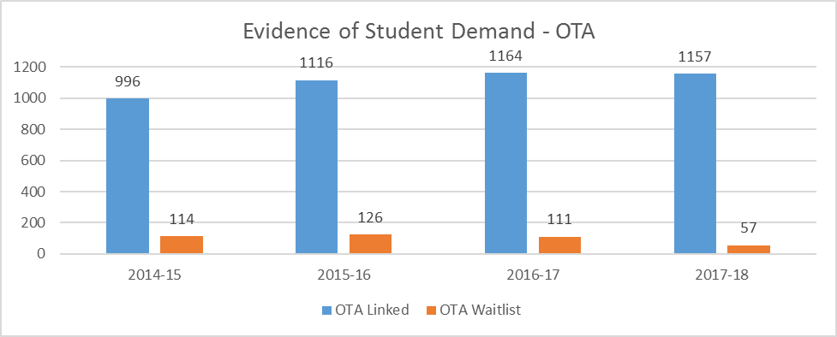
The OTA program has consistently had a large number of linked students, as well as students on the waitlist, indicating a strong demand. There are still two more semesters to add students for the 2017-18 academic year OTA Waitlist, and it is anticipated the final number will be similar to previous years.

PTA:
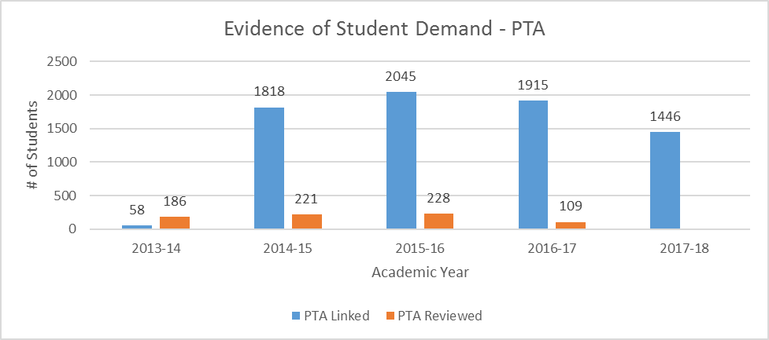
The PTA program has consistently had a large number of linked students, as well as students who are reviewed, indicating a strong demand. It is believed that the low number of linked students in 2013-14 is due to a change in the reporting method (i.e. Visual Analytics may have been just implemented) rather than an indication of the actual number of interested students. In 2016-17, the PTA program experienced a decrease in the number of students who were eligible to be reviewed. The reason for the decrease in eligible students was due to the Test of Essential Academic Skills (TEAS) requirement not being completed. It is still unknown why so many students did not complete this requirement. In 2016-17, the PTA program also demonstrates a decrease in the number of linked students; however, this decline is related to the list being “cleaned up”. The Transcript Review has not yet occurred for 2017-18.
In both the PTA and OTA Programs, there is limited ability to admit a larger cohort of students due to several factors, including: clinical site availability, workforce demand, employment rates, lab space, and time required to assure clinical competence for all students.

- Evidence of program quality from sources outside of the department (e.g., advisory committees, accrediting agencies, other departments on campus, transfer partners, etc.)
What evidence does the department have about evaluations or perceptions of department/program quality from sources outside the department? Who are your stakeholders, and what feedback are you receiving from them about program quality?
OTA: OTA stakeholders include our accrediting organization, clinical instructors, employers, and clients. The OTA program has maintained accreditation throughout this review period. Clinical instructors and employer rate our students highly on surveys. Based on employer data received in 2016 75% (9/12) employers report SCC OTA students perform “Good” or “Very Good” in all identified areas. 100% of those surveyed, reported SCC OTA students perform “Good” or “Very Good” in 11-12 of 12 identified areas. Please see AppendixU for OTA Employer Data 2016 details.
PTA: PTA stakeholders include our accrediting organization, clinical instructors, employers, and patients. The PTA program has maintained accreditation throughout this review period. Clinical instructors, employers, and patients rate our students highly on assessment instruments and/or surveys. 100% of students from 2013 – 2017 have been rated at or above “Entry Level” by their Clinical Instructors at the end of their final clinical rotation. AppendixJ Additionally, an overwhelming majority of clinical instructors report our students were prepared for their clinical, and they would hire our students and/or feel comfortable supervising them. AppendixL Employers and co-workers surveyed showed well-above threshold satisfaction with Sinclair PTA alumni who work in their facilities. AppendixK / AppendixO Finally, patients are extremely happy with the care they receive by our students, as noted by 98.6%-99.8% satisfaction (Dayton) and 98.2% - 99.4% satisfaction (Courseview). AppendixM

- Evidence of the placement/transfer of graduates
What evidence does the department/program have regarding the extent to which its students transfer to other institutions? What evidence does the department have regarding the rate of employment of its graduates? What data is available regarding the performance of graduates who have transferred and/or become employed? What data is available from RAR graduate surveys?

Evidence of transfer to other institutions: Currently, the Associate of Applied Science (in OTA and PTA) is meant to be a terminal degree. There are potential plans for OTA to eventually move to a bachelor’s degree. At this point in time, PTA transitioning to a bachelor’s degree is not supported by the professional organization. Therefore, only a few students continue on to earn a master’s or doctoral degree in occupational therapy, or a doctor of physical therapy degree. If a student does continue their education in this manner, the programs are usually informed via anecdotal evidence. At this time, neither program directly tracks this information.

Evidence of employment rate: Both programs are required to track and report employment rates per accreditation. Currently, 100% of licensed PTA graduates from the Class of 2017 from both Dayton and Mason campuses are employed. Please see Appendix C for PTA Employment data.

100% of 2016 OTA graduates are currently employed and 9/12 (75%) 2017 OTA graduates that are actively seeking employment, are currently employed. In addition to our students acquiring employment soon after graduation, a new trend we are seeing with new COTAs is the type of employment and the therapy setting options available. Historically, in recent times, our OTA grads could only find PRN (as needed) positions at nursing homes. These positions remain available but many of our grads are being hired part- or full-time and in addition to nursing homes, by settings such as outpatient pediatrics, schools, hand therapy and inpatient rehabilitation.

Data regarding performance of graduates: Both programs utilize Employer Surveys to obtain data related to graduate performance. Per RAR data, employers’ evaluations of OTA and PTA graduates’ skills and preparation were very positive. Similarly, employers are generally positive when evaluating the relative preparation of OTA and PTA graduates. See Appendix O for Employer Survey Results for OTA and PTA (obtained by RAR). See also Appendix K for PTA Employer/Co-Worker Data (obtained by the PTA program).

- Evidence of the cost-effectiveness of the department/program
What is the department doing to manage costs? What additional efforts could be made to control costs? What factors drive the costs for the department, and how does that influence how resources are allocated? What has the Average Class Size been for the department since the last Program Review, and what are steps that the department could take to increase Average Class Size? If Average Class Size has decreased, what is the explanation?

OTA:
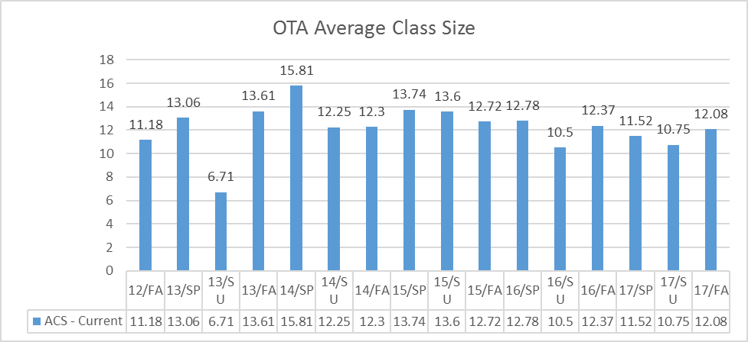

- Contribution margin report information: The OTA program has experienced a small decrease in FTE between FY 2014 through FY 2018. The annualized changed for Revenue per FTE, which includes primarily tuition/fees, is equal to that of the Health Sciences division at 4.7%. Expense per FTE, which is primarily personnel, is demonstrating a 4.0% increase on a year over year basis, with the largest increase occurring between FY 2016 and FY 2017. The annualized change rate for the OTA program’s contribution margin is 6.4%, which is positive, yet expenses are growing faster than growth though FTE. With the restructuring of the OTA curriculum, additional hands-on skills competencies and lab practicals have been installed into the courses. These lab skill assessments require additional faculty to complete.

PTA:
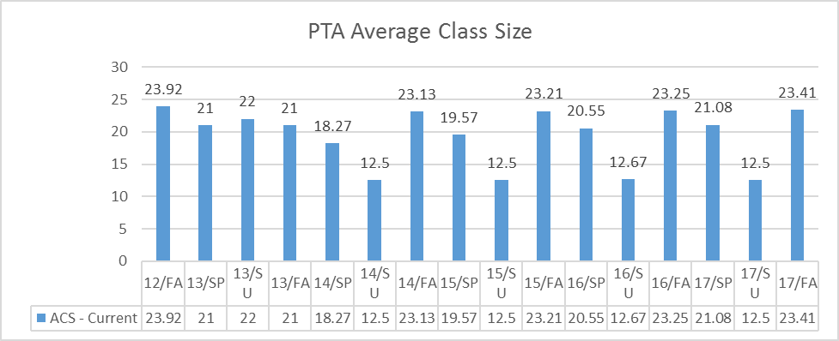
To manage costs, the PTA program is working to standardize the number of adjuncts that are needed as lab assistants for each course, as well as proctors for lab practicals. The program offers only one section per technical course, and therefore, Average Class Size (ACS) is kept at the maximum number (with the exception of students lost through attrition).

An additional effort that is being made to control costs includes the new timing of the competitive selection process (as discussed previously in this report). The program hopes that a competitive selection process that occurs closer to the start of the Fall term will decrease attrition and improve Average Class Size for PTA technical courses.

Factors that drive the costs for the PTA program include personnel and equipment. A relatively large number of adjuncts are needed as lab assistants to assure an adequate number of proctors for students to complete skills checks and competencies in a timely manner. Additionally, the PTA program utilizes lab practicals as a means of assessing students. Lab practicals are time and labor intensive, and require a large number of proctors (including adjuncts) to accomplish all that is required in the time frame allotted. The Rehabilitation Services department was recently tasked with starting a Rehabilitation Clinic. Equipment associated with this endeavor was costly, as equipment will no longer be used for educational purposes only, but for patient care as well. Maintenance, calibration, and safety checks add to the cost.

The graph above depicts the ACS for the PTA program since the last Program Review. As seen in the graph, ACS is higher in Fall terms than in Spring terms. As previously documented in this report attrition is highest in the first Fall term; therefore, it makes sense that Spring term has a lower ACS. Overall, ACS for Fall terms has remained flat, as has ACS for Spring terms, albeit decreased as compared to Fall. As previously mentioned, the PTA program offers only one section per technical course, so the only factor affecting ACS is attrition/retention. In addition to a change in the timing of the competitive selection process, the PTA program continues to enlist a variety of initiatives to improve retention. Examples of initiatives to improve retention include mandatory faculty advising to assist students with identifying behaviors contributing to (or hindering) success, and an Early Alert and Monitoring system to identify at-risk students and implement remediation plans as needed (as discussed previously in this report).

Contribution margin report information: The PTA program has experienced a solid increase in growth with regard to FTE (> 50% growth rate) between FY 2014 through FY 2018, some of which was probably due to the addition of a 2nd cohort of students on the Mason campus. The Revenue per FTE, which includes primarily tuition/fees, has demonstrated an average 4.6% growth per year. The Expense per FTE, which is primarily personnel, is only demonstrating 1.5% growth per year. In relation to the division, the PTA program’s contribution margin, which is Revenue minus Expenses per FTE, demonstrates a 25.9% increase on a year over year basis, as compared to 18.1% for the Health Sciences division. Student FTE per FT Faculty FTE for the PTA program is 3, as compared to 6 for the division, and the year over year trend is positive, which indicates an efficiency gain.

Section VI: Department/Program Status and Goals
- List the department’s/program’s strengths, weaknesses, opportunities, and threats (SWOT analysis).
OTA:
- Strengths:
  - Interprofessional education
  - Faculty and staff: Excellent teamwork, committed to doing a great job and going the extra mile, student-oriented, credentials, knowledgeable and competent, professional
  - Community partnerships: Montgomery County Developmental Disabilities (Fun Night), Prevent Blindness Ohio
  - Fun Night: On-site nontraditional Level I fieldwork for first year students
  - Curriculum:
    - Updated prerequisites and science requirements are bringing in more qualified students
    - Redesign
  - Strong and active Advisory Board
  - Wide professional and personal network with community OTs/OTAs
  - Realistic homecare lab for student use
- Weaknesses:
  - Challenge with educational space in new, more realistic home health apartment setting (compared to prior, more open, less realistic lab space)
  - Adjunct faculty professional development
  - Challenges related to logistics of new workspace
    - Workstation/suite environment: New cubicle design makes concentration more difficult; lack of privacy for nonscheduled, emotionally charged student interactions; FERPA concerns when receiving phone calls from external stakeholders
    - Challenges with lack of privacy when utilizing conference rooms, especially related to emotionally charged student interactions and reviewing private, computerized student information (due to glass walls, large wall monitor),
    - Due to open concept of building and elevated ceilings in lab, noise travels and echoes, effecting both student learning and faculty concentration at workstations
    - Multiple work orders have had to be submitted in order for appropriate cleaning of educational spaces to occur
  - Challenges with securing appropriate spaces on campus that are large enough to accommodate inter-professional activities, as the number of large spaces continues to diminish
- Opportunities:
  - Bachelor of Science
  - Rehabilitation Clinic
  - IPE Trainer (Ms. McGohan)
  - Community partnerships: Expanding Level I fieldwork
  - HS Building:
    - OTA Lab: Potential to outfit with kitchen appliances
  - ACF: Potential to balance faculty workload with one-term ACF in Fall semester
  - Possibility to offer certificate program
  - OTA review courses
  - Restructuring Intro course
  - Regular assessment, summary and analysis of data
- Threats:
  - 65 credit hour max: Requires extensive faculty/student workloads for small amount of credit hours
  - Aramark: Cost prohibitive to provide food at events/activities
  - Potential for accrediting body to require a Bachelor’s degree for OTA’s

PTA:
- Strengths:
  - Faculty and staff: Excellent teamwork, committed to doing a great job and going the extra mile, student-oriented, credentials, knowledgeable and competent, professional
  - Curriculum: Current and evidence-based; logical and organized, variety of instructional methods (i.e. team-based learning), interprofessional education activities, designed to meet and exceed accreditation standards
  - Equipment (on the Dayton campus):
  - Integrated clinical observations:
  - Interprofessional education
- Weaknesses:
  - Lab practical rubrics
  - Adjunct faculty professional development
  - Challenges related to logistics of new workspace
    - Lack of privacy in the PTA lab due to windowed wall with transparent blinds (as students must be in various states of undress for clinical practice)
    - Workstation/suite environment: New cubicle design makes concentration more difficult; lack of privacy for nonscheduled, emotionally charged student interactions; FERPA concerns when receiving phone calls from external stakeholders
    - Challenges with lack of privacy when utilizing conference rooms, especially related to emotionally charged student interactions and reviewing private, computerized student information (due to glass walls, large wall monitor),
    - Due to open concept of building, elevated ceilings in lab, and windows for walls, noise travels and echoes, effecting both student learning and faculty concentration at workstations
    - Multiple work orders have had to be submitted in order for appropriate cleaning of educational spaces to occur
      - Challenged with securing appropriate spaces on campus that are large enough to accommodate these activities, as the number of large spaces continues to diminish
    - Challenges with safety due to floor outlets that are above-ground instead of flush-set and cord covers that do not lay flat, producing uneven surfaces and trip hazards.
  - Classrooms are not large enough to accommodate large groups for interprofessional education sessions or combined Dayton / Mason activities
- Opportunities:
  - Rehabilitation clinic
  - ATC to PTA degree
  - Expansion of clinical education offerings for area clinicians (i.e. CCIP, additional resources offered to clinical instructors)
  - Facebook: Communication with alumni and employers
  - Change to timing of competitive selection process
  - Regular assessment, summary and analysis of data
- Threats:
  - Fewer students taking the TEAS
  - Attrition
  - Marketing: Limited assistance with requested needs (i.e. clinical education website, limited ability to update program webpages in a timely and efficient manner
  - Aramark: Cost prohibitive to provide food at events/activities
  - Parity: Dayton campus versus Mason campus
  - 65 credit hour max: Requires use of 1:3 lab ratios and extensive faculty/student workloads for small amount of credit hours
  - If students have completed all requisite classes for graduation outside of the PTA technical curriculum, they only have 5 credit hour of coursework during second-year Spring semester, creating financial aid issues

- What are the department’s/program’s goals and rationale for expanding and improving student learning, including new courses, programs, delivery formats and locations? Are there unmet goals from the most recent Program Review? Please note that the department goals listed in this section will be reviewed for progress on Annual Updates and in your next Program Review.

Rehabilitation Services:
- Develop a business plan for a rehabilitation clinic.
- Implementation of a rehabilitation clinic.
- Enhance interprofessional education.

OTA:
- Preparation for accreditation site visit (Fall 2020) and maintenance of full accreditation.
- Research feasibility and necessity for alternate/new program formats; implementation as appropriate.
  - Additional research related to transition to BS degree.
- Developing community psychosocial Level I fieldwork sites (including provision of adjuncts as fieldwork educators)

PTA:
- Preparation for accreditation site visit (Spring 2019) and maintenance of full accreditation.
- Research feasibility and necessity for alternate/new program formats; implementation as appropriate.
  - Additional research related to ATC to PTA degree
- Continue to analyze competitive selection process and outcomes.

- What resources and other assistance are needed to accomplish the department’s/program’s goals?
Marketing: to assist with program advertising
RAR: to assist with data analysis and trend tracking
CTL: to assist in adjunct and full-time faculty professional development
Facilities: to assist in continuing to enhance educational spaces

Section VII: Appendices: Supporting Documentation

Appendix A

PTA Incoming Student Data

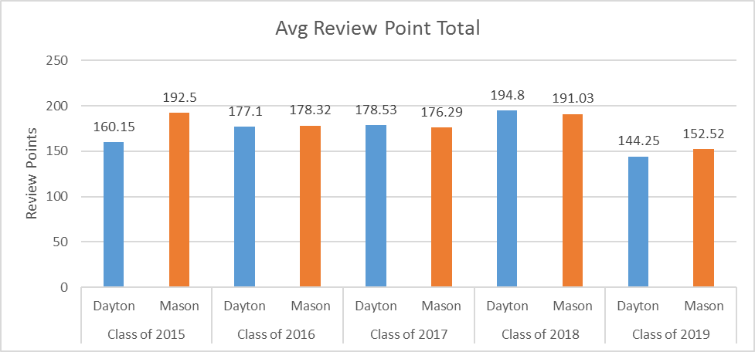

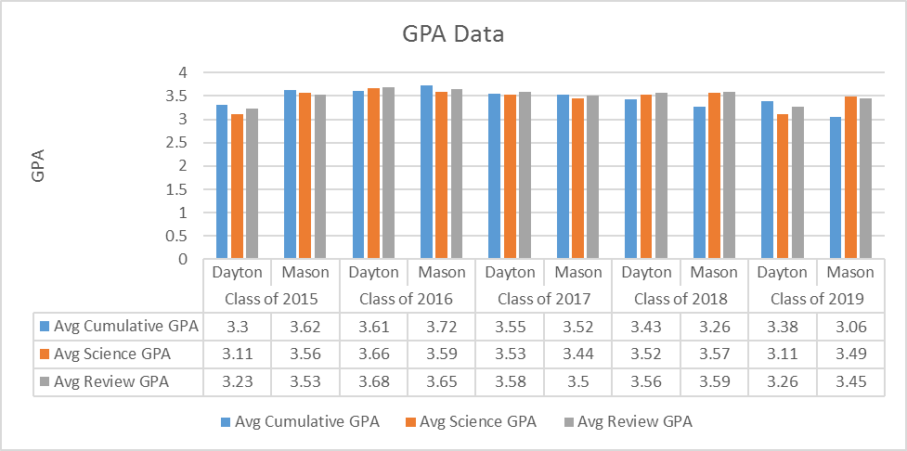

Appendix B

PTA Attrition Data

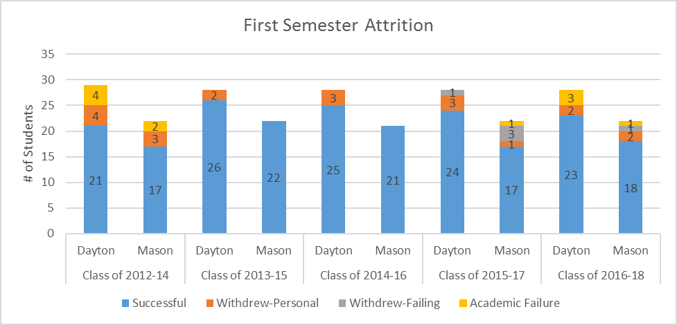

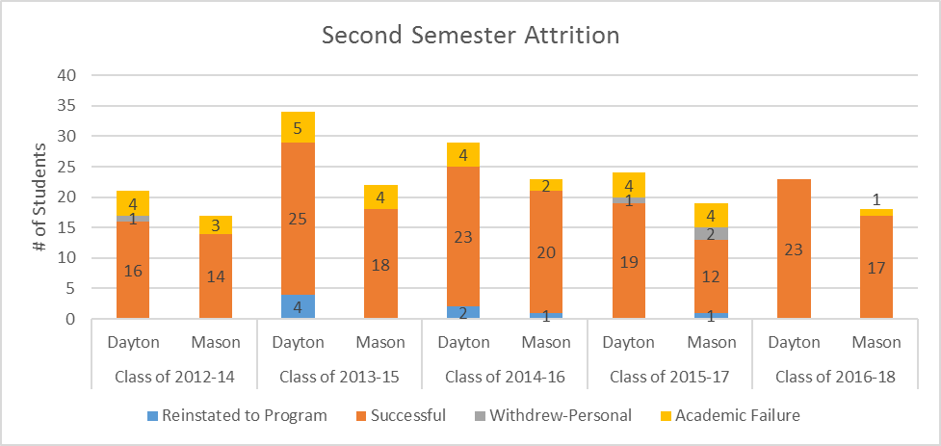

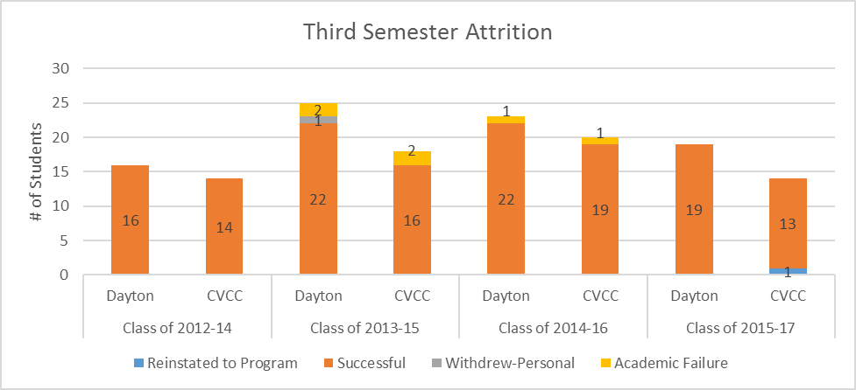

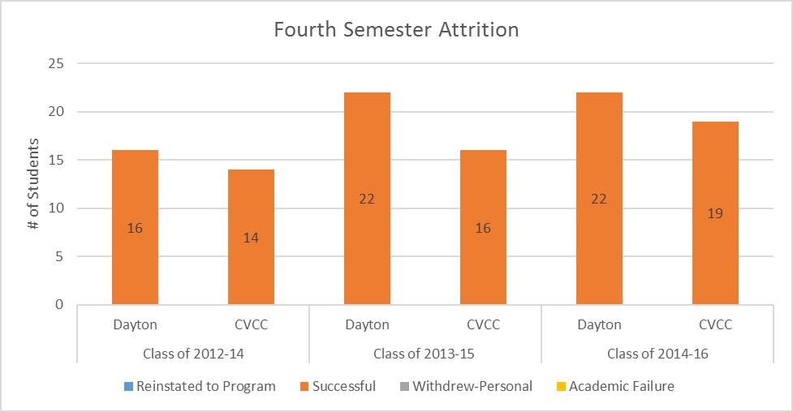

Appendix C

PTA Graduation/Licensure/Employment Data

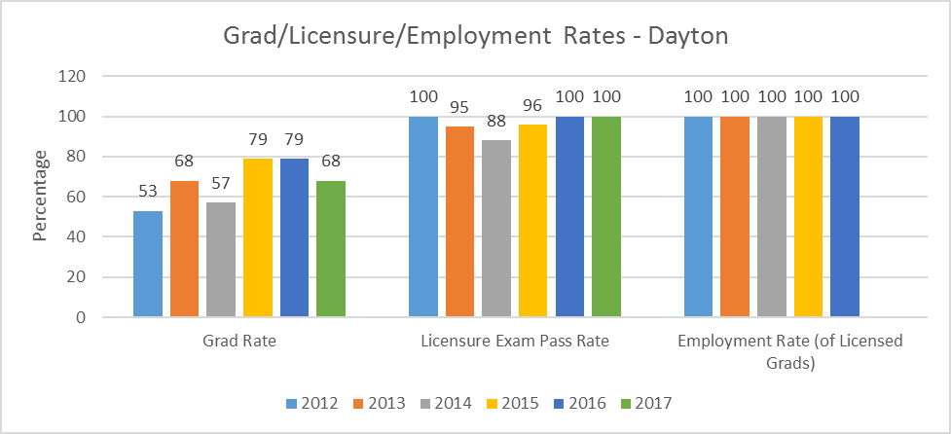

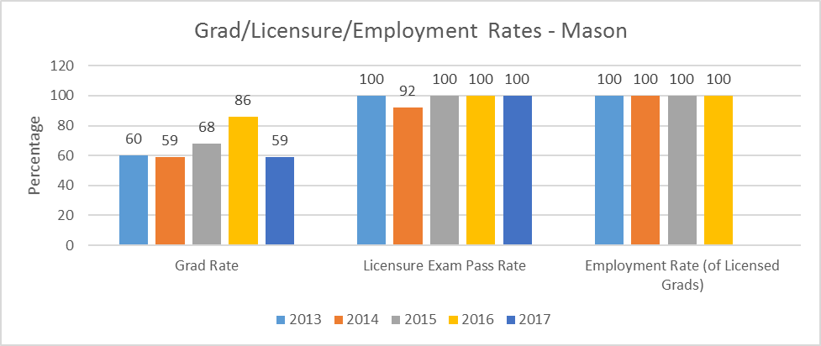

Appendix D

First-Term Anatomy and Kinesiology Course Success Data

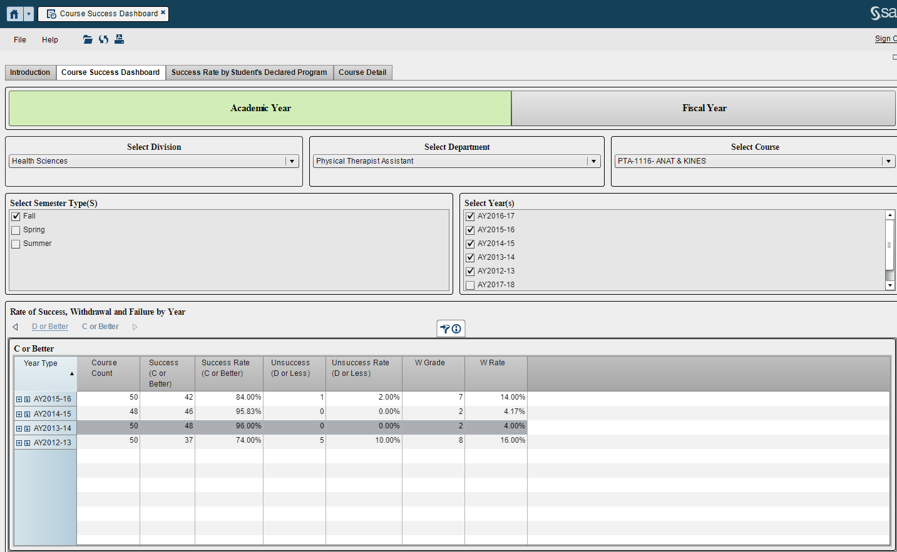

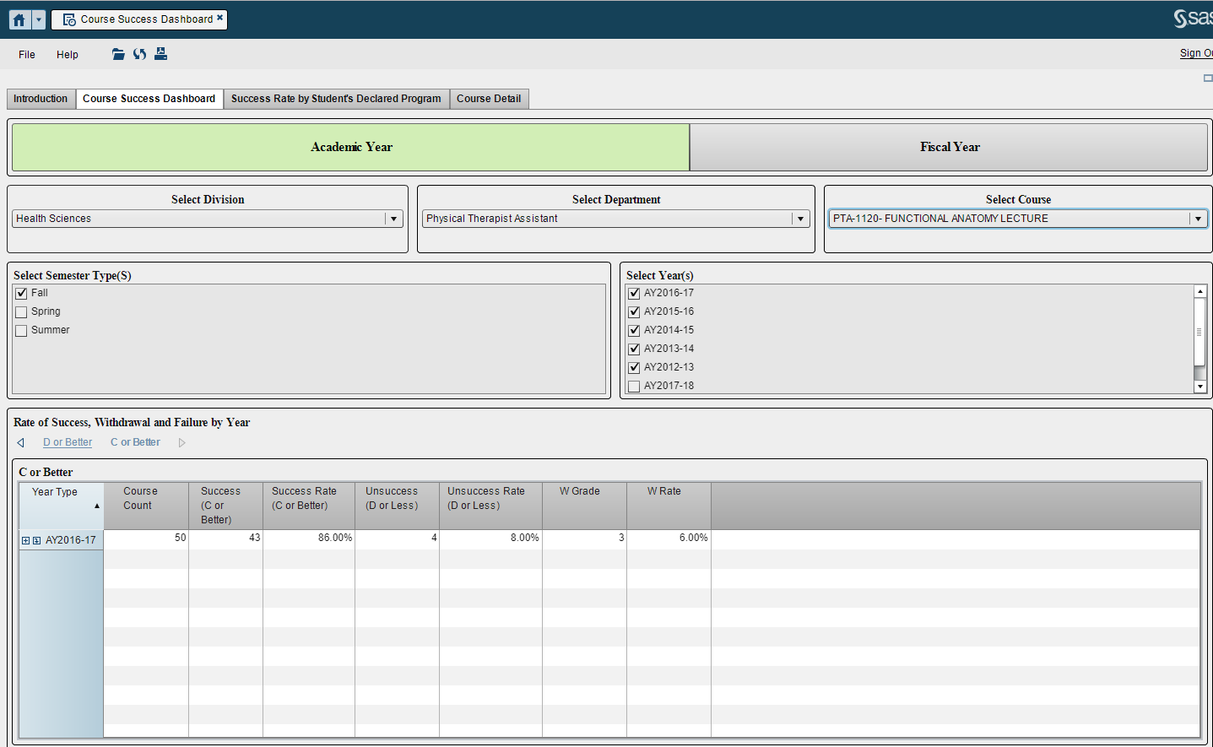
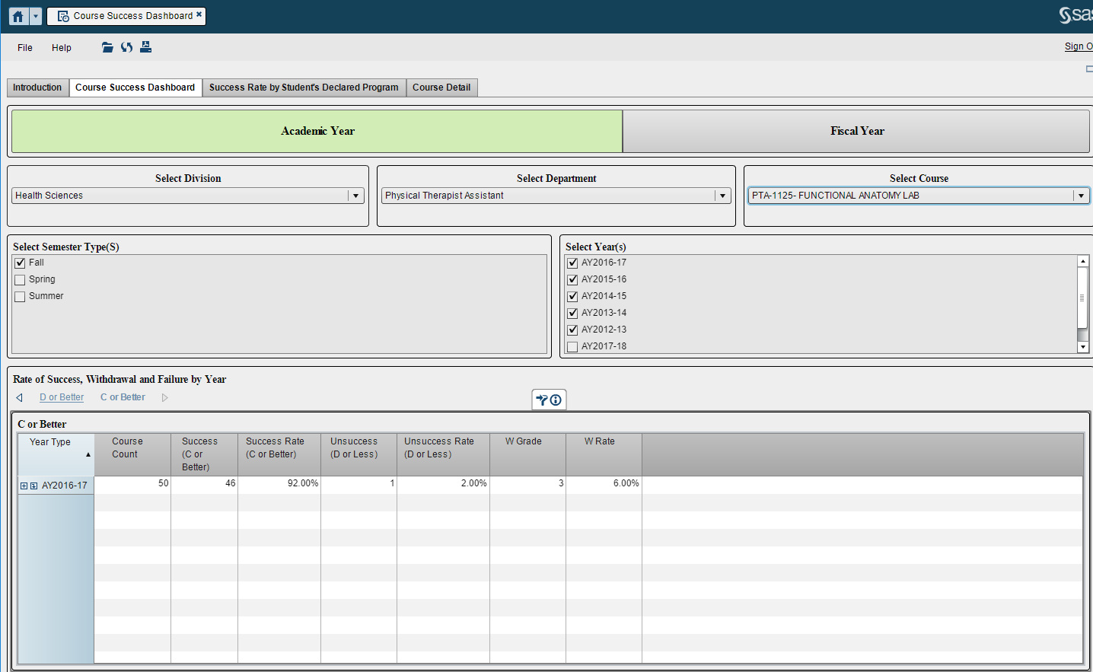

Appendix E

Investigation of Student Inputs on Academic Performance in a Physical Therapist Assistant Program
- The purpose of this causal-comparative and correlational quantitative study was to examine what differences existed in the final percentage grade in a first-term Anatomy and Kinesiology (A&K) course between students who completed the Test of Essential Academic Skills (TEAS) and students who had a prior academic degree (PAD) (inputs) and whether TEAS score and prior academic degree were associated with the final A&K percentage grade among students in a PTA program in a community college setting in the Midwestern United States.
- Archival data for 222 students enrolled in the PTA program from 2012-2016 admission cycles were extracted from the college’s student records. Data for 24 students were removed due to missing final percentage grades for the first-term A&K course. One student was removed from the sample due to a final percentage A&K grade of 104.01%, which was deemed an outlier. Eight students with data for both the TEAS and a prior academic degree were removed. The final study sample included 189 students.
Sample Characteristics
Variable | Total Sample  n = 189 | TEAS (No PAD) Group  n = 114 | PAD Group  n = 75
Gender | Male: 69 (36.5%); Female: 120 (63.5%) | Male: 41 (36%); Female: 73 (64%) | Male: 28 (37.3%); Female: 47 (62.7%)
Admission Age | Mean: 31.50;  Min: 19  Max: 57  Median: 26 | Mean: 30.56  Min: 19  Max: 55  Median: 28 | Mean: 32.92  Min: 22  Max: 57  Median: 30
Note. TEAS = Test of Essential Academic Skills. PAD = prior academic degree.
- R₁: What differences exist, if any, between the TEAS group versus the PAD group on final percentage grade in a first-term A&K course among students in a PTA education program?
  - Independent-samples t-test statistic: A statistically significant difference in A&K final percentage grades for the TEAS group (M = 86.473, SD = 5.167) and PAD group (M = 89.591, SD = 5.584; t(187) = -3.931, p = .000, two-tailed) was found. The magnitude of the difference in the means (mean difference = -3.118, 95% CI: -4.683 to -1.553) was medium (Cohen’s d = .580).
- R₂: Is there a relationship between overall TEAS score and final percentage grade in a first-term A&K course among students in a PTA education program?
  - Pearson r correlation statistic: A small, positive correlation was found between the two variables, r = .193, n = 114, p = .040, with high TEAS scores associated with high A&K course grades. The coefficient of determination between the two variables was calculated as .037 (3.7% shared variance).
- R₃: Is there a relationship between PAD status and final percentage grade in a first-term A&K course among students in a PTA education program?
  - Point biserial correlation statistic: A small, negative correlation was found between the two variables, r = -.276, n = 189, p = .000. The PAD group was coded as 0, and the No PAD group was coded as 1. The negative correlation indicated a movement from “1” to “0” according to the coding of the variables. Therefore, having a prior academic degree was associated with a higher final percentage grade in a first-term A&K course. The coefficient of determination between the two variables was calculated as .076 (or 7.6% shared variance).

Appendix F
Revised PTA Program Mission, Goals, Outcomes, and Assessment Tools/Data Sources
Sinclair Mission: We help individuals turn dreams into achievable goals through accessible, high quality, affordable learning opportunities.
PTA Program Mission: To provide high quality education to students seeking the opportunity to practice as a physical therapist assistant under the direction and supervision of a physical therapist.
Goals and Outcomes:
- Student/Graduate Goal: Students/graduates will demonstrate professionalism.
  - Outcome: Students will participate in a minimum of four interprofessional education experiences.
    - Data Source: Course syllabi, Clinical Site Visit Form
  - Outcome: Students/graduates will demonstrate Professional Behaviors and Values-Based Behaviors for the Physical Therapist Assistant as evidenced by minimum average ratings of 75% on assessments.
    - Assessment(s): Triple Jump Lab Practical (Professionalism component), CPI (Cultural Competency, Accountability, Clinical Behavior, Communication, Self-Assessment and Lifelong Learning, and Resource Management components), Employer/Co-Worker Survey
- Student/Graduate Goal: Students/graduates will engage in effective communication.
  - Outcome: Students/graduates will demonstrate effective written, oral, and nonverbal communication and interpersonal interactions as evidenced by minimum average ratings of 75% on assessments.
    - Assessment(s): Triple Jump Lab Practical and Documentation (Communication component), CPI (Communication and Documentation components), and Employer/Co-Worker Survey
- Student/Graduate Goal: Students/graduates will provide high quality patient care under the direction and supervision of a physical therapist.
  - Outcome: Students/graduates will demonstrate quality, safe patient care as evidenced by minimum average ratings of 75% on assessments.
    - Assessment(s): Triple Jump Lab Practical (Clinical Safety component), CPI (Safety), Patient Satisfaction Surveys, Employer/Co-Worker Survey
  - Outcome: Students/graduates will demonstrate sound critical thinking and problem solving as evidenced by minimum average ratings of 75% on assessments.
    - Assessment(s): Triple Jump Lab Practical (Clinical Problem Solving component), CPI (Clinical Problem Solving), Employer/Co-Worker Survey
  - Outcome: Students/graduates will demonstrate evidence-based decision-making/practice as evidenced by minimum average ratings of 75% on assessments.
    - Assessment(s): Modalities II Assignment, Inservice, Employer/Co-Worker Survey
- Program Goal: The program will engage in assessment for the purpose of continuous improvement.
  - Outcome: Full-time faculty will engage in a minimum of three appropriate professional development activities annually to enhance teaching/learning and program improvement.
    - Data Source: CV, FPR, Professional Development Plan
  - Outcome: Adjunct faculty will engage in a minimum of one appropriate professional development activity annually to enhance teaching/learning and program improvement.
    - Data Source: Course Objectives Self-Assessment, Lab Assistant End-of-Term Student Survey, Lab Assistant End-of-Term Lead Instructor Survey, CV, Professional Development Plan
  - Outcome: The program will review, analyze, and utilize evidence to respond to the evolving nature of education, research, and practice as evidenced by assessment meetings with follow-up action plans occurring semi-annually.
    - Data Source: Meeting minutes (Advisory Committee, Assessment Meetings), End-of-First Year Survey, Record of Clinical Experience, Exit Interview, Scorebuilders Comprehensive Exam (70% of students achieve a minimum of 70% on the exam)

Appendix G
Program Outcome Data (Old Outcomes)
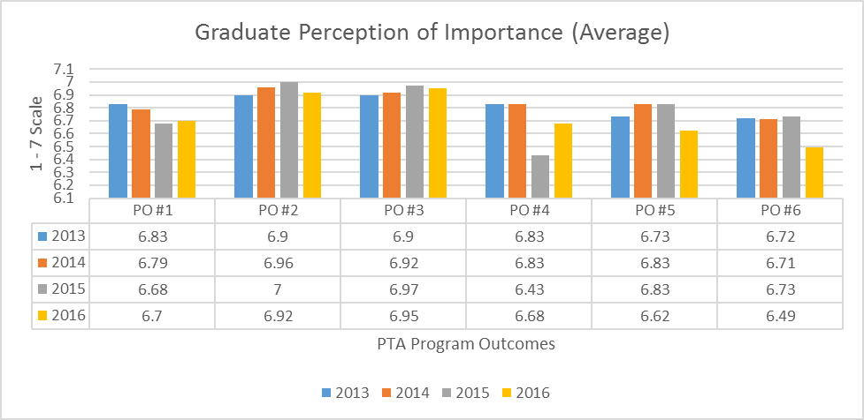

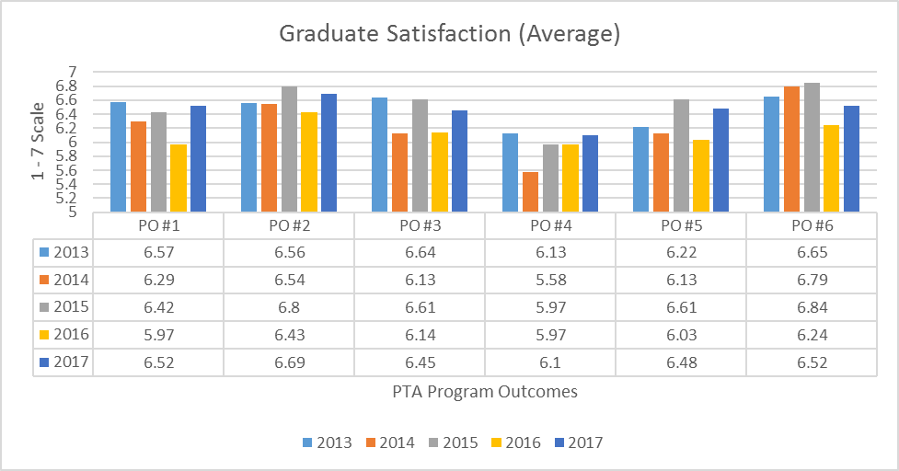

Appendix H
Interprofessional Education Data
Question asked of Clinical Instructors during clinical education experiences: Has or will the student have the opportunity to be involved in interprofessional patient care?

Dayton – Fall 2016 (n=19)

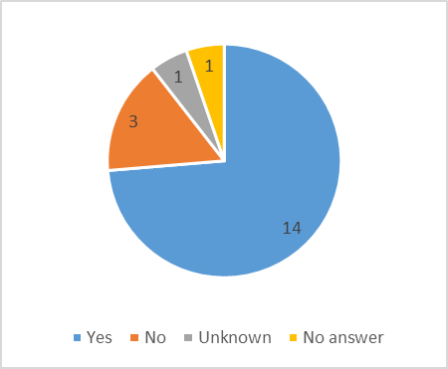

Dayton – Spring 2017 (n=19)

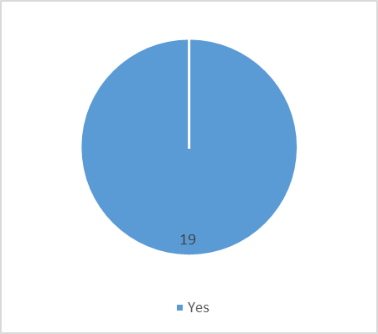

Question asked of Clinical Instructors during clinical education experiences: Has or will the student have the opportunity to be involved in interprofessional patient care?

Fall 2016 – Mason (n=13)

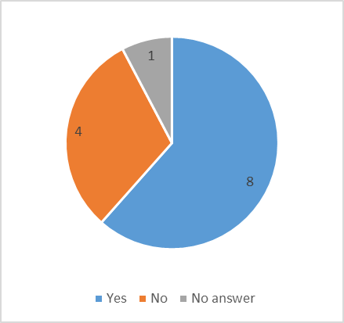

Spring 2017 – Mason (n=13)

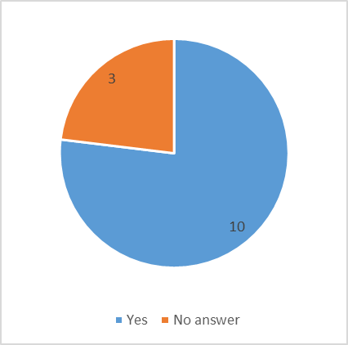
Appendix I
Triple Jump Lab Practical Data
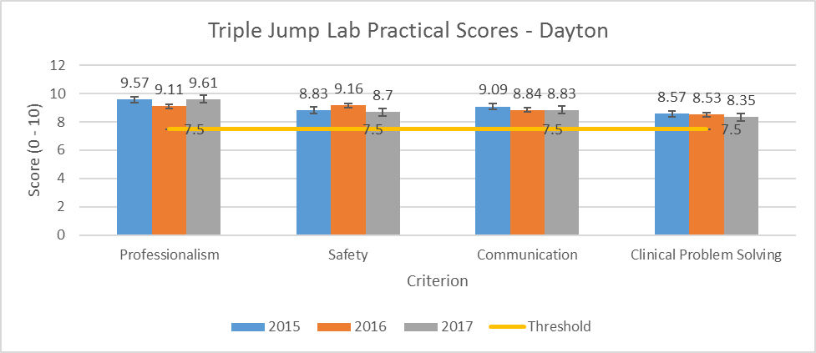
Note. 2015: n=23, 2016: n=19, 2017: n=23.
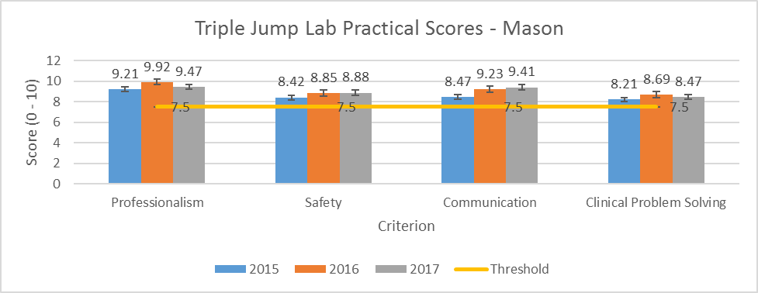
Note. 2015: n=19, 2016: n=13, 2017: n=17.
Appendix J
Clinical Performance Instrument Data
Legend for Clinical Performance Instrument (CPI) Rating

B: Beginning Performance (0 points)
AB: Advanced Beginner Performance (4 points)
I: Intermediate Performance (8 points)
AI: Advanced Intermediate Performance (12 points)
E: Entry-Level Performance (16 points) * (Target by end of final clinical experience)
B |  |  |  | AB |  |  |  | I |  |  |  | AI |  |  |  | E |  |  |  | WD
0 | 1 | 2 | 3 | 4 | 5 | 6 | 7 | 8 | 9 | 10 | 11 | 12 | 13 | 14 | 15 | 16 | 17 | 18 | 19 | 20
WD: With Distinction (20 points)
Students are expected to achieve Entry-Level Performance by the end of the final clinical.

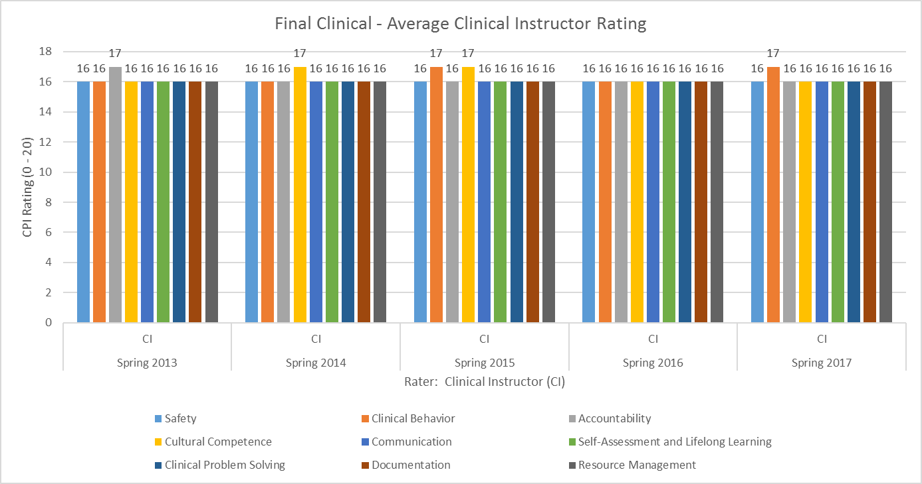

Appendix K
Employer/Co-Worker Survey Data

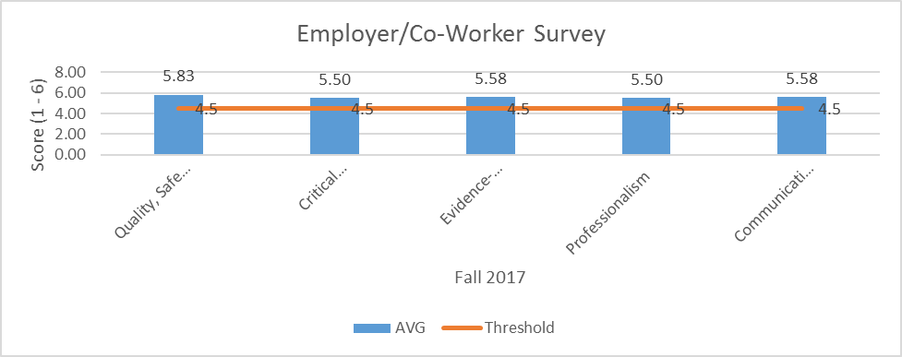
Note. n=12

Appendix L
Clinical Instructor Feedback
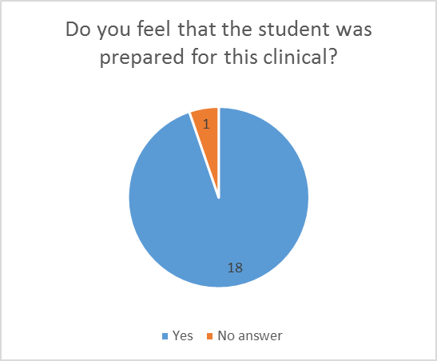
Note. Fall 2016 – Dayton, n=19.

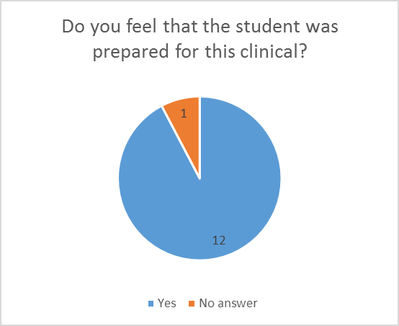
Note. Fall 2016 – Mason, n=13.
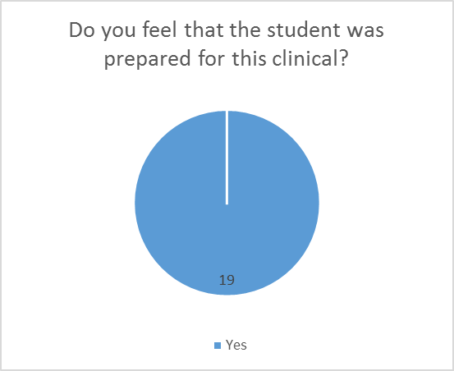
Note. Spring 2017 – Dayton, n=19.

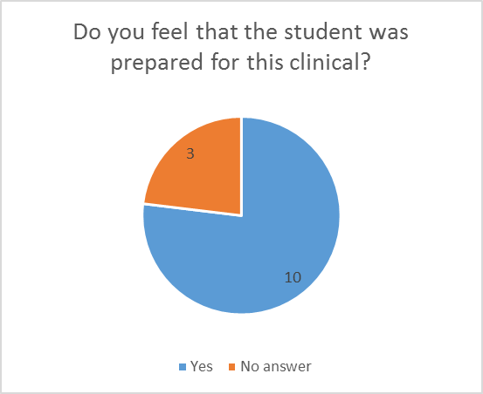
Note. Spring 2017 – Mason, n=13.

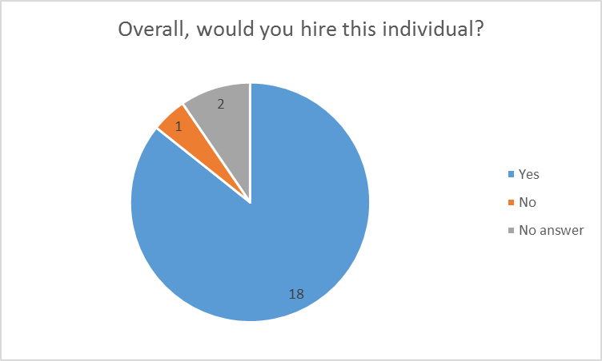
Note. Fall 2017 – Dayton, n=21.
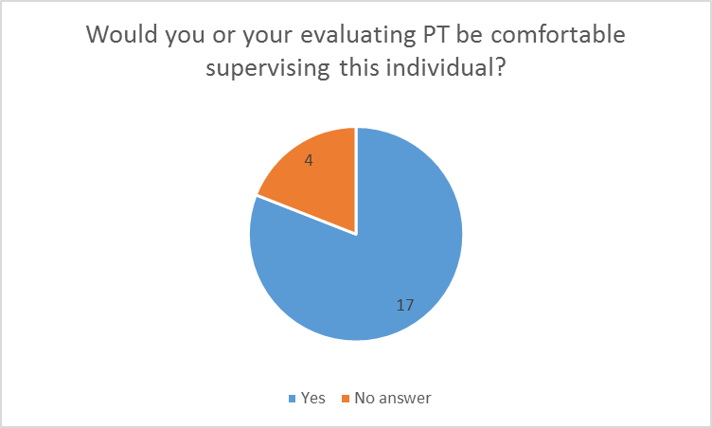
Note. Fall 2017 – Dayton, n=21.

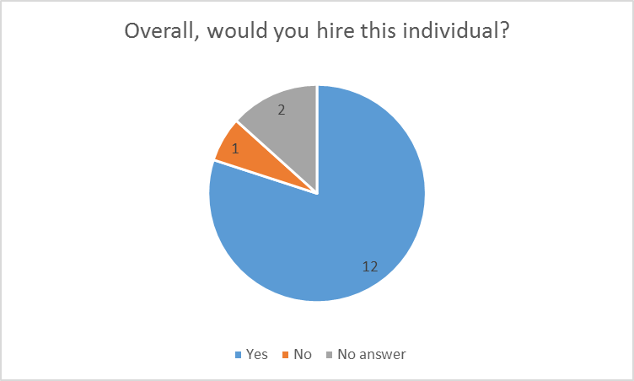
Note. Fall 2017 – Mason, n=15.

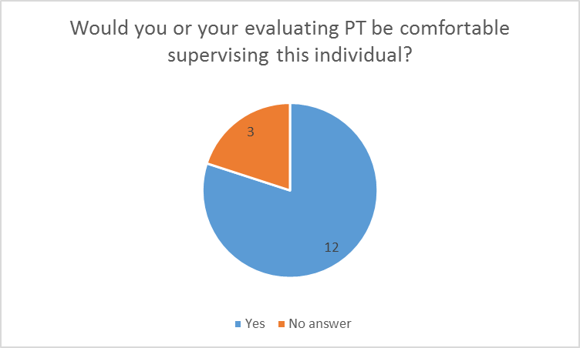
Note. Fall 2017 – Mason, n=15.

Appendix M
Patient Satisfaction Survey Data
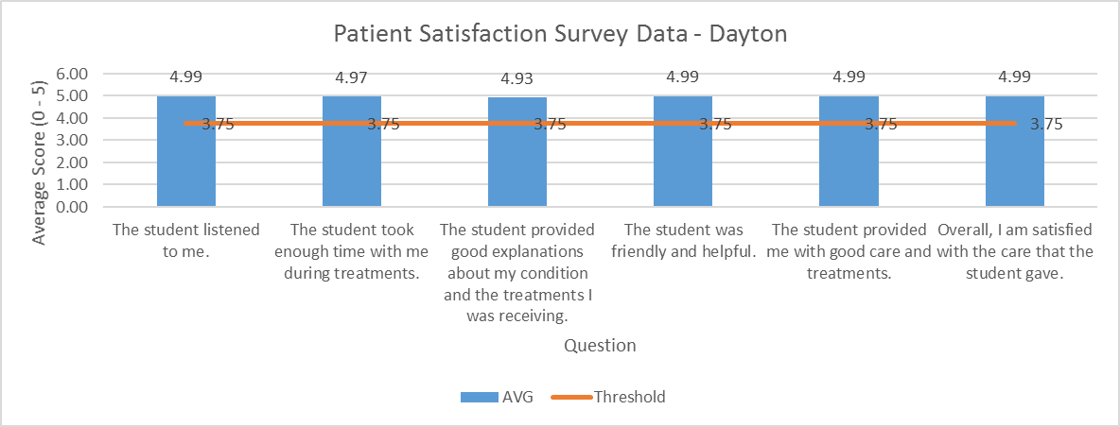
Note. Fall 2017, n=91.

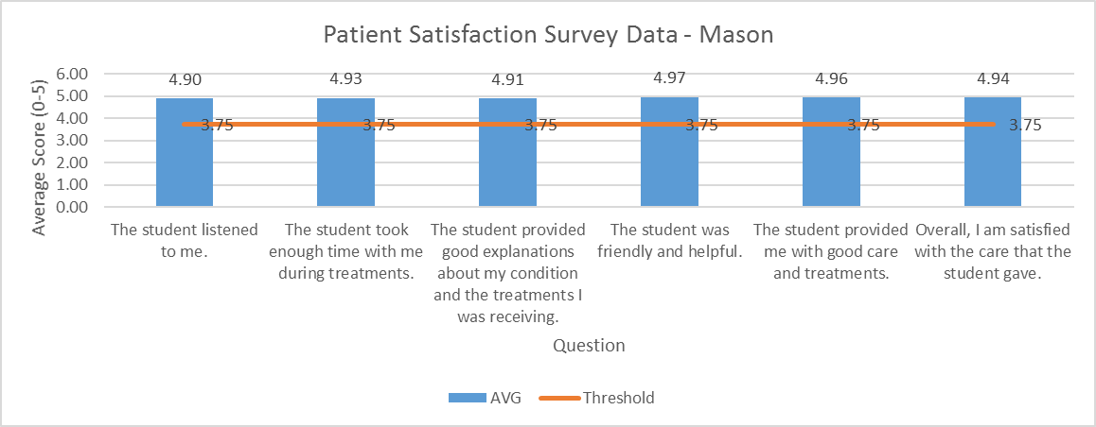
Note. Fall 2017, n=69.

Appendix N
Exit Interview Data (Class of 2017, n=29)
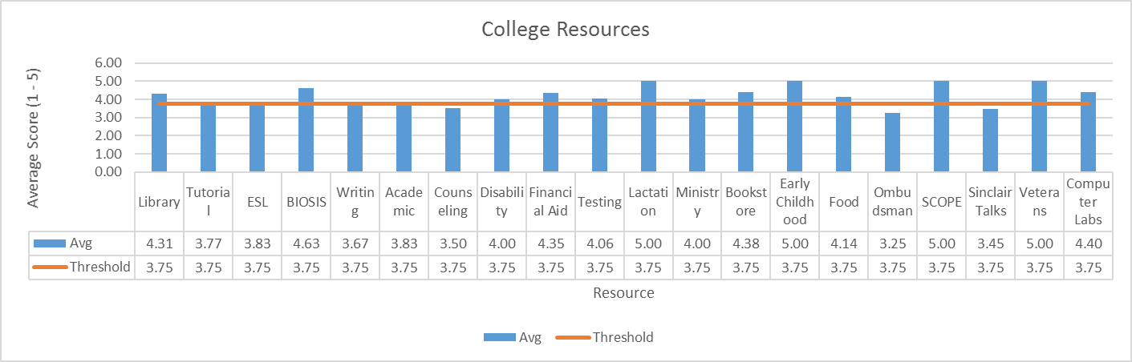

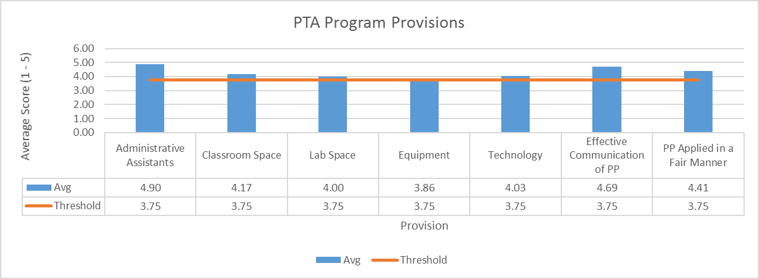

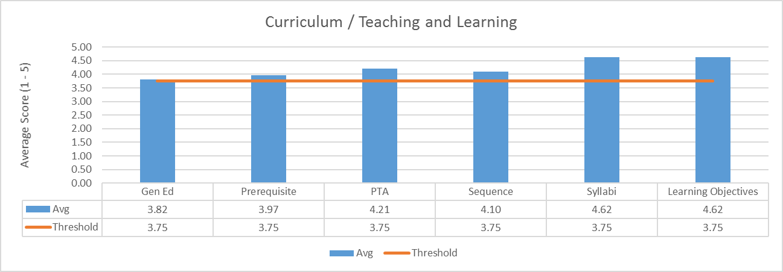

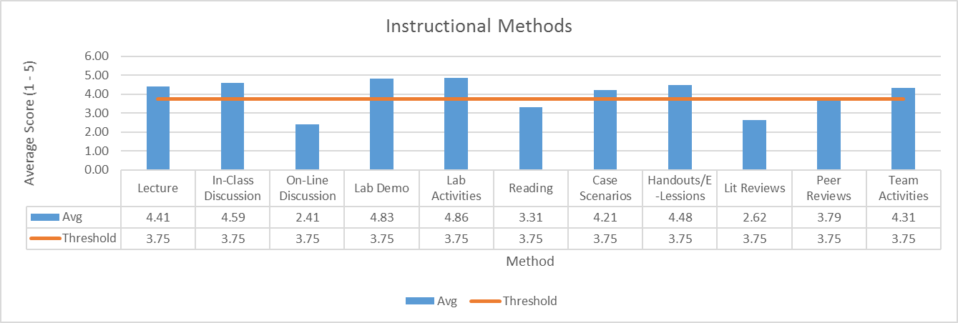

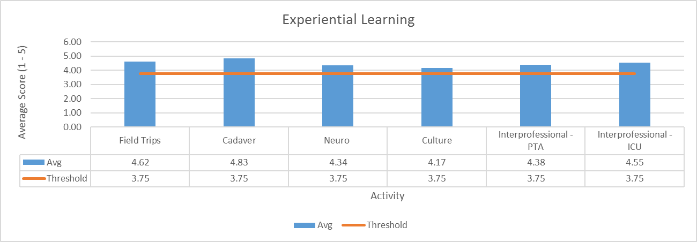

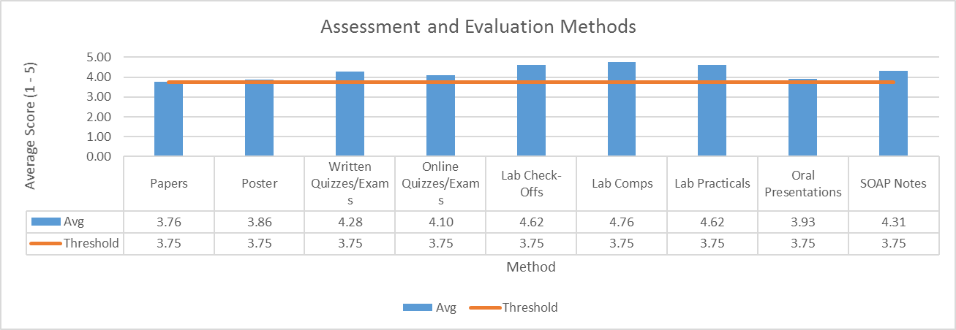

Appendix O
Employer Survey Results for OTA and PTA
There were a total of seven responses from employers for PTA and OTA graduates from 2013 to the present.
Employers’ evaluations of graduates’ skills and preparation were very positive.
On a six point scale from Very Poor (1) to Very Good (6) PTA and OTA students are evaluated by employers across the following categories:
Competency | Score
Conceptual knowledge | 5.6
Technical Knowledge | 5.7
Professionalism | 5.7
Work Quality | 5.7
Logic | 5.5
Critical Thinking | 5.5
Oral Communication | 5.5
Written Communication | 5.7
Interpersonal Communication | 5.5
Computer Skills | 5.8
Data Gathering | 5.8
Job Preparation | 5.7

Similarly, employers are generally positive when evaluating the relative preparation of PTA and OTA graduates:
On a six point scale from Much Worse Prepared (1) to Much Better Prepared (6) PTA and OTA graduates are evaluated as:
Graduates' Relative Preparation | 4.7

The open ended responses from employers about what our graduates could do better are as follows:
Areas for improvement
Patient approach + interaction skills with family/staff.
X has passion. His post work makes him comfortable in settings. He had difficulty following POC'S. Doing better.
X is an excellent worker!
Managing difficult patients. Trying different approaches when current one not bringing a + response. Critical and creative thinking.

Appendix P
General Education Outcome Data (PTA Program Data)
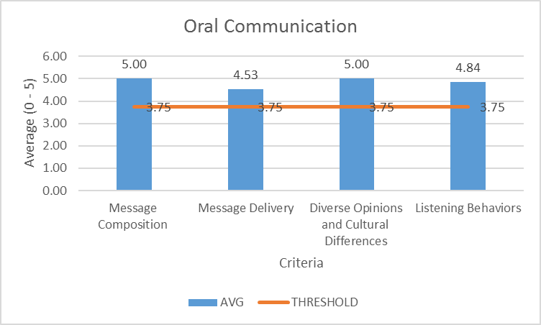
Note. Data is for 2017 graduates of the PTA program (n=19).

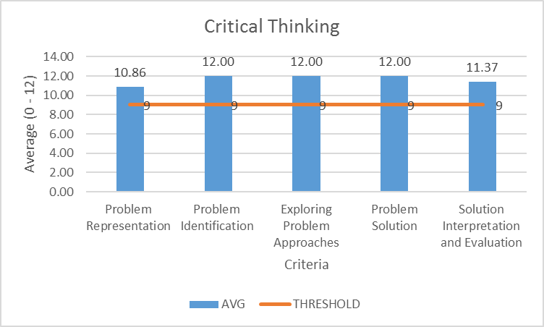
Note. Data is for 2017 graduates of the PTA program (n=19).
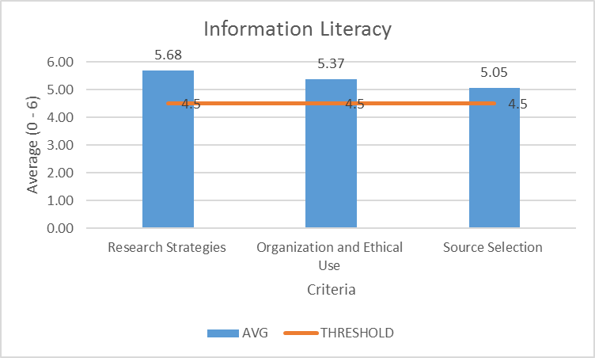
Note. Data is for 2017 graduates of the PTA program (n=19).

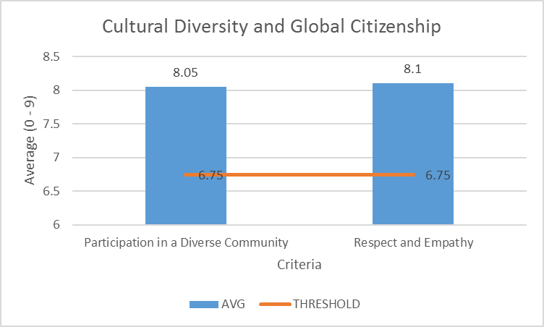
Note. Data is for 2017 graduates of the PTA program (n=20).

Appendix Q
General Education Outcomes Data (RAR Data)
Information Literacy Rubric Results for Students with a Program Code in 0681-Physical Therapist Assistant / 0685 Occupational Therapist Assistant
Dept. | General Education Component | 16/SP - 17/SP DEVELOPING | 16/SP - 17/SP COMPETENT | 16/SP - 17/SP EXCEPTIONAL | 16/SP - 17/SP PERCENT COMPETENT OR EXCEPTIONAL
0681 | Criterion 1: Pose valid research or discovery questions based on need and formulate thesis idea and purpose connected to research. | 0 | 1 | 0 | 100.0%
0681 | Criterion 2: Organize and integrate information and use information ethically. | 0 | 1 | 0 | 100.0%
0681 | Criterion 3: Select sources that are appropriate, credible and relevant to the idea being supported. | 0 | 0 | 1 | 100.0%
SINCLAIR OVERALL | Criterion 1: Pose valid research or discovery questions based on need and formulate thesis idea and purpose connected to research. | 2 | 108 | 1 | 98.2%
SINCLAIR OVERALL | Criterion 2: Organize and integrate information and use information ethically. | 8 | 104 | 4 | 93.1%
SINCLAIR OVERALL | Criterion 3: Select sources that are appropriate, credible and relevant to the idea being supported. | 10 | 97 | 7 | 91.2%

Oral Communication Rubric Results for Students with a Program Code in 0681-Physical Therapist Assistant / 0685 Occupational Therapist Assistant

Dept. | General Education Component | General Education Subcomponent | 17/SP - Level 5 Not Applicable / Did not Complete | 17/SP - Level 4 Developing | 17/SP - Level 3 - Competent | 17/SP - Level 2 Competent | 17/SP - Level 1 Exemplary | Percent Competent or Exemplary (Excludes Level 5)
0681 | Compose and organize oral communication messages appropriately. | Note - Four measures of this Gen Ed Component are added together across each level (Stages 1-4 in the assignment) | 2 | 2 | 11 | 26 | 47 | 95.5%
0681 | Use effective verbal and non-verbal skills to deliver appropriate messages effectively | Proofreading and Organization |  |  | 2 | 9 | 11 | 100.0%
SINCLAIR OVERALL | Compose and organize oral communication messages appropriately. | Note - Four measures of this Gen Ed Component are added together across each level (Stages 1-4 in the assignment) | 13 | 94 | 364 | 1057 | 1324 | 96.2%
SINCLAIR OVERALL | Use effective verbal and non-verbal skills to deliver appropriate messages effectively | Proofreading and Organization | 5 | 17 | 102 | 235 | 354 | 96.9%

Written Communication Rubric Results for Students with a Program Code in 0681-Physical Therapist Assistant / 0685 Occupational Therapist Assistant

Dept. | General Education Component | General Education Subcomponent | TOTAL FAILING 15/FA - 17/SU | TOTAL PASSING 15/FA - 17/SU | TOTAL PERCENT PASSING 15/FA - 17/SU
0681 | Critical Response: Appropriately and effectively incorporate another writer 's material. | Read and respond critically to another writer 's material | 6 | 54 | 90.0%
0681 | Structure of the Message: Prepare written material whose message is shaped to appeal to appropriate audiences and situations. | Shape messages to appeal to appropriate audiences and situations | 6 | 56 | 90.3%
0681 | Structures of Composition: Prepare written material that applies the correct structures of composition. | Compose works using the correct structures of composition | 6 | 54 | 90.0%
0681 | Topics and Controlling Ideas: Select a topic that is clear, manageable, flows logically, and has sufficient supporting examples. | Arrange ideas appropriately | 8 | 56 | 87.5%
0681 | Topics and Controlling Ideas: Select a topic that is clear, manageable, flows logically, and has sufficient supporting examples. | Generate and select logical and sufficient support | 8 | 56 | 87.5%
0681 | Topics and Controlling Ideas: Select a topic that is clear, manageable, flows logically, and has sufficient supporting examples. | Identify and develop clear topics and controlling ideas | 6 | 58 | 90.6%
0685 | Critical Response: Appropriately and effectively incorporate another writer 's material. | Read and respond critically to another writer 's material | 8 | 30 | 78.9%
0685 | Structure of the Message: Prepare written material whose message is shaped to appeal to appropriate audiences and situations. | Shape messages to appeal to appropriate audiences and situations | 4 | 38 | 90.5%
0685 | Structures of Composition: Prepare written material that applies the correct structures of composition. | Compose works using the correct structures of composition | 4 | 34 | 89.5%
0685 | Topics and Controlling Ideas: Select a topic that is clear, manageable, flows logically, and has sufficient supporting examples. | Arrange ideas appropriately | 6 | 36 | 85.7%
0685 | Topics and Controlling Ideas: Select a topic that is clear, manageable, flows logically, and has sufficient supporting examples. | Generate and select logical and sufficient support | 8 | 34 | 81.0%
0685 | Topics and Controlling Ideas: Select a topic that is clear, manageable, flows logically, and has sufficient supporting examples. | Identify and develop clear topics and controlling ideas | 6 | 36 | 85.7%
SINCLAIR OVERALL | Critical Response: Appropriately and effectively incorporate another writer 's material. | Read and respond critically to another writer 's material | 552 | 3234 | 85.4%
SINCLAIR OVERALL | Structure of the Message: Prepare written material whose message is shaped to appeal to appropriate audiences and situations. | Shape messages to appeal to appropriate audiences and situations | 314 | 3532 | 91.8%
SINCLAIR OVERALL | Structures of Composition: Prepare written material that applies the correct structures of composition. | Compose works using the correct structures of composition | 440 | 3350 | 88.4%
SINCLAIR OVERALL | Topics and Controlling Ideas: Select a topic that is clear, manageable, flows logically, and has sufficient supporting examples. | Arrange ideas appropriately | 370 | 3478 | 90.4%
SINCLAIR OVERALL | Topics and Controlling Ideas: Select a topic that is clear, manageable, flows logically, and has sufficient supporting examples. | Generate and select logical and sufficient support | 578 | 3282 | 85.0%
SINCLAIR OVERALL | Topics and Controlling Ideas: Select a topic that is clear, manageable, flows logically, and has sufficient supporting examples. | Identify and develop clear topics and controlling ideas | 234 | 3620 | 93.9%
OTA

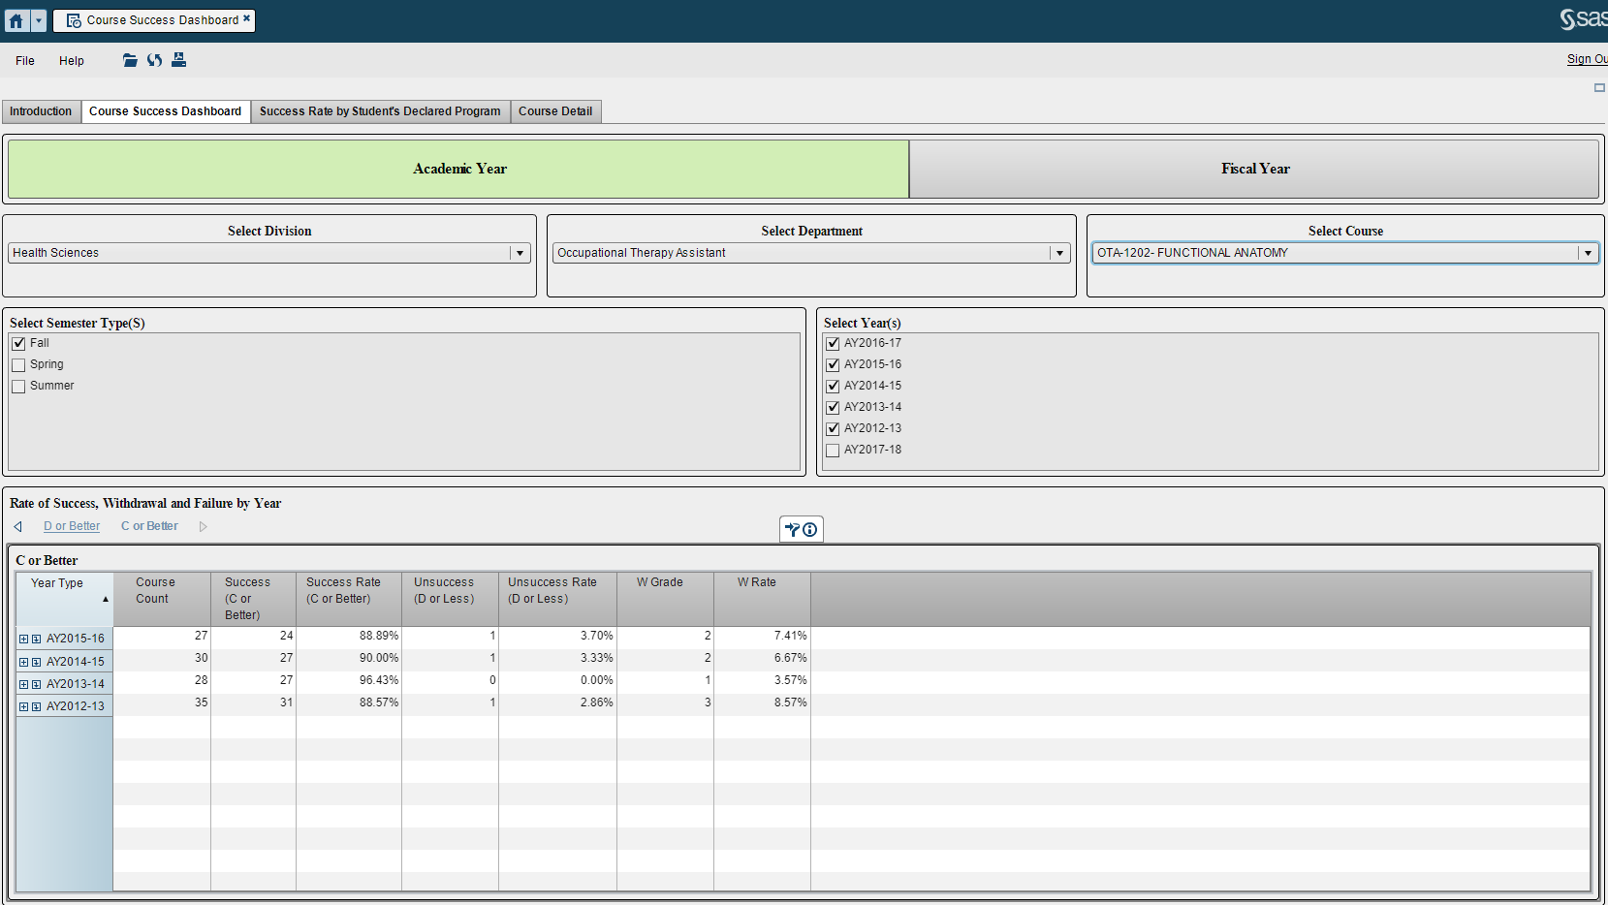

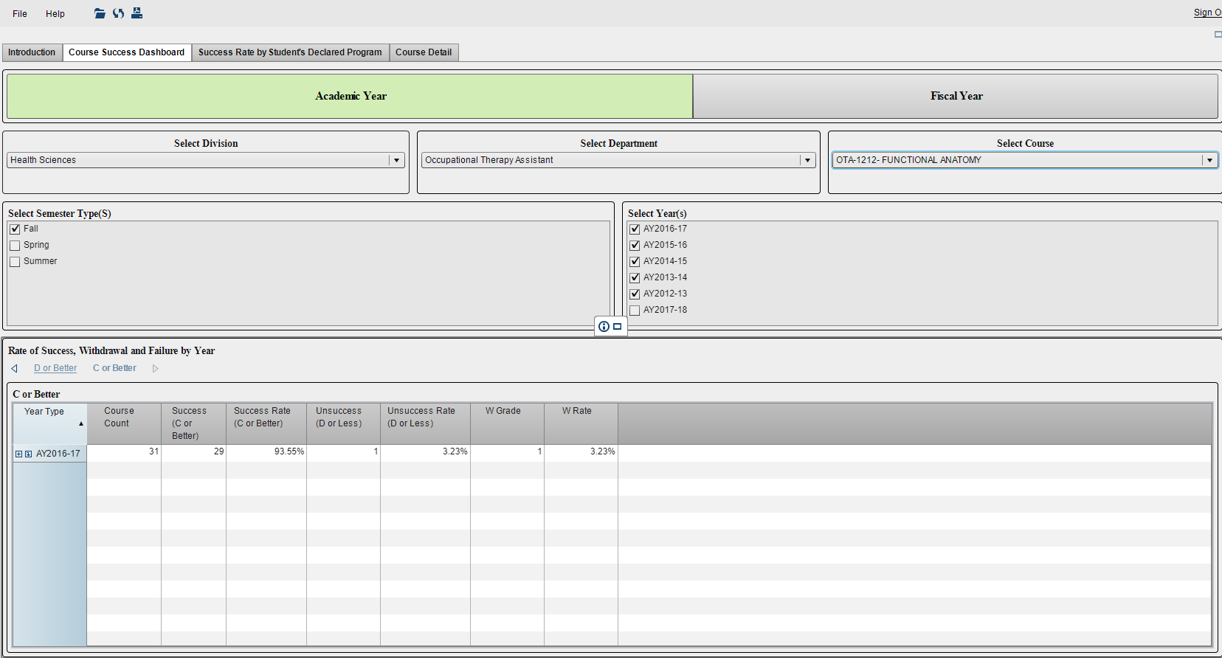

Appendix R
OTA Graduate Data

Total Accepted 2012 | 27
Wait List | 19 |  | 70%
AAAA | 10 |  | 37%
Tech Prep | 2 |  | 7%
Race: Black | 0 |  | 0%
White | 0 |  | 0%
NR | 0 |  | 0%
AN | 0 |  | 0%
Ethnicity Hispanic: | 0 |  | 0%
Non-Hispanic | 0 |  | 0%
NR | 0 |  | 0%
Gender Male: | 0 |  | 0%
Female | 0 |  | 0%
L2 Fieldwork Passed | 28 |  | 117%
2016 Total Graduates | 28 |  | 104%
2016 Total Withdrawals* | 3 |  | 11%
*all withdrawals were in 1st semester
Wait List Graduated | 18 |  | 64%
AAAA Graduated | 8 |  | 29%
Tech Prep Graduated | 2 |  | 7%
2016 Grads Passed NBCOT | 22 |  | 79%
2016 Grads Failed NBCOT | 5 |  | 18%
2016 Grads Employed FT | 6 |  | 21%
2016 Grads Employed PT | 0 |  | 0%
2016 Grads Employed PRN | 0 |  | 0%
Total Grads Employed | 6 |  | 21%
Total Accepted 2013 | 27
Wait List | 13 | 48%
AAAA | 13 | 48%
Tech Prep | 1 | 4%
Race: Black | 6 | 22%
White | 20 | 74%
NR | 1 | 4%
Ethnicity Hispanic: | 0 | 0%
Non-Hispanic | 19 | 70%
NR | 8 | 30%
Gender Male: | 3 | 11%
Female | 24 | 89%
L2 Fieldwork Passed | 25 | 100%
2015 Total Graduates | 25 | 93%
2015 Total Withdrawals* | 2 | 7%
*all withdrawals were in 1st semester
Wait List Graduated | 11 | 44%
AAAA Graduated | 13 | 52%
Tech Prep Graduated | 1 | 4%
2015 Grads Took NBCOT | 21 | 84%
2015 Grads Passed NBCOT | 21 | 84%
2015 Grads Employed FT | 9 | 36%
2015 Grads Employed PT | 3 | 12%
2015 Grads Employed PRN | 3 | 12%
Total Grads Employed | 15 | 60%
Total Accepted 2016 | 27
Wait List | 12 | 44%
AAAA | 14 | 52%
Tech Prep | 1 | 4%
Race: Black | 3 | 11%
White | 20 | 74%
NR | 3 | 11%
AN | 1 | 4%
Ethnicity Hispanic: | 2 | 7%
Non-Hispanic | 20 | 74%
NR | 5 | 19%
Gender Male: | 4 | 15%
Female | 23 | 85%
L2 Fieldwork Passed | 22 | 96%
2016 Total Graduates | 22 | 81%
2016 Total Withdrawals* | 4 | 15%
*all withdrawals were in 1st semester
Wait List Graduated | 9 | 41%
AAAA Graduated | 12 | 55%
Tech Prep Graduated | 0 | 0%
2016 Grads Passed NBCOT | 19 | 86%
2016 Grads Failed NBCOT | 0 | 0%
2016 Grads Employed FT | 5 | 23%
2016 Grads Employed PT | 9 | 41%
2016 Grads Employed PRN | 0 | 0%
Total Grads Employed | 14 | 64%

Total Accepted 2017 | 25
Wait List | 12 | 48%
AAAA | 12 | 48%
Tech Prep | 1 | 4%
Race: Black | 1 | 4%
White | 21 | 84%
NR | 3 | 12%
AN | 0 | 0%
Ethnicity Hispanic: | 2 | 8%
Non-Hispanic | 17 | 68%
NR | 6 | 24%
Gender Male: | 3 | 12%
Female | 22 | 88%
L2 Fieldwork Passed | 18 | 72%
2017 Total Graduates | 18 | 72%
2017 Total Withdrawals | 0 | 0%
Wait List Graduated | 7 | 39%
AAAA Graduated | 11 | 61%
Tech Prep Graduated | 0 | 0%
2017 Grads Passed NBCOT | 13 | 72%
2017 Grads Failed NBCOT | 0 | 0%
2017 Grads Employed FT | 9 | 50%
2017 Grads Employed PT | 2 | 11%
2017 Grads Employed PRN | 0 | 0%
Total Grads Employed | 11 | 61%

Appendix S
OTA Assignments: Creative VS Non-Creative & Individual VS Group

NEW OTA Course # | NEW Course Name | Course Total Points | Group Projects Possible Points | Percentage of Total Course Points is Based on Group Work | Individual Assignments’ Possible Points | Percentage of Total Course Points is Based on Individual Work | Percentage of Total Course Points is Considered a Creative Assignment | Percentage of Total Course Points is Considered a NON-Creative Assignment
1111 | Intro to OTA | 553 | 102 | 18.44% | 451 | 81.56% | 25.68% | 74.32%
1211 | OT Foundations 1 | 475 | 150 | 31.58% | 325 | 68.42% | 31.58% | 68.42%
1212 | Functional Anatomy | 500 | 145 | 29% | 355 | 71% | 29% | 71%
1213 | OT & Adults w/ Physical Dysfunction | 534 | 100 | 18.73% | 434 | 81.27% | 31.84% | 68.16%
1214 | LAB for OT & Adults w/ Physical Dysfunction | 755 | 0 | 0% | 755 | 100% | 19.21% | 80.79%
1311 | OT Foundations 2 | 550 | 275 | 50% | 275 | 50% | 50% | 50%
1312 | OT & Human Development | 500 | 100 | 20% | 400 | 80% | 45% | 55%
1313 | OT & Adults with Neurologic Dysfunction | 818 | 0 | 0% | 818 | 100% | 17.11% | 82.89%
1314 | LAB for OT & Adults with Neurologic Dysfunction | 680 | 160 | 23.53% | 520 | 76.47% | 36.03% | 63.97%
1315 | Therapeutic Use of Self | 466 | 60 | 12.88% | 406 | 87.12% | 37.55% | 62.47%
TOTAL (1st Year Courses) |  | 5831 | 1092 | 18.73% | 4739 | 81.27% | 32.3% | 67.7%

NEW OTA Course # | NEW Course Name | Course Total Points | Group Projects Possible Points | Percentage of Total Course Points is Based on Group Work | Individual Assignments’ Possible Points | Percentage of Total Course Points is Based on Individual Work | Percentage of Total Course Points is Considered a Creative Assignment | Percentage of Total Course Points is Considered a NON-Creative Assignment
2412 | OT & Pediatrics | 610 | 50 | 8% | 560 | 92% | 31% | 69%
2413 | LAB for OT & Pediatrics | 840 | 125 | 15% | 715 | 85% | 30% | 70%
2414 | OT & Psychosocial Dysfunction | 520 | 10 | 2% | 510 | 98% | 18% | 82%
2415 | LAB for OT & Psychosocial Dysfunction | 675 | 159 | 24% | 516 | 76% | 37% | 63%
2416 | OTA Level 1 Fieldwork | 775 | 170 | 22% | 605 | 78% | 34% | 66%
2511 | OTA Level II Fieldwork A | 380 | 0 | 0% | 380 | 100% | 20% | 80%
2523 | OTA Clinical Issues A | 300 | 0 | 0% | 300 | 100% | 20% | 80%
2512 | OT Level II Fieldwork B | 380 | 0 | 0% | 380 | 100% | 20% | 80%
2524 | OTA Clinical Issues B | 200 | 0 | 0% | 200 | 100% | 20% | 80%
TOTAL 2nd Year Courses
 |  | 4680 | 514 | 11% | 4166 | 89% | 26% | 74%
TOTAL OTA PROGRAM |  | 10,511 | 1606 | 15% | 8905 | 85% | 29.15% | 70.85%

Appendix T
2014 OTA Graduates
 | ADMIT | GRAD
Waitlist | 19 | 18 (95%)
AAAA | 10 | 8 (80%)
Tech Prep | 2 | 2 (100%)
TOTAL | 31 | 28 (90%)

2015 OTA Graduates
 | ADMIT | GRAD
Waitlist | 13 | 11 (85%)
AAAA | 13 | 13 (100%
Tech Prep | 1 | 1 (100%)
TOTAL | 27 | 25 (93%)

2016 OTA Graduates
 | ADMIT | GRAD
Waitlist | 12 | 9 (75%)
AAAA | 14 | 12 (86%)
Tech Prep | 1 | 0 (0%)
TOTAL | 27 | 21 (78%)

2017 OTA Graduates
 | ADMIT | GRAD
Waitlist | 12 | 7 (58%)
AAAA | 12 | 11 (92%)
Tech Prep | 1 | 0 (0%)
TOTAL | 25 | 18 (72%)

Total OTA Graduates Years 2014-2017
 | ADMIT | GRAD
Waitlist | 56 | 45 (80%)
AAAA | 49 | 44 (90%)
Tech Prep | 5 | 3 (60%)
TOTAL | 110 | 92 (84%)
AAAA=Accelerated Admission for Academic Achievement

Appendix U
OTA Employer Survey Data 2016
Technical Education Evaluation: | # of Employers Completed Survey | Very Poor | Poor | Somewhat Poor | Somewhat Good | Good | Very Good
Job-related conceptual knowledge | 12 |  |  |  | 1 |  | 11
Job-related technical knowledge | 12 |  |  |  | 1 | 1 | 10
Work attitude | 12 |  |  |  |  |  | 12
Quality of work | 12 |  |  |  |  | 2 | 10
Ability to think logically | 12 |  |  |  |  | 3 | 9
Problem-solving abilities | 12 |  |  |  | 1 | 4 | 7
Oral communication skills | 12 |  |  |  |  | 4 | 8
Written communication skills | 12 |  |  |  |  | 5 | 7
Interpersonal skills | 12 |  |  |  |  | 1 | 11
Computer skills | 12 |  |  |  |  | 8 | 4
Data gathering skills | 12 |  |  |  |  | 4 | 8
Overall job preparation | 12 |  |  |  |  | 3 | 9
Relative Preparation: |  | No basis | Much better prepared | Better prepared | Somewhat better prepared | Somewhat worse prepared | Worse prepared | Prepared the Same
How would you compare the preparation of this Sinclair-trained employee to that of non-Sinclair-trained employees working in similar positions? |  | 1 | 2 | 7 |  |  |  | 2

